General Notes

- Two hour Exam
- Answer 2 of 3 Questions
- 1 hour per question

Flow Control

* U-Frame – Setup*
* I-Frame – Information Transfer*
* S-Frame – ACK / NAK*
--------------------------------------------------
- First send U-Frame between nodes to setup the connection
-Wait for U-Frame response (ACK)
- Use I-Frame to send information between nodes
- Wait for S-Frame to return ACK / NAK
- If NAK re-send I-Frame
- If ACK send next I-Frame
- After 5 transactions send U-Frame to disconnect

Flow Control is the method by which the amount of data transmitted to a receiver is controlled. It determines how packets are sent between two nodes within a telecommunication network and defies how errors should be handled.

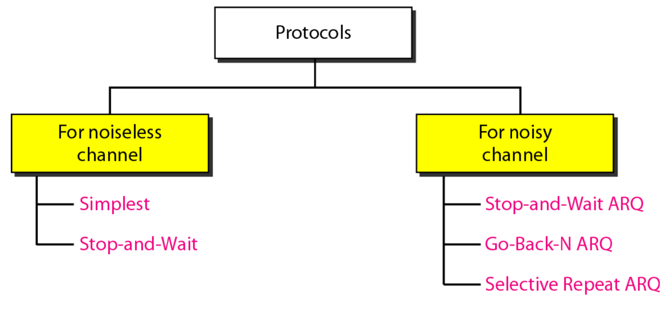

- Stop-And-Wait ARQ: This is when a sender waits to receive an ACK from the receiver before sending the next packet. Good because it ensures no packets are lost, however it is time consuming and isn’t very efficient.

- Go-Back-N ARQ: This is when if an ACK for a specific frame has not been received within a given time frame the system re-sends all subsequent frames from the last ACK onwards. This is good because it allows transmission to continue, however all subsequent frames must be resent which is very ineffecient.

- Selective Repeat ARQ: This is when a receiver keeps track of the frame it expects next, informing the sender also which frame it expects. If a receiver receives a packet that does not match the packet number it expected it returns an NAK informing the sender of which packet it is missing. This is good because it allows continuous transmission and it also enables individual packets to be resent rather than the entire transmission.

- Selective Repeat ARQ (Window Size = 2^{m}/2)
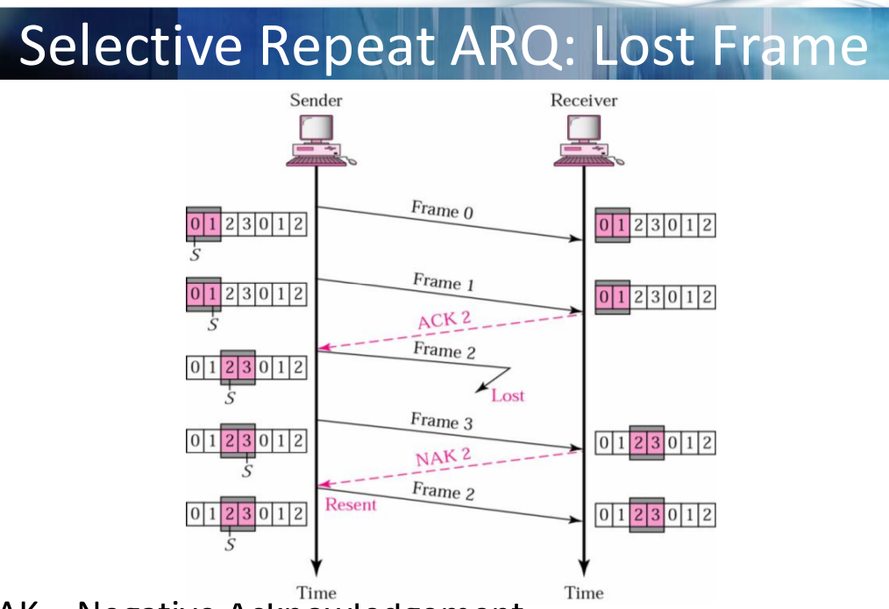
- Frame 0 is the first packet sent between A and B.

- Frame 1 is then sent, receiver expected this frame, returns ACK2 (expects Frame 2 next)

- Frame 2 is lost, next frame received is Frame 3.

- This is the wrong frame so receiver returns NAK2 informing that it expected Frame 2.

- Frame 2 is resent.

- Go-Back-N ARQ (Window Size = 2^{m}-1 )
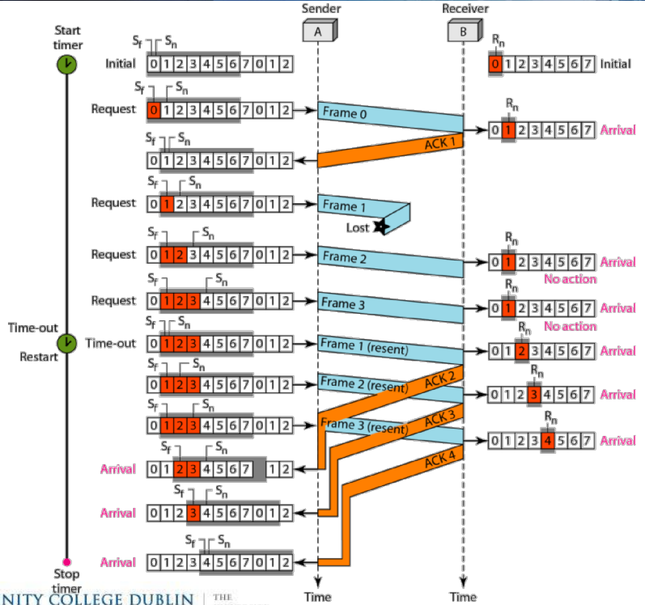
- Frame 0 is sent, senders receives an ACK informing it that Frame 1 is expected next.

- Frame 1 is sent, but is lost. Transmission continues and no ACK is received within time period.

- Transmission is timed out. System goes back to last ACK and re-sends Frame 1.

- Transmission continues from here onwards and all subsequent are re-transmitted to receiver.

Error Detection & Correction

1. Even-Parity Concept

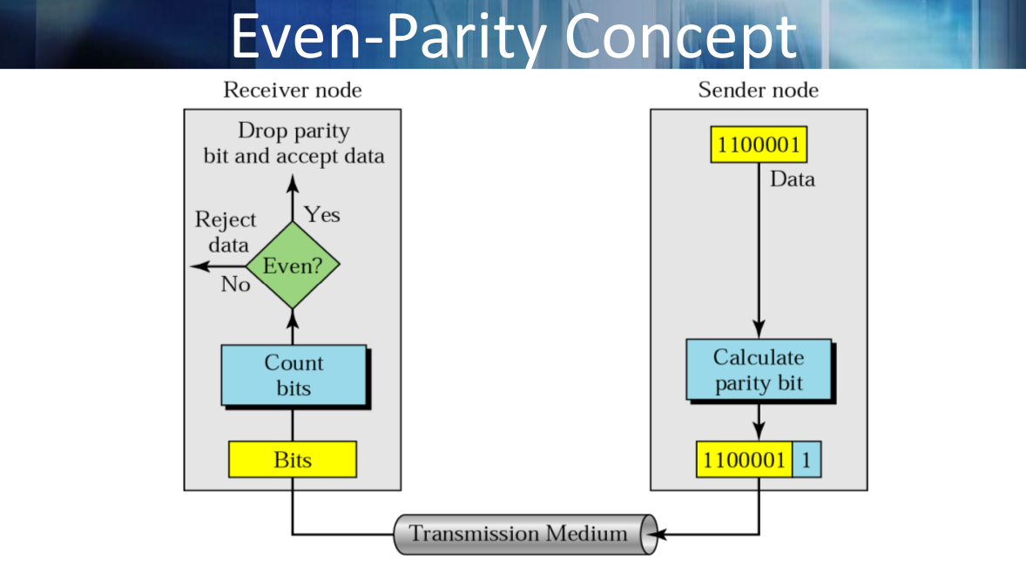
- Add an extra 1 to the bit sequence to ensure that the total number of 1’s are even.

- If the total number of 1’s are already even, add a 0 to the end of the sequence.

- At receiver, count bits and ensure that received sequence contains even number of bits.

- Can detect single-bit errors.

2. Cyclic-Redundancy Checksum (CRC)
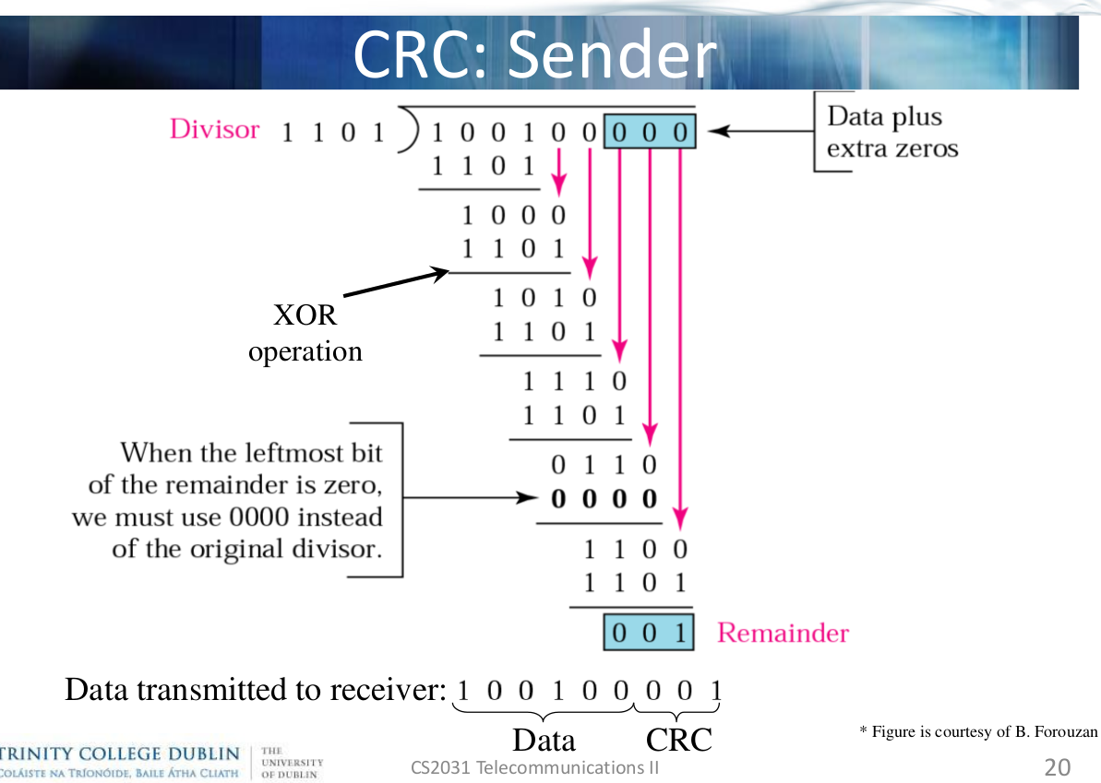
- Based on the polynomial (divisor) of n bits, add
n-1 * 0’s to the end of the data.

- Perform an XOR division operation (if leftmost bit of remainder is zero, use 0000 instead).

- Add this CRC remainder [001] to the end of the data and transmit.

- Can detect burst errors that affect odd number of bits or all burst errors with length < deg.
3. Checksum
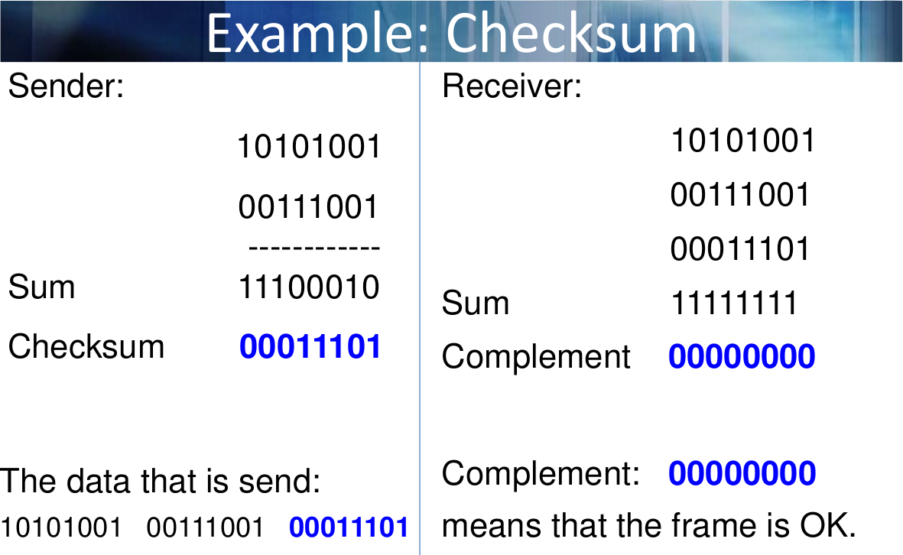
- All of the sections of the data are added together using binary addition.

- Then, get the complement of this sum.Transmit this Checksum as well as the original bits.

- At the receiver, add the sections of bits together once again and complement sum. If result is all 0’s, frame is OK.

