Discrete Maths – Definitions

Graph Theory

Complete Graph: A complete graph is a graph containing the highest number of edges possible for its given set of vertices.

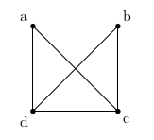

Regular Graph: A regular graph is a graph where every vertex has the same degree. A graph is considered to be k-regular if every vertex has a degree of k.

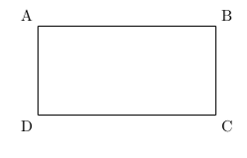

Incidence Table: A graphs incidence table is the table of Edges vs Vertices marking incidency.

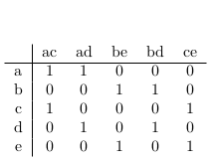

Adjacency Table: A graphs adjacency table is the table of Edges vs Vertices marking adjacency.

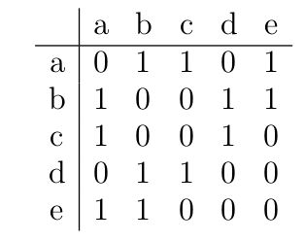

Bipartite Graph: A bipartite graph is a graph that contains two seperate unique subsets of vertices that when taking every edge into account, every edge will be of the form E = vw where v is from subset one and w is from subset 2.

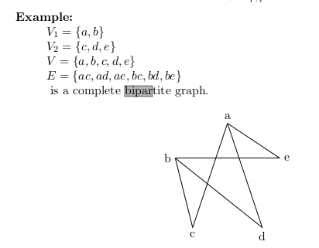

Isomorphism: An isomorphism between two graphs (V, E) and (V , E ) is a bi-jective function φ : V→ V satisfying that ∀a, b ∈ V with a = b the edge ab ∈ E ⇔ the edge φ(a)φ(b) ∈ E

Walk: A walk in a graph is a defined route of vertices that traverses a given set of edges passing through a given set of vertices.

Trail: A trail in a graph is a walk that traverses edges at most once.

Path: A path in a graph is a walk that passes through vertices at most once.

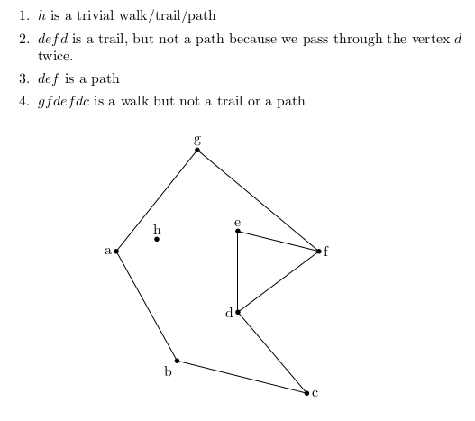

Connected Graph: A connected graph is a graph where there exists a path in the graph from every u to every v.

Circuit: A circuit is a nontrivial closed trail i.e. a closed walk with no repeated edges passing through at least two vertices.

Eulerian Trail: An Eulerian trail in a graph is a trail that traverses every edge of that graph. In other words, an Eulerian trail is a walk that traverses every edge of the graph exactly once.

Trail ⇒ an edge is traversed at most once.
Eulerian ⇒ every edge is traversed.

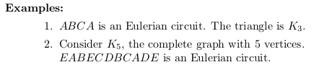

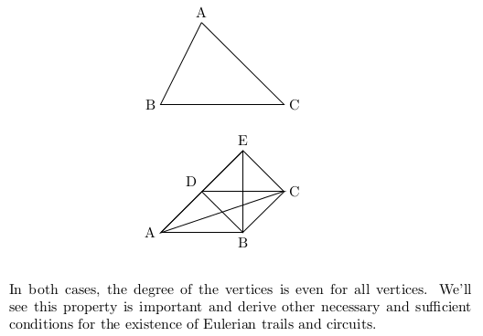

Hamiltonian Path: A Hamiltonian path in a graph is a path that passed exactly once through every vertex of a graph.

Path ⇒ we pass through a vertex at most once (no repeated vertices)
Hamiltonian ⇒ we pass through every vertex.

Hamiltonian Circuit: A Hamiltonian circuit in a graph is a simple circuit that passes through every vertex of the graph.

A Tree: A tree is a graph defined by the formula:

#V = 2 * #E

