Telecommunications Exam Solutions

- Two hour Exam
- Answer 2 of 3 Questions
- 1 hour per question

2016 Exam:

Q1 (a) – Flow Control

I) Define the term ‘flow control’ and explain the trade-off in the design of flow control mechanisms by discussing a number of flow control mechanisms.

Flow Control is the method by which the amount of data transmitted to a receiver is controlled. It determines how packets are sent between two nodes within a telecommunication network and defies how errors should be handled.

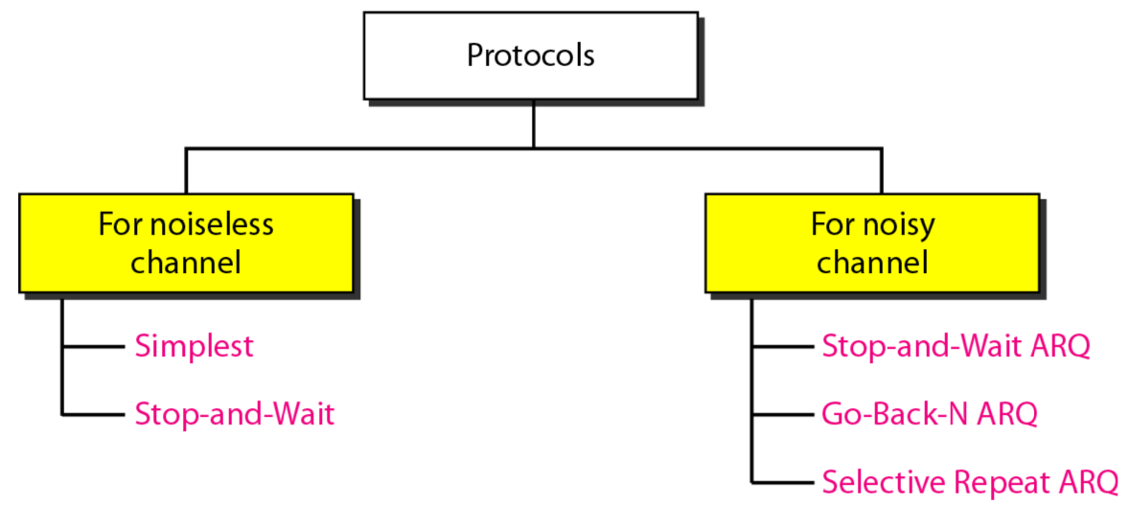

- Stop-And-Wait ARQ: This is when a sender waits to receive an ACK from the receiver before sending the next packet. Good because it ensures no packets are lost, however it is time consuming and isn’t very efficient.

- Go-Back-N ARQ: This is when if an ACK for a specific frame has not been received within a given time frame the system re-sends all subsequent frames from the last ACK onwards. This is good because it allows transmission to continue, however all subsequent frames must be resent which is very ineffecient.

- Selective Repeat ARQ: This is when a receiver keeps track of the frame it expects next, informing the sender also which frame it expects. If a receiver receives a packet that does not match the packet number it expected it returns an NAK informing the sender of which packet it is missing. This is good because it allows continuous transmission and it also enables individual packets to be resent rather than the entire transmission.

II) Assume that you are asked to provide a Selective Repeat mechanism and a Go-Back-N mechanism for communication between two stations A and B. Describe with the help of diagrams the exchange of 10 frames between A and B for both mechanisms.

- Selective Repeat ARQ
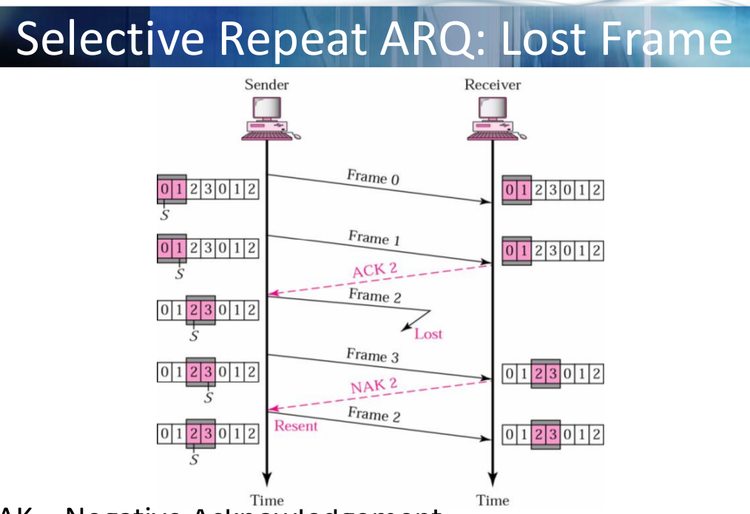
- Frame 0 is the first packet sent between A and B.

- Frame 1 is then sent, receiver expected this frame, returns ACK2 (expects Frame 2 next)

- Frame 2 is lost, next frame received is Frame 3.

- This is the wrong frame so receiver returns NAK2 informing that it expected Frame 2.

- Frame 2 is resent.

- Go-Back-N ARQ

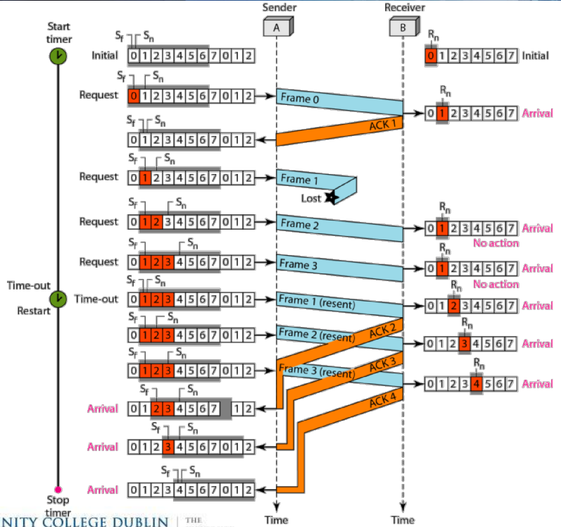
- Frame 0 is sent, senders receives an ACK informing it that Frame 1 is expected next.

- Frame 1 is sent, but is lost. Transmission continues and no ACK is received within time period.

- Transmission is timed out. System goes back to last ACK and re-sends Frame 1.

- Transmission continues from here onwards and all subsequent are re-transmitted to receiver.

III) Discuss the advantages and disadvantages of a Selective Repeat Mechanism in comparison to a Stop-and-Wait mechanism.

By using a Selective Repeat Mechanism it enables you to fluidly transmit between a sender and a receiver whilst also handling any lost packets quite efficiently as only individual lost packets need to be resent.

In comparison, a Stop-and-Wait mechanism doesn’t allow for fluid transmission as the sender must halt transmission and wait to receive an ACK from the receiver before transmitting the next frame. This is not ideal in a real-life situation where transmission times may be long and transmissions may expensive.

Q1 (b) – Cyclic Redundancy Checks

Cyclic-Redundancy Checksums (CRCs) may be used as error control mechanisms in the Link layer. Suppose we want to transmit the message 1011001001001011 and protect it from errors using the CRC-8 polynomial x⁸+x²+x+1.

I) Describe the calculation of a CRC and demonstrate the first four steps of the calculation.

When selecting the CRC devisor it should :

- Not be divisible by x
- Be divisibly by x+1

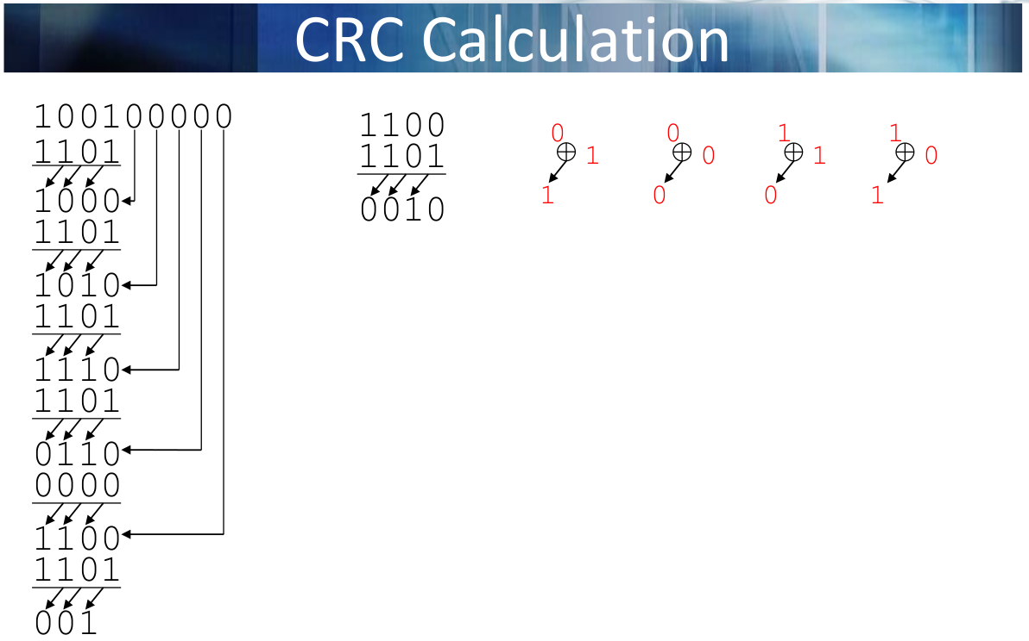

- Divide Payload ( + 3 * 0’s for remainder ) by selected CRC polynomial e.g 1101
- Perform XOR between the bits, shifting left each bit
- Carry down the next bit, perform the XOR operation again
- Repeat until no more bits to carry down
- Remainder is then your CRC value to be transmitted

- Polynomial x⁸+x²+x+1 to bit value:

x⁸+x²+x+1 → 100000111 = CRC Divisor

- Divide first n message bits by CRC divisor

1011001001001011[000]
100000111
--------------
011000111

- Divide new remainder n message bits by CRC divisor

1011001001001011[000]
100000111
--------------
011000111
100000111
--------------
110000000

- Divide new remainder n message bits by CRC divisor

1011001001001011[000]
100000111
--------------
011000111
100000111
--------------
110000000
100000111
--------------
100001110

II) Show the data bits and CRC bits of the bit sequence that would be transmitted and discuss the interpretation of the possible outcomes of the calculation at the receiver

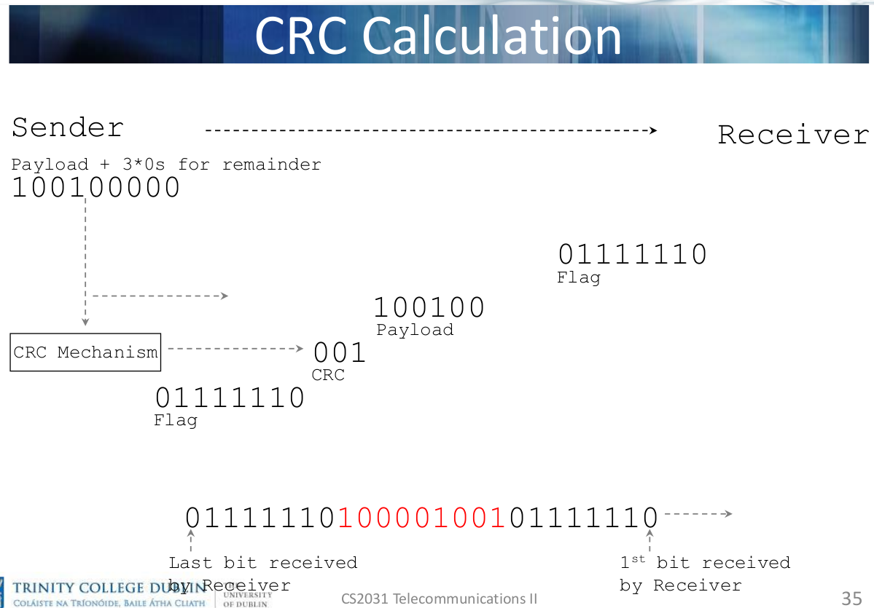

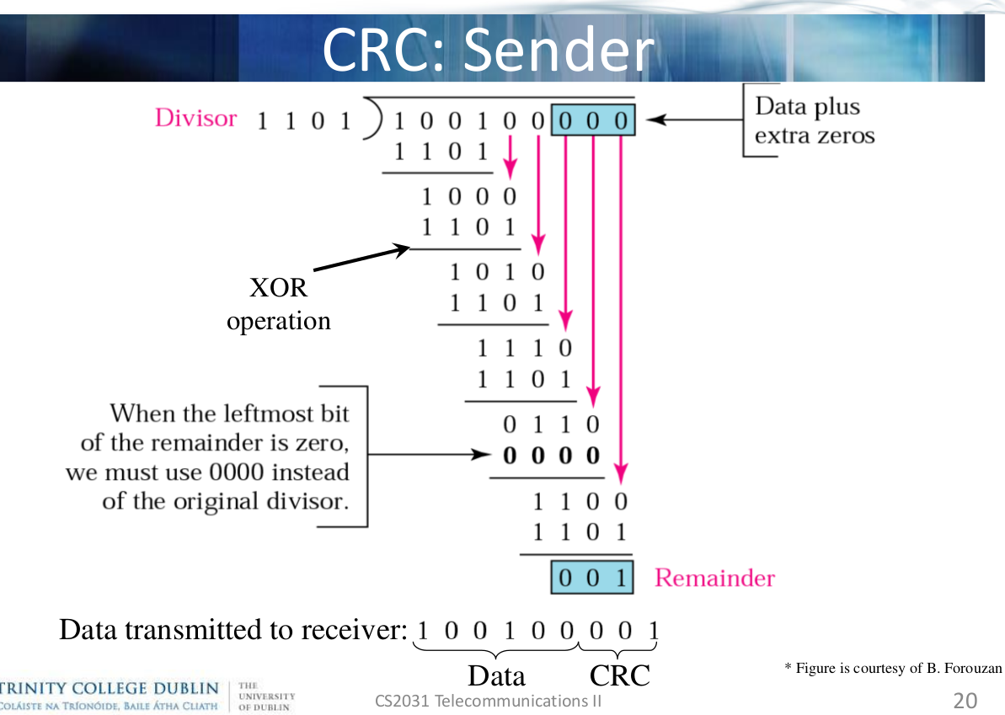
Sender Process:

- The payload + 3*0s are sent to the CRC mechanism.

- The CRC mechanism uses the CRC polynomial to calculate the CRC for the payload.

- The packet is then formed in the form [FLAG] [CRC] [PAYLOAD] [FLAG].

- Packet is sent to receiver.

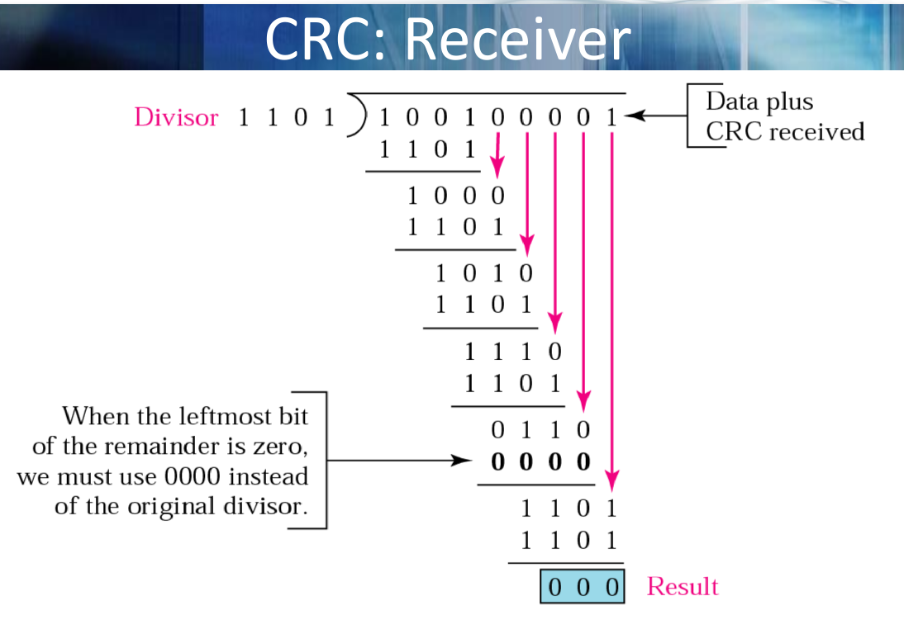
Receiver Process:

- The receiver receives a packet, extracts the payload + CRC.

- The CRC mechanism divides the Payload+CRC by the polynomial.

- If remainder is 0, correct bits, otherwise incorrect bits.

