XML Notes

Baic XML Example

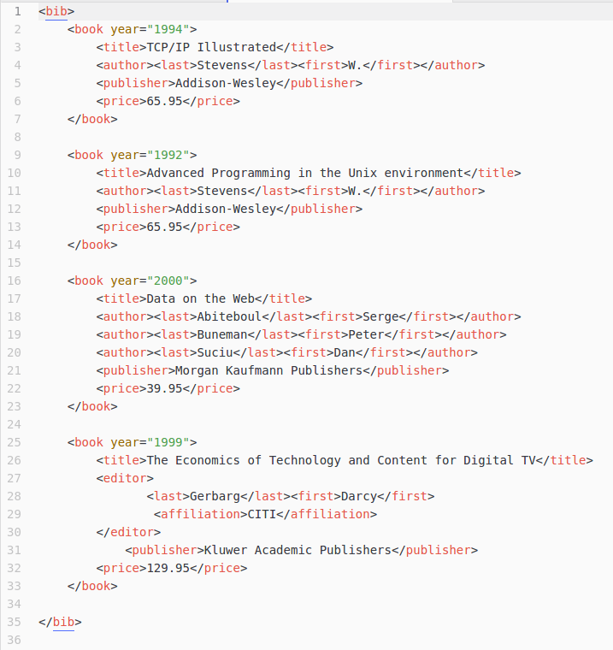

XML Notation

XML Declaration: Placed at start of XML document, informs XML of the version, character encoding, whether to use external declarations

<?xml
version="1.0"
encoding="UTF-8"
standalone="yes"
?>

<!DOCTYPE person [<!ELEMENT person (name, adult, nationality)>]>.

XML Elements: Used to define logical structure and sections of XML documents.

- Data Content: <title> Java Gently </title>
- Element Content: <author> Judy Bishop </author>
- Mixed Content: <text> this is <bold>bold</bold> text </text>
- Empty: <paragraph/>

Character Data (CDATA): Data which is to be parsed is called PCDATA. Useful for including source code in XML.

<![CDATA[]]>

Processing Instructons: You can pass additional information to an application using a parser.

<?myapp filename='test.txt'?>

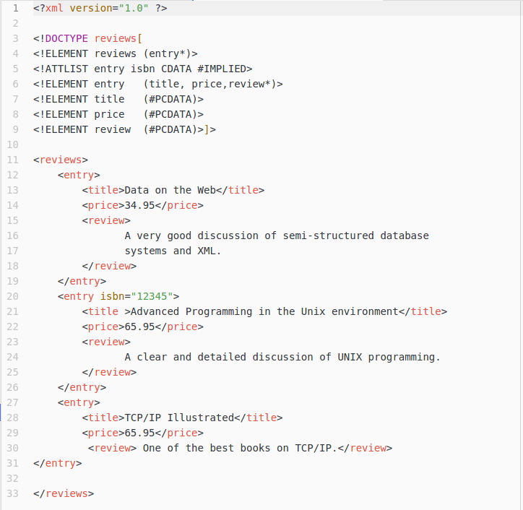

Document Type Declaration (DTD)

Document Type Declaration (DTD): Used to define structure/model of XML documents. Certain elements will have to be of a certain type e.g date and also follow a set structure. This is defined within the DTD.

Element Type Declaration: Used to define structure and occurances of elements.

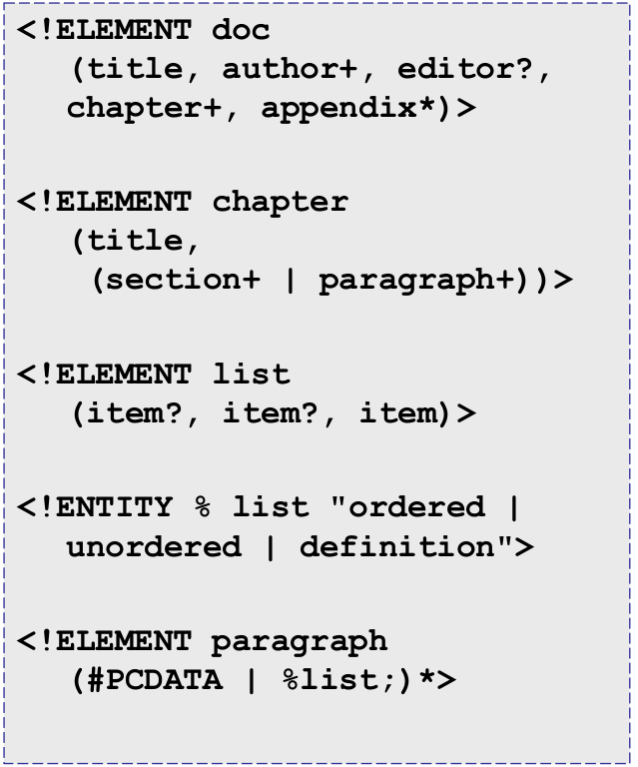

← Defines grouping of elements

- ? = Zero-Or-One

- + = One-Or-More

- * = Zero-Or-More

Entity Declaration: Used to define internal, built-in entities.

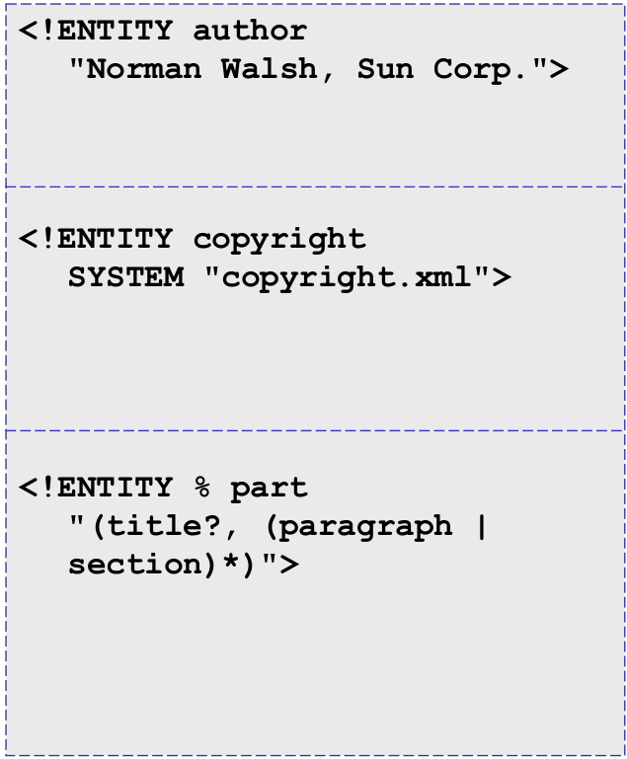

← Self Defined Entity

← Externally Defined Entity

← Parameterised Entity

Attribute List Declaration: Used to define the type of an attribute, where or not it is required, fixed etc.

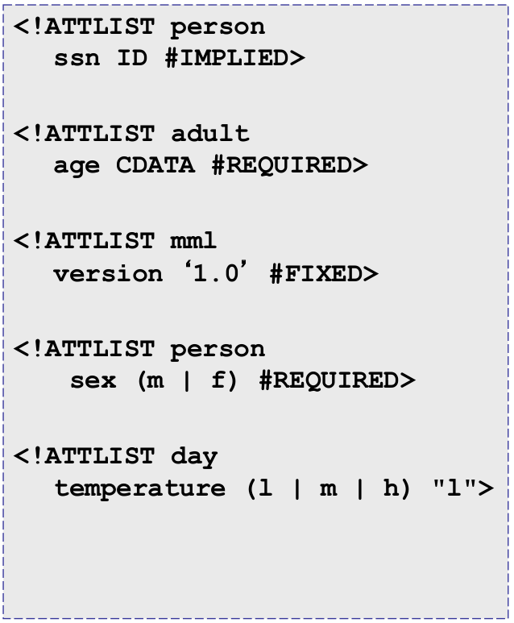
← Implied Attribute

← Required Attribute

← Fixed Attribute

Simple DTD Example

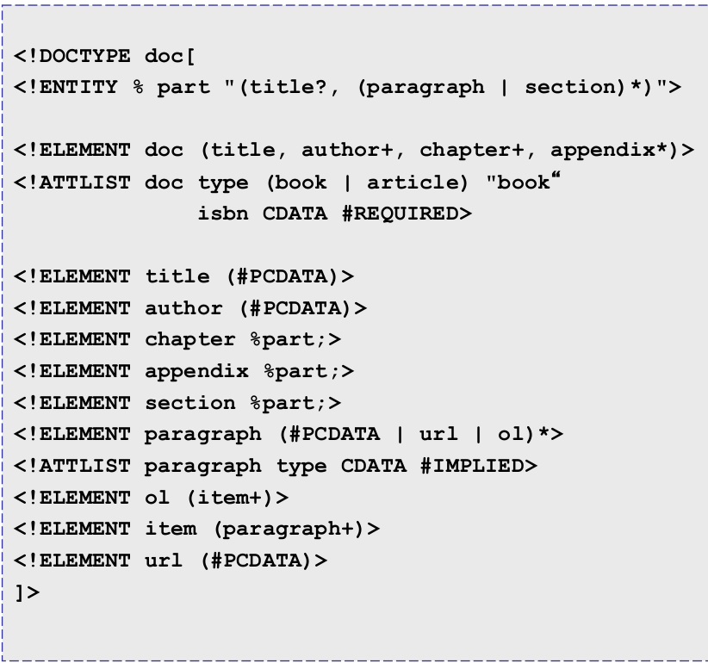

← Entity Declaration

← Attribute List Declaration

← Element Type Declaration

UML → XML Mapping

------------------------------------------------------------------------------------------------------

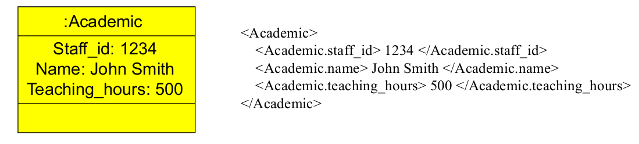

-------------------------------------------------------------------------------------------------------

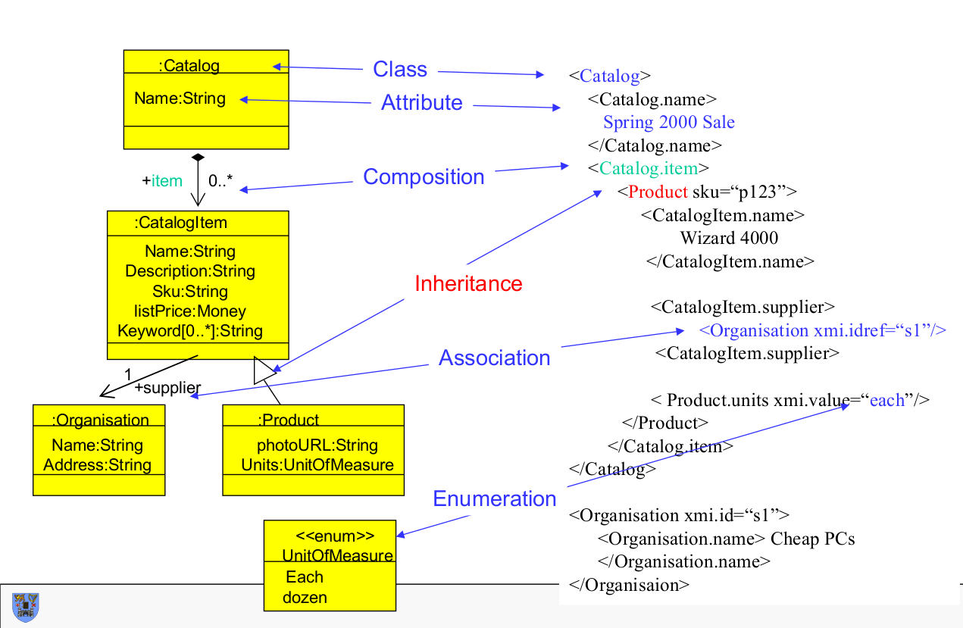

XML Namespaces

XML Namespace: Each XML vocabulary is considered to own a namespace in which all elements (and attributes) are unique. Other documents can use and access elements from other namespaces.

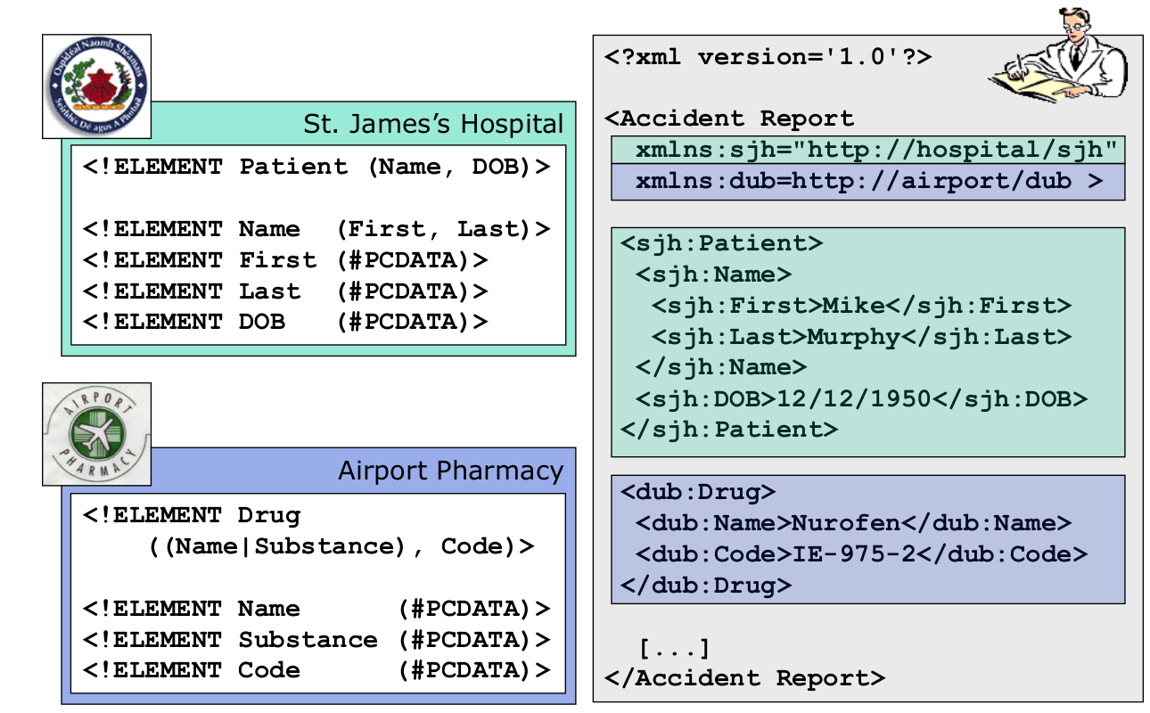

XML Schemas

XM Schemas: XML Schemas are a type declaration similar to DTD but written using XML Syntax to enhance readability. XML Schemas allow for support of namespaces.

-------------------------------------------------------------------------------------------------------

Basic XML Schema

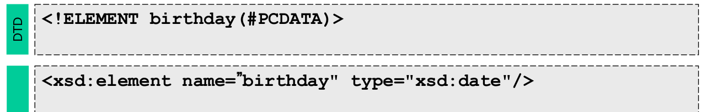
-------------------------------------------------------------------------------------------------------

Complex XML Schema

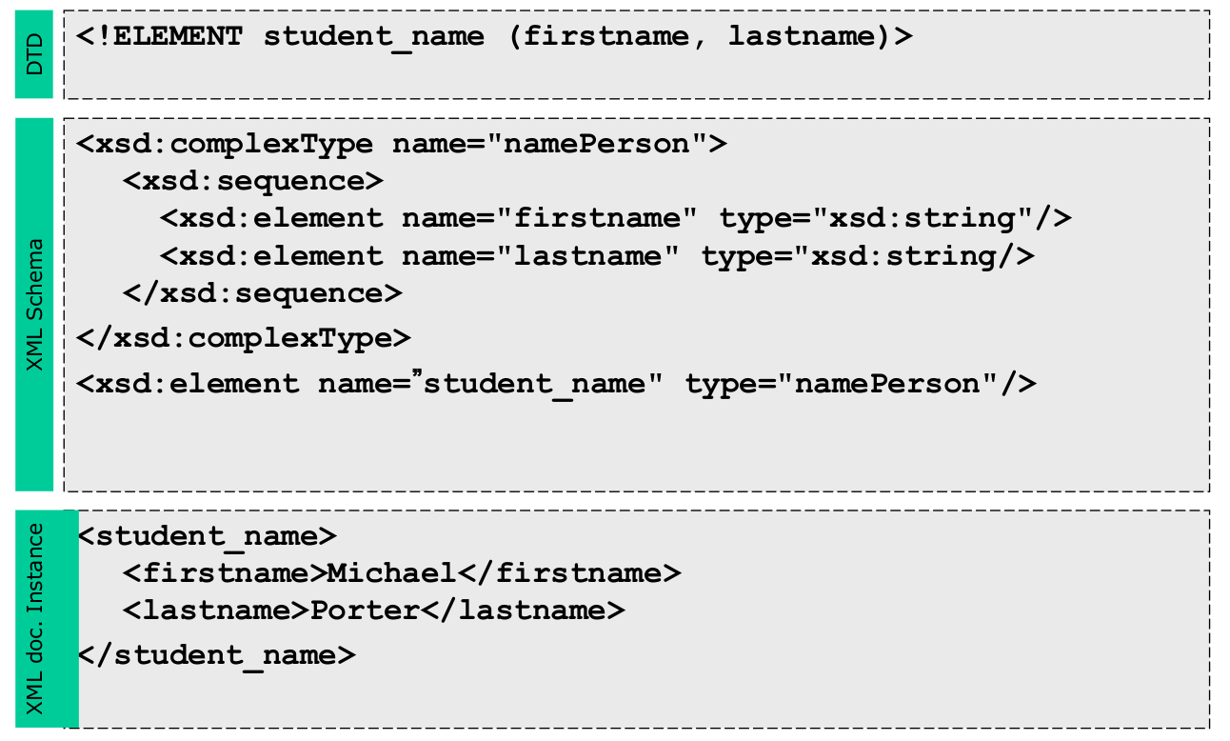

-------------------------------------------------------------------------------------------------------

Cardinalities XML Schema

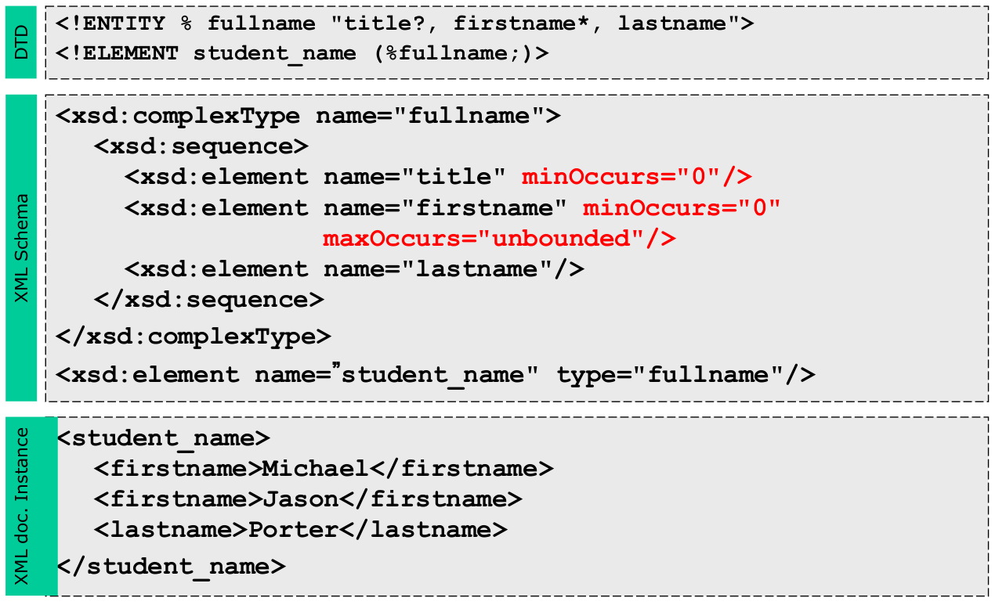
-------------------------------------------------------------------------------------------------------

Restriction XML Schema

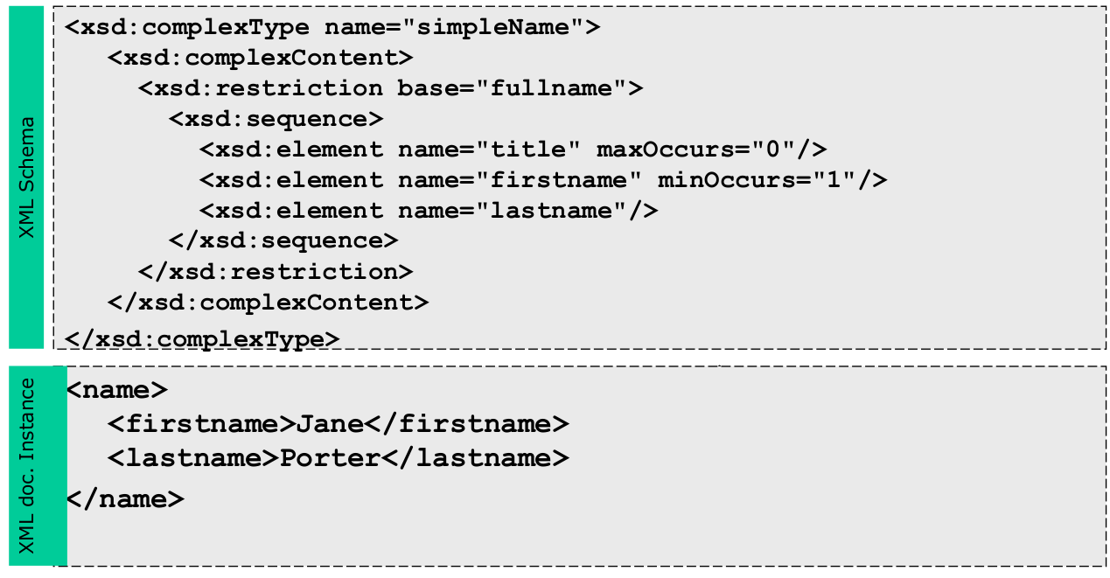
-------------------------------------------------------------------------------------------------------

Attributes XML Schema

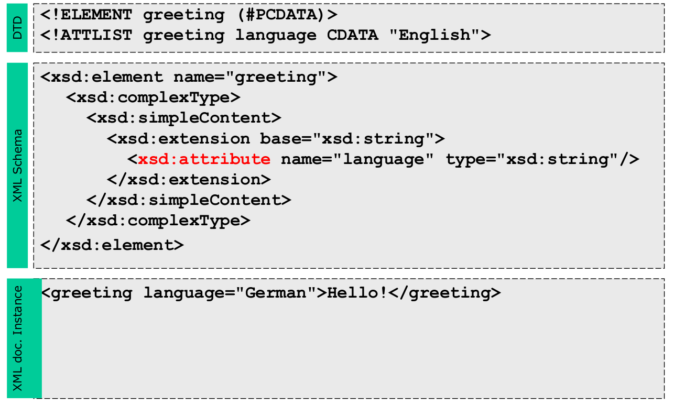
-------------------------------------------------------------------------------------------------------

XML Schema Example

