Computer Architecture – Microprogrammed Control
Simulation Results

Brandon Dooley (#16327446)

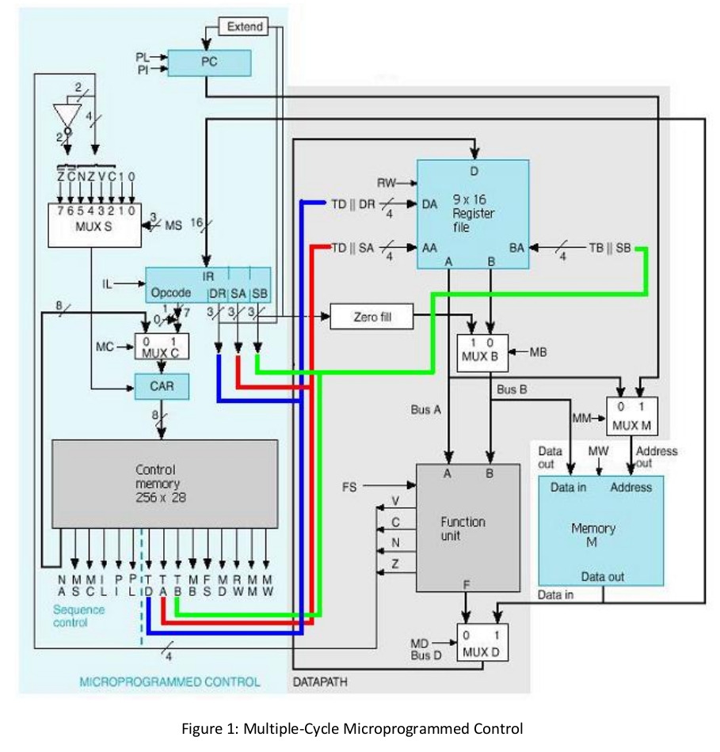

Table of Contents

Multiple‐Cycle Microprogrammed Control

Datapath:

Register File (9 x 16bit Register File)

1. Reg16 (16bit Data Register)
2. 4-to-9 Decoder (16bit)
3. 9-to-1MUX
4. Register File (9 x 16bit Register File)

Function Unit

1. Arithmetic Logic Unit (1bit)
2. Arithmetic Logic Unit (16bit)
3. Shifter (1bit)
4. Shifter (16bit)
5. 2-to-1 MUX (16bit)
6. Zero Detect
7. Function Unit

Microprogrammed Control

Program Counter (PC)
Extend
Instruction Register (IR)
Control Address Register (CAR)
MUXS 8-to-1(1 bit)
MUXC 2-to-1(8 bit)
Control Memory

Memory

DATAPATH

Register File (9 x 16bit Register File)

1. Reg16 (16bit Data Register)

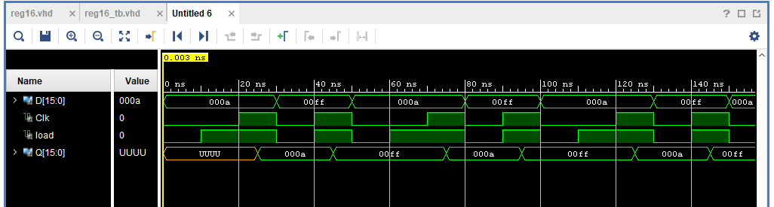
Register is loaded based on Clk and Load. When Clk and Load are both high the contents of the register is loaded with the 16bit value of D. When either Clk or Load are low, contents of the register do not change.

2. 4-to-9 Decoder (16bit )

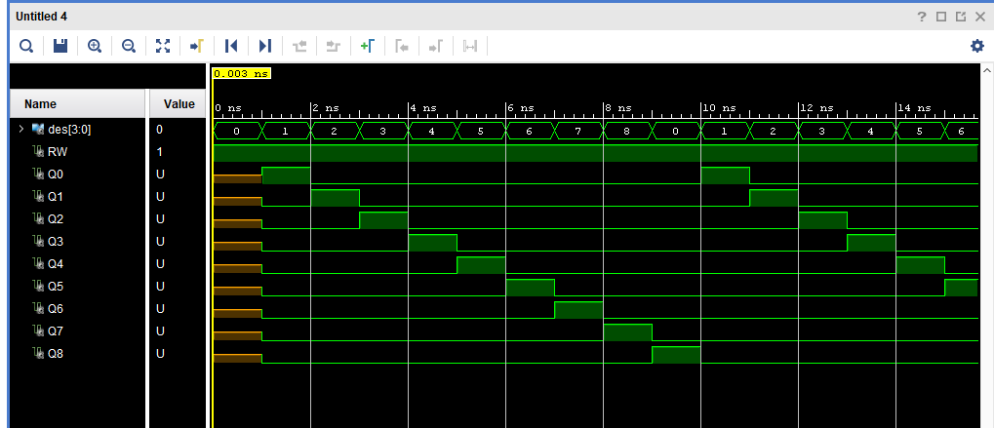
The value at the output lines of the decoder depend on the input vector des. Here each output line is individually tested to ensure selection works correctly. The output line only goes high when RW (Read-Write) is also high.

3. 9-to-1 MUX (16bit)

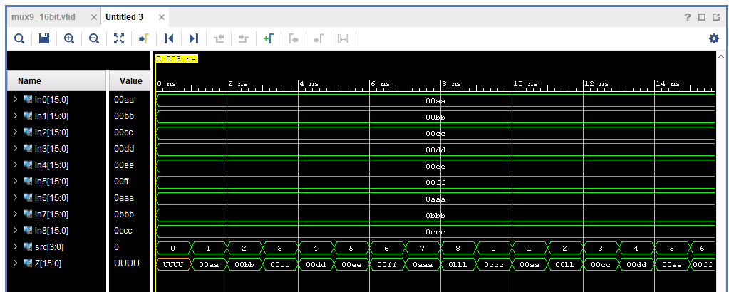
Each input line In0 – In8 contains a unique 16 bit value. The value of the output line Z is dependent on the vector src. This testbench individually selects each input line and ensures the correct value is carried through to the output line.

4. Register File (9 x 16bit Register File)

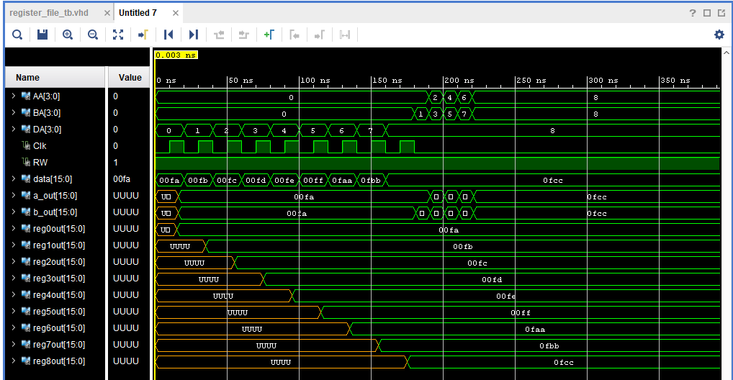
Between 0 and 175ns each individual register is loaded with a unique value upon every Clk cycle. This can be seen in the respective regXout lines. The destination register is decided by the DA vector and the value to be loaded is found in the Data vector. Around the 175ns mark tests are carried out to test the AA (A Register) and BA (B Register) select vectors. The correct corresponding outputs can be seen in the testbench above.

Function Unit

1. Arithmetic Logic Unit (1bit)

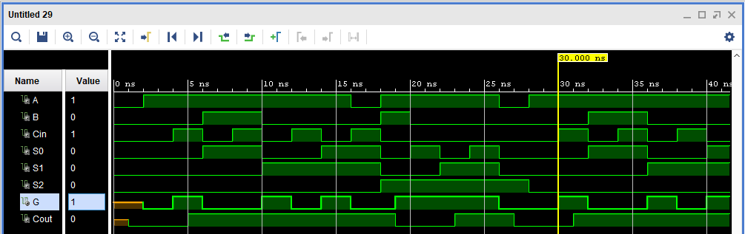
Every 2ns each of the different desired arithmetic operations are tested. The first of which can be seen as testing all zeros. The second test tests G = A which has the select code of S(000). When Cin = 0, the output G can be seen to be 1. When Cin changes to 1, G can be seen to change to 0, successfully performing G=A+1. A detailed description of the testbench can be found in alu_tb.vhd.

2. Arithmetic Logic Unit (16bit)

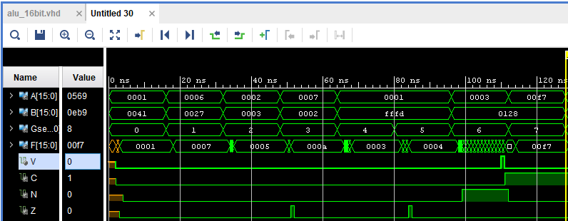
Arithmetic Tests: Various arithmetic operations are performed and tested. The first of which is F = A, the output line can be seen to display the correct result. The second is F = A+1, once again the desired output is shown at F. A detailed description of the testbench can be found in alu_16bit_tb.vhd.

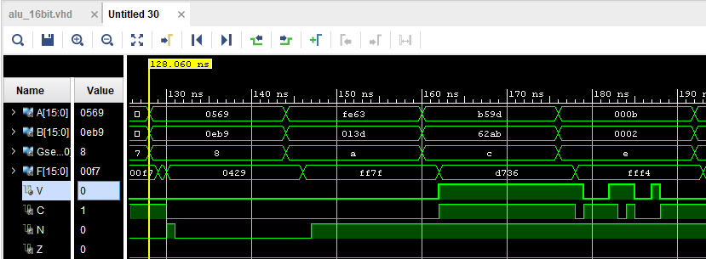
Logic Tests: Various logic operations are performed and tested. The first of which is F = A^B, the output line can be seen to display the correct result. The second is F = A or B, once again the desired output is shown at F. A detailed description of the testbench can be found in alu_16bit_tb.vhd.

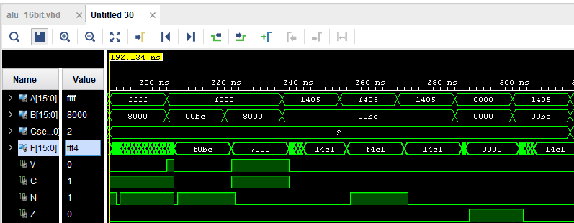
Flag Tests: Various arithmetic operations are performed and tested in order to ensure the flags are working correctly. The first of which is the Overflow flag (V), the operation performed is 0xFFFF + 0x8000 = 0x7FFF -> V = 1. A detailed description of the testbench can be found in alu_16bit_tb.vhd.

3. Shifter (1bit)

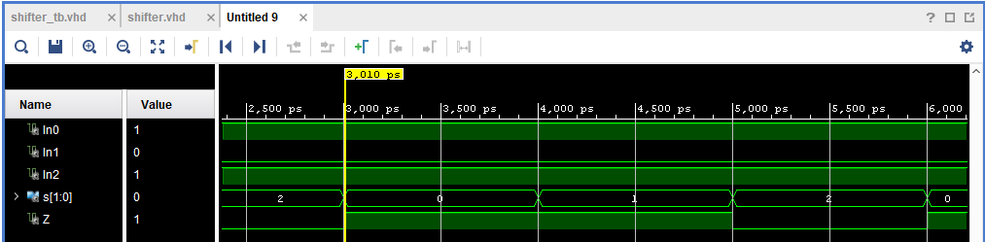
Various shift operations are performed and tested on a 1 bit vector. The input vector In0 was shifted twice as can be seen at the output line Z.
4. Shifter (16bit)

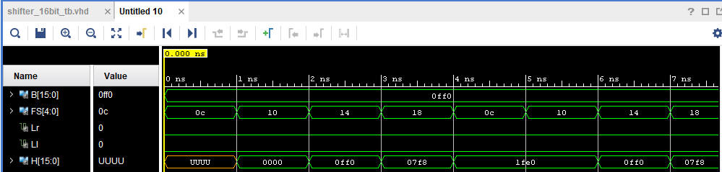
Various shift operations are performed and tested on a 16 bit input vector B. The first test ensures incorrect Opcode (FS) doesn’t perform any operation. After this F=B is tested (shift of 0 bits). Followed by LSR, then LSL.

5. 2-to-1 MUX (16bit)

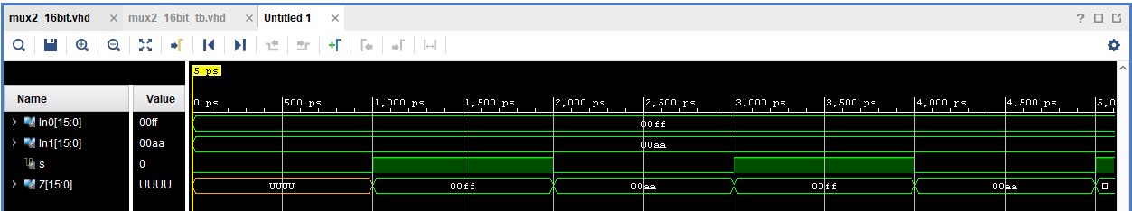
Each of the input lines are selected using the S vector and transferred through to the output line Z.

6. Zero Detect

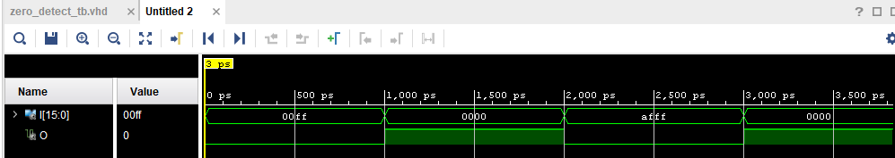
The Zero Detect device is tested to ensure that the Z flag will be set correctly upon a 0 value.

7. Function Unit (16 bit) ** NEEDS TO BE REDONE**

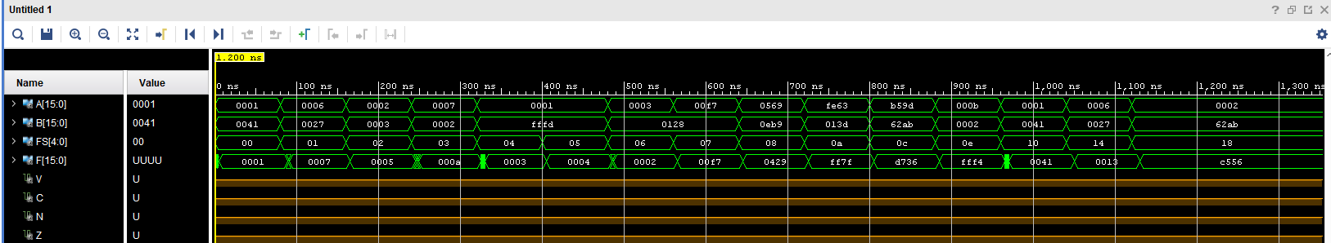
Here …..

8. Zero Fill

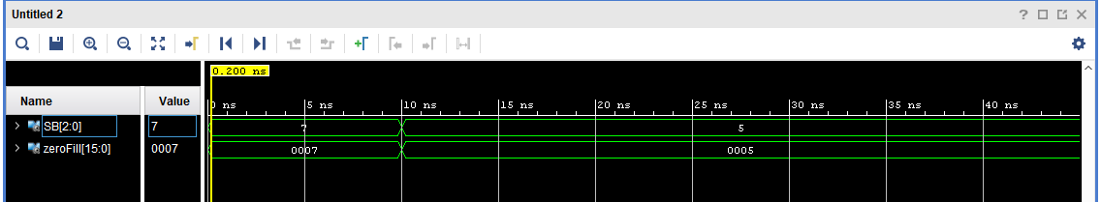
A 3 bit vector (SB) is extended and filled with 0’s and converted into a 16 bit vector of the same initial value as SB.

9. Datapath ** NEEDS TO BE REDONE**

….

MICROPROGRAMMED CONTROL

Program Counter (PC) ** NEEDS TO BE REDONE**

….

Extend ** NEEDS TO BE REDONE**

….

Instruction Register (IR) ** NEEDS TO BE REDONE**

….

Control Address Register (CAR) ** NEEDS TO BE REDONE**

….

MUXS 8-to-1 (1bit) ** NEEDS TO BE REDONE**

….

MUXC 2-to-1 (8bit) ** NEEDS TO BE REDONE**

….

Control Memory ** NEEDS TO BE REDONE**

….

