Telecommunications Exam Solutions

- Two hour Exam
- Answer 2 of 3 Questions
- 1 hour per question

2017 Exam:

Q1 - Pthreads

a) The pthreads library is a toolkit for writing parallel programs. What tools does it provide?

- Thread Creation & Deletion: The pthreads library provides the functionality to allow you to create a series of threads that can work concurrently acting on various functions (processes) that are programmed by the user. These threads can also be exited and (cleanly*) deleted using the pthreads library.

- Mutex Locking & Unlocking: The pthreads library provides the functionality to make use of mutex locks which are used to protect shared resources between concurrent programs. By using mutex locks it allows programs to ensure they are the only ones using a shared resource at a given time. This ensures that concurrent programs run correctly and don’t access shared resources at the same time.

- Condition Variables: The pthreads library provides the functionality to make use of condition variables which allow you to create a somewhat deterministic program execution in multi-threaded programs. It allows for processes to wait upon a given variable, and also allows process to broadcast condition variables to other concurrent processes.

- Semaphores: A semaphore is a variable or abstract data type used to control access to a common resource by multiple processes in a concurrent system such as a multitasking operating system.

b) What is the principal difference between a thread and a process.

Both processes and threads run independent sequences of execution. The typical difference is that threads (of the same process) run in a shared memory space, while processes run in separate memory spaces.

A thread is an entity within a process that can be scheduled for execution. All threads of a process share its virtual address space and system resources. Usually a process has only one thread of control. A process may also be made up of multiple threads of execution that execute instructions concurrently.

A process is an executing instance of a program. A process is always stored in main memory. Several processes may be associated with the same program.

c) Explain the operation of the pthread library functions pthread_mutex_lock and pthread_mutex_join.

- pthread_mutex_lock: This is a method which grabs access to a mutex and attempts to lock it. If it is successfully locked the mutex is then inaccessible until it is finally unlocked again by calling the method pthread_mutex_unlock. The reason for this functionality means that a parallel system operating on a shared resources can unsure that the resource is not acted upon simultaneously, especially when processes are dependent on the shared resource.

- pthread_mutex_join: This is a method which allows the master thread (main program running multiple separate pthreads) to join the existing threads up once they have finished execution. This ensures that the programs resources aren’t wasted running idle threads idefinitely.

d) Imagine you have inputted a large color picture, say a JPEG, and have expanded it into a two-dimensional array of pixels. Ten threads, each executing a copy of a thread function, cooperate to create a grey-level version of the picture in another array.

- Write the thread function
- Write the function that creates the threads

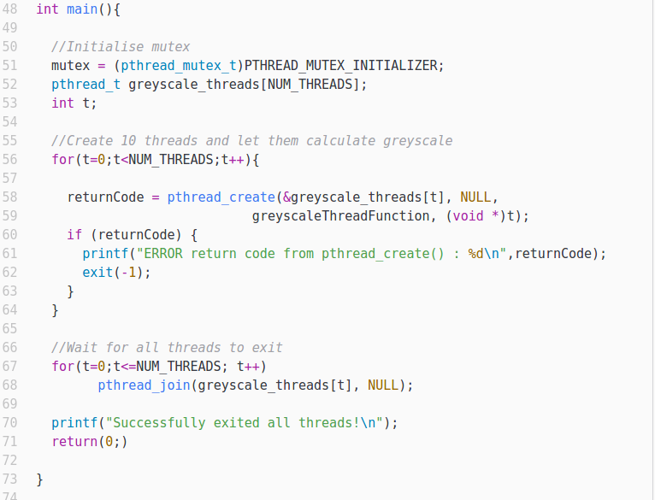
- Main Function (Creating Threads)

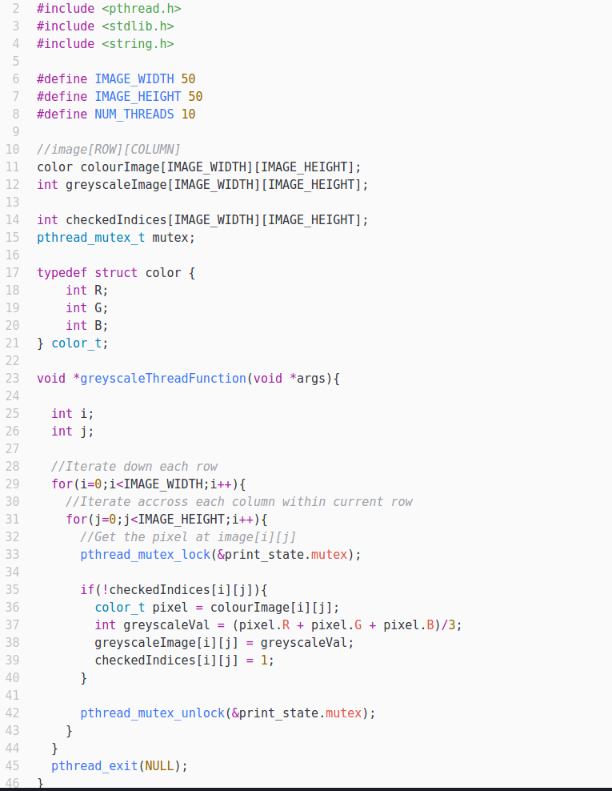
B) Thread Function

Q2 – SPIN & Promela

a) SPIN and its associated modelling language Promela are radically different from most software development tools. Explain why this is so.

SPIN and Promela, when used together allow you to model a system or program quite simply whilst also allowing you to conduct in-depth performance testing of a given system.

By using Promela and SPIN you are able to fully ensure that a system is designed safely and is free of any deficiencies that might lead to the occurance of deadlock, livelock or starvation. Through SPINs’s verification mode you can verify that even the most complicated of systems is free from any of the above problems.

“Something bad never happens” - SPIN tries to disprove this statement by finding a path to a case when something bad happens.

“Something good always happens eventually” - SPIN tries to find an infinite loop in which good doesn’t happen.

b) SPIN has two principal modes of operation – interpretation and verification. Explain the difference between them, and explain their importance.

Interpretation mode is when SPIN takes a basic overview of the model and executes it. It finds any immediate flaws and notifies them for one given scenario.

However, verification allows us to verify claims that we ourselves make. For example we can claim the statements above - “Something bad never happens” and “Something good always happens eventually”.

Verification allows us to make the following constructs:

- Basic Assertions
- End-State Labels
- Progress-State Labels
- Accept-State Labels
- Never Claims
- Trace Assertions

c) Explain the terms deadlock, livelock and starvation.

- Deadlock: In an operating system a deadlock occurs when a process or a thread enters a waiting state because a requested resource is held by another waiting process, which in turn in waiting for another waiting process etc. If a process is unable to change its state indefinitely then the system is said to be in deadlock.

- Livelock: Livelock is similar to deadlock however, the states of the processes involved in the livelock are constantly changing with regard to one another, none progressing.

- Starvation: Starvation is a problem encountered in concurrent computing where a process is perpetually denied necessary resources to process its work.

d) What is the Dining Philosophers problem and why is it of interest in the context of concurrent systems?

The Dining Philophers problem is when several philosophers are sitting around a table about to have something to eat. As philosophers do, they can only either think, become hungry and eat. However, the issue is that there are not enough forks for the philosophers so each philosopher will have to share a fork with his neighbour.

This is of interest in the context of concurrent systems as it provides quite a graphical and easy to understand representation of the issues that can occur within a concurrent system such as that of deadlock, livelock and concurrency.

For example, when a philosopher becomes hungry he will then attempt to eat. For a philosopher to be able to eat he needs to grab hold of two forks (both of which are shared with a neighbour). If he is unable to grab a fork he waits until one has become available. Also, if he manages to get hold of one fork he retains this fork and waits until the other fork has become available.

This leads to both deadlock, livelock and starvation within the system.

e) Write a Promela description of a reduced version of the Dining Philosophers Problem which has just two identical philophers at a table for two and with just two forks.

- First initialize data structures to hold information about your philosophers and also the forks.

- Then create an init() process to run each philosopher process.

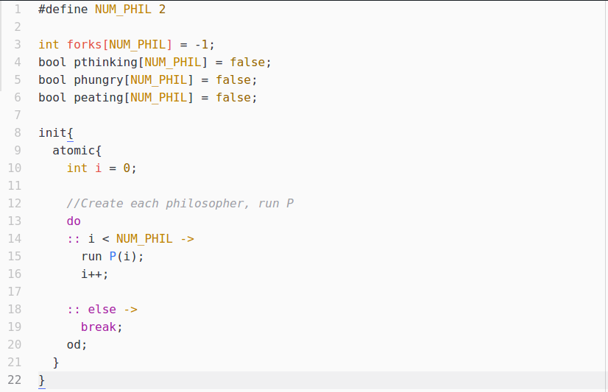

- Then create the actual process to model the philosophers themselves.

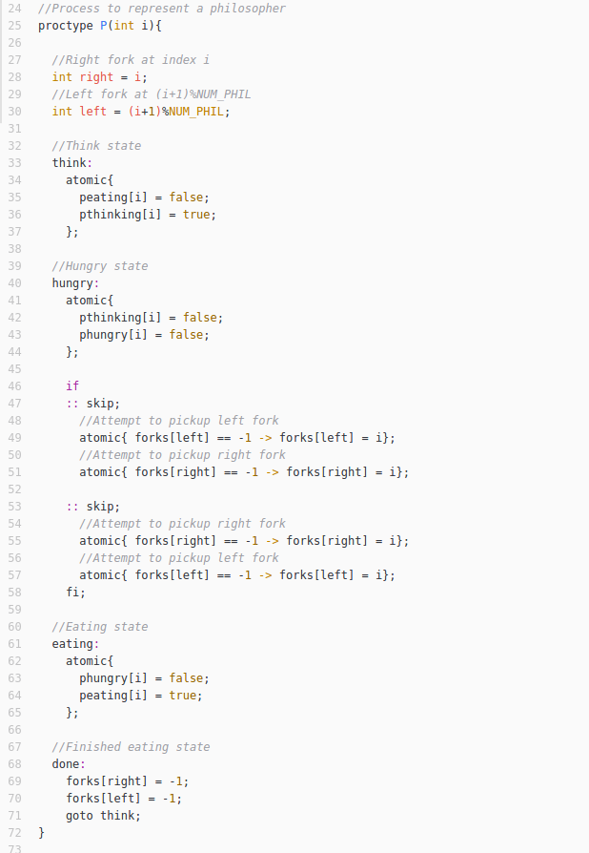

f) Show how the system you describe will suffer from some combination of deadlock, livelock and/or starvation.

- Deadlock: Both of the philosophers seated at the table will be sharing the same resources i.e forks. Therefore there could exist a state where both philosophers are hungry and have instantaneously grabbed a fork, leaving no more forks on the table. This means that both are caught in deadlock waiting on a fork to be released from the other.

- Livelock: Livelock could occur within this system if the philosophers decide that if they have not managed to get a second fork within 60 seconds they will place down the fork they currently hold. However, if it occurs that both philosophers 60 second intervals are in sync the system will then be in livelock as there could arise a situation whereas they will never be able to get a fork and will continue the loop indefinitely.

- Starvation: Starvation could occur within this system if say Philosopher A becomes hungry and tries to pick up for 1. At the same time Philosopher B becomes hungry and manages to get a hold of fork 1 and 2 first. Philosopher B continues eating, finishes and starts thinking again. However, Philosopher B immediately becomes hungry again and grabs the forks before Philosopher A. This happens indefinitely thus starving Philosopher B to death.

