Concurrent Systems Exam Notes

- Two hour Exam
- Answer 2 of 3 Questions
- 1 hour per question

Concurrency

- In concurrent programs only one execution agent is active at any one time, while there are many execution sites only one will be active at a time. In a parallel program there may be multiple execution agents active at any one time.

Mutexs & Pthreads

- Mutex locks allow shared resources to be protected. An agent must first acquire a lock on the mutex variable. If the mutex is locked the agent is usually blocked until the lock is acquired.

- Calling pthread_mutex_lock(<mutex variable>) attempts to acquire a lock on a shared resource.

- When finished using a resource, agents must then free up the resource again for use by using the pthread_mutex_unlock(<mutex variable>).

- Usually condition variables are used to indicate whether a thread has finished as follows

pthread_lock(&m)
while (!C)
pthread_cond_wait(&v,&m)
or
pthread_cond_timedwait(&v,&m,<time>)
continue...
pthread_unlock(&m)

- Threads waiting for a resource should be signaled using the pthread_cond_signal or pthread_cond_broadcast functionality

pthread_lock(&m)
do something...
pthread_unlock(&m)
pthread_cond_signal(&v)
or
pthread_cond_broadcast(&v)

Deadlock, Livelock & Starvation

- Deadlock is when a process arrives in a state from which it can make no further transitions.

- Livelock is when the system continues down a path indefinitely without making progress towards the desired end state.

- Starvation is when a process dies in a non-critical section of a program depriving other process of a desired resource thus starving them to death.

- Livelock is when the system continues down a path indefinitely without making progress towards the desired end state.

SPIN & Promela

- Each :: introudces a non-deterministic statement which is executed randomly if there are multiple selections available.
- Skip is always executed and does nothing but increase the process counter

if
: : ( n < 2 ) → n + 1
: : ( n > 2 ) → n = n+2
: : ( n % 3 == 0 ) → n = n – 6
: : else → skip

- Do statements are similar to the if statements however it repeats the choice at the end. Use break statements to exit the loop.

do
: : choice1 → n + 1
: : choice2 → n + 1
break;
: : choice3 → n + 1
od
- Atomic statements are statements that are executed sequentially and deterministically. They follow the defined order and will be executed in that order.

- SPIN allows us to execute given Promela problems however this will only generate a scenario. To verify the system it must be done using verification.

-Verification can be achieved by using assert statements when you know the desired end value of a variable e.g assert(n == 4);

Scheduling

- Scheduling is used to allow processes to be given CPU time in a defined/random order. Processes often alternate between bursts of CPU and I/O activity.

- When the CPU becomes idle the operating system must select another process to schedule. This is the role of the CPU Scheduler.

- Co-Operative Scheduling: This is when a process is given an unlimited amount of time to run.
- Preemptive Scheduling: This is when a process is given a defined amount of time to run.

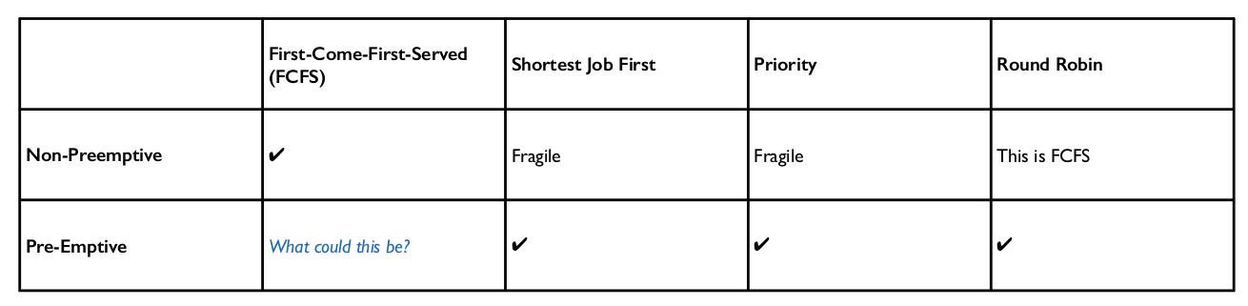

Virtual Memory

- Instead of writing and reading from/to physical memory (slow) processes are given a chunk of Vitrual Memory to use whilst they are running.

