Microprocessor Exam Solutions

2016 Exam:

Q1 - Memory & Pipelining

a) Write a fragment of ARM assembly code to form the sum of 1,000 integers stored from location ARRAY upwards and to store the result at location SUM. How would you deal with arithmetic overflow.

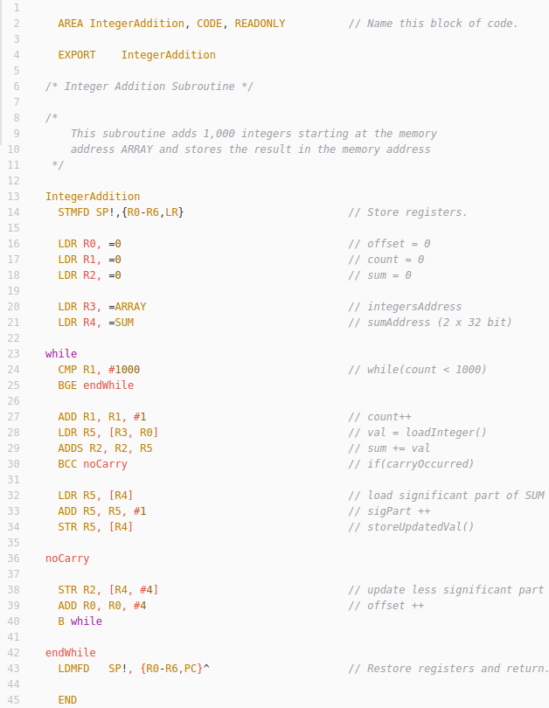
b) Give an account of what cache is. How is cache organised and managed?

Main memory is very slow by comparison with instruction execution. It is extremely expensive and time consuming to read/write to/from memory and this has direct impacts with the performance time of a system.

As a result Cache sits logically between main memory and the CPU. It serves the purpose of implementing a middle ground between the CPU and main memory and allows for extremely fast memory accesses that can be used in a program.

There can be different levels of cache:

- L1 – On Chip, Closest to the CPU, Very Fast, Very Small
- L2 – On Chip, between CPU and Bus
- L3 – Off Chip, between chip and main memory

Typically the L1 cache is divided into an Instruction Cache (I-Cache) and Data Cache (D-Cache)

Caches are un-named and un-numbered memory stores managed by hardware in response to run time conditions. Caches usually but not always contain duplicates of the contents of memory locations.

A cache is organised as a (very small) number of block frames each capable of holding a chunk of contiguous main memory locations in a structure called a ‘cache line’ or a ‘cache block’. Due to problems building tag RAM there are different kinds of cache management

- Direct Mapping
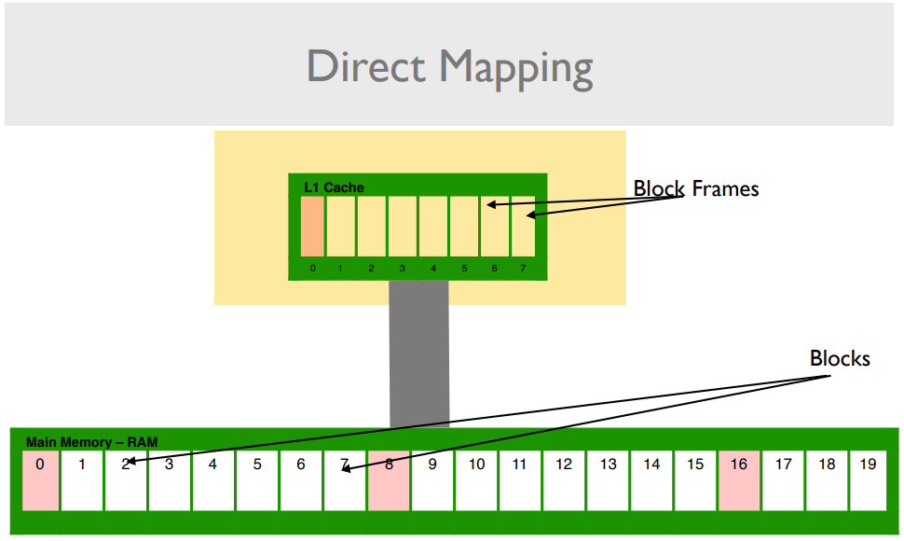

- Each block frame in cache can only cache a subset of memory blocks.

- Faster.

- Restrictive

- Fully Associative Mapping
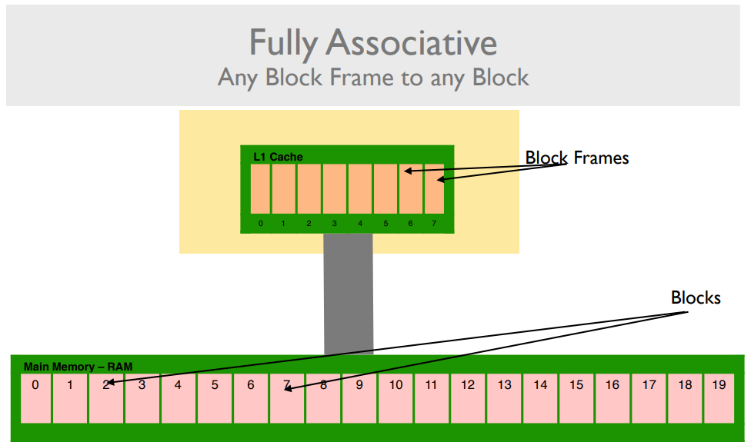

- Any RAM block can be mapped into any block frame in cache.

- Simple to understand.

- Problem is that to find a reference the entire tag RAM must be searched.
- Four-Way Set Associative Mapping

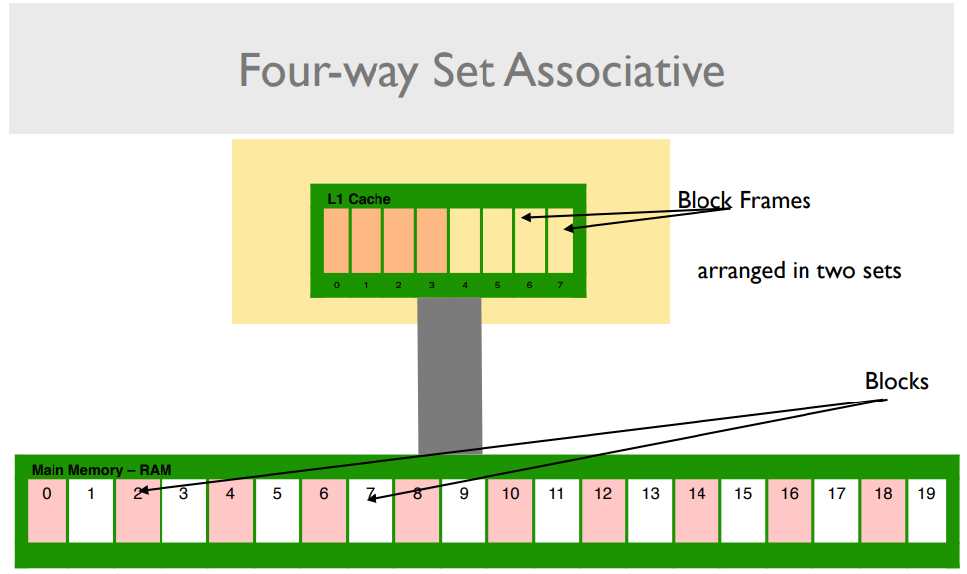

- Blocks and block frames are divided into sets.

- Full associativity is possible within the sets.

Caches are invariably smaller than main memories therefore there is pressure for space within them. As programs execute over time caches will fill up and new references will have to be accomodated. This requires some form of Cache Replacement / Eviction Policy. Ideally this replacement policy should have minimum effect on the overall performance.

A Cache Miss is when a reference is made that the cache can’t satisfy. There are three main reasons for a cache miss occuring:

- Compulsory Miss: The reference was never stored in cache.
- Collision Miss: A reference was stored in cache but was evicted because of replacement.
- Capacity Miss: A reference was stored in cache but was evicted because of memory.

c) Assuming a three-stage pipeline, a 1 nanosecond processor clock, 10 nanosecond main memory and a cache that can be accessed by the processor instantly, estimate the amount of time it would take to execute the main loop of your code fragment above.

/* These are taken from elsewhere, not applicable to solution above*/

Estimation of time:
- 1005 Memory Read/Writes => 10ns each = 10050ns
- 2002 Move/Add/Sub operations => 1ns each = 2002ns (if no overflow)
- At least 1000 branch operations => 3ns each (clearing pipeline) = 3000ns (if no overflow)
--------------------------------------------------------------------------------------------------------------
=15052ns
= 0.015052ms

Problems with this estimation:
- Determining how many times overflow would occurr
- Branch prediction difficult
- Determining what would be stored in cache during execution
Q2 - Modes & Interrupts

a) List the different modes available in the ARM processor. What are they for, and how does the ARM processor move between them? Write a fragment of code to put the processor into the user mode.

- User: Unprivileged mode, used for execution of normal programs.

Access to : R0 – R12, SP, LR, PC and CPSR.

- FIQ: Fast Interrupt Request mode this is used when responding to interrupts from outside of the system in a quick manner. It is used when handling high priority interrupt requests.

Access to : R8 – R14, SPSR.

- IRQ: Interrupt Request mode this is used when responding to general-purpose interrupt requests.

Access to : R13 – R14, SPSR.

- Supervisor: Privileged mode used when OS calls (Software Interrupts – SWI’s) occur within a system.

Access to : R13 – R14, SPSR.

- Undefined: Mode used to handle undefined instructions that occur within program execution.

Access to : R13 – R14, SPSR.

- System: Privileged mode, but with access to all registers. It is a cross between User and Supervisor mode offering the privileges of Supervisor with the register banks of User.

Access to : R0 – R12, SP, LR, PC, CPSR.

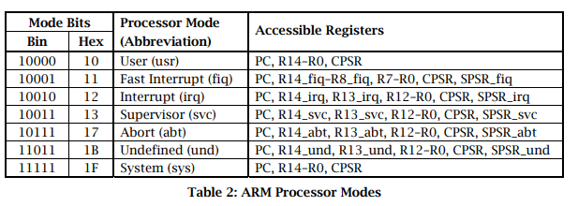

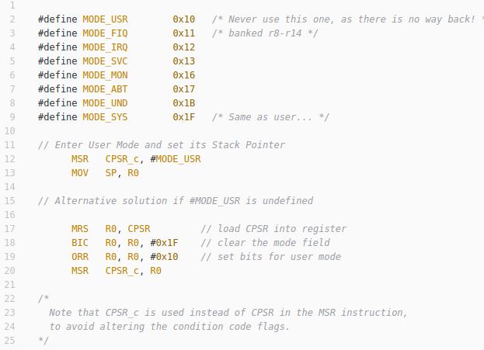

b) Write an interrupt handler that is called by a quartz crystal-controller clock interrupt every 0.1641417 ms to maintain a seconds counter in location SECONDS. Your code must introduce no extra inaccuracies to the time by making any approximations.

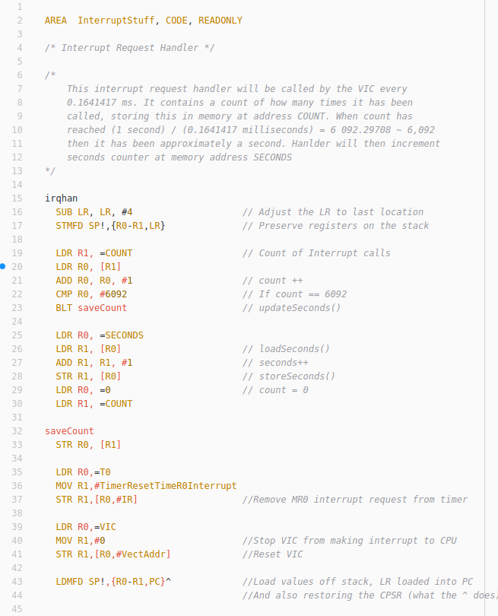

Q3 – Interrupts

a) Explain exactly what the context of a program is. How does an interrupt handler preserve the context of programs when it interrupts a program.

The context of a program can be considered in many different forms. In large it is the status of the all registers currently being used within the program. The context also encapsulates what mode the current program is in, e.g User, System, Supervisor etc. It also takes into account the value of the conditional flags at a given moment e.g V, C, N, Z. All of these details must be preserved in order for the processor to resume execution exactly as normal when the interrupt has finished.

An interrupt handler preserves the context of a program when it causes an interrupt by performing the following steps:

Preservation Steps:

- Change into System Mode (privilege needed to return to IRQ mode)

- Get the SP and LR of program.

- Change into Interrupt Request Mode (IRQ)

- Store SPSR, PC, LR, SP onto Programs Stack

- Store Registers R0 – R12 onto Programs Stack

- Perform Interrupt functionality

- Return from Interrupt restoring original programs R0 – R12, PC (from LR) and CPSR.

LDMFD SP!,{PC}^

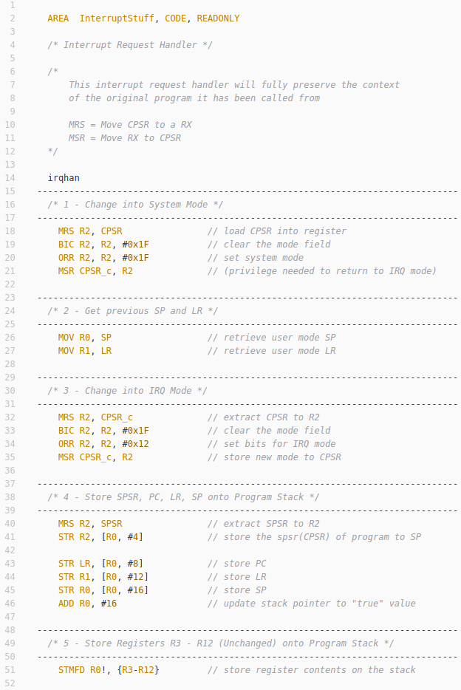
b) Write a fragment of an interrupt handler to save the entire register and CPSR context of a user mode program.

