Microprocessor Systems Exam Notes

- Two hour Exam
- Answer 2 of 3 Questions
- 1 hour per question

Pipelining

- Microprocessor systems mainly operate using pipelining be it a three-stage pipeline or a four-stage pipelines.
- Fetch
- Decode
- Execute
- (Write)

- Pipelining passes partially completed instructions to the next stage upon each clock cycle.

- Sometimes an instruction will stall whilst within a given stage of the pipeline. Can be as a result of:
      - Memroy Access
      - Control Hazards (Branch Instructions causing flush)
      - Data Hazards (Data/Flow Dependencies)
      - Structural Hazards (Hardware Ineffeciency)

Assembly

- Most assembly language compilers operate on a two-pass compilation structure.
      - First Pass → Labes
      - Second Pass → Generates Code

- Some basic, yet useful instructions include:
      - EQU → Set a label equal to a value
      - DCB → Reserve a byte at this label
      - DCW → Reserve a half-word (16 bit) at this label
      - DCD → Reserve a word (32 bit) at this label

Memory

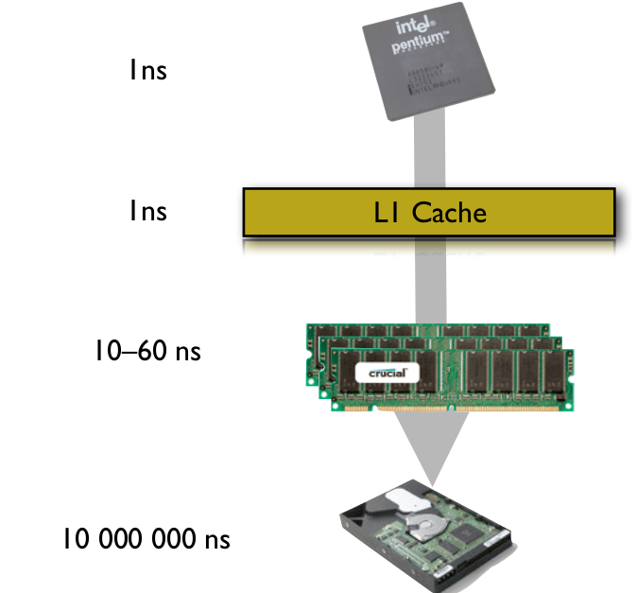
- Main memory is very slow (physical access) as a result Cache is used, this is a smaller space of memory that sits between main memory and CPU.

- There is different levels of cache, based on relative location to the CPU and also the size of the cache

- Typically L1 (closest and smallest) is divided up into an Instruction-Cache ( I-Cache) and a Data-Cache ( D-Cache)

Modes
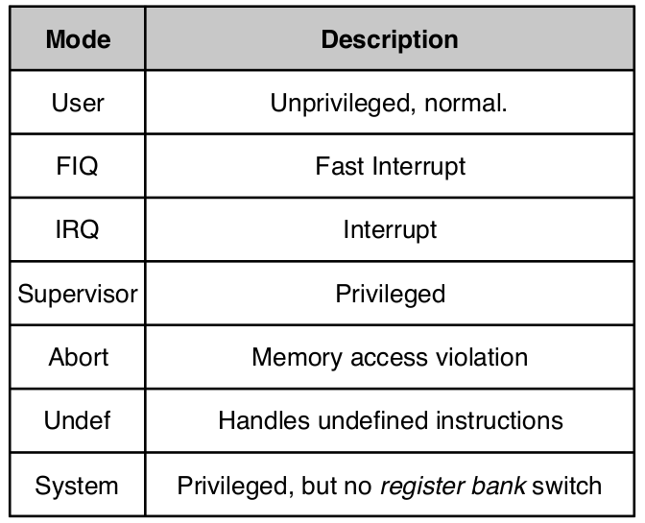
- ARM has multiple different modes of operation that effect how programs can be executed.

- Exceptions generally cause the processor to jump into another mode.

- Certain instructions can also cause a change in mode.

- Each mode has access to a specific number of registers as seen below

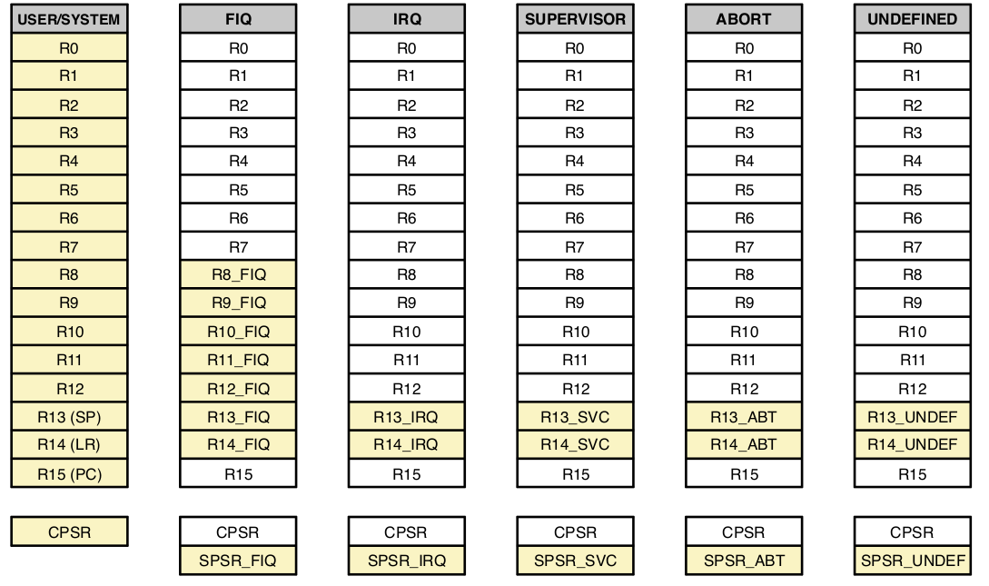
- Supervisor, Abort, IRQ Undefined: Limited access, only R13, R14 and SPSR.

- FIQ: Access to R8-R14 and SPSR.

- User/System: Full access.

Exceptions

- Current Program Status Register (CPSR) : This is a register used to preserve various information about the current state of a program in the event of an interrupt or an exception occuring.

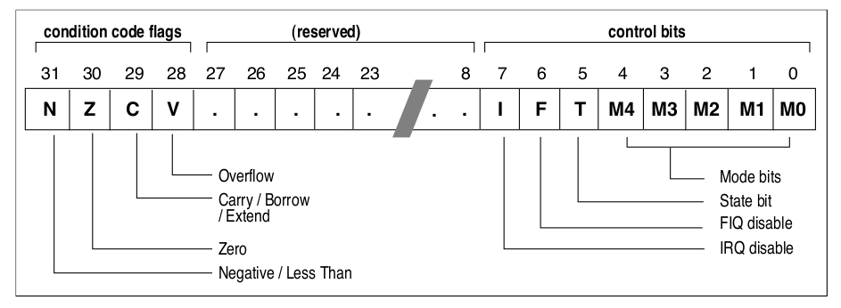
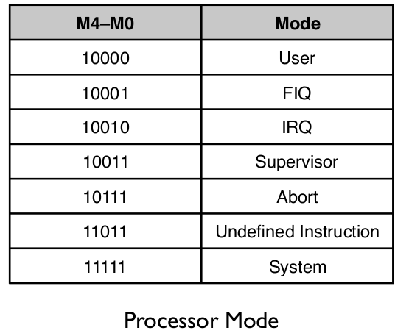

- The CPSR also preserves the Mode that the system was in previous to an exception or interrupt.

- This is to ensure that the system is restored to it’s correct initial state following the execution of an exception or interrupt.

- When returning from an exception a number of steps must be taken in the following order:
- Restore the PC from the modes LR (adjusted slightly*)
- Restore the CPSR from the current modes CPSR
- Restore the interrupt flags

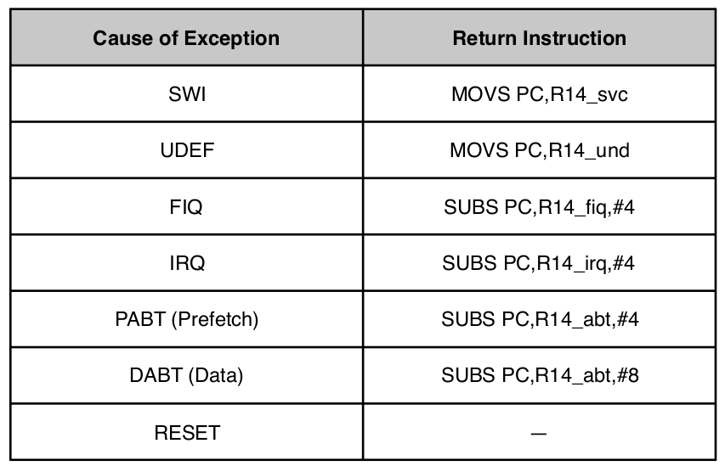
*depending on the exception, the way it is raised and handled can affect the value of the link register hence why it needs to be adjusted differently as follows:

←

Interrupts

- When an interrupt is raised the interrupt request is routed to the Vectored Interrupt Controller (VIC). Here it processes them and makes an IRQ (Interrupt Request) or a FIQ (Fast Interrupt Request).

- The steps that must be taken when setting up the VIC are as follows:
    - Priority
    - Vectoring
    - Mode of Interrupt Generation

