Binary Multiplier

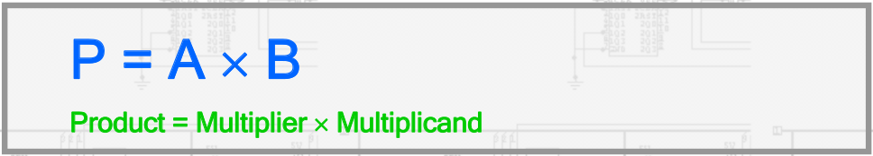

- Initial Partial Product of 0
- If multiplierBit = 1, add multiplicand
- If multiplerBit = 0, shift partial product right

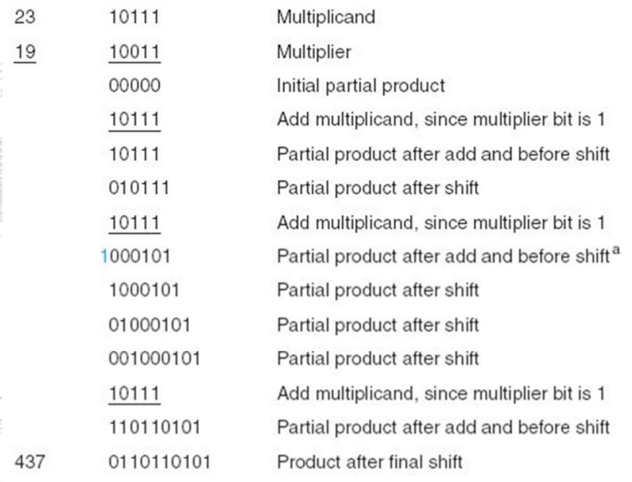

Components of Binary Multiplier

- Counter P: Counter used to keep track of multiplication iterations.

- Zero Detect: Checks if counter is 0 (finished).
- Control Unit: Controls the flow of events, signals to multiplexers etc.
- Register B: Register to hold Multiplicand.

- Parallel Adder: Adder used to add A+B, includes CarryOut.

- Shift Register A: Register to be passed back to Parallel Adder.
- Shift Register Q: Register used to hold Multiplier.

- Z: Zero Control signal (finished)
- Q₀: Least significant bit of Multiplier

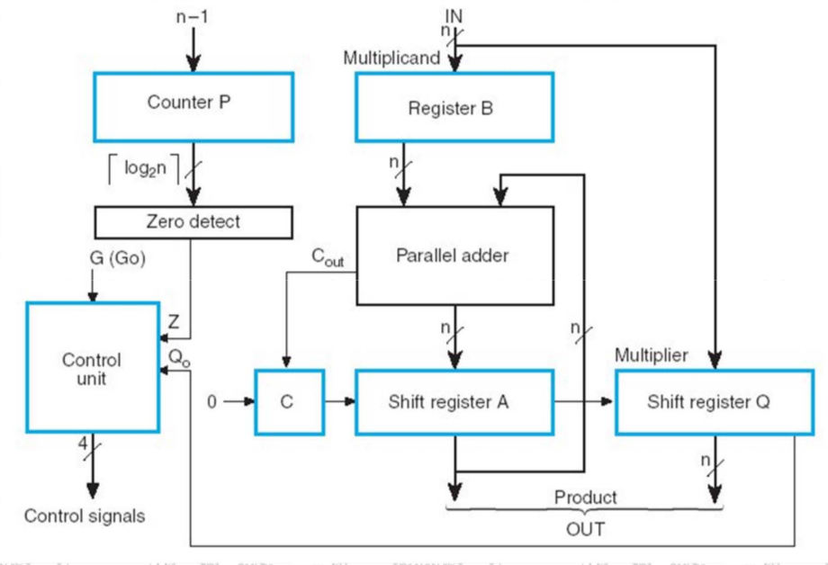

Binary Multiplier ASM

[G] :
--------------------------------------------------------------------------------
- G = Go Signal

[INIT] :
--------------------------------------------------------------------------------
- Set C to 0
- Set Register A to 0
- Set Counter = n-1

[MUL0] :
--------------------------------------------------------------------------------
- If Q₀ = 0 → MUL1
- If Q₀ = 1 → Register A = Register A + Register B (Multiplicand)
→ C = C_{out}

[MUL1] :
--------------------------------------------------------------------------------
- Reset C | C ← 0
- Combine Carry, Register A and Qbit | C || A || Q
- Shift C || A || Q Right | sr C || A || Q
- Decrease Counter | P ← P-1

[Z] :
--------------------------------------------------------------------------------
- If Z = 0 → Continue Multiplying
- If Z = 1 → Finished Multiplying

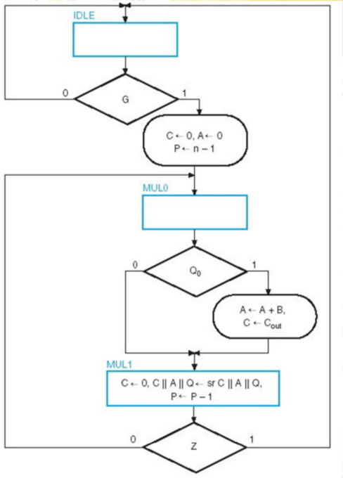

Control Signals for ASM

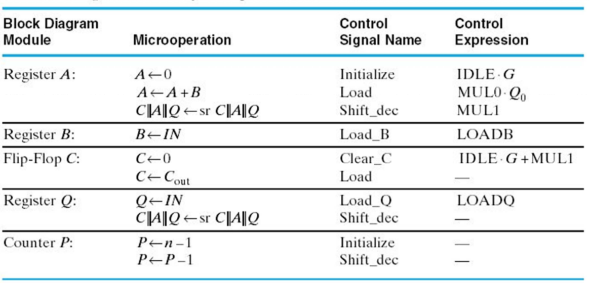
- Each different element has various Microoperations that can be performed upon it

Register A:

A ← 0 = Initialize A to 0 (IDLE & GO)
A ← A+B = Reg A = Reg A + Reg B (Multiplicand) (MUL0 & Q_{O})
C || A || Q ← sr C || A || Q = Concatenate and Shift Right (MUL1)

Register B:

B ← IN = Load In Multiplicand (LOADB)

Flip-Flop C:

C ← 0 = Reset Carry (( IDLE & G ) or MUL1)
C ← C_{out} = Carry Out Load (LOADB)

Register Q:

Q ← IN = Load Input (Multiplier) (LOADQ)
C || A || Q ← sr C || A || Q = Concatenate and Shift Right

Counter P:

P ← n-1 = Load Input (Multiplier) (LOADQ)
C || A || Q ← sr C || A || Q = Concatenate and Shift Right

Sequence Registers for Control Unit

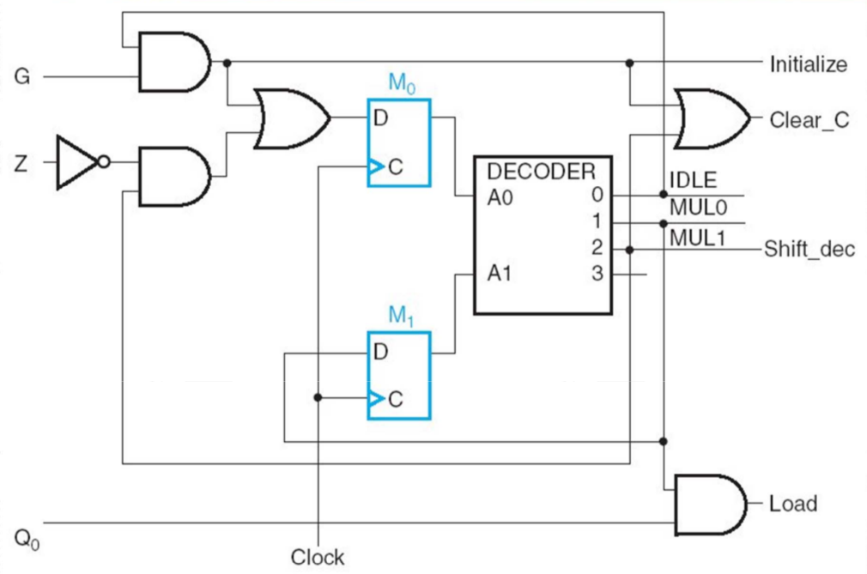

- Within the Control Unit, implement two D-Flip flops and a 2 to 4 decoder. These will be used to control the State signals as can be seen on output.

- D_{M0} = (IDLE & G) or (MUL1 & !Z)
- D_{M1} = MUL0

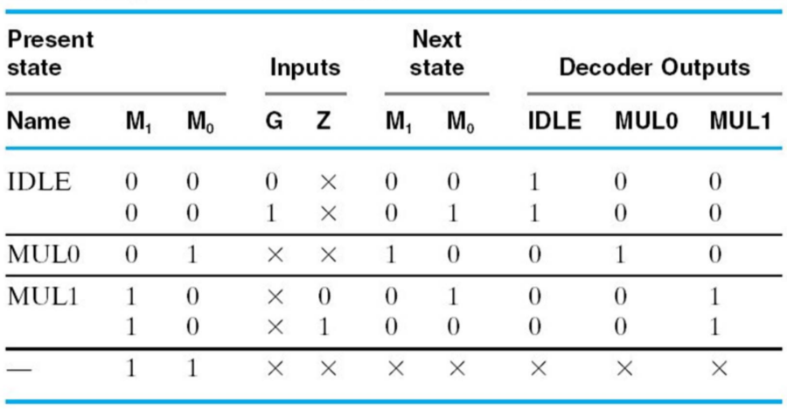

Binary Multiplier Transformation

Replace :

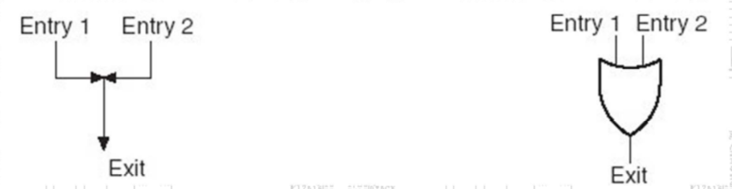
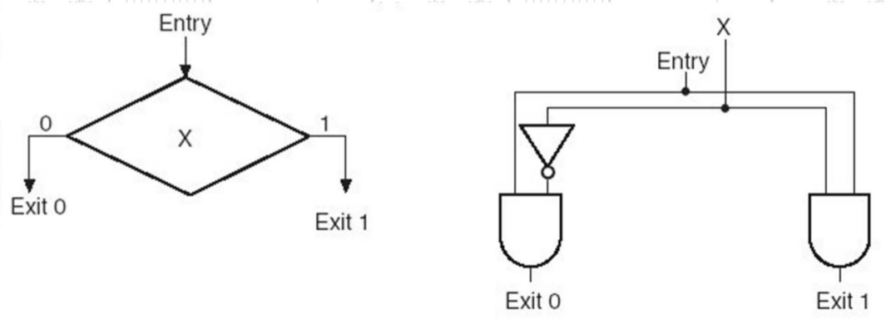
1. Junctions → OR Gates 2. Decision Boxes → Demultiplexers

3. State Boxes → Flip-Flops
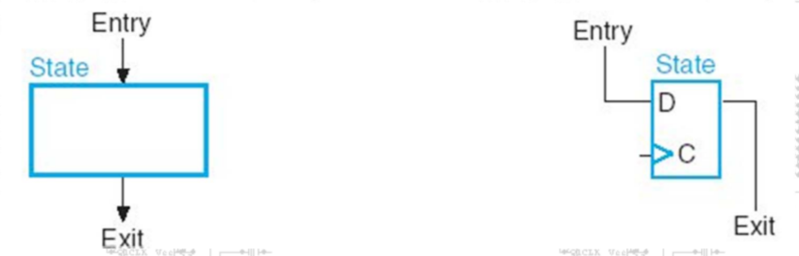

Binary Multiplier Control Unit (With Flip-Flops)

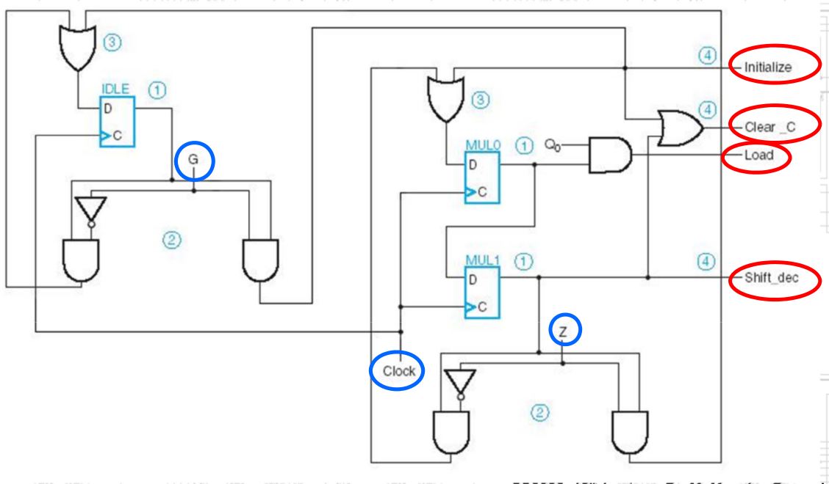

Hardwired Binary Multiplier

- We can also implement a Control Memory which is used to house Control Words which thus control the execution of the multiplication.

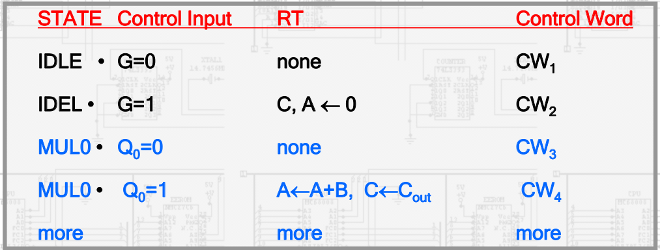
- We must also introduce additional states to supply these alternative control words

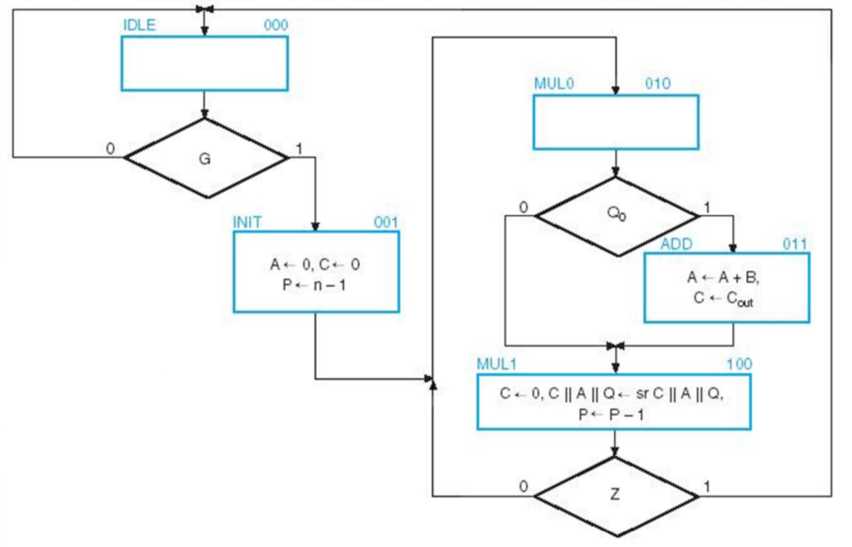

- IDLE = Instruction at Control Memory Address 000

- INIT = Instruction at Control Memory Address 001

- MUL0 = Instruction at Control Memory Address 010

- ADD = Instruction at Control Memory Address 011

- MUL0 = Instruction at Control Memory Address 100
Control Word

- The system must be able to respond to two status bits:

- Z (Zero Detect)
- Q₀ (Q-Bit)

- One Control Bit:
- G (Go Signal)

- Hence, two SEL bits must be included in the control word

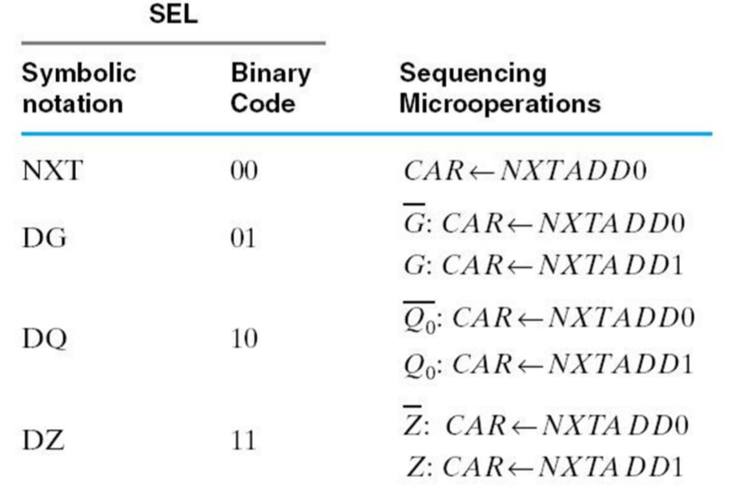

- Finally we add two next-address fields:

- NXTADD0 (Next Address 0)
- NXTADD1 (Next Address 1)

- The control word must also supply four control signals as follows

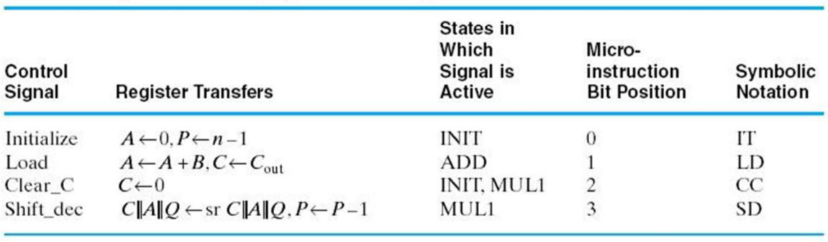

- All of this results in a 12-bit Control Word which could take the following layout:

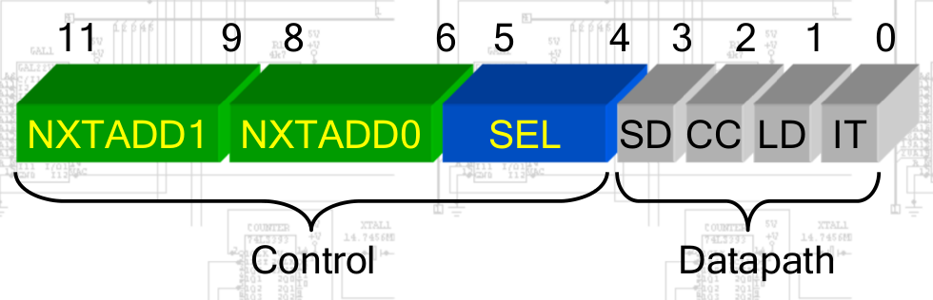

- The new Control Unit now looks something like this:

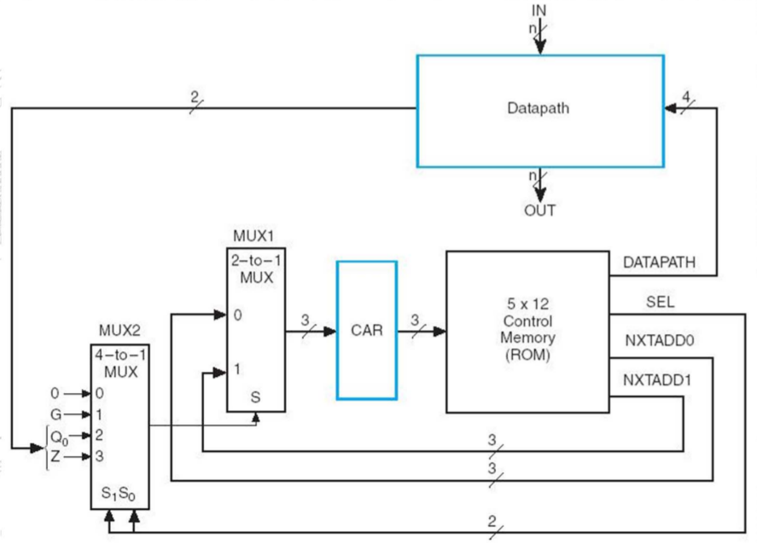

Register Transfer Description

- Next we design the microprogram in symbolic Register Transfer Form:

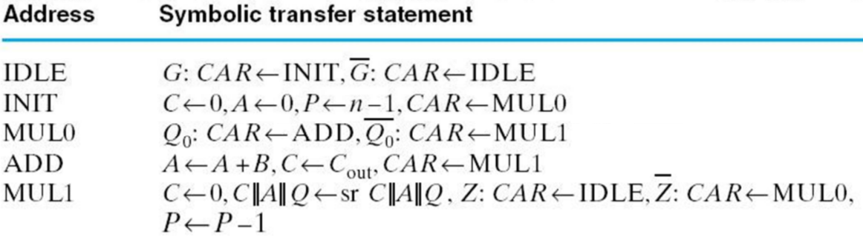
- This is then translated into micro code:

