Xpath Notes

XPath

-Used to address parts of an XML document
-Mainly derived using a directory structure

e.g /ASSESMENTS/STUDENT/MARK

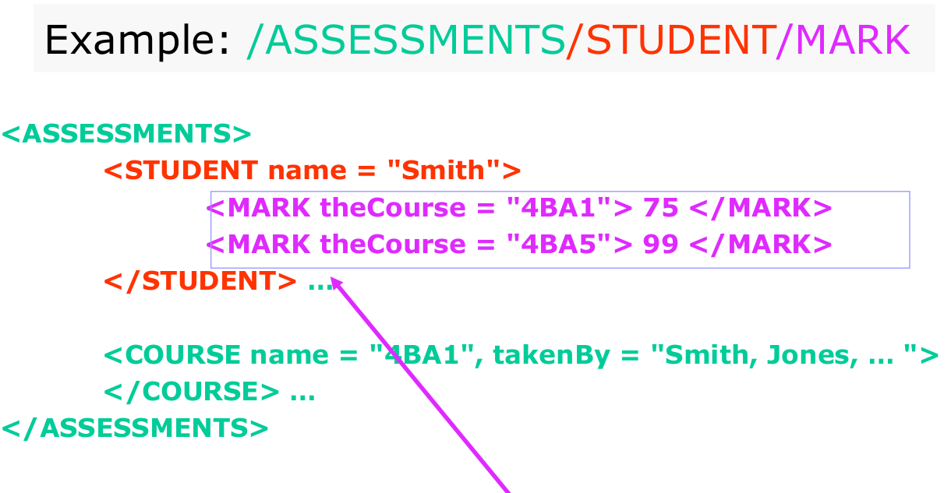

-Can access all elements of the same type in one simple call

e.g /ASSMENTS//MARK

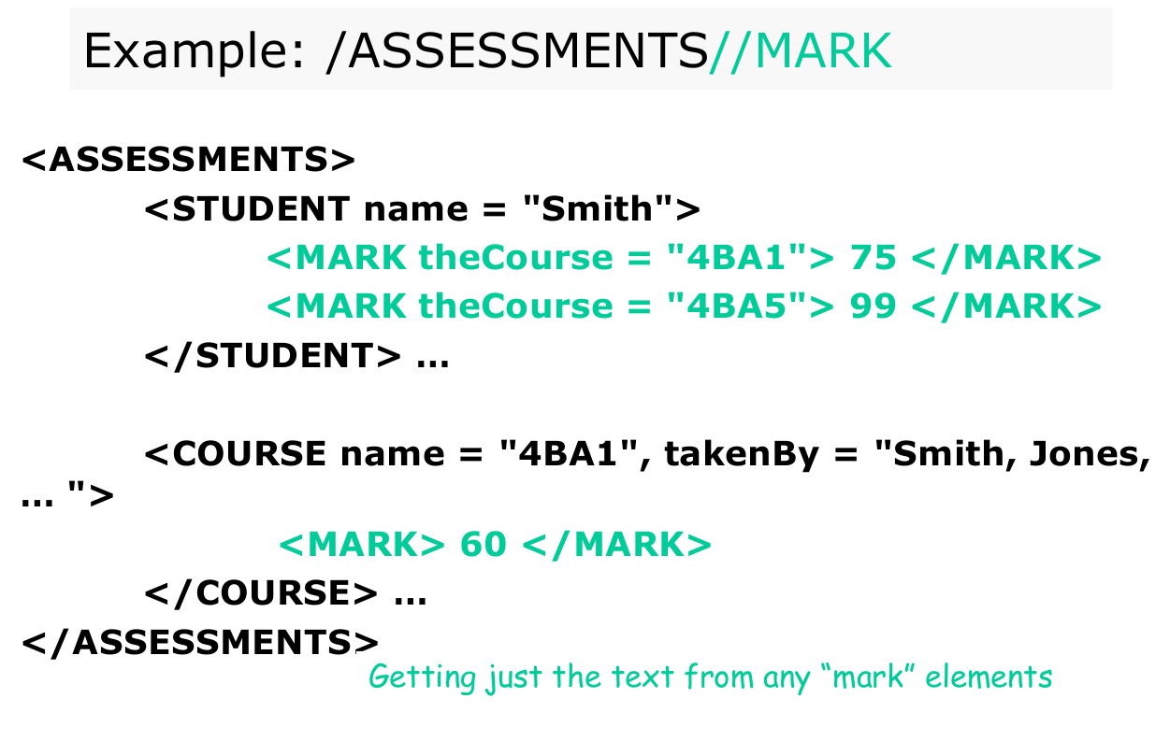

-To access the text value stored within an element use the string() function

e.g /ASSESMENTS//MARK/string()

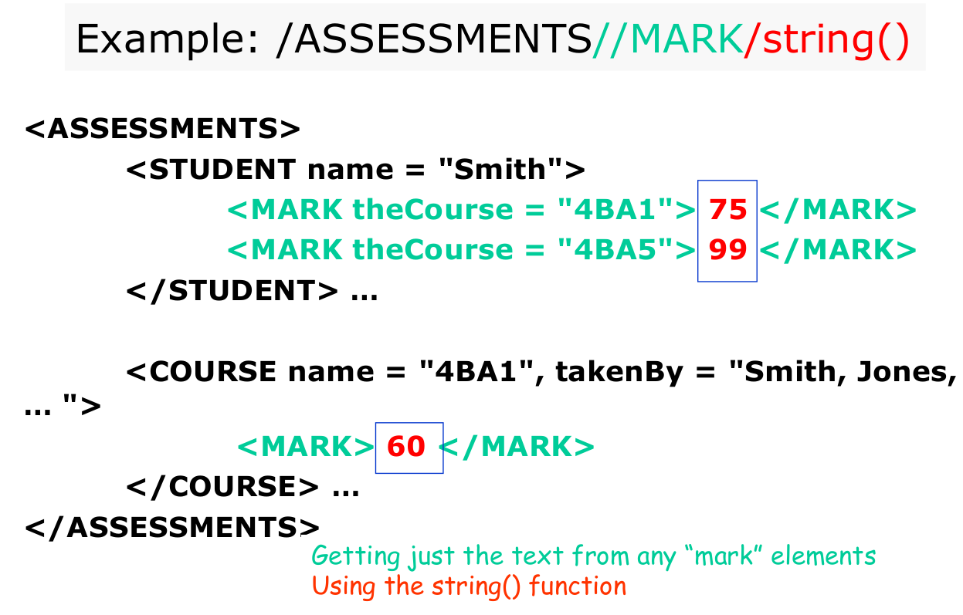

-Wildcards ( * ) are used to access nested elements within a defined structure

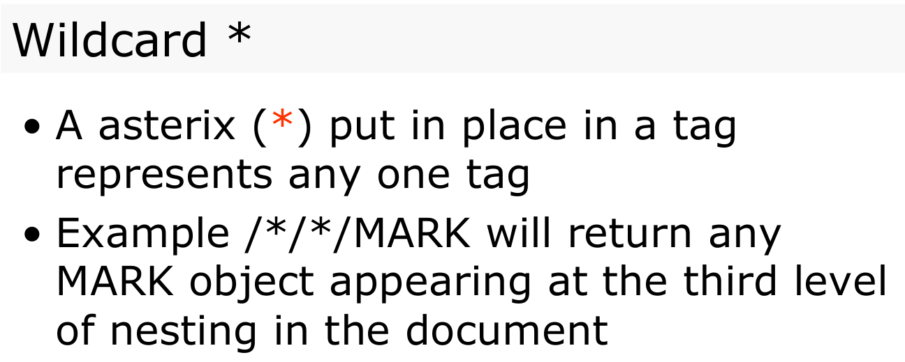

- Attribute tags ( @ ) are used to refer to attributes

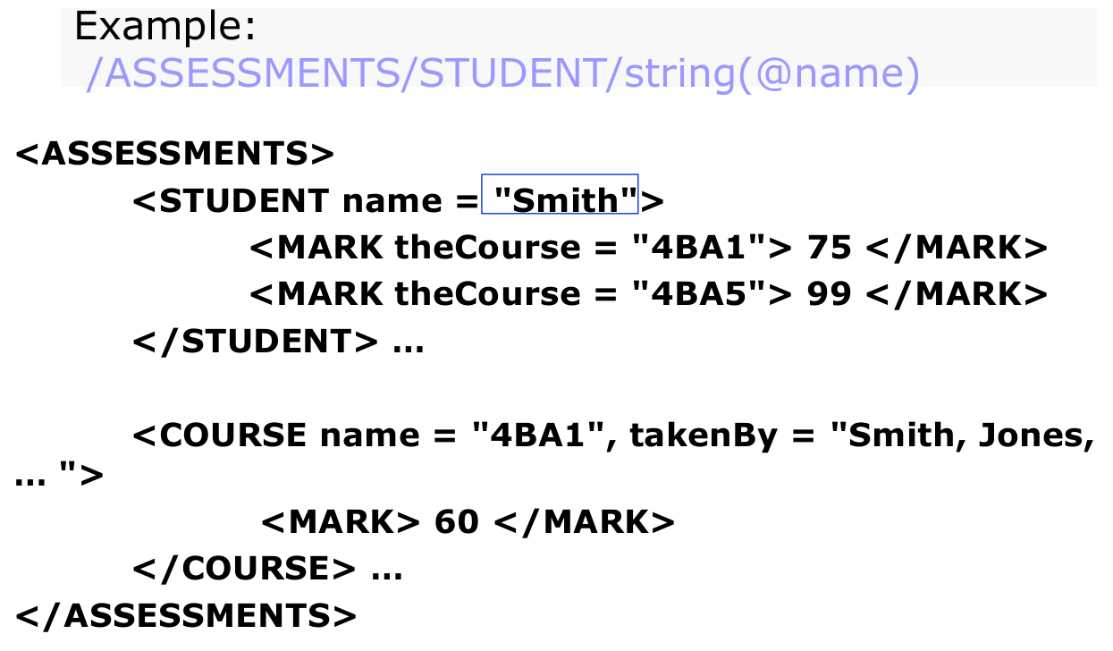

- Predicate Filters ( [ … ] ) are used to allow for conditional selections

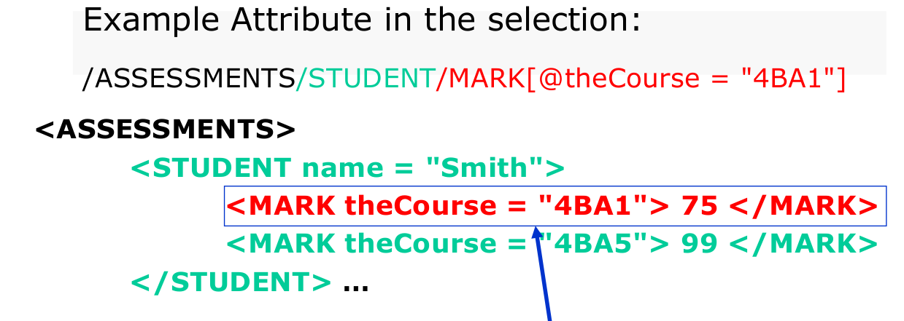

- Below are some sample Xpath queries

