XQuery Notes

XQuery

-Used to retrieve information from XML documents
-XQuery is a language for finding and extracting elements and attributes from XML documents.
-Used in conjunction with Xpath

For-Let-Where-OrderBy-Return (FLWR)

- For / Let: Used for gathering nodes into sets from a series of queries.
- Where: For filtering nodes into the sets using conditions.
- Order By: For returning your sets in a particular order
- Return: How to return the identified nodes in the set.

LET

- LET <variable> := <xpath expression>, <xpath xpression>

e.g let $c:= doc("data/tcd.xml")/assessments/course/mark

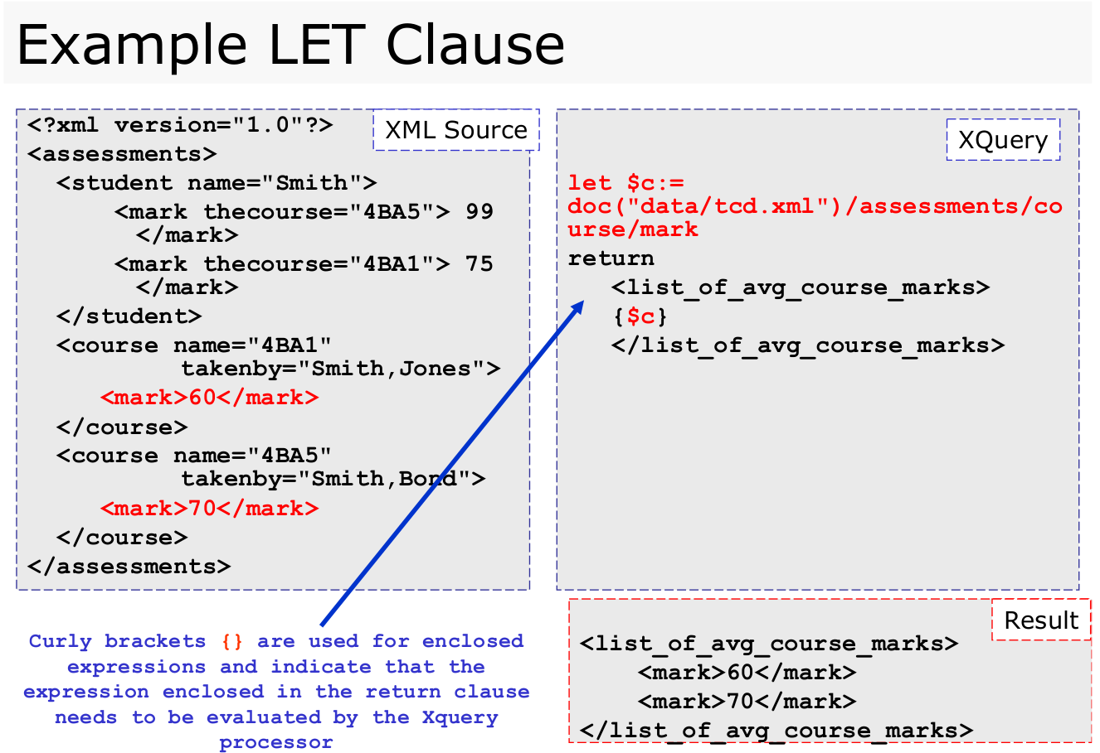

FOR

- FOR <variable> IN <xpath expression>, <xpath expression>, <xpath expression>

e.g for $j in doc("data/tcd.xml")/assessments/course
return
("Course Node:”,$j)

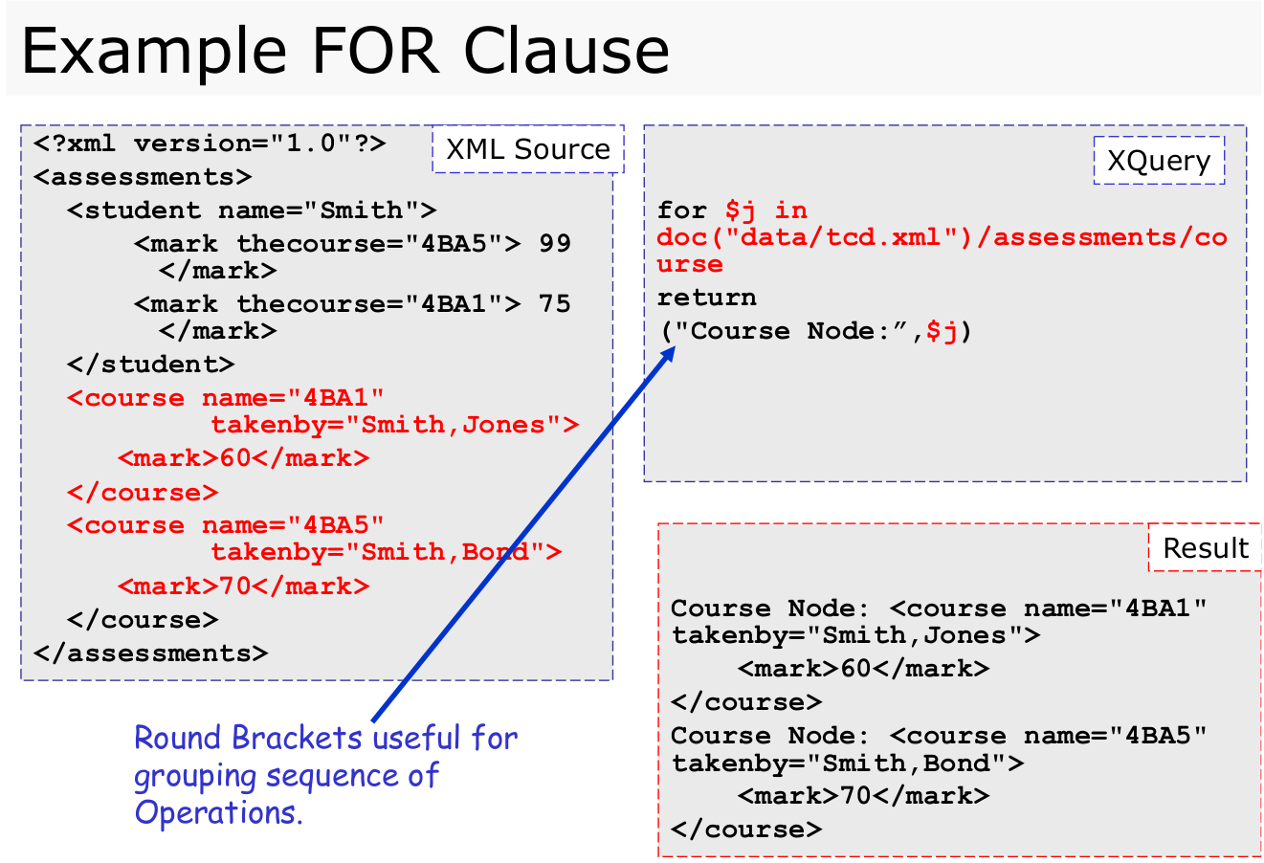

WHERE

- where contains($j/@takenby,"Bond")

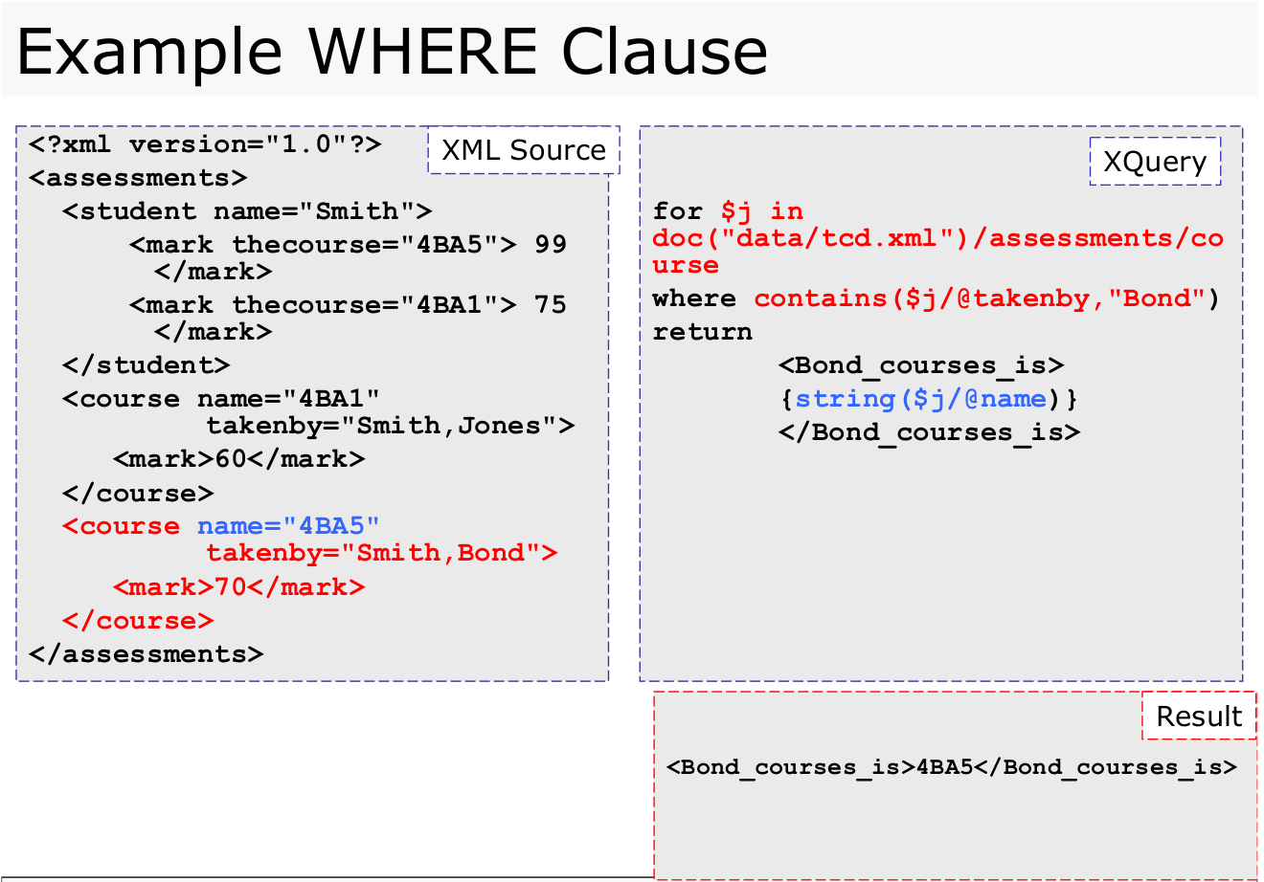

ORDER BY

- order by $x/enrolled descending

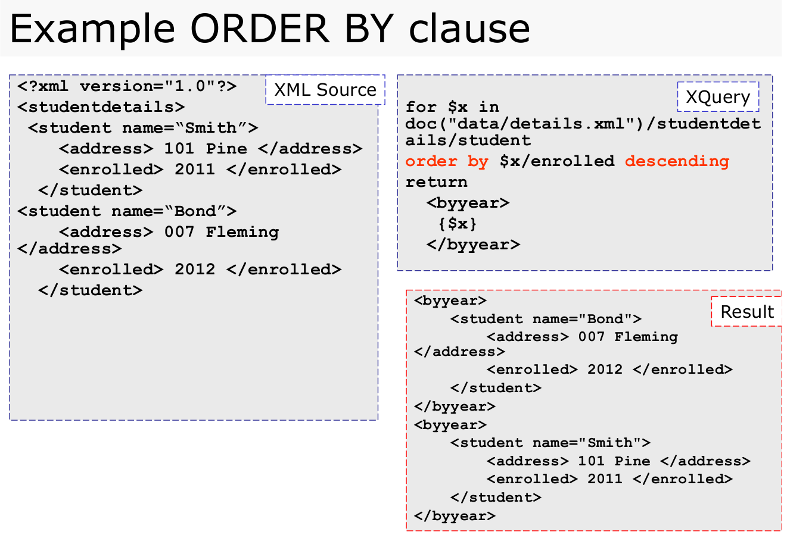

QUERYING OVER SEVERAL DOCUMENTS

-Can simultaneously access multiple documents

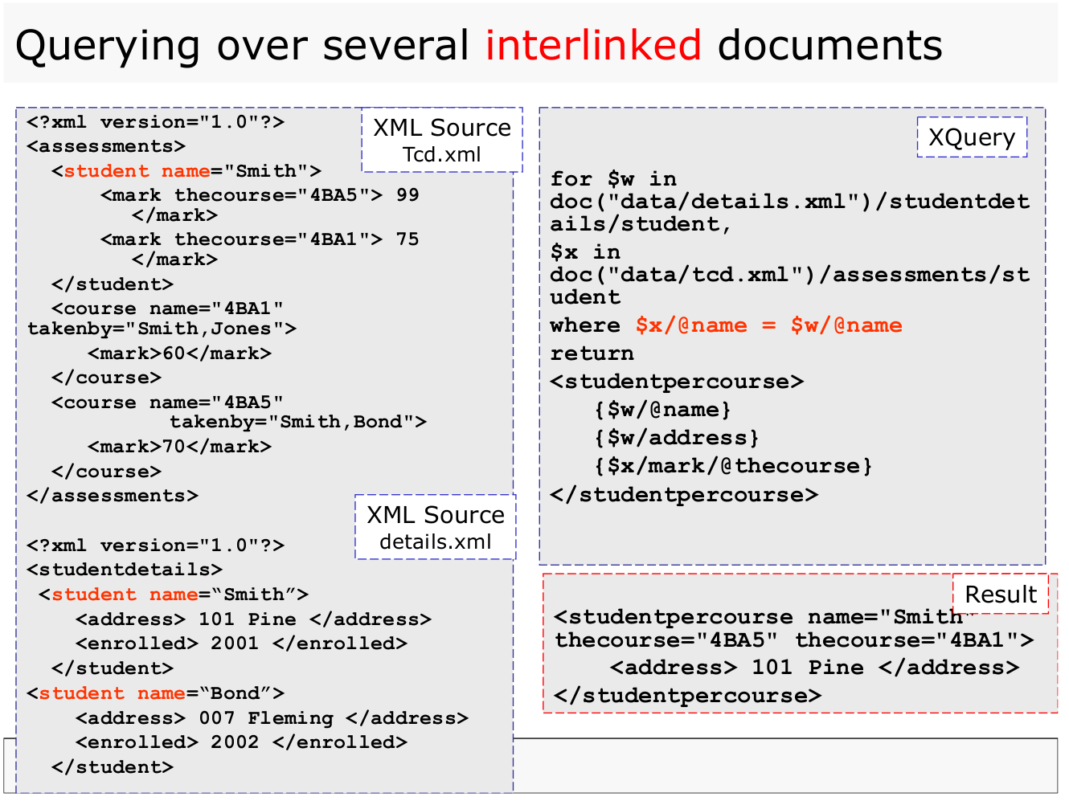

CONDITIONAL STATEMENTS

-Can use conditional statements within your queries

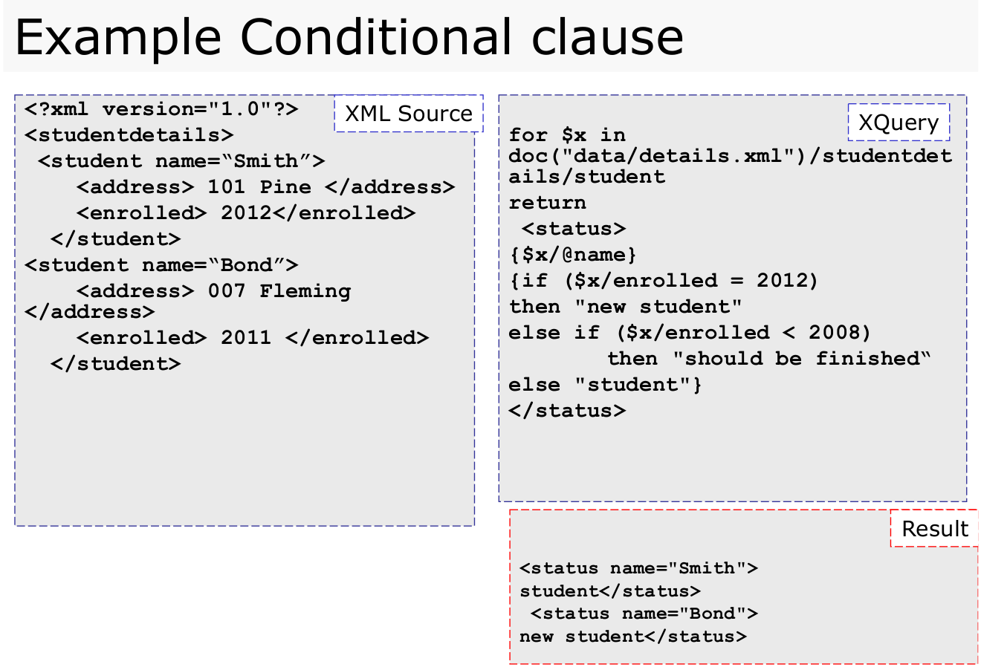

QUANTIFIED EXPRESSIONS

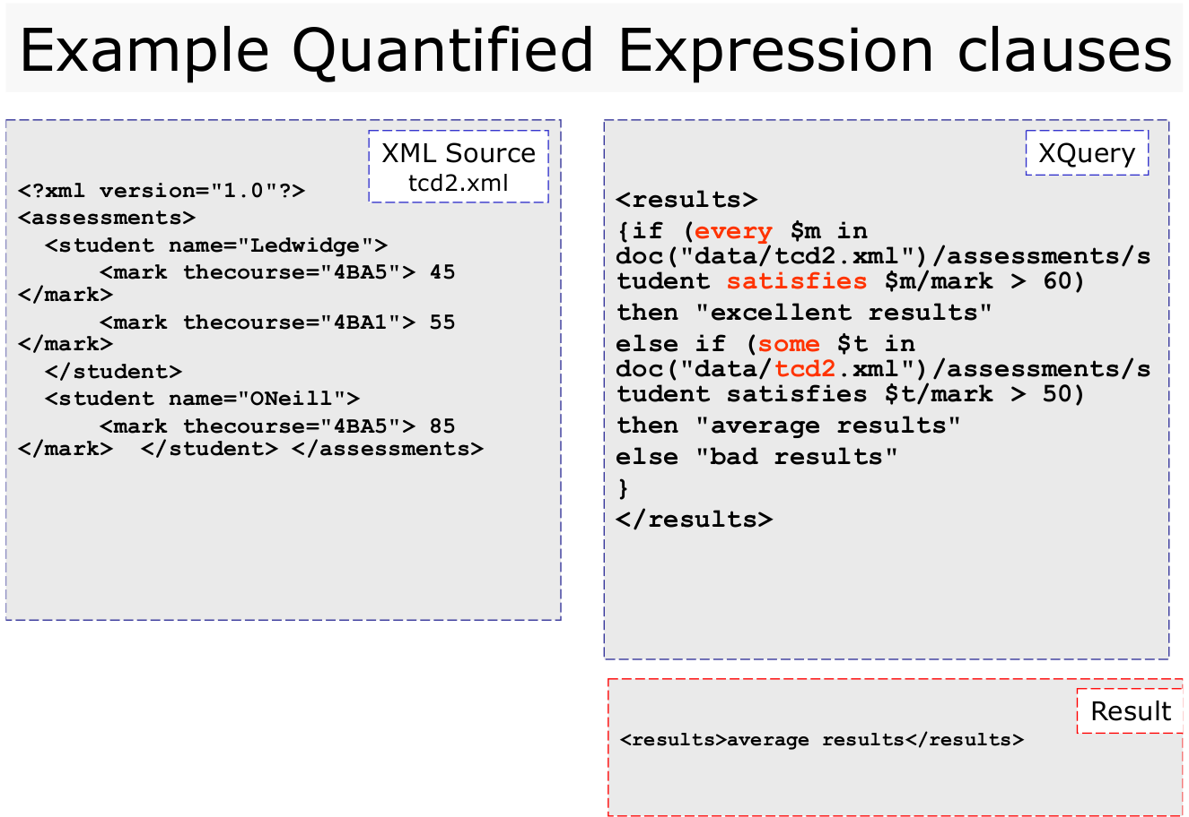

FUNCTIONS

