**CS3061 – Artificial Intelligence**

**2018 Exam Solutions**

**Question 1**

*Recall that a goal node connected by arc to Node can be searched by calling frontierSeach([Node]), with the following Prolog clauses:*

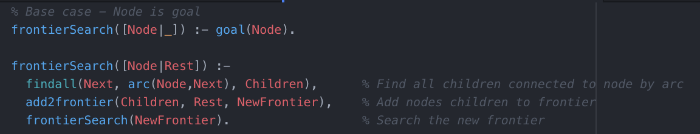

*a) Define add2frontier(Children, Rest, NewFrontier) so that frontierSearch([Node]) searches* ***depth-first*** *for a goal connected to Node by arc.*

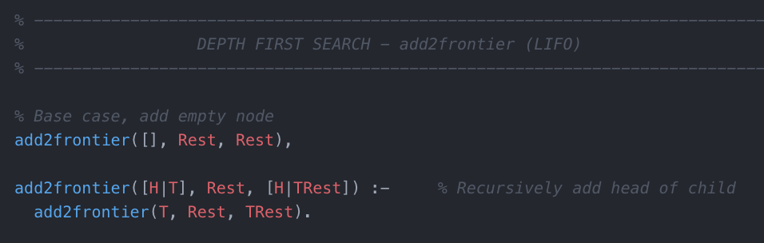

*b) Define add2frontier(Children, Rest, NewFrontier) so that frontierSearch([Node]) searches* ***breadth-first*** *for a goal connected to Node by arc.*

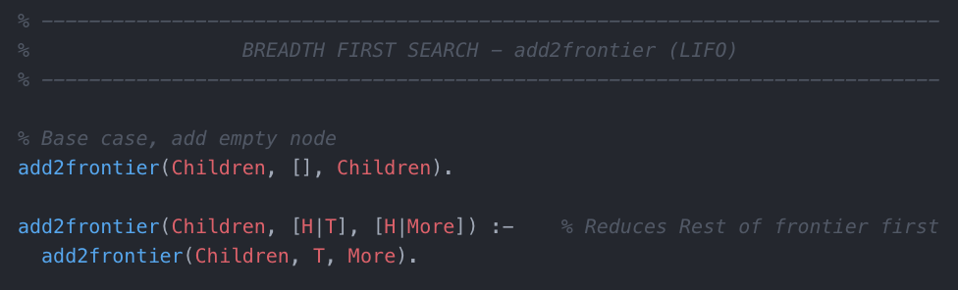

*c) What modifications to add2frontier(Children, Rest, NewFrontier) are required for A-star?*

The modifications needed to add2frontier that are required for A-star search is that it must ensure:

*\*\* where Head has minimal f \*\**

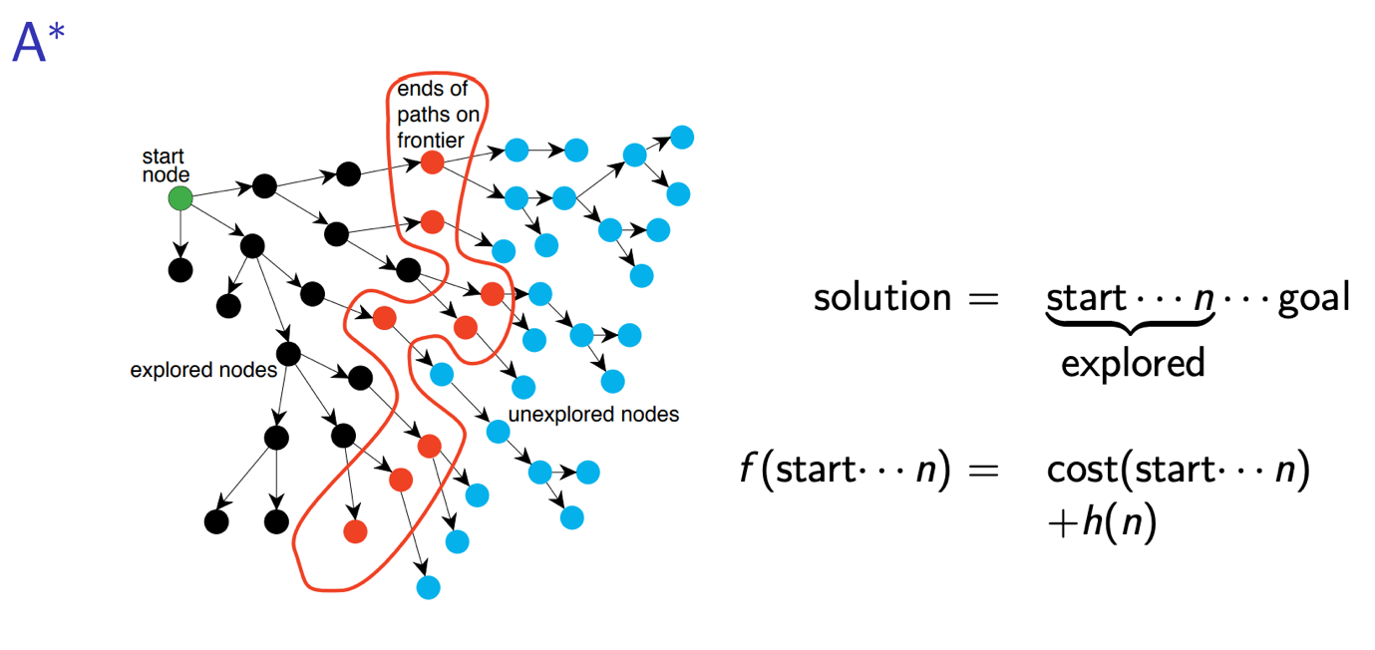

A* search takes into account a **heuristic value** h which estimates the cost of the cheapest path from the current node n to the target node.

*d) What does it mean for A-star to be* ***admissible****?*

A* is admissible (under cost, h) if it returns a solution of min cost whenever a solution exists i.e A* is fool-proof. A heuristic function is said to be admissible if it never overestimates the cost of reaching the goal i.e the cost it estimates to reach the goal is not higher than the lowest possible cost from the current point in the path.

*e) Give three conditions sufficient for A* to be admissible. Do these conditions guarantee that A* will terminate? Justify your answer.*

* Returns a solution of min cost (under cost and h) whenever a solution exists.
* If there is a path from start to goal, A* terminates with optimal path.
* It never overestimates the cost of reaching the goal.

These conditions do guarantee that A* will terminate as if A* does not terminate it does not satisfy condition two and thus, is not admissible. If a solution cannot be found, A* search immediately terminates.

*f) True or False: Breadth-first is admissible. Justify your answer*

True. Breadth-first search is admissible because the algorithm will always find the shortest path (it might not be the optimal path, if arcs have different costs). Breath-first search will also always terminate and is considered complete.

However, depth-first search is not guaranteed to be admissible.

*g) Suppose we were to apply A* to the graph below:*

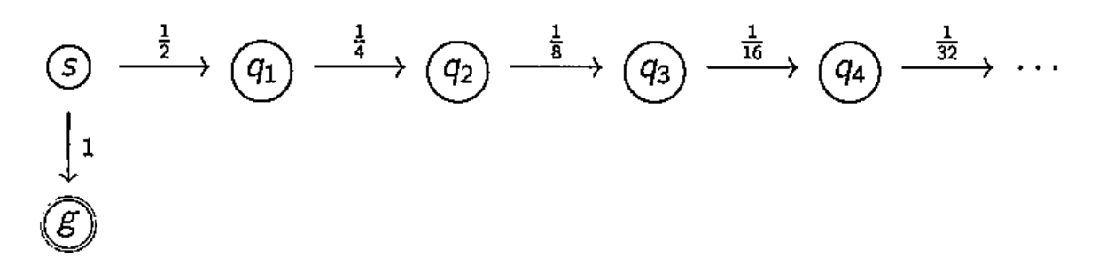

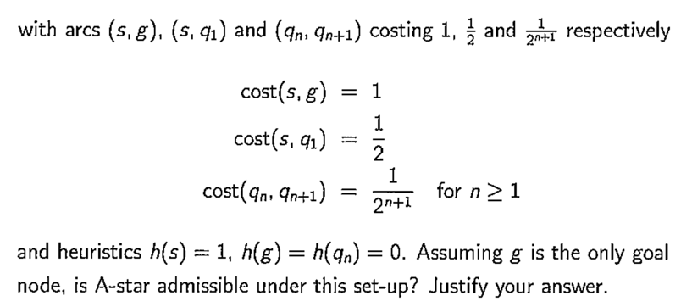

A* search is based off of the cost decision function:

Starting with start node *s* and goal node *g* we calculate f(n) for both arcs connected to *s*:

Since , A* search will choose to explore the route through in search of , as the heuristic values down this route are also decreasing and will never exceed 1 so it will continue to explore this infinite route and will not terminate. As a result A-star is not admissible under this set-up.

*h)*

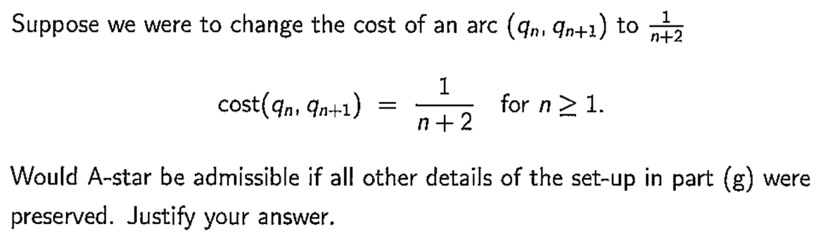

A* search is based off of the cost decision function:

With the newly improved cost function it will only take 3 steps away from in the direction of for it to exceed the other explored route via .

**First Exploration**

Choose to explore route to goal via q1 since

**Second Exploration**

Choose to explore route to goal via q2 since

**Third Exploration**

Now, since , we revert back to our first explored branch since this will provide us with a route of least cost to the goal node.

As a result of this change to the cost function A* does become admissible as it provides a solution of minimum cost to the the goal given that a route from the start node to the goal node exists.

**Question 2**

*Let be a Markov decision process.*

*a) What is a* ***policy****? Suppose S consists of three states, and A of two actions, how many possible policies are there?*

A policy is a **decision of what to do** at a given state. This is decided using the Markov decision process based on the probabilities returned from function p. For our given example there are 2 possible policies (action1 or action2).

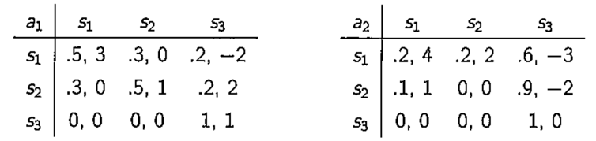

*b) What is a* ***-optimal policy*** *and how is it computed from the* ***-discounted value*** *of a pair (s,a)? How are -discounted values computed by value iteration*

A ***-optimal policy*** is a policy that chooses the best action to take for each state in the MDP. It is computed from the ***-discounted value*** of a pair (s,a) by exploring the best possible action to take by seeking the greatest expected reward. These rewards decay the further away from the current state they become at a decay factor of .

The ***-discounted value*** of a pair (s,a) is:

Where:

*c) Compute for:*

--------------------------------------------------------------------------------------------------------------------------

--------------------------------------------------------------------------------------------------------------------------

--------------------------------------------------------------------------------------------------------------------------

--------------------------------------------------------------------------------------------------------------------------

--------------------------------------------------------------------------------------------------------------------------

--------------------------------------------------------------------------------------------------------------------------

--------------------------------------------------------------------------------------------------------------------------

--------------------------------------------------------------------------------------------------------------------------

--------------------------------------------------------------------------------------------------------------------------

--------------------------------------------------------------------------------------------------------------------------

--------------------------------------------------------------------------------------------------------------------------

--------------------------------------------------------------------------------------------------------------------------

--------------------------------------------------------------------------------------------------------------------------

--------------------------------------------------------------------------------------------------------------------------

--------------------------------------------------------------------------------------------------------------------------

--------------------------------------------------------------------------------------------------------------------------

--------------------------------------------------------------------------------------------------------------------------

--------------------------------------------------------------------------------------------------------------------------

--------------------------------------------------------------------------------------------------------------------------

--------------------------------------------------------------------------------------------------------------------------

--------------------------------------------------------------------------------------------------------------------------

--------------------------------------------------------------------------------------------------------------------------

--------------------------------------------------------------------------------------------------------------------------

--------------------------------------------------------------------------------------------------------------------------

*d) How can we learn the the* ***-discounted value*** *when we do not know the probabilities p and immediate rewards r?*

We can learn the ***-discounted value*** by reinforcement learning or q-learning. For this purpose it is useful to define another function, which corresponds to taking the action a and then continuing optimally (or according to whatever policy one currently has):

While this function is also unknown, the experience during learning is based on (s,a) pairs (together with the outcome s’; that is “I was in state s and I tried doing a and s’ happened”). Thus, one has an array Q and uses experience to update it directly. This is known as Q-learning.

*e) The exploration-exploitation trade-off in c) and how can we adjust the notion of a policy to accommodate the trafe-off.*

The **exploration-exploitation** trade-off in c) is that if we need to decide when it is best to explore and when it is best to exploit our knowledge of the environment.

To adjust our policy we can introduce the notion of a **epsilon greedy strategy**. With this strategy we define an exploration ratewhich we initially set to 1. The exploration rate is the probability that our agent will choose to explore the environment rather than exploit it’s knowledge. As the agent learns more about the environment, at the start of each new episode will decay by some rate that we set so that the likelihood of exploration becomes less and less probable as the agent learns more about its environment.

To determine whether the agent will explore or exploit, choose a random number between 0 and 1 and compare it to .