**CS3081 – Computational Mathematics**

**2018 Exam Solutions**

**Question 1**

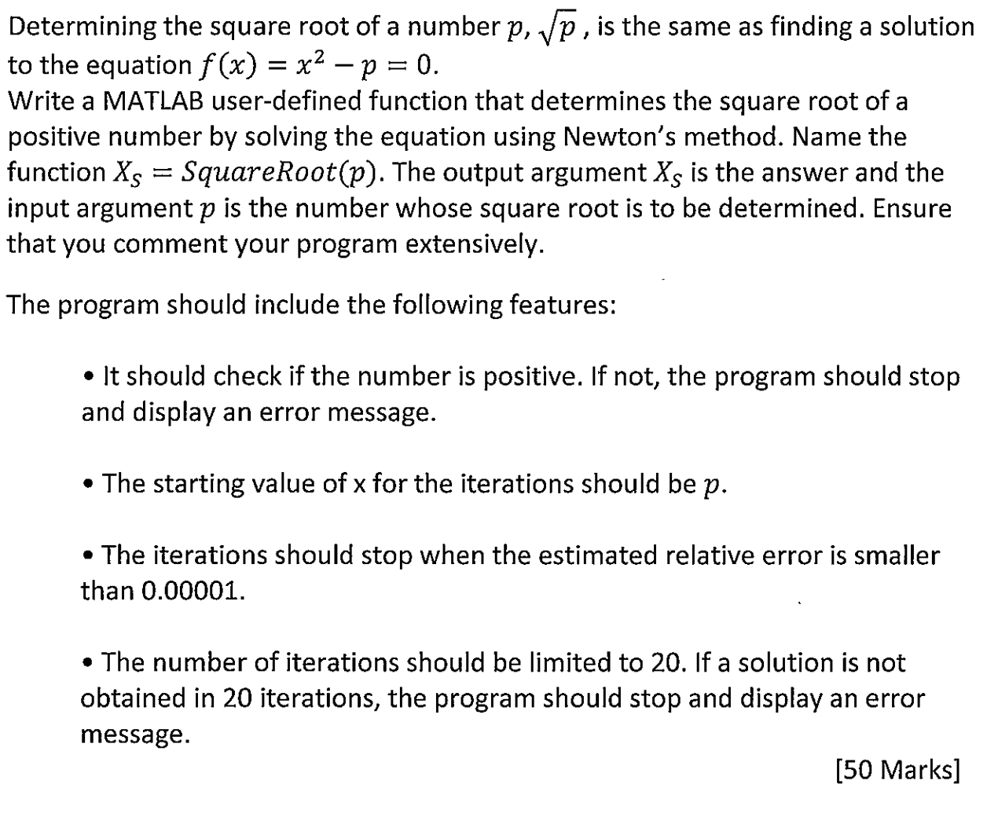

Newtons method of solving the roots to an equation is as follows:

Take an initial estimate for for the iterations (p) and solve:

So, in our case our solution to the first iteration would be:

This is repeated for 20 iterations until a solution is found or not found.

The iterations in Newtons method are stopped when the estimated relative error is smaller than a specified value (0.00001).

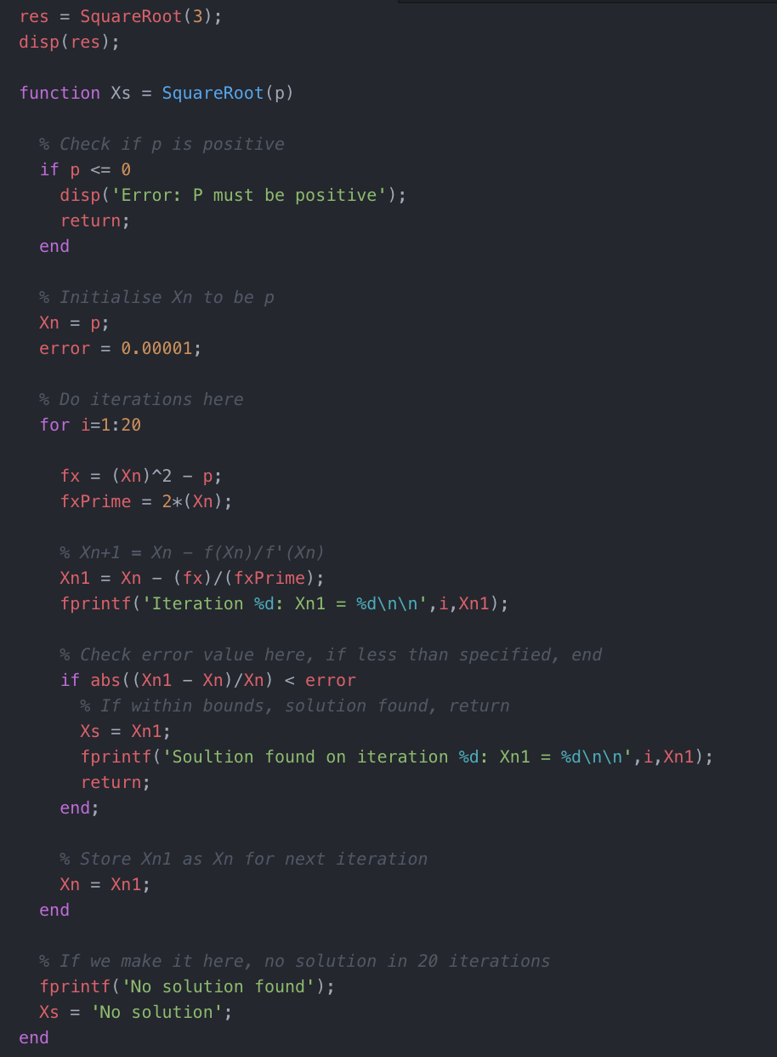

**Question 2**

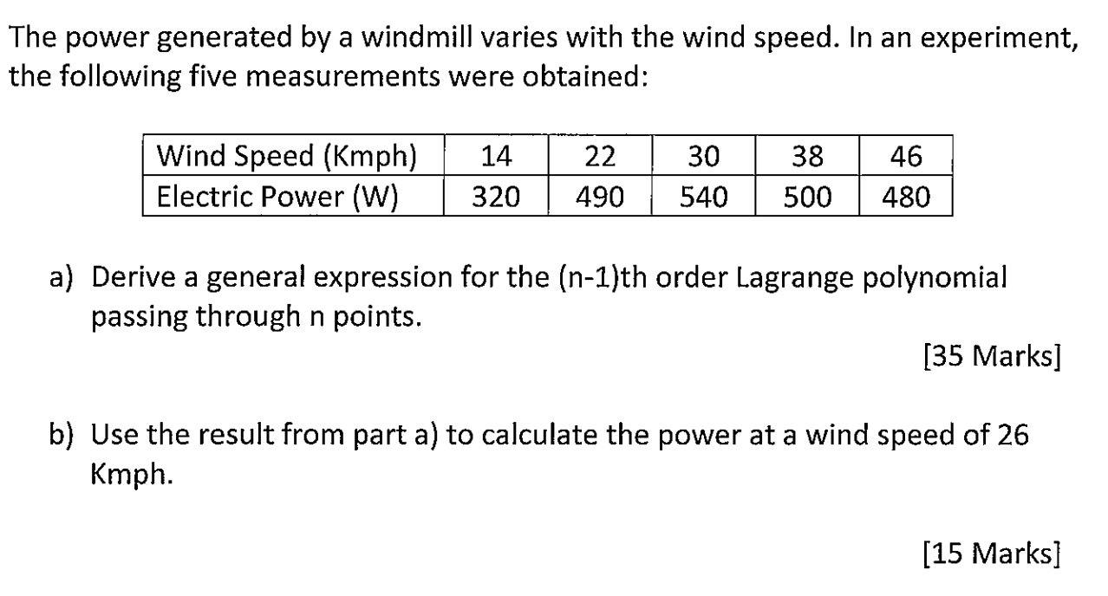

a) The n-1th order Lagrange polynomial passing through n points can be defined as:

The section highlighted in red just highlights the fact that at each iteration of a Lagrange polynomial you exclude the factor.

b) First select three points to use within our Lagrange polynomial:

* )

Then, derive the second order Lagrange polynomial passing through 3 points:

Then, sub in the values from above:

Then, using the above equation, solve for f(26):

Therefore, using the second order Lagrange polynomial we have estimated that the power produced by the windmill when the wind speed is 26 km/h is approximately 463.33 W. However, from looking at the data points we can see that this is not likely as this is less power than when the wind is at 22 km/h. To improve accuracy we could have used a higher order polynomial.

**Question 3**

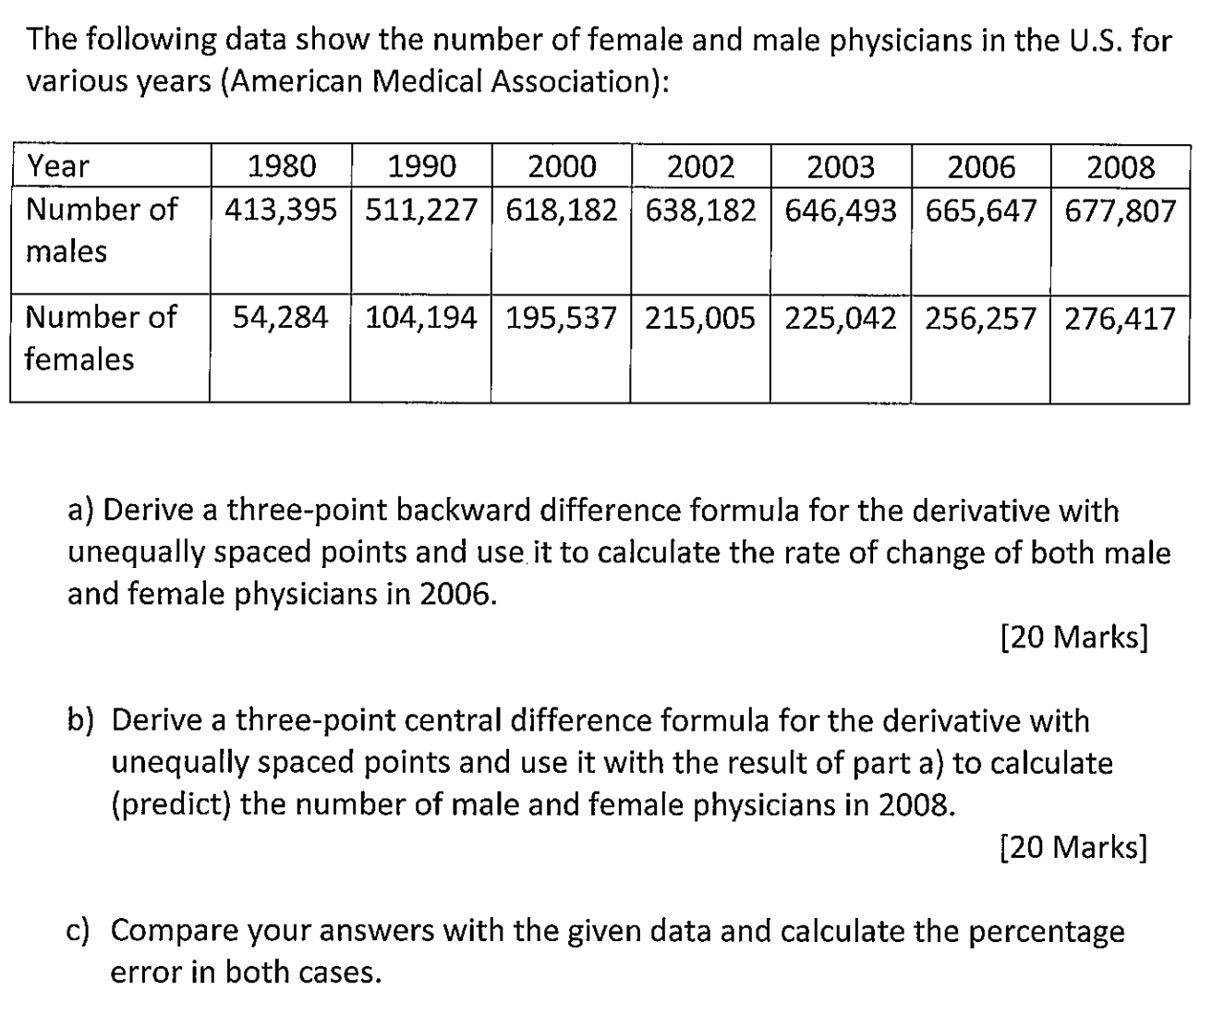

a) The three-point backward difference formula for the derivative with unequally spaced points is as follows:

We can then use this to calculate the rate of change of **male physicians** in 2006 as follows:

* )

Therefore, the rate of change of **male physicians** in 2006 is approximately 4939.916.

We can then also use this to calculate the rate of change of **female physicians** in 2006 as follows:

* )

Therefore, the rate of change of **female physicians** in 2006 is approximately 10,681.

b) The three-point central difference formula for the derivative with unequally spaced points is as follows:

* )

Using this, we can predict the number of **male physicians** in 2008 as follows:

Given that we already know f’(2006) from above, we then sub this back in: and solve for y3:

Therefore, the estimated number of **male physicians** in 2008 is approximately 673,601.

Using the above formula, we can also predict the number of **female physicians** in 2008 as follows:

* )

Therefore, the estimated number of **female physicians** in 2008 is approximately 227,987.

c) Using these predictions we can then calculate the error of the prediction using this method by comparing these to the actual numbers from the provided data: