**ST3009 – Statistics**

**2016 Exam Solutions**

**Question 1**

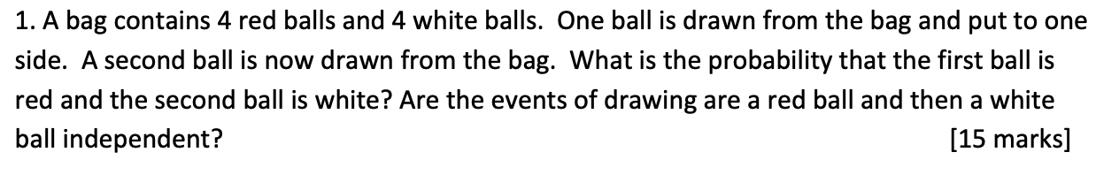

Sample Space = { R, R, R, R, W, W, W, W }

Balls removed without replacement.

$$P\left(First Red\right)= \frac{4}{8}= 0.5$$

$$P\left(Second White\right)= \frac{4}{7}= 0.5714$$

$$P\left(First Red and Second White\right)= 0.5*0.5714= 0.2857$$

For two events to be independent:

$$P\left(X∩Y\right)=P\left(X\right)*P(Y)$$

$$P\left(Red First\right)=\frac{1}{2}$$

$$P\left(White Second\right)=P\left(White Second | Red First\right)P\left(Red First\right)+P(White Second|WhiteFirst)P(White First)$$

$$P\left(White Second\right)=\left(\frac{4}{7}\right)\left(\frac{4}{8}\right)+ \left(\frac{3}{7}\right)\left(\frac{4}{8}\right)=0.5$$

$$P\left(Red First\right)P\left(White Second\right)=0.5*0.5=0.25$$

But:

$$P\left(Red First\right)P\left(White Second\right)≠P\left(First Red and Second White\right)$$

Therefore, the events are not independent.

**Question 2**

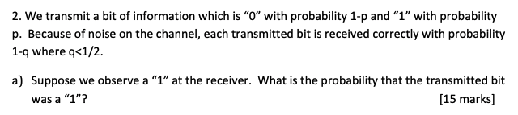

Probability of receiving a 0 🡪 1-p

Probability of receiving a 1 🡪 p

Probability of correct result 🡪 1-q

$$P\left(E | F\right)= \frac{P\left(F | E\right)P\left(E\right)}{P\left(F\right)}$$

$$P\left(F\right)=P\left(F | E\right)P\left(E\right)+P\left(F | E^{'}\right)P(E^{'})$$

$$P\left(1 transmitted | 1 observed\right)=\frac{P\left(1 observed|1 transmitted\right)P(1 transmitted)}{P(1 observed)}$$

$$P\left(1 transmitted | 1 observed\right)=\frac{\left(1-q\right)p}{P\left(1 observed\right)}$$

$$P\left(1 observed\right)=\left[\left(1-q\right)p\right]+\left[\left(1-p\right)q\right]$$

$$P\left(1 transmitted | 1 observed\right)=\frac{(1-q)p}{\left[\left(1-q\right)p\right]+\left[\left(1-p\right)q\right]}$$

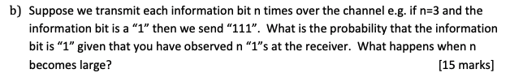

Let F be the event that n 1’s are observed at the receiver and E be the event that a 1 is sent:

$$P\left(E | F\right)= \frac{P\left(F | E\right)P\left(E\right)}{P\left(F\right)}$$

$$P\left(F\right)=P\left(F | E\right)P\left(E\right)+P\left(F | E^{'}\right)P\left(E^{'}\right)$$

$$P\left(F | E\right)={(1-q)}^{n}$$

$$P(E)=p$$

$$P\left(F\right)={\left(1-q\right)}^{n}\left(p\right)+q^{n}\left(1-p\right)$$

$$P\left(E | F\right)= \frac{{\left(1-q\right)}^{n}\left(p\right)}{{\left(1-q\right)}^{n}\left(p\right)+q^{n}\left(1-p\right)}$$

$$P\left(E | F\right)= \frac{p}{p+\frac{q^{n}\left(1-p\right)}{{\left(1-q\right)}^{n}}}$$

As n becomes large, $\frac{q^{n}\left(1-p\right)}{{\left(1-q\right)}^{n}}$ goes to 0 since q < 0.5 and so, as a result P(E|F) tends to 1.

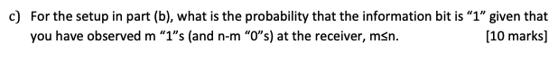

Let F be the event that m 1’s are observed at the receiver and E be the event the information bit is a 1:

$$P\left(F | E\right)=\left({n \atop m}\right){\left(1-q\right)}^{m}{(q)}^{m-n}$$

$$P\left(F | E'\right)=\left({n \atop m}\right){\left(q\right)}^{m}{(1-q)}^{m-n}$$

And so:

$$P\left(E | F\right)= \frac{\left({n \atop m}\right){\left(1-q\right)}^{m}{(q)}^{m-n}\left(p\right)}{\left({n \atop m}\right){\left(1-q\right)}^{m}{(q)}^{m-n}+\left({n \atop m}\right){\left(q\right)}^{m}{(1-q)}^{m-n}}$$

**Question 3**

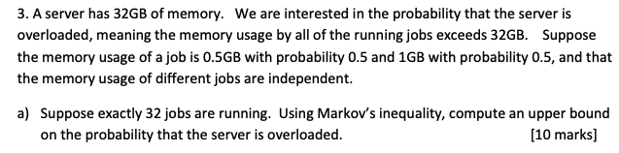

Overloaded 🡪 Memory of all running jobs > 32GB

Memory of a job 🡪 0.5GB w/ probability of 0.5

🡪 1GB w/ probability of 0.5

Let $X_{i}$ be the memory used by job i:

$$E\left[X_{i}\right]=0.5*0.5+1*0.5=0.75$$

The total memory usage is:

$$U= \sum_{i=1}^{32}{ X_{i}}$$

Therefore, the expected memory usage is:

$$E\left[U\right]=\sum_{i=1}^{32}{ E\left[X_{i}\right]}=32*0.75=24$$

By Markov’s inequality:

$$P\left(X≥a\right)≤\frac{E[X]}{a}$$

$$P\left(U≥32\right)≤\frac{24}{32}$$

$$P\left(U≥32\right)≤0.75$$

Therefore, the upper bound on the probability that the server is overloaded is 0.75 or 75%.

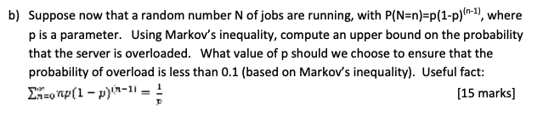

Random number N of jobs running at any one time with:

$$P\left(N=n\right)=p{(1-p)}^{n-1}$$

Now the memory usage, U can be defined as:

$$U= \sum_{i=1}^{N}{X_{i}}$$

The new expected value is then:

$$E\left[U\right]= \sum_{n=0}^{∞}{E\left[\left.\sum_{i=1}^{n}{X_{i}} \right|N=n \right]P\left(N=n\right)= \sum_{n=0}^{∞}{\sum_{i=1}^{n}{E\left[\left.X_{i}\right|N=n\right]*P\left(N=n\right)}} }$$

$$E\left[U\right]=\sum_{n=0}^{∞}{\sum_{i=1}^{n}{{E[X}_{i}]*P\left(N=n\right)}}$$

$$E\left[U\right]=\sum_{n=0}^{∞}{n*}{E[X}_{i}]*P\left(N=n\right)$$

$$E\left[U\right]=0.75*\sum_{n=0}^{∞}{n*P\left(N=n\right)}$$

$$E\left[U\right]=0.75*E\left[N\right]$$

We can also calculate E[N] as follows:

$$E\left[N\right]=\sum_{n=0}^{∞}{n*P\left(N=n\right)}$$

$$E\left[N\right]=\sum_{n=0}^{∞}{n*p{(1-p)}^{n-1}}$$

$$E\left[N\right]=\frac{1}{p}$$

Therefore:

$$E\left[U\right]=\frac{0.75}{p}$$

Using this we can then calculate an upper bound of Markov’s inequality as follows:

$$P\left(X≥a\right)≤\frac{E[X]}{a}$$

$$P\left(U≥32\right)≤\frac{E[U]}{32}$$

$$P\left(U≥32\right)≤\frac{0.75}{32p}$$

In order to ensure the probability of overloading the server has an upper bound of 0.1 solve:

$$\frac{0.75}{32p}=0.1$$

$$0.75=3.2p$$

$$p=0.2343$$

**Question 4**

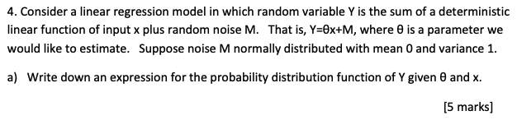

Noise is a number M normally distributed with mean 0 and variance of 1:

$$M \sim N(0,1)$$

So we can then express the probability distribution function f of y given $θ$ and x as:



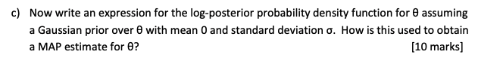

By Bayes rule the posterior is:

$$f_{θ|D}\left(θ | d\right)=\frac{f_{D|θ}\left(d | θ\right)f_{θ}\left(θ\right)}{f_{D}\left(d\right)}$$

We know $f_{D|θ}\left(d | θ\right)$ from part (b):

$$f_{D|θ}\left(d | θ\right)={\left(\frac{1}{\sqrt{2}π}\right)}^{n}\exp\left(-\frac{\sum_{i=1}^{n}{{\left(y_{i}-θx_{i}\right)}^{2}}}{2}\right)$$

The prior ($f_{θ}\left(θ\right)$) is as follows (Gaussian with mean 0 and standard deviation $σ$:

$$f_{θ}\left(θ\right)=\frac{1}{σ\sqrt{2}π}\exp\left(-\frac{θ^{2}}{2σ^{2}}\right)$$

Putting these together and taking logs we get:

$$\log{f_{θ|D}\left(θ | d\right)∝}-\frac{\sum_{i=1}^{n}{{\left(y_{i}-θx_{i}\right)}^{2}}}{2}-\frac{θ^{2}}{2σ^{2}}$$

The MAP estimate for $θ$ is the value that maximises this.