**ST3009 – Statistics**

**2018 Exam Solutions**

**Question 1**

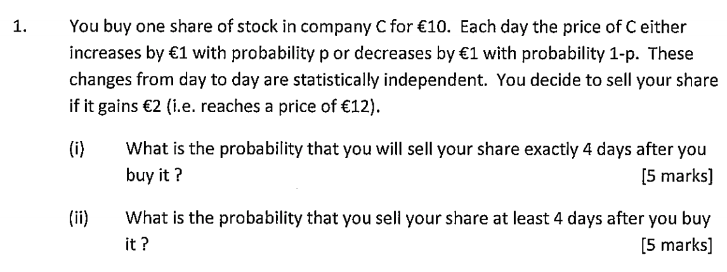

Increase = p

Decrease = 1-p

Sell if gain €2

i) In order to satisfy criteria to sell the share price must reach €12. For this to happen exactly 4 days after purchasing it, the following must occur:

* Decrease -> Increase -> Increase -> Increase
* Increase -> Decrease -> Increase -> Increase

The probability of either of these scenarios occurring is as follows:

ii) In order to sell our share at least 4 days after you buy it we can do 1-(Prob Sell on Day 1 + Prob Sell on Day 2 + Prob Sell on Day 3).

* Prob Sell on Day 1 = 0
* Prob Sell on Day 2 = (Increase -> Increase) =
* Prob Sell on Day 3 = 0

Therefore the probability of us selling our share at least 4 days after we buy it is:

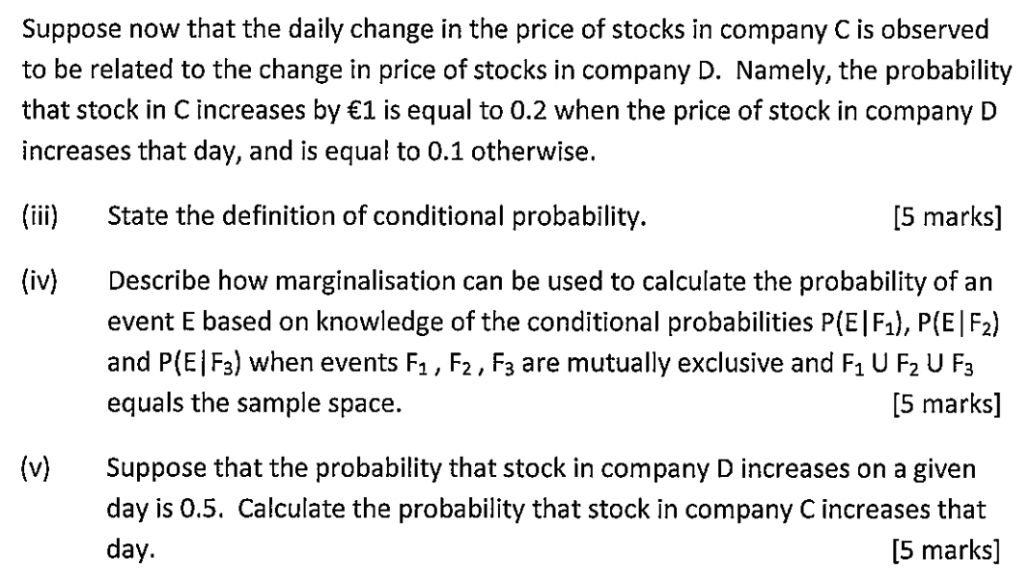

iii) **Conditional probability** is the probability that event E will occur given that event F has already been observed.

iv) Suppose we have mutually exclusive events F1 , F2  and F3 which together equal the entire sample space S, then:

v) Probability of D increasing on a given day is 0.5. Let C be the probability that company C’s stock increases:

**Question 2**

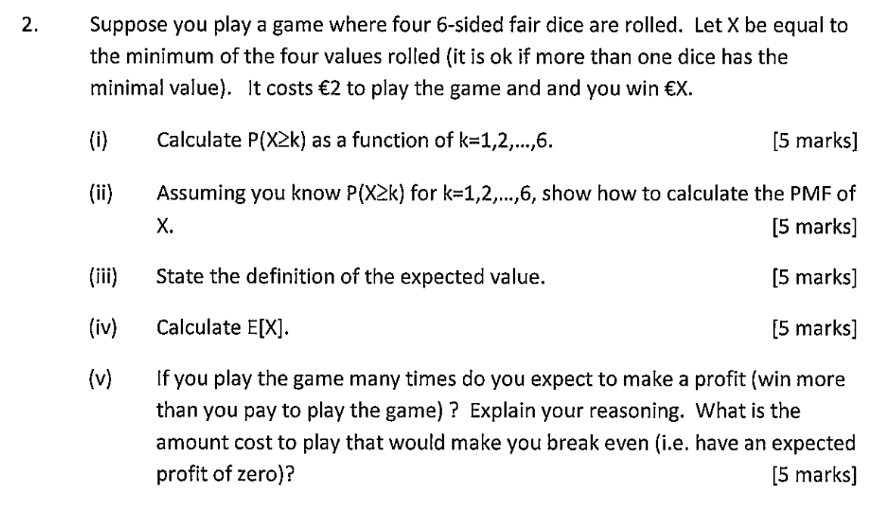

i)



ii) We can use the above values to calculate the PMF as follows:

iii) The definition of the expected value of a discrete random variable X taking values in {x1, x2, …, xn} is defined to be:

iv) For our given dice game we can calculate the expected value as follows:

v) The expected profit for the game is as follows:

If we were to play the game N times, with N being substantially large we could expect a profit of:

In order for the cost to play to enable us to break even:

Therefore, the cost to play must equal the expected value in order for us to break even.

**Question 3**

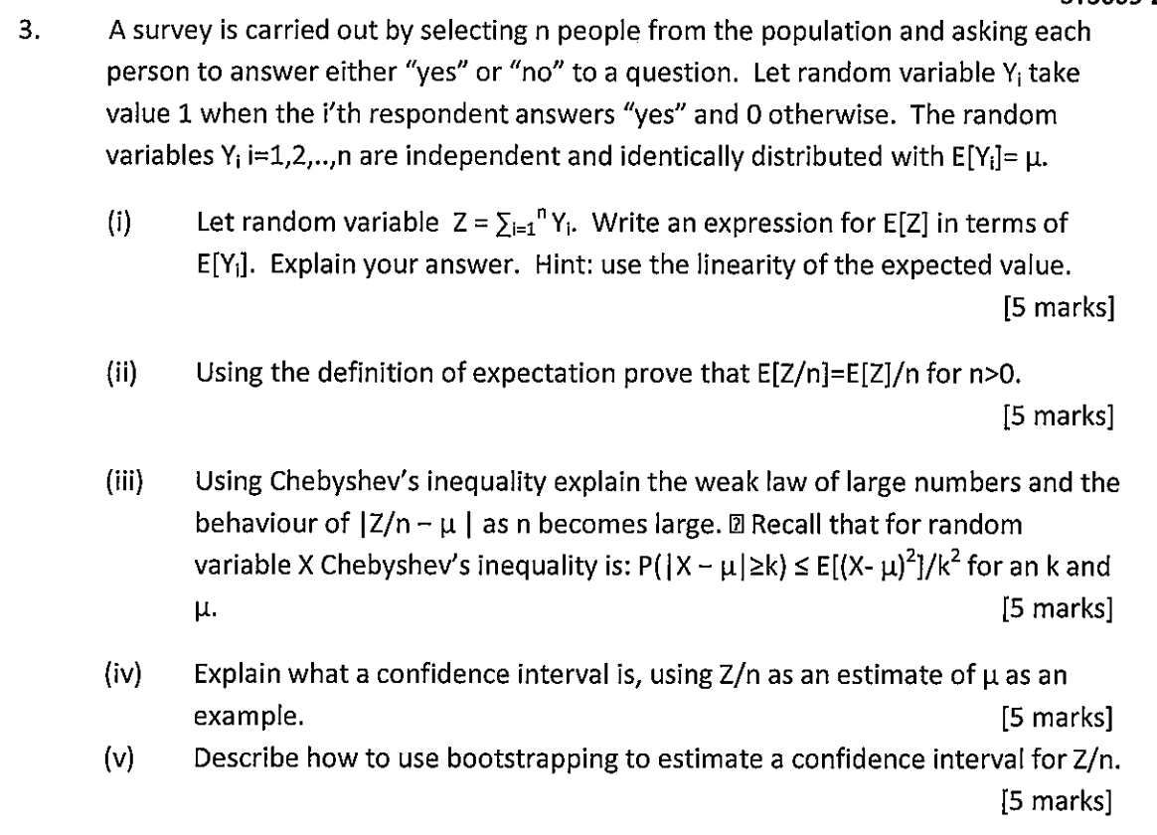

i) Using the linearity of the expected value we can write an expression for E[Z] as follows:

ii) Using the definition of expectation we can prove the above by:

iii)

Using the above formulae we can then plug then into Chebyshev’s inequality:

From this, we can infer that for any value of k>0, as n goes to infinity then the RHS goes to 0.

iv) A confidence interval, is an interval [a, b] within which a random variable X lies with a specified probability e.g with a probability of at least 0.95. This can be written as:

In the case of Z/n, as an estimate of we might consider the interval:

From part iii) we know that the above probability tends to 1 for any as n grows large. Thus, as we increase the number of samples our confidence in stating the that X lies within any given interval tends to 1.

v) From the observed data, and i=1, 2, …, n, draw a sample of m points uniformly at random with replacement. Using this sample calculate an estimate for Z/n. Repeat to obtain a multiple number of estimates. From the distribution of these estimates we can then estimate a confidence interval for Z/n.

**Question 4**

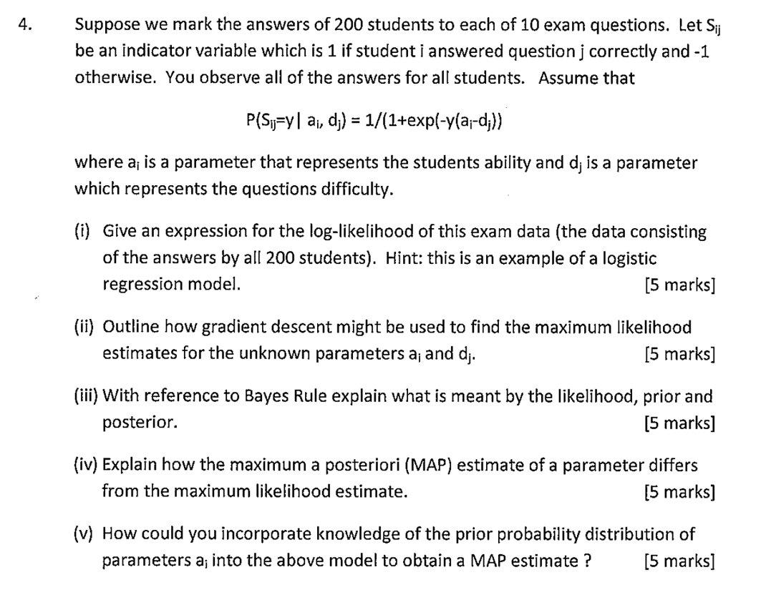

i) The log-likelihood of the observed marked data with the variables:

Is:

We can re-write the probability as:

Therefore the likelihood is:

Taking the log of this likelihood gives us:

ii) The gradient descent can be used to create an estimate which can select the parameters and to maximise the likelihood L. Starting from an initial estimate, these values van be found iteratively by updating the estimates such that L decreases after each update until the decrease in L becomes small enough. We can find updates that decrease L by local search or by taking a step in the direction of the derivatives of L wrt and .

iii) For random events E and F, Bayes Rule states:

* is the Likelihood
* is the Prior
* is the Posterior

iv) In a *maximum a posteriori (MAP)* estimate the parameter values are selected to maximise the posterior probability P(parameters|data) rather than the likelihood P(data|parameters).

v) By Bayes, the posterior is proportional to:

Therefore, the MAP estimate of the maximises this value.