**ST3009 – Statistics**

**Linear Regression**

* **Line of Best Fit Guess: $h_{θ}\left(x\right)=θ_{0}+θ_{1}x$**
* **Parameters: $θ_{0}$**(Y-intercept), $θ_{1}$ (Slope)
* **Cost Function:** The cost function represents the distance of each actual data point ($y_{i}$) from the line of best fit ($h_{θ}\left(x_{i}\right))$.
$$J\left(θ_{0}, θ_{1}\right)=\frac{1}{m}\sum_{i=1}^{m}{{\left(h_{θ}\left(x_{i}\right)-y_{i}\right)}^{2}}$$

* **Goal:** Select a y-intercept ($θ_{0}$) and a slope ($θ_{1}$) for our line of best fit that minimises $J\left(θ_{0}, θ_{1}\right)$ i.e gives us the most accurate line of best fit.
* **Adding Noise:** Most of the time our sample data is affected by randomly distributed Gaussian noise M. This can be factored into our line of best fit simply by:

$$h_{θ}\left(x\right)=θ_{0}+θ_{1}x$$

$${Y=h}_{θ}\left(x\right)+M$$

Our training data can now be considered as:

$$\{\left(x_{1}, h_{θ}\left(x_{1}\right)+M_{1}\right), …(\left(x_{i}, h_{θ}\left(x_{i}\right)+M_{i}\right)\}$$

* **Gaussian RV:** A Gaussian random variable Z with mean $μ$ and variance $σ^{2}$ has pdf:

$$f_{z}\left(Z\right)=\frac{1}{σ\sqrt{2π}}e^{-\frac{{(Z-μ)}^{2}}{2σ^{2}}}$$

Take for example an M with mean 0 and variance 1, we can then assume:

$$f_{M}\left(m\right)=\frac{1}{σ\sqrt{2π}}e^{-\frac{m^{2}}{2}}$$

$$f_{Y}\left(y\right)=\frac{1}{σ\sqrt{2π}}e^{-\frac{{(y-h_{θ}\left(x\right))}^{2}}{2}}$$

* **Bayes Rule:** Using Bayes rule we can infer the posterior, likelihood and prior:

$$f_{θ|D}\left(θ | d\right)= \frac{f_{D|θ}\left(d | θ\right)f_{θ}(θ)}{f_{D}(d)}$$

Posterior: The probability of parameter given data

Likelihood: The probability of data given parameter

Prior: Probability of prior

* **Likelihood:** The likelihood - $f_{D|θ}\left(d | θ\right)$– of the training data d is therefore:

$$f_{D|θ}\left(d | θ\right)=\prod_{i=1}^{m}{\frac{1}{\sqrt{2π}}e^{-\frac{{(y_{i}-h_{θ}\left(x_{i}\right))}^{2}}{2}}}$$

$$=\frac{1}{{\left(\sqrt{2π}\right)}^{m}}e^{-\sum_{i=1}^{m}{\frac{{(y_{i}-h_{θ}\left(x_{i}\right))}^{2}}{2}}}$$

Taking the log of both sides we get:

$$\log{f_{D|θ}\left(d | θ\right)}=log\frac{1}{{\left(\sqrt{2π}\right)}^{m}}-\sum_{i=1}^{m}{\frac{{(y_{i}-h_{θ}\left(x_{i}\right))}^{2}}{2}}$$

* **Maximum Likelihood Estimate (ML):** The ML of $θ$ maximises the likelihood. Equivalently, it maximises the log-likelihood. We can also drop the scaling factor $\frac{1}{\sqrt{2π}}$. This, therefore leaves us with a new equation to me maximised:
$$-\sum_{i=1}^{m}{\frac{{(y_{i}-h_{θ}\left(x_{i}\right))}^{2}}{2}}$$

* **Maximum Posterior Estimate (MAP):** The MAP is an estimate for $θ$ that maximises the posterior of Bayes rather than the likelihood.

Consider the following model:

$$Y=\sum_{i=1}^{m}{θ_{i}x_{i}+M }$$

Where:

$M\sim N(0,1)$ i.e Gaussian distributed with mean 0 and variance 1

$θ_{i}\sim N(0,λ)$ i.e Gaussian distributed with mean 0 and variance $λ$

We already know that the likelihood is:

$$f_{D|θ}\left(d | θ\right)∝e^{-\sum_{j=1}^{n}{\frac{{(y_{j}-{θ_{i}x_{i}}_{j})}^{2}}{2}}}$$

From our model, we have prior as:

$$f_{θ_{i}}\left(θ\right)∝e^{-\frac{θ^{2}}{2λ}}$$

The evidence (denominator - $f_{D}(d)$) is a normalising constant, so area under PDF = 1. Combing these rules with Bayes we then have:

$$f_{D|θ}\left(d | θ\right)∝e^{-\sum_{j=1}^{n}{\frac{{\left(y_{j}-{θ_{i}x_{i}}_{j}\right)}^{2}}{2}}}*e^{-\frac{θ^{2}}{2λ}}$$

The MAP estimation for this given model is the value of $θ$ that maximises $f_{D|θ}\left(d | θ\right)$

**Logistic Regression**

* **Classification:** Logistic regression serves the purpose of classification (email – spam or not spam?). Y values now only take values {-1, 1} whereas before Y was real-valued. We want to build a classifier that predicts the label of a new object (whether spam or not).

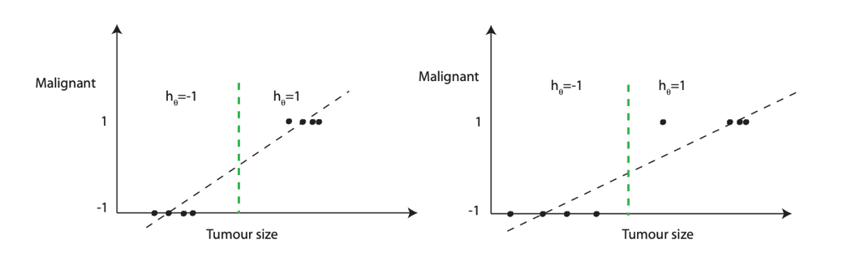

Line of best fit no longer works here, can result in misclassification. A more suitable model would be to predict output 1 (malignant) when $θ^{T}x≥0$ and output -1 (not malignant) when $θ^{T}x<0$

$$h_{θ}\left(x\right)=sign(θ^{T}x)$$

* **Plane Fitting:** Instead of trying to choose a line of best fit between data points, logistric regression aims to choose a plane that separates Y=1 data from the Y=0 data.

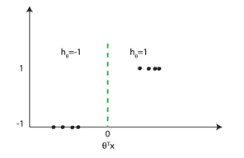

* **Logistic Regression Cost Function:** Similar to how in linear regression we used a cost function such as least squares to find the line of best fit, in logistic regression we use:

$$\frac{1}{m}\sum_{i=1}^{m}{\frac{\log\left(1+e^{-y_{i}θ^{T}x_{i}}\right)}{\log\left(2\right)}}$$

Scaling by log(2) here is optional, but it makes the loss 1 when $y_{i}θ^{T}x_{i}=0$.

* **Maximum Likelihood Estimate (ML):** Label Y only takes values of -1 and 1. Assume:

$$P\left(Y=y\right|θ,x)=\frac{1}{1+e^{-yθ^{T}x}}$$

The likelihood $P(d|θ$) of the training data d is therefore:

$$P\left(d | θ\right)=\prod_{i=1}^{m}{\frac{1}{1+e^{-yθ^{T}x}}}$$

Taking logs, this gives us:

$$\log{P\left(d | θ\right)}=\sum_{i=1}^{m}{\log{\frac{1}{1+e^{-yθ^{T}x}}}}$$

The ML can be considered the value of $θ$ that maximises the above equation. However, in order to simplify this, we can use the log rule $\log\left(\frac{1}{z}\right)=-\log\left(z\right)$ and then the ML becomes the value of $θ$ that **minimises**:

$$-\sum_{i=1}^{m}{\log{\frac{1}{1+e^{-yθ^{T}x}}}}=\sum_{i=1}^{m}{\log{(1+e^{-yθ^{T}x})}}$$

* **Example:** Using the above examples, and the hypothesis $h_{θ}\left(x\right)=sign(θ^{T}x)$, we now have an estimate for our confidence in the prediction, namely: $\frac{1}{1+e^{-yθ^{T}x}}$

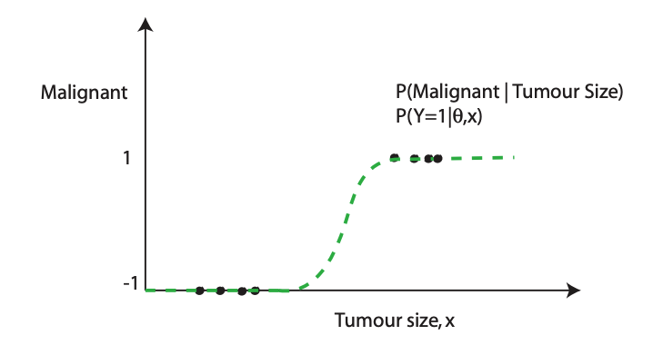

We can see that when $\frac{1}{1+e^{-yθ^{T}x}}$ is close to 1 then we are confident in our prediction, but when $\frac{1}{1+e^{-yθ^{T}x}}$ is small then we are less confident in our prediction.