**ST3009 – Statistics**

**Regression Questions**

**Linear Regression**

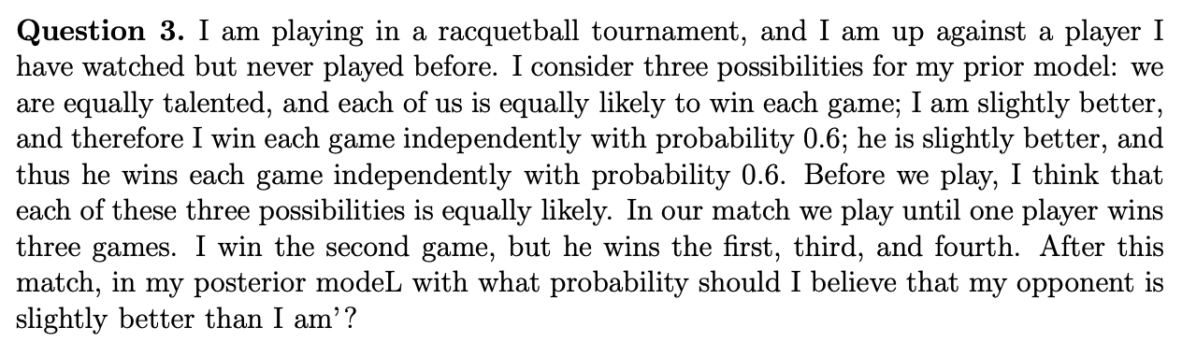

Use Bayes Rule. Let E be the observed set of wins and let F be the event that the opponent is better than me. By Bayes,

$$P\left(F | E\right)=\frac{P\left(E | F\right)P\left(F\right)}{P\left(E\right)}$$

Now, prior to the wins the probability that the opponent is better than me is:

$$P\left(F\right)=\frac{1}{3}$$

Since it is equally likely to be better or worse than me also.

$$P\left(E | F\right)=P\left(LOSE\right)*P\left(WIN\right)*P\left(LOSE\right)*P\left(LOSE\right)$$

$$P\left(E | F\right)=0.6*\left(1-0.6\right)*0.6*0.6$$

$$P\left(E | F\right)=0.0864$$

We can calculate P(E) using marginalisation:

$$P\left(E\right)=P\left(E | F\right)P\left(F\right)+P\left(E | G\right)P\left(G\right)+P\left(E | H\right)P\left(H\right)$$

$$P\left(E\right)={\left(0.6\right)}^{3}(1-0.6)\frac{1}{3}+{\left(0.5\right)}^{3}(1-0.5)\frac{1}{3}+{(1-0.6)}^{3}(0.6)\frac{1}{3}$$

$$P\left(E\right)=0.0624$$

Where G is the event that we are equally talented and H is the event that I am more talented. $$P\left(F | E\right)=\frac{(0.0864)(1/3)}{(0.0624)}=0.4615$$