**CS3031 – Advanced Telecommunications**

**2018 Exam Solutions**

**Question 1**

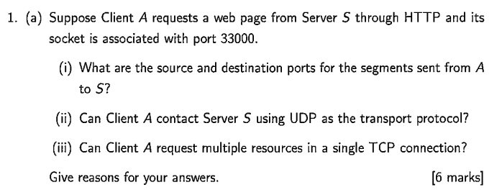

1. The source and destination ports for the segments sent from A to S are as follows:

* **Source:** 33000
* **Destination:** 80

The reasons for this is that Client A is an application running on some machine on port 33000 and that Server S is a generic web server accepting HTTP requests at the standard port 80.

1. HTTP is a text-transfer based protocol that runs over TCP/IP. If the client wanted to contact the server using UDP as the transport protocol the server would have configured to provide a service that listened on port 80 and accepted UDP requests.
2. Client A can request multiple resources in a single TCP connection. The connection between a client and server remains open until one of the parties closes the connection by sending a FIN request. Once the connection remains open the client can request as many resources as it likes.

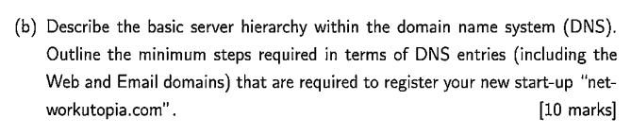

The basic server hierarchy within the domain name system (DNS) is as follows:

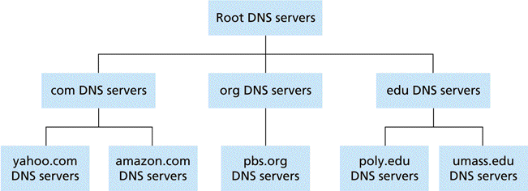

The minimum steps that would be required to register our new start-up *“networkutopia.com”* are as follows:

* Register name *“networkutopia.com”* with a DNS registrar (e.g Network Solutions).
* Provide names & IP addresses of **authoritative name server** (NS records)
* Create **A record** for [www.networkutopia.com](http://www.networkutopia.com) that points to a valid IP
* Create **MX record** for networkutopia.com

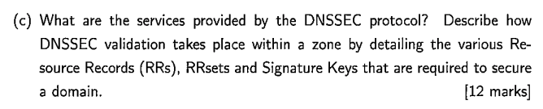

DNSSEC provides origin authentication and integrity assurance services for DNS data. This prevents malicious attackers from spoofing DNS responses and redirecting users to malicious websites (e.g fake bank login page).

The first step towards securing a zone with DNSSEC is to group all the records with the same type into a resource record set (RRset).



Each zone in DNSSEC has a zone-signing key pair (ZSK). A zone operator creates digital signatures for each RRset using the private ZSK. Zone operators must also make their public ZSK available by adding it to their name server in a DNSKEY record. When a DNSSEC resolver requests a particular record type (e.g AAAA), the name server also returns the corresponding RRSIG.





A **centralized service** is one that can be considered as a client-server architecture. Multiple clients all request individual resources from one centralized server(s). Even though there may be numerous servers serving these clients the content that they are providing is in fact centralized and not distributed across the entire network.

A **decentralized (P2P) service** is where there is no always-on server providing the service. The service itself relies heavily on other peers within the network serving the content to other peers. This brings self-scalability, the more peers that join the network the more it will scale and the quicker it will become.

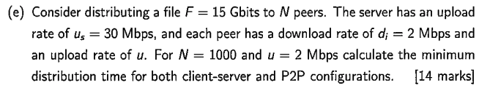

* **File:** 15 Gbits
* **N:** 1000 peers
* **Server Upload:** 30 Mbps
* **Peer Download:** 2 Mbps
* **Peer Upload:** 2 Mbps

For a **client-server** configuration the minimum distribution time can be considered as:

$$D_{CS }≥\max\left(\frac{NF}{u_{s}},\frac{F}{d_{min}}\right)$$

This means that the minimum distribution time is either how long it takes to upload the file to N peers OR how long it takes for the slowest peer to download the file (if this is larger). For our given example we have:

$$D_{CS }≥\max\left(\frac{(1000)(15×{10}^{9})}{(30×{10}^{6})},\frac{(15×{10}^{9})}{(2×{10}^{6})}\right)$$

$$D_{CS }≥\max\left(500000,7500\right)$$

$$D_{CS }≥500,000s$$

For a **peer-to-peer (P2P)** configuration the minimum distribution time can be considered as:

$$D_{CS }≥\max\left(\frac{F}{u_{s}},\frac{F}{d_{min}},\frac{NF}{(u_{s}+\sum{u_{i})}}\right)$$

For our given example we have:

$$D_{P2P }≥\max\left(\frac{(15×{10}^{9})}{(30×{10}^{6})},\frac{(15×{10}^{9})}{(2×{10}^{6})},\frac{(1000)(15×{10}^{9})}{\left(30×{10}^{6}\right)+1000(2×{10}^{6})}\right)$$

$$D_{P2P }≥\max\left(500,7500,7389.1652\right)$$

$$D_{P2P }≥7500s$$

Thus, we can clearly see that as more peers join the network the minimum distribution time of a P2P network greatly surpasses that of a client-server architecture.