**CS3081 – Computational Mathematics**

**Assignment 2**

*Brandon Dooley - #16327446*

***Question 4.23 –*** *Write a user-defined MATLAB function that decomposes an n x n matrix [A] into a lower triangular matrix [L] and an upper triangular matrix [U] using Gauss elimination without pivoting.*

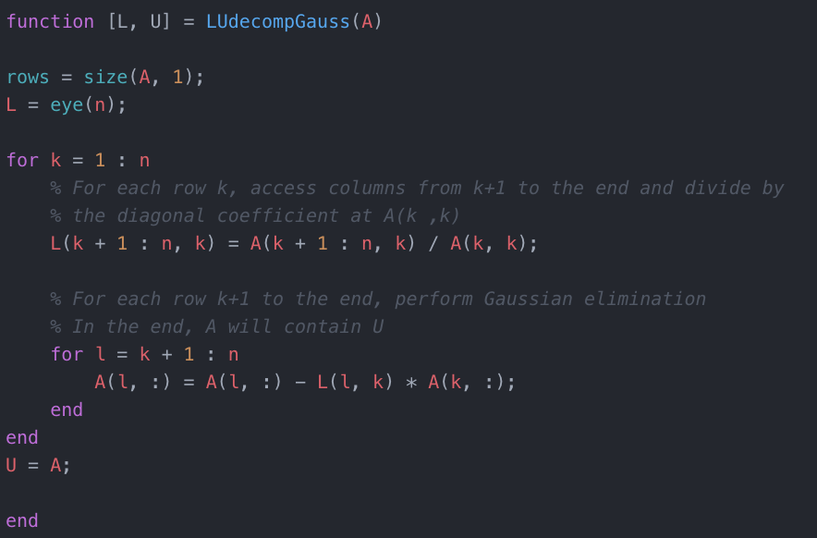

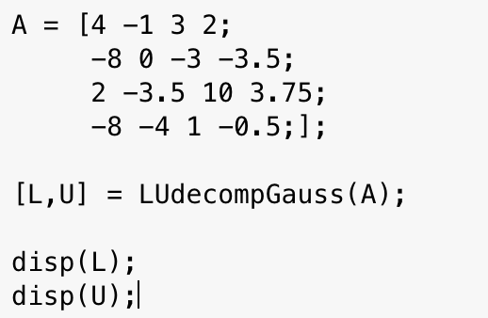

L =

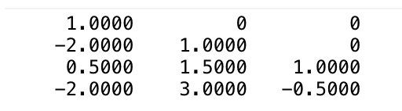

U =

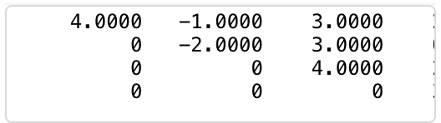

***Question 5.17 –*** *A football conference has six teams. The outcome of the games is recorded in a binary fashion. For example if team 1 defeats teams 5 and 6, then the equation*

*x1 = x5 + x6 is written to indicate these results.*

1. *Find the eigenvalues and the corresponding eigenvectiors of [A] using MATLAB’s built-in function eig.*

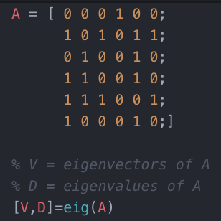

**Eigenvalues:**

* 2.618033989
* 0.3820
* 0
* -1

**Eigenvectors:**

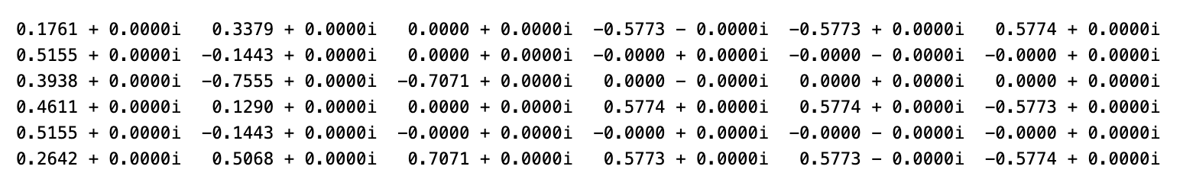

1. *Find the eigenvector from part (a) whose entries are all real and of the same sign. Rank the teams from best to worst based on the indices of the teams corresponding to the largest to the smallest entries in that eigenvector.*

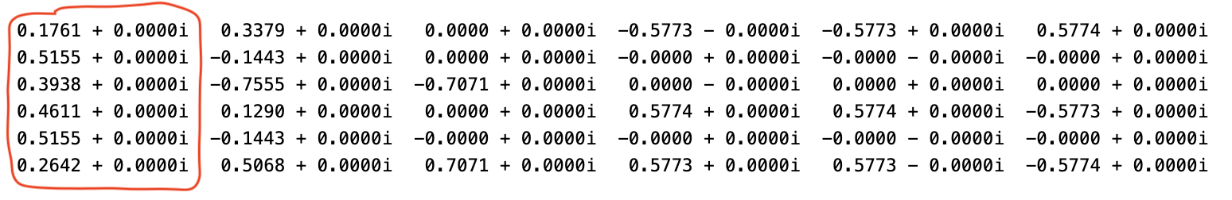

From above we can see that the eigenvector whose entries are all real and of the same sign is the eigenvector:

$$\left[\begin{matrix}0.1761 \\ 0.5155 \\ 0.3938 \\ 0.4611 \\ 0.5155\end{matrix}\right]$$

This vector can be interpreted as the weighted score of each team. We can then, using this eigenvector rank the teams from best to worst as follows:

$$x_{1}=0.1761$$

$$x_{2}=0.5155$$

$$x_{3}=0.3938$$

$$x_{4}=0.4761$$

$$x_{5}=0.5155$$

Following this we can determine that teams $x_{2}$ and $x_{5}$ can be considered the best teams with regards to wins, followed by $x_{4}$ then $x_{3}$ then $x_{1}$.

However, team $x_{2}$ did in fact beat $x_{5}$ so in theory they could be considered the best.