**CS3081 – Computational Mathematics**

**Assignment 4**

*Brandon Dooley - #16327446*

***Question 4.26 –*** *Write a user-defined MATLAB function that calculates the infinity norm of any matrix. For the function name and arguments use N = InfinityNorm (A), where A is the matrix, and N is the value of the norm. Use the function for calculating the infinity norm of A and B.*

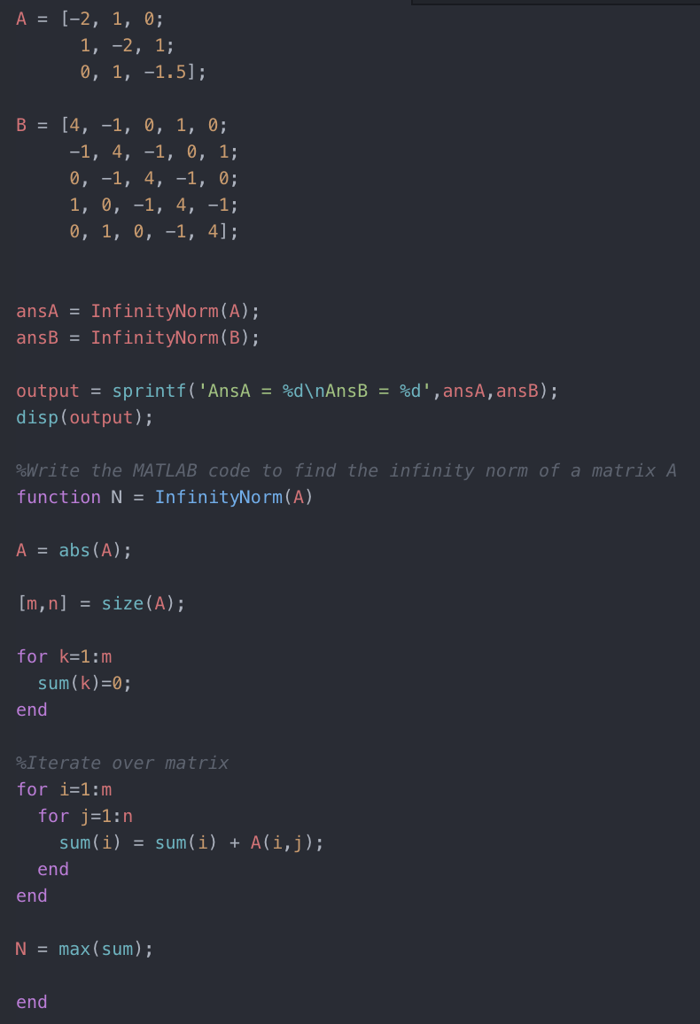

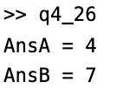

***Question 6.13 –*** *The power generated by a windmill varies with the wind speed. In an experiment, the following 5 measurements were obtained:*

**

*Determine the fourth-order polynomial in the Lagrange form that passes through the points. Use the polynomial to calculate the wind speed of 26mph.*

The fourth order Lagrange polynomial passing through the 5 points ($x_{1}$, $y_{1}$), ($x_{2}$, $y_{2}$), ($x_{3}$, $y_{3}$), ($x_{4}$, $y_{4}$), ($x_{5}$, $y_{5}$) is defined as

$$f\left(x\right)= \left[\begin{aligned}\frac{\left(x-x_{2}\right)\left(x-x_{3}\right)\left(x-x_{4}\right)\left(x-x_{5}\right)}{\left(x_{1}-x_{2}\right)\left(x_{1}-x_{3}\right)\left(x_{1}-x_{4}\right)\left(x_{1}-x_{5}\right)} y_{1}+ \\ \frac{\left(x-x_{1}\right)\left(x-x_{3}\right)\left(x-x_{4}\right)\left(x-x_{5}\right)}{\left(x_{2}-x_{1}\right)\left(x_{2}-x_{3}\right)\left(x_{2}-x_{4}\right)\left(x_{2}-x_{5}\right)} y_{2}+ \\ \frac{\left(x-x_{1}\right)\left(x-x_{2}\right)\left(x-x_{4}\right)\left(x-x_{5}\right)}{\left(x_{3}-x_{1}\right)\left(x_{3}-x_{2}\right)\left(x_{3}-x_{4}\right)\left(x_{3}-x_{5}\right)} y_{3}+ \\ \frac{\left(x-x_{1}\right)\left(x-x_{2}\right)\left(x-x_{3}\right)\left(x-x_{5}\right)}{\left(x_{4}-x_{1}\right)\left(x_{4}-x_{2}\right)\left(x_{4}-x_{3}\right)\left(x_{3}-x_{5}\right)} y_{4}+ \\ \frac{\left(x-x_{1}\right)\left(x-x_{2}\right)\left(x-x_{3}\right)\left(x-x_{4}\right)}{\left(x_{5}-x_{1}\right)\left(x_{5}-x_{2}\right)\left(x_{5}-x_{3}\right)\left(x_{5}-x_{4}\right)} y_{5}+\end{aligned}\right]$$

Now, using the provided data substitute the points (14, 320), (22, 490), (30, 540), (38, 500) and (46, 480) into the Lagrange polynomial for ($x_{1}$, $y_{1}$), ($x_{2}$, $y_{2}$), ($x_{3}$, $y_{3}$), ($x_{4}$, $y_{4}$), ($x_{5}$, $y_{5}$)

$x_{1}$ = 14, $x_{2}$ = 22, $x_{3}$ = 30, $x_{4}$ = 38, $x_{5}$ = 46

$y_{1}$ = 320, $y_{2}$ = 490, $y_{3}$ = 540, $y_{4}$ = 500, $y_{5}$ = 480

$$f\left(x\right)= \left[\begin{aligned}\frac{\left(x-22\right)\left(x-30\right)\left(x-38\right)\left(x-46\right)}{\left(14-22\right)\left(14-30\right)\left(14-38\right)\left(14-46\right)} (320)+ \\ \frac{\left(x-14\right)\left(x-30\right)\left(x-38\right)\left(x-46\right)}{\left(22-14\right)\left(22-30\right)\left(22-38\right)\left(22-46\right)} (490)+ \\ \frac{\left(x-14\right)\left(x-22\right)\left(x-38\right)\left(x-46\right)}{\left(30-14\right)\left(30-22\right)\left(30-38\right)\left(30-46\right)} (540)+ \\ \frac{\left(x-14\right)\left(x-22\right)\left(x-30\right)\left(x-46\right)}{\left(38-14\right)\left(38-22\right)\left(38-30\right)\left(30-46\right)} (500)+ \\ \frac{\left(x-14\right)\left(x-22\right)\left(x-30\right)\left(x-38\right)}{\left(46-14\right)\left(46-22\right)\left(46-30\right)\left(46-38\right)} (480)+\end{aligned}\right]$$

When this polynomial is multiplied out and simplified we are left with:

$f\left(x\right)=8.98 × {10}^{-4}x^{4}-0.085x^{3}+2.016x^{2}+10.468x-23.212$

Using this polynomial we can determine the power of the windmill when the windspeed is 26mph. This is done by solving $f\left(x\right)$ for $x=26$:

$$f\left(26\right)=\left(8.98 × {10}^{-4}\right){\left(26\right)}^{4}-\left(0.085\right){\left(26\right)}^{3}+\left(2.016\right){\left(26\right)}^{2}+\left(10.468\right)\left(26\right)-23.212$$

$=528.18 W$

Therefore, we have determined using the fourth order Lagrange polynomial that the power of the windmill when the windspeed is 26mph is $528.18 W$.