**CS3081 – Computational Mathematics**

**Assignment 4**

*Brandon Dooley - #16327446*

***Question 4.26 –*** *Write a user-defined MATLAB function that calculates the infinity norm of any matrix. For the function name and arguments use N = InfinityNorm (A), where A is the matrix, and N is the value of the norm. Use the function for calculating the infinity norm of A and B.*

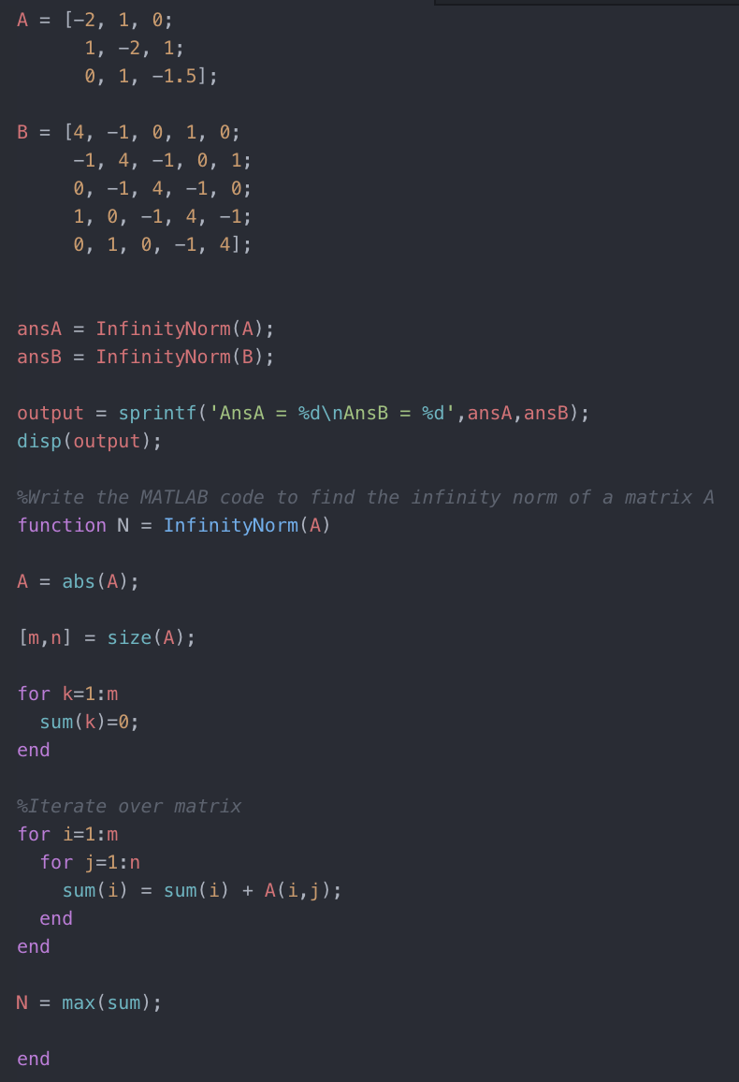

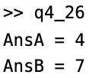

***Question 6.13 –*** *The power generated by a windmill varies with the wind speed. In an experiment, the following 5 measurements were obtained:*

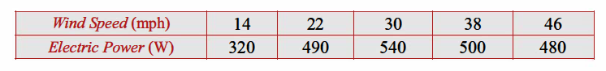

*Determine the fourth-order polynomial in the Lagrange form that passes through the points. Use the polynomial to calculate the wind speed of 26mph.*

The fourth order Lagrange polynomial passing through the 5 points (, ), (, ), (, ), (, ), (, ) is defined as

Now, using the provided data substitute the points (14, 320), (22, 490), (30, 540), (38, 500) and (46, 480) into the Lagrange polynomial for (, ), (, ), (, ), (, ), (, )

= 14, = 22, = 30, = 38, = 46

= 320, = 490, = 540, = 500, = 480

When this polynomial is multiplied out and simplified we are left with:

Using this polynomial we can determine the power of the windmill when the windspeed is 26mph. This is done by solving for :

Therefore, we have determined using the fourth order Lagrange polynomial that the power of the windmill when the windspeed is 26mph is .

***Question 8.7 –*** *Derive a finite difference approximation formula for using three points , , where the spacing is such that and that*

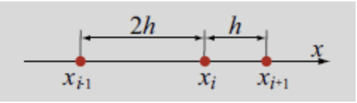

The formula for a function at the point using the Taylor series expansion is as follows:

This can then be simplified since :

The formula for a function at the point using the Taylor series expansion is as follows:

This can then be simplified since :

We must then multiply the equation for by 2 (the aim of the game is to eliminate f’(x):

Then add the equations for and :

--------------------------------------------------------------------------------------------------------------------------

We must then re-arrange this equation and solve for :

Therefore, the finite difference approximation for using three points *, ,* is:

From this we can also determine the order of the truncation error to be:

***Question 8.9 –*** *The following data show the number of female and male physicians in the U.S. for various years (American Medical Association):*

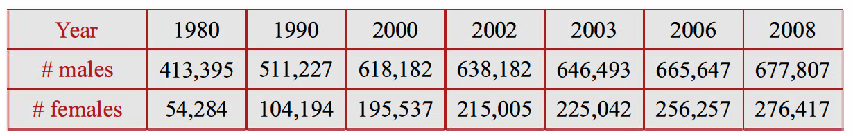

1. *Calculate the rate of change in the number of male and female physicians in 2006 by using the three point backward difference formula for the derivative, with unequally spaced points, Eq. (8.37).*

The three point backward difference formula for the derivative, with unequally spaced points (Eq. 8.37) is defined as:

Using the above formula calculate the rate of change in the number of **male physicians** in 2006 by using the variables:

,

,

,

Therefore the rate of change in the number of **male physicians** in 2006 is approximately 4,940.

Similar to above, we can calculate the rate of change in the number of **female physicians** in 2006 by using the variables:

,

,

,

Therefore the rate of change in the number of **female physicians** in 2006 is 10,681.

1. *Use the result from part (a) and the three-point central difference formula for the derivative with unequally spaced points, Eq. (8.36), to calculate (predict) the number of male and female physicians in 2008.*

The three point central difference formula for the derivative, with unequally spaced points (Eq. 8.37) is defined as:

Using the above formula we can predict the number of **male physicians** in 2008 by using the variables:

,

,

,

We can then use the above equation and solve for :

Therefore the estimated number of **male physicians** in 2008 is approximately 673,601.

Similar to above, we can calculate the estimated number of **female physicians** in 2008 by using the variables:

,

,

,

We can then use the above equation and solve for :

Using these predictions we can then calculate the error of the prediction using this method by comparing these to the actual numbers from the provided data:

--------------------------------------------------------------------------------------------------------------------------