**ST3009 - Statistical Methods for Computer Science**

**Week 3 Questions**

*Brandon Dooley - #16327446*

***Question 1 –*** *Say we roll a fair 6-sided die six times. Using the fact that each roll is an*

*independent random event, what is the probability that we roll:*

1. Since each roll is an independent event we consider the probability of each event individually for each occurrence. The probability of rolling a specific number on a six sided die is:

As a result, the probability of rolling the sequence 1,1,2,2,3,3 is:

1. The probability of an independent event p occurring exactly k times on n trials is:

Therefore the probability of a three occurring (1/6) exactly 4 times over 6 trials is:

1. An event E is a subset of the sample space S. Consider the events E1, E2, E3 as the events that 1 two is rolled, 2 two’s are rolled and 3 two’s are rolled. The number of elements in each event is:

For E1 the total number of outcomes is calculated using 3 choose 1 (since you want 1 of the three rolls to produce a 2) and then by the product rule you multiply this by the remaining numbers for each of the remaining two rolls (5 * 5). The same is applied for E2 and E3 taking in to account the reduction in subsequent rolls.

These are summed to produce E, the event that a 2 is rolled at least once in the three rolls.

Using this we can calculate the probability that E occurs using the rule:

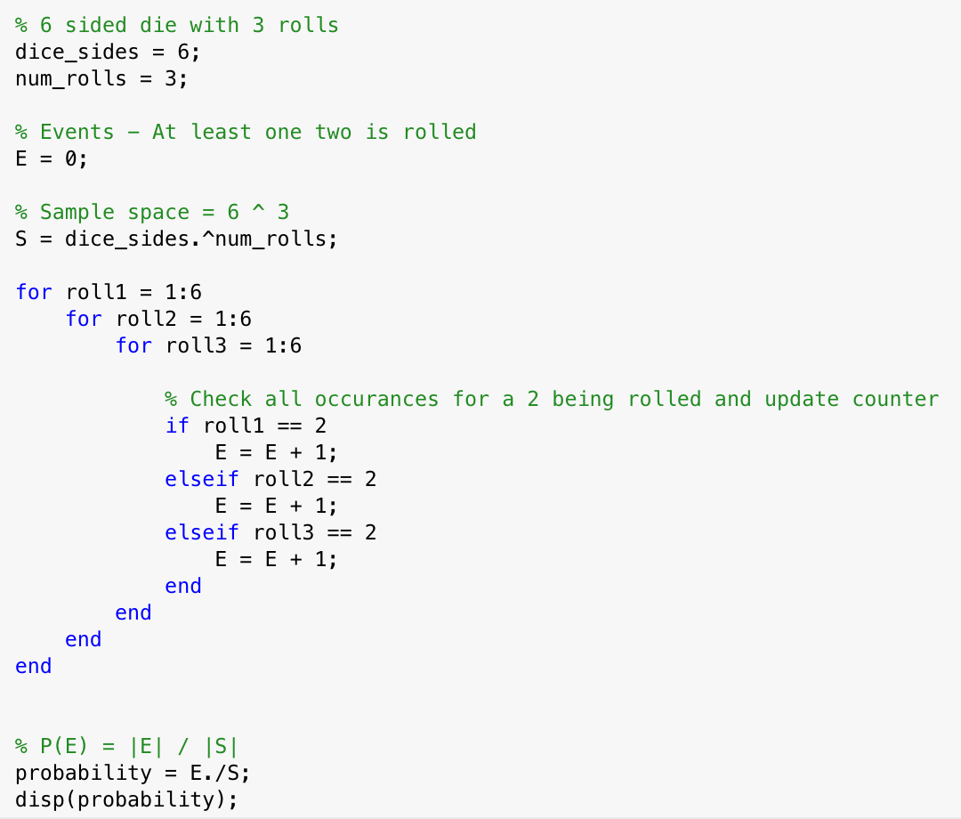



1. The number of possible outcomes for the event E where the sum of all three rolls is as follows:

The total sample space S for all three rolls the different combinations that numbers 1-6 can appear over three rolls of a six sided die. This is the same as the answer calculated in part (a).

1. The sample space S of all possible outcomes for the event E that the sum of all rolls add to 12 given that the first roll was a 1 is as follows:

Since the first roll has to be a 1 our sample space S has now changed to being the total number of possible outcomes that can occur from two dice rolls. This can be calculated as follows:

As a result then the probability of E occurring is as follows:

***Question 2 –*** *I roll a 6-sided die. If it comes up a 1 then I throw a six-sided die and*

*otherwise a 20-sided die.*

1. There are two events to be considered in this question:

E1 – A one is rolled on the first die and then a 5 on the second die (6 sided)

E2 – A one is rolled on the first die and then a 5 on the second die (20 sided)

The probability of E1 occurring is the probability of a one being rolled on a 6 sided die followed by a 5 on a six sided die is as follows:

The probability of E2 occurring is the probability of a one **not** being rolled on the first die (6-sided) and then a five being rolled on a 20 sided die on the second roll which is as follows:

The probability of the second throw being a five is as follows:

1. The probability that the second throw comes up a 15 is similar to the calculation of E2 in part (a). We must first calculate the probability that a one does **not** occur in the first roll. Then we must also calculate the probability of a 15 being rolled on the second roll of the 20 sided die.

***Question 3 –*** *At a certain stage of a criminal investigation, the inspector in charge is*

*60 percent convinced of the guilt of a certain suspect. Suppose, however, that a new*

*piece of evidence which shows that the criminal has a certain characteristic (such as left-*

*handedness, baldness, or brown hair) is uncovered. If 20 percent of the population possesses*

*this characteristic, use Bayes Rule to calculate how certain of the guilt of the suspect should*

*the inspector now be if it turns out that the suspect has the characteristic.*

Bayes Rule:

* **P(F|E) = 1**, this is the probability that the suspect has these characteristics given that he is guilty. Since it is certain that the suspect has this characteristic.
* **P(E)** , this is the certainty of the inspector of how guilty the suspect is.
* **P(F)** , this is the probability that the suspect is left handed.

Applying Bayes rule to this scenario we get:

Using marginalisation we must figure out P(F), i.e the probability our current suspect is left handed. We must factor in the possibility that our suspect is left handed but not guilty. This can be done using marginalisation as follows:

Plugging this back into our original equation for Bayes rule gives us the desired result:

This means that the inspector would now be 88.24% certain that the suspect was guilty if it turned out that he had the given characteristic.

***Question 4 –*** *Your cell phone is constantly trying to keep track of where you are. At any*

*given point in time, for all nearby locations, your phone stores a probability that you are in*

*that location. Right now your phone believes that you are in one of 16 different locations*

*arranged in a grid with the following probabilities.*

