**ST3009 - Statistical Methods for Computer Science**

**Week 4 Questions**

*Brandon Dooley - #16327446*

***Question 1 –*** *Consider an experiment where we roll two 6-sided dice. Let random variable*

*Y be the sum of the values rolled. The sample space is {(1, 1),(1, 2),(1, 3), . . .,(6, 6)} and*

*recall that a random event is a subset of the sample space.*

1. The random event E that corresponds to Y = 2 is when two 1’s are rolled:
2. The random event E that corresponds to Y = 3 is the event where a 1 and a 2 are rolled. From the sample space given there are two possible permutations of this occurring:
3. The random event E that corresponds to Y = 4 is the event where the sum of the two numbers rolled equals 4. This can be achieved in the following ways:

1. An indicator random variable takes a value of 1 if an event E occurs and 0 if event E does not occur. Given that X is the indicator random variable associated with the event { (1,1), (2,2), (3,3) } the probabilities that X = 1 can be calculated by finding the probability of one of these outcomes occurring. is the probability that event Ex occurs i.e

Let be the event that the outcome of two rolls of a six-sided die is one of the following: { (1,1), (2,2), (3,3) }. This can be calculated as follows:

***Question 2 –*** *. Let X represent the difference between the number of heads and the number*

*of tails obtained when a coin is tossed 3 times.*

1. The possible values of X can be calculated by investigating the minimum and maximum number of times that a head or a tail can occur.

Since the coin is being tossed three times there can be a maximum and minimum of 3 heads/tails. As a result if X represents the difference between the number of heads and the number of tails X lies within the range of 3 excluding 0 and 2 since it is not possible for the same number of heads and tails to occur. Therefore the possible values of X are represented as follows:

1. is the probability that the difference between the number of heads and the number of tails over three coin tosses equal -3. is the probability that event Ex occurs.

Let be the event that the difference between the number of heads and the number of tails tossed is -3. This can only occur as a result of the roll (T, T, T). The probability of a tail being tossed is and given that the events are independent P(X=-3) can be calculated as follows:

1. is the probability that the difference between the number of heads and the number of tails over three coin tosses equal -1. is the probability that event Ex occurs.

Let be the event that the difference between the number of heads and the number of tails tossed is -1. This can occur as a result of a number of different rolls, namely:

The sample space S of all possible outcomes of three coin tosses is:

The probability of an event occurring can be calculated using the event space and the sample space as follows:

1. The **Probability Mass Function (PMF)** of discrete random variable X is the probabilities .

Given that X represents the difference between the number of heads and the number of tails obtained over three coin tosses. The total possible probabilities of X is as follows:

This can be graphed as follows:

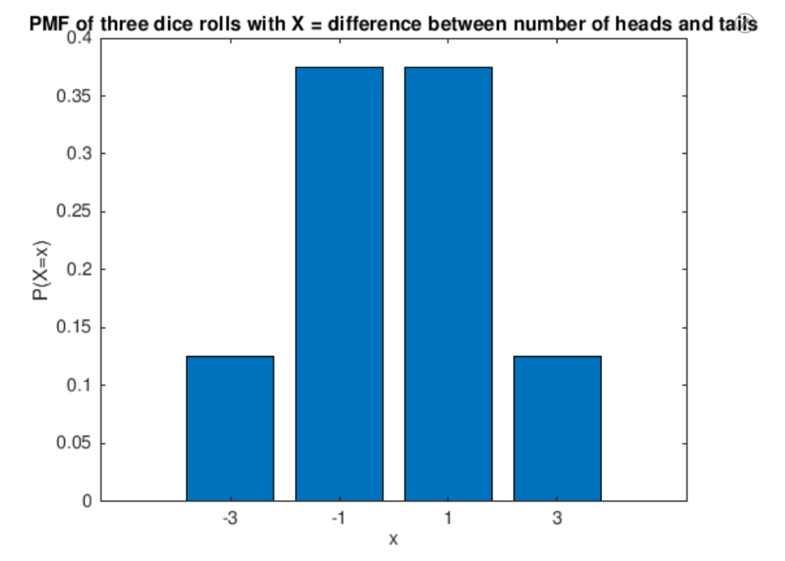

1. The **Cumulative Distribution Function (CDF)** is defined as :

For the discrete random variable taking values in D = { } the CDF is:

For the random variable X the cumulative distribution function (CDF) is defined as follows:

This can be graphed as follows:

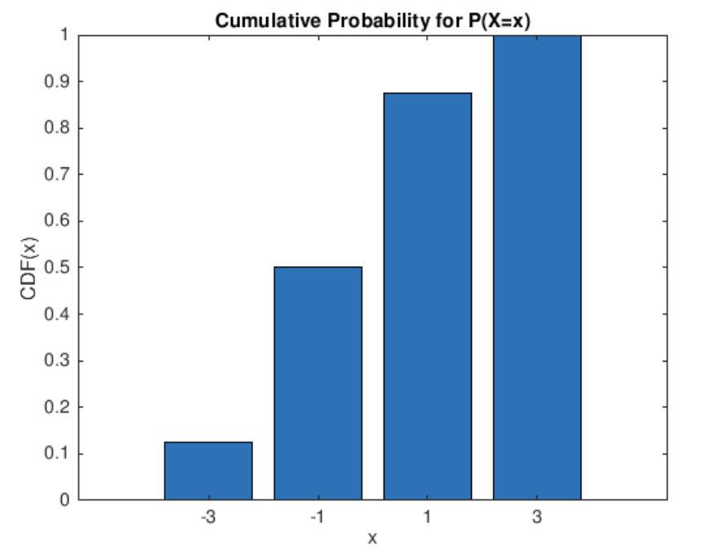

***Question 3 –*** *. Four 6-sided dice are rolled. The dice are fair, so each one has equal probability of producing a value in {1, 2, 3, 4, 5, 6}. Let X =the minimum of the four values*

*rolled. (It is fine if more than one of the dice has the minimal value.)*

1. With X being the minimum of four dice rolls. is the probability that over four rolls the minimum of all four numbers rolled is 1. This is certain since it is not possible for any of the four dice to produce an output less than 1 given that the sample space for each roll is {1, 2, 3, 4, 5, 6}. Therefore:
2. is the probability that over four rolls the minimum of all four numbers rolled is 1. This is also that over four rolls of dice a 1 does not occur. This can be calculated by determining the probability of any number besides 1 occurring on a dice roll. Since they are independent events this probability can just be raised to the exponent of the number of rolls.
3. Using the same method as in part (b) the The **Cumulative Distribution Function (CDF)** of X i.e for all values of k (1-6) is as follows:

* ) =

This can be graphed as follows:

