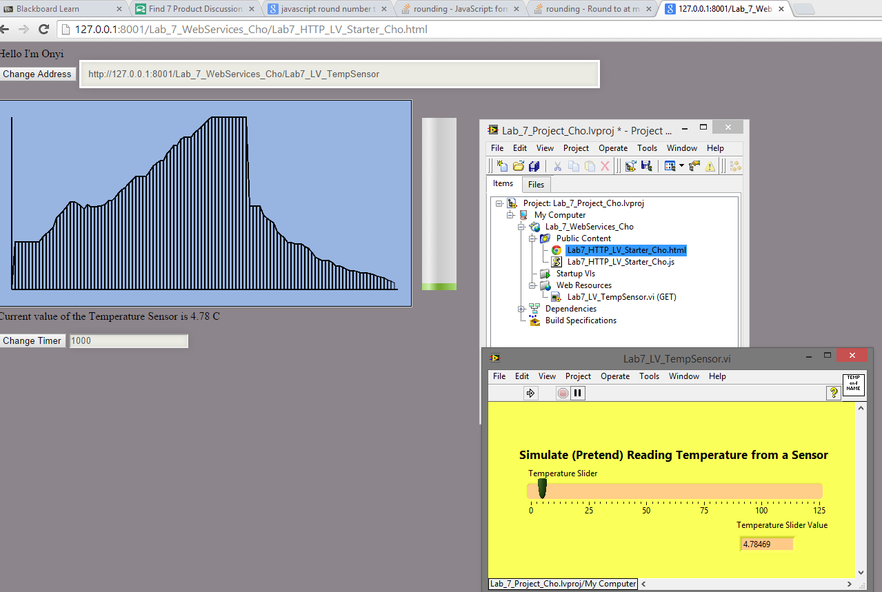

Here is how the UI looks. Each new X point has a line drawing vertically as an indicator. The Y position and the height of the progress bar is synced. The X position will never exceed the maximum length of X axis since it will pause the interval.

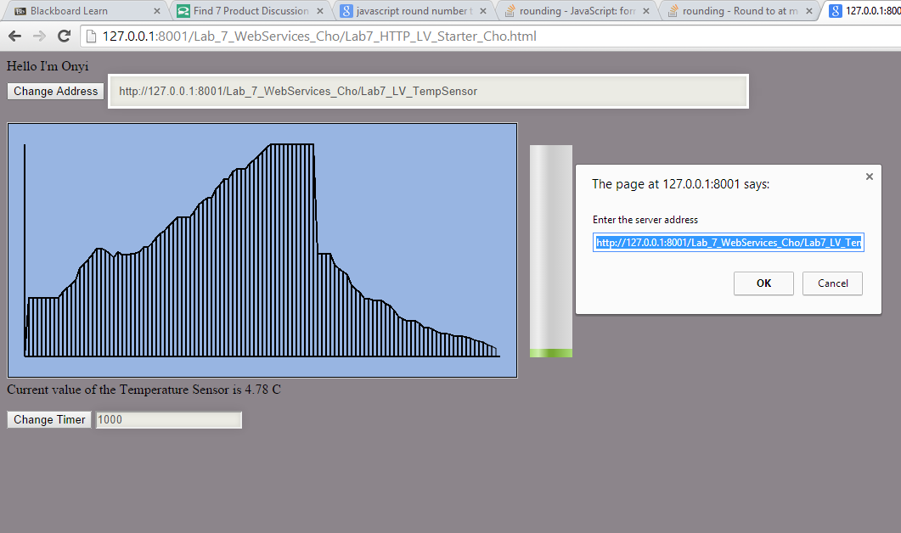

Ability to change server address so that user can use smart phone to view the website since 127.0.0.1 is the localhost IP and by using cellphone to view the data the server address has to be in the server’s actual IPV4 address.

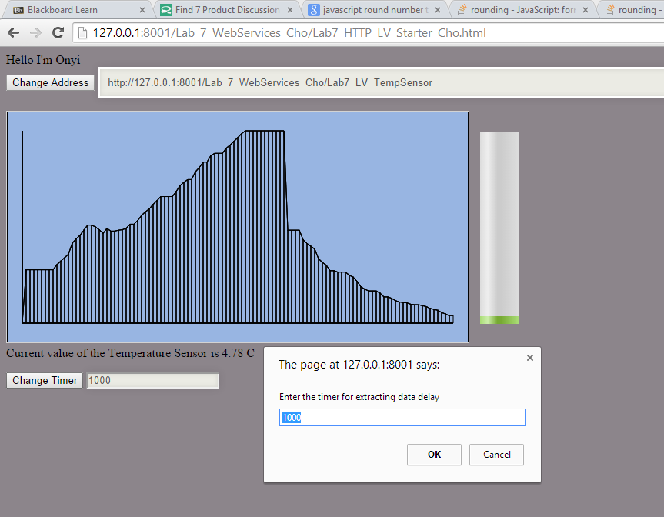Ability to change the timer. Minimum and default timer is 1000ms.

However, the application does not has the ability to read data from other server by using the HTML on this computer because we will need enable credentials by adding this line “Access-Control-Allow-Credentials: true”. I could not find a way to edit it on the LabView application.