Description of Project
The Historical Battle Simulator(HBS) uses java to recreate historical battles from a top down turn based point of view. The game allows players to take on the role of generals from antiquity to early modern warfare, and through an intuitive turn based system, lead there troops to victory or defeat against another player. The play style is simple, but allows players a better understanding of what challenges faced different military forces throughout history.
The HBS also includes the ability for an instructor to construct units, maps and scenarios, and save them. Both the map creator and unit creator methods rely on the instructor to place units and map tiles on the grid based screen. The unit creator, on the other hand, allows the instructor to create a unit, choose an icon to represent it, and give it the appropriate stats. Whereas the gameplay is intuitive, understanding how to make units have the appropriate stats will require the instructor looking at some tables in order to understand the system.
Furthermore, the HBS features some pre-generated scenarios, made by our team, that allow players to take roles in epic historic battles, such as the Battle of Agincourt or Waterloo.

Why This?

We choose this project because we believe that there exists a need for new and engaging ways to communicate history and promote critical thinking in students. Although we do not seek to replace conventional methods of teaching, we believe that there is an important need to adapt the classroom to the technologies of the 21st century. It is our hope that this project will give instructors another way to present historical situations in a simple, straightforward manner that will allow students to get a first hand experience of what a battle may have been like in reality, and the strategic constraints placed on commanders. It is likely however, that if an instructor were to use this program in classes it would be as a sort of reward toward the end of a period, as it is naturally engaging and could be used to present scenarios discussed in the lectures before hand.
Due to our love of strategy games, computers, and history, this was the ideal undertaking for us. As we have interest in military matters and education, the combination of the two in a program was a very appealing task. We also further hoped that by developing this program we could gain some more experience in developing educational software, and turn based strategy games.

Requirements Specification

Functional Requirements

This product is required to, on a very basic level do two things:

  - Build a Military Scenario
  - Execute the Scenario

However, both of these can be expanded into further parts, complete with there own requirements, both on the development side, and of the user.

Build A Military Scenario

For our purposes, the user needed to have the ability to build a scenario, complete with a map, units and positions, that could be loaded up at a moments notice. For this it was required that we not only build the interface for that, but also that we developed a way of saving and loading scenarios. While it would have been more convenient and faster for us to simply develop some preset scenarios embedded in the code, creating textual files representative of these things provides us with a more versatile product. Thus, the requirements for building a military scenario are highlighted below.

  - Create Units
    - Include All Stats, complete with description of what exactly the stats were.
    - Save the Unit as part of an 'army'
    - Allow the Unit to be loaded later
    - Allow the user to choose a graphical representative for the unit
  - Create Maps
    - Allow the User to place tiles, with different effects all over the map.
    - Save the map, and all tiles as a textual file*
  - Create Scenarios
    - Place units on the field of battle, and save there position, along with the map and unit types.
    - Allow this to be loaded and executed

We distributed the code for this into three different buttons on the main screen, and set them up to execute simple save methods. Furthermore, we used a variety of buffered loaders to load images, as well as image icons. Overall, these three requirements are exceptionally important and essential to what defines this project as an educational technology to be used by instructors, and not simply a game to be played.
Execute Military Simulation

Executing the military simulation requires a large amount of classes to be implemented. However, what we essentially need in order to play the game is (relatively) simple. We need a Graphical User Interface(GUI), a 'game class', players, units and soldiers. The concept overall is that these would all interact simply in order to produce a close knit game.
  - GUI – GUI should allow for the graphical representation of all movement, attacks, units and etc.
    - Act as a static method that can be called by other methods.
    - Get User Input
      - Mouse Position
        - Tile Selected – It is essential that we be able to know which tile has been selected for attacking, moving, and unit (and tile) placement.
        - Unit Selected – It is essential that the user be able to select unit, which will than cause a panel to show up on the bottom of the screen for them to select an action.
    - User Panels – As opposed to getting input from scanners or simple mouse clicks, we use button panels that call a variety of methods.
      - Selected Unit Panel – A transparent panel with buttons for a variety of actions. Due to the complexity of most of the buttons, many of them result in further panels.
        - Attack Panel – Should open up another panel which will contain all units in range for the unit to attack. This should be generated by doing a loop of all units within the range of the selected unit.
        - Defend – Should set the unit 'defending' which grants them a bonus to their armor class when they are attacked. Different ways of defending may be added.
        - Check Stats – Should open a panel in the top right with the units statistics visible.
        - Move – Should open up a compass pane, which allows units to move North, NorthEast, East, SouthEast, South, SouthWest, West, NorthWest.
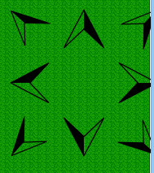
        - Set Formation – Should open a panel revealing the different formations that a unit can be set in. Switching units should cost one 'point'.
          - Example Formations: Square, Line, Wedge
      - Unit Placer – This panel should be used eventually only in the scenario creator, and will allow units to be placed on a specific place.
      - Tile Placer – This panel should allow editing of the map, and creation of different tiles.
  - Game – This should be very simple, simply calling the different methods of player and monitoring for a winner.
  - Player – This creates a 'player' who should possess an army, and the ability to 'take turns'. The associated army should be stored in a unit list, and referenced as the game is played.
  - Units – Units are the combinations of soldiers that can be selected, moved around and etc. They must be able to be placed in different formations, move, and to attack. The majority of what they do should be executed behind the scenes.
    - Soldiers – Soldiers are the backbone of the unit, and thus the player and thus the game. When unit creator is called, they are built and initialized.
      - Soldier Images :
      - Soldier Statistics:
        - Described in Depth in Historical Battle Simulator Unit Statistics

Non Functional Requirements

Fluidity – The combat system and movement system should operate in a smooth and non-obtrusive way. The program should never be to complex for the user to engage in.
Interactivity – Combat should remain interactive for the players, throughout the entire duration, and the appeal of combat should not end upon first contact between units. This is to say, that battles between two units should not simply be dice rolling match for many rounds on end.
Educational – The program should be able to host and allow for any historical scenario to be played out, prior to the invention of automatic weapons and airplanes.

Use Cases
Player
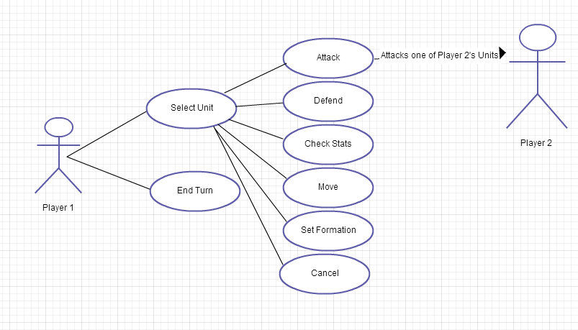
Instructor
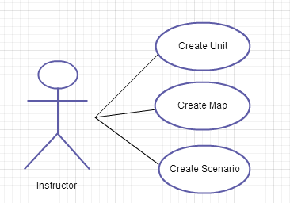
Future Work

We would like to implement more statistics, and build more scenarios. We hope that with this project we can lay the groundwork for what can be used by instructors to build many many battles. We would like to implement a morale system, as well as a database for all the units and scenarios being created, so instructors could use other peoples 'builds'.

Design Description

The project has been implemented much in the way that we described earlier along with the system requirements. It is essentially split in such a way that the design part (Character building, map building, scenario building) are one essential part, and the actual playing of the game, is another. However, there is crossover, as the static GUI is used for both.

Additional Help
Tanner Stahara, a Benedictine artist, is currently designing some cover art to replace the title page. As of now, the images are taken from Deviant Art and drawn by Phoenix8341.

