CS211 Assignment 1: Concordance
Owain Jones <odj@aber.ac.uk>

1. Data Structure
I'm going to use Java's Hash Table implementation for the basis of my data structure, but with a modified add() method which checks whether a word (key) already has a value associated (which will always be a Linked List) and appends to that linked list, otherwise it creates a new linked list.
I have decided that the data structure I intend to use to store the references (page numbers, line numbers and contexts) for words will be a Doubly-Linked List implementation, but of my own design.
The Node objects will contain, instead of pointers to objects, several parameters: the page number, line number and a string containing the sentence in which the specific word has been found.
Since the text file will be read sequentially in a known order (from front to back), I feel confident that a Doubly-Linked List will be an efficient way of holding the indexes for every word.
A more visual representation of how my data structure may look like is as follows:
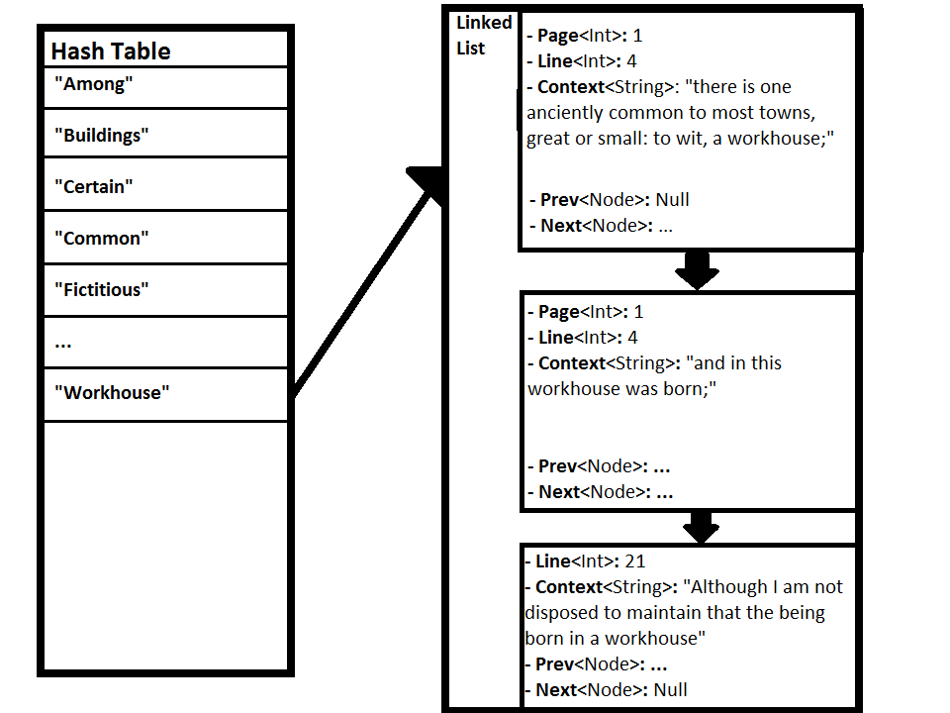

If I were to use a conventional Linked List, using conventional Nodes which simply point to other objects, the number of objects/pointers used per entry in the concordance would increase.
Considering that in a conventional Linked List, the encapsulating object counts as one pointer, and holds head, tail and length properties – that's 4 pointers per Linked List. Then every conventional Node has 3 properties, previous node, next node and data. That data property is a pointer to an object which holds the actual data for each index for that given word, which holds 3 more properties; page, line and context. So the total number of references per word is
4+(n*7)
where n is the number of entries for any given word, and 7 is the sum of the objects for the Node, its properties and the object it points to.
In my approach the nodes don't encapsulate an object, they contain the properties for that entry, and we don't necessarily need to keep reference of the previous sibling of each Node, so the total number of references per word is potentially down to:
4+(n*5)
Whilst the number of references used in the concordance's underlying data structure isn't important when you're only dealing with a small number of words, or a small piece of text, the amount of storage needed for the concordance in a large text (The version of Oliver Twist taken from the Project Gutenberg website has 161,013 words in total, for example) can increase exponentially, as seen in this graph:
(X Axis range: 1000,10000,100000,161013 – the last value being the sum of the words in Oliver Twist)
(Number of references to each word: 3)

I'm not sure how much of an impact on the overall CPU/memory usage the slightly altered data structure will have – it could be

