Dashboards for Clicker Data
  - INFO 4100 Learning Analytics
[[Chanwoo Yang (cy573), Jocelyn Wong (jcw353), Carrie Zheng (cz376), Bryan Chae (byc27), Jibran Khan (jhk297), Wassan Nasreddin (wn66)]]
This project is about developing a learning analytics dashboard based on clicker data. You will work as a team to learn how to make a dashboard using R Shiny (official page with several tutorials: https://shiny.rstudio.com/tutorial/).
Learning Objectives
- Understand the structure of clicker data
- Create multiple different visualizations
- Design and implement an instructor and student dashboard
- Critically evaluate your own dashboard design
You are given aggregated clicker records for a CS course taught at Cornell. There are two datasets: the experience dataset and the quiz dataset.
Scenario
You are approached by a college instructor who uses iClickers in her CS class on Business Intelligence. She would like to gain insights about her students and how they are engaging/performing in order to better help them in class. She would also like to better support students by giving them feedback at scale about where they stand and perhaps how they compare to others in the class.
You offer to build a prototype of a dashboard using her clicker data: this is a dashboard for the instructor which offers an overview of the class characteristics, engagement, and performance; and it is a dashboard for students which offers a specific student an overview of their engagement and performance (and how it compares to others).
Data
The experience dataset contains one record per student who completed the CS course between 2016-2018. There are two sources to this dataset: Faculty Center and a Skills Survey (administered via the Blackboard LMS) where students self reported their skill level for various skills the first week of class. This data has been de-identified. Name, netid, emplid, major have all been removed and replaced with a unique numeric identifier. Note that not all students completed the skills survey, they will have null values for the survey result fields.
Attribute Name | Data Type | Definition
student_key | numeric Unique key | Assigned as part of de-identification process. Uniquely identifies student records for this data set only.
year | numeric | Four digit year student was enrolled in BI Class.
prog | character Values (GRAD, UGRAD) | Indicates whether the student was a graduate or undergraduate student when they were enrolled in BI course.
database_score | numeric (0-5) | Self reported experience level with database technology prior to taking course. 0= no experience, 5= expertise
sql_score | numeric (0-5) | Self reported experience level with SQL prior to taking course. 0= no experience, 5=expertise
programing_score | numeric (0-5) | Self reported experience level with Any Programing language prior to taking course. 0=no experience, 5=expertise
stored_proc_score | numeric (0-5) | Self reported experience level with stored procedure languages prior to taking course. 0=no experience, 5=expertise
etl_score | numeric (0-5) | Self reported experience level with Extract Transform Load (ETL) development prior to taking course. 0=no experience, 5=expertise
data_vis_score | numeric (0-5) | Self reported experience level using data visualization tools prior to taking course. 0=no experience, 5=expertise
requirement_gather_score | numeric (0-5) | Self reported experience level gathering customer requirements prior to taking course. 0=no experience, 5=expertise
skill_survey_score | numeric | Sum of the self reported skill level scores.
The quiz dataset contains one record per student per class session held where iClickers were used. Sources used in the creation of this data set include: iClicker session xml files, Blackboard gradebook (for quiz scores), and the Blackboard class schedule (used to map iClicker session to related quiz scores). Note that in some cases there are multiple iClicker sessions / lectures associated with a single quiz. This dataset may be joined to the experience dataset by the student_key field.
Attribute Name | Data Type | Definition
Acad_date_key | numeric | Date key in the form of YYYYMMDD indicating the date the class session was held.
student_key | numeric | Unique identifier for students who took BI class 2016-2018. This key is the primary key for the experience_data file.
year | numeric | Four digit year class session was held.
session_number | numeric | Identifies the session number for a particular semester. Session number is assigned by iClicker.
quiz_number | numeric | There are 10 quizzes throughout the BI course. This attribute indicates which quiz is associated with the iClicker session(s).
attended | numeric (0,1) | Binary indicating whether the student attended that particular class session / lecture. 0=no, 1=yes.
total_possible_clicker | numeric | The total number of iClicker questions asked that session.
total_completed_clicker | numeric | The number of iClicker questions answered by student that session.
completed_q_clicker | numeric | The number of completed Quiz iClicker questions
correct_q_clicker | numeric | How many correct Quiz answers by student that session.
completed_t_clicker | number | How many Temperature questions answered by student that session. Temperature questions are 0-5, 0= bad, 5=great. There is no correct answer to Temperature questions, they are used to guage how students are feeling about a particular subject, assignment, etc.
avg_t_clicker | number | The average temperature answer by student for that session. An average of 1 or 2 would be generally negative, while 4 or 5 would be generally positive responses.
quiz_score | numeric | Quiz score out of 20 points possible.
library(tidyverse)
library(scales)
# Below you are loading 2 new packages:shiny + shinydashboard.
# Install them once, then comment out the install command.
#install.packages("shiny")
library(shiny)
#install.packages("shinydashboard")
library(shinydashboard)
# This should load the datasets:
# experience (123 by 11) and quiz (2423 by 13)
load("info4100.proj.dashboard.rda")

Part 1: Planning / Sketching
Go through the planning / sketching process described in the reading about dashboards. While some dashboards are certainly better than others, there is not one correct solution here. However, spending enough time to make a concrete plan is essential for the success of your project. Everything you do to make the dashboards will be easier if you have a clear plan, especially because you will be splitting up the work and everyone needs to know what they should work on.
Question 1: You will make a student dashboard and a teacher dashboard. Carefully consider the implications of this for design and content. To plan, answer the following prompts once for the student dashboard and then for the teacher dashboard. The more concrete you are here the easier it will be later. Focus on the concrete ideas that you will implement in the next steps. You can iterate on this step and modify your responses as your ideas for the dashboard become clearer. You should explore the dataset in R for 5-10 minutes to get a good sense of what the dataset has to offer.
Planning for the student dashboard
- For whom? Who will use it and what is their background?
  - The student dashboard will be targeted towards students taking the CS course on Business Intelligence. This can include both undergrad and graduate students.
  - For the most part the students have a basic familiarity with CS and Business Principles. They likely have varying levels of expertise. We have to create a dashboard that is considerate of this diversity in experience.
- Why? What is the goal? What questions to answer?
  - Help students track their own engagement and quiz performance over the semester.
  - Let them see how they compare to classmates so they can self-correct early if they are falling behind.
- What? What data to show and what is its structure?
  - Quiz scores per session and cumulative, clicker completion and accuracy rates, attendance, and their incoming skill profile compared to class averages. All drawn from the quiz and experience datasets filtered to the selected student.
- How? How will visualizations support the goal?
  - A line chart of cumulative quiz points shows trajectory over time. A bar chart of clicker accuracy per session flags specific sessions where they struggled. An engagement bar shows attended vs missed sessions.
  - A radar/bar chart comparing their skill scores to the class average gives useful self-awareness context.
Planning for the teacher dashboard
- For whom? Who will use it and what is their background?
  - The teacher dashboard is for the course instructor or teaching team, who already understand the course structure, quizzes, and clicker questions but need a fast way to monitor patterns across the whole class.
  - This user is less interested in one specific student and more interested in identifying overall trends, participation issues, and places where intervention may be needed.
- Why? What is the goal? What questions to answer?
  - The goal is to help instructors identify trends across sessions, evaluate how engagement (clicker completion) relates to performance, and understand the incoming skill profile of their class.
  - The dashboard should answer questions like: How is attendance changing over time? Which sessions had weaker quiz performance? Is clicker engagement related to quiz success? What kind of skill background does the class enter with?
- What? What data to show and what is its structure?
  - The dashboard should show class-level summaries from the quiz dataset, including attendance, average quiz scores, clicker completion, and session-by-session trends.
  - It also incorporates aggregated student data to examine relationships between engagement and performance (e.g., clicker completion vs quiz scores), along with skill-survey summaries from the experience dataset to provide background context about the class.
- How? How will visualizations support the goal?
  - Info boxes give the instructor an immediate snapshot of class size, attendance, quiz performance, and clicker participation without requiring interpretation of a full graph.
  - Trend charts across sessions help the instructor see when performance or participation changes over time, while the scatterplot and skill chart help explain relationships between engagement and outcomes and provide context about the class’s incoming preparation.
Question 2: Based on your plan above, make a sketch of what the dashboard would look like. See this week’s readings for examples. Be detailed about what kinds of data points and visualizations you want to see in different parts of the page. Consider the user experience and how you should position more general information compared to more specific information, and where you may need some additional explanation to help the viewer understand a graphic, for example. In your sketch, it is useful to give labels to different objects, because in the steps below you can split up work between team members and the labels will help you connect the UI with the data objects. Show your sketches in section to get feedback from the teaching team.
Each dashboard should contain at least 4 data visualizations. You may include any additional summary statistics (e.g. key percentages or tables).
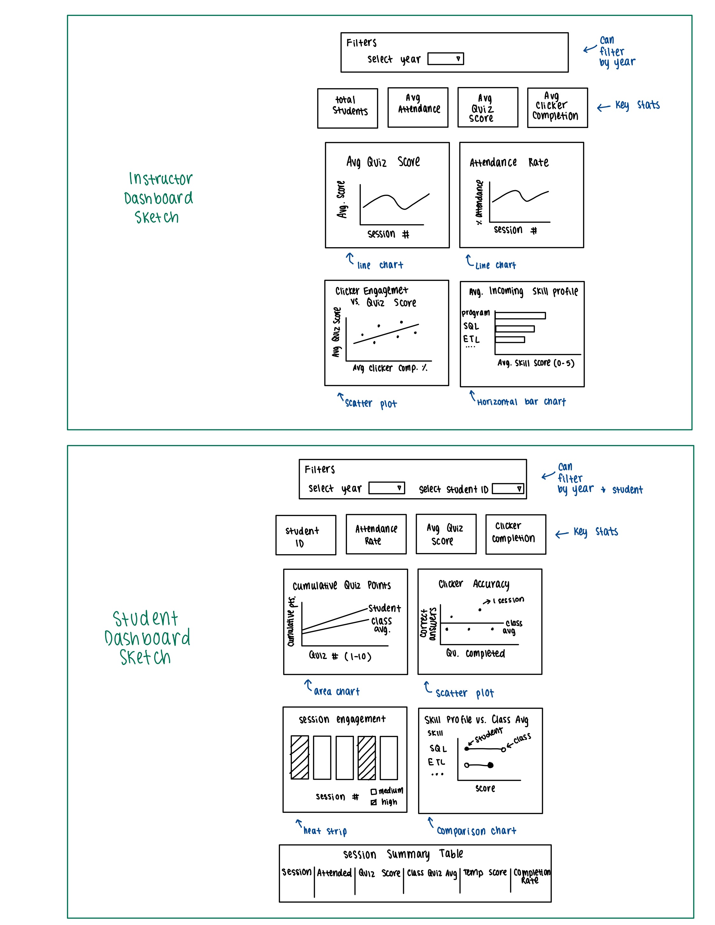
Dashboard Sketches

Part 2: Dashboard Wire-frame Implementation
This is where you generate the dashboard layout. You are given a very basic wire frame example for the dashboard below. For more information on how R Shiny Dashboards work, look at https://rstudio.github.io/shinydashboard/get_started.html and https://rstudio.github.io/shinydashboard/structure.html. You can add different types of content into a fuidRow(). In the starter code, there are 2 rows of content: the first has two little info boxes; the second has two larger viz boxes. You can add more rows and change what is in them as you wish. Follow the naming convention, e.g. inst.info1 is the first info box for instructors.
Your team can split up the tasks. Some work on creating the UI (this part), while others work on pre-processing the data and creating the statistics and visualizations that will populate the UI (next part).
Question 3: Create the layout for the dashboard tabs. You can have as many “tabs” as you like. Each tab is the content displayed when the user clicks on one of the menu items (so it is the page content). Here you are just specifying the wire frame i.e. what goes where on the pages, not what goes into it.
#######################################
####### BEGIN INPUT: Question 3 #######
#######################################
instructor_dash = tabItem(
tabName = "instructor",
h2("Instructor Dashboard"),
fluidRow(
box(
title = "Filters",
width = 12,
status = "primary",
solidHeader = TRUE,
column(
width = 12,
selectInput(
"inst_year",
"Select year",
choices = sort(unique(quiz$YEAR)),
selected = sort(unique(quiz$YEAR))[1]
)
)
)
),
fluidRow(
infoBoxOutput("inst.info1"),
infoBoxOutput("inst.info2"),
infoBoxOutput("inst.info3"),
infoBoxOutput("inst.info4")
),
fluidRow(
box(
title = "Average Quiz Score by Session",
width = 6,
status = "primary",
solidHeader = TRUE,
plotOutput("inst.plot1", height = 260)
),
box(
title = "Attendance Rate by Session",
width = 6,
status = "primary",
solidHeader = TRUE,
plotOutput("inst.plot2", height = 260)
)
),
fluidRow(
box(
title = "Clicker Engagement vs Quiz Performance",
width = 6,
status = "primary",
solidHeader = TRUE,
plotOutput("inst.plot3", height = 260)
),
box(
title = "Average Incoming Skill Profile",
width = 6,
status = "primary",
solidHeader = TRUE,
plotOutput("inst.plot4", height = 260)
)
)
)
student_dash = tabItem(
tabName = "student",
h2("Student Dashboard"),
fluidRow(
box(
title = "Filters",
width = 12,
status = "primary",
solidHeader = TRUE,
column(
width = 6,
selectInput(
"student_year",
"Select year",
choices = sort(unique(quiz$YEAR)),
selected = sort(unique(quiz$YEAR))[1]
)
),
column(
width = 6,
selectInput(
"student_id",
"Select student ID",
choices = NULL
)
)
)
),
fluidRow(
infoBoxOutput("stu.info1"),
infoBoxOutput("stu.info2"),
infoBoxOutput("stu.info3"),
infoBoxOutput("stu.info4")
),
fluidRow(
box(
title = "Cumulative Quiz Points",
width = 6,
status = "primary",
solidHeader = TRUE,
plotOutput("stu.plot1", height = 260)
),
box(
title = "Clicker Accuracy",
width = 6,
status = "primary",
solidHeader = TRUE,
plotOutput("stu.plot2", height = 260)
)
),
fluidRow(
box(
title = "Session Engagement",
width = 6,
status = "primary",
solidHeader = TRUE,
plotOutput("stu.plot3", height = 260)
),
box(
title = "Skill Profile vs Class Average",
width = 6,
status = "primary",
solidHeader = TRUE,
plotOutput("stu.plot4", height = 260)
)
),
fluidRow(
box(
title = "Session Summary Table",
width = 12,
status = "primary",
solidHeader = TRUE,
tableOutput("stu.table")
)
)
)
#######################################
#######################################

Part 3: Data Pre-processing
Get the data ready for use in the dashboard. Before the next stage, you want to have the data ready in the right format for simple computations and plotting. To do this effectively, you need to know by now what you want to display in each dashboard. However, this is also an iterative process. Once you have completed a first iteration of the design, you can come back to this step and add further pre-processing for more visualizations you like to add. This step is also an opportunity to better understand the structure of the datasets.
The instructor dashboard should show information for all students. The student dashboard is typically focused on an individual student. You can either pick a student (at random or intentionally) and use them as the “reference student” for the student dashboard. Or, a bit more ambitious but also more rewarding to try out, you can create an interactive dashboard in which you select the student and then the dashboard updates to show the information for that student. I would recommend you start with the simpler version and get that to work before you try to make it dynamic.
Use the space below to be ready for your information visualizations in the dashboards.
#######################################
####### BEGIN INPUT #######
#######################################
names(quiz) <- toupper(names(quiz))
names(experience) <- toupper(names(experience))
quiz_clean <- quiz %>%
mutate(
DATE = as.Date(as.character(ACAD_DATE_KEY), format = "%Y%m%d"),
COMPLETION_RATE = if_else(TOTAL_POSSIBLE_CLICKER > 0,
TOTAL_COMPLETED_CLICKER / TOTAL_POSSIBLE_CLICKER,
NA_real_),
QUIZ_PCT = QUIZ_SCORE / 20
)
experience_clean <- experience %>%
mutate(PROG = as.factor(PROG))
# Master list of all student IDs by year (union of quiz + experience)
# This makes sure no student is missed in the dropdown
student_id_lookup <- bind_rows(
quiz_clean %>% distinct(YEAR, STUDENT_KEY),
experience_clean %>% distinct(YEAR, STUDENT_KEY)
) %>%
distinct(YEAR, STUDENT_KEY) %>%
arrange(YEAR, STUDENT_KEY)
skill_cols <- c(
"DATABASE_SCORE",
"SQL_SCORE",
"PROGRAMING_SCORE",
"STORED_PROC_SCORE",
"ETL_SCORE",
"DATA_VIS_SCORE",
"REQUIREMENT_GATHER_SCORE"
)
skill_labels <- c(
DATABASE_SCORE = "Databases",
SQL_SCORE = "SQL",
PROGRAMING_SCORE = "Programming",
STORED_PROC_SCORE = "Stored Procedures",
ETL_SCORE = "ETL",
DATA_VIS_SCORE = "Data Visualization",
REQUIREMENT_GATHER_SCORE = "Requirements"
)
class_by_session <- quiz_clean %>%
group_by(YEAR, SESSION_NUMBER) %>%
summarise(
class_attendance = mean(ATTENDED, na.rm = TRUE),
class_quiz = mean(QUIZ_SCORE, na.rm = TRUE),
class_temp = mean(AVG_T_CLICKER, na.rm = TRUE),
class_completion = mean(COMPLETION_RATE, na.rm = TRUE),
.groups = "drop"
)
class_skills <- experience_clean %>%
group_by(YEAR) %>%
summarise(across(all_of(skill_cols), ~mean(.x, na.rm = TRUE)), .groups = "drop") %>%
pivot_longer(
cols = all_of(skill_cols),
names_to = "skill",
values_to = "class_avg"
) %>%
mutate(skill = recode(skill, !!!skill_labels))
# Safe percent formatter so the dashboard never breaks even if scales isn't attached
fmt_pct <- function(x, digits = 0) {
if (length(x) == 0) return(character(0))
ifelse(is.na(x), "—",
paste0(formatC(100 * x, format = "f", digits = digits), "%"))
}
# Student-level summary for instructor scatterplot
inst_student_summary <- quiz_clean %>%
group_by(YEAR, STUDENT_KEY) %>%
summarise(
attendance_rate = mean(ATTENDED, na.rm = TRUE),
avg_quiz_score = mean(QUIZ_SCORE, na.rm = TRUE),
avg_completion = mean(COMPLETION_RATE, na.rm = TRUE),
.groups = "drop"
)
#######################################
#######################################

Part 4: Prepare All Data Visualizations
This is where you create the content for the wire frames you created above. Again, you can refer to the examples and documentation in https://rstudio.github.io/shinydashboard/get_started.html and https://rstudio.github.io/shinydashboard/structure.html for guidance. You can also find many examples online just by searching with Google.
Question 4: For each of the pieces of content you planned for in the wire frames above, generate the relevant content. You need to assign them all to the output variable by referencing the name of the wire frame element you chose above like this output$name.of.element.
server = function(input, output, session) {
# Pull student IDs from the union of quiz + experience so no one is missed
student_ids <- reactive({
student_id_lookup %>%
filter(YEAR == input$student_year) %>%
pull(STUDENT_KEY)
})
observe({
ids <- student_ids()
if (length(ids) > 0) {
updateSelectInput(
session = session,
inputId = "student_id",
choices = ids,
selected = ids[1]
)
}
})
# ---------- Student reactives ----------
student_quiz <- reactive({
req(input$student_year, input$student_id)
quiz_clean %>%
filter(YEAR == input$student_year,
STUDENT_KEY == as.numeric(input$student_id)) %>%
arrange(SESSION_NUMBER)
})
student_exp <- reactive({
req(input$student_year, input$student_id)
experience_clean %>%
filter(YEAR == input$student_year,
STUDENT_KEY == as.numeric(input$student_id))
})
student_session_compare <- reactive({
req(nrow(student_quiz()) > 0)
student_quiz() %>%
select(YEAR, SESSION_NUMBER, ATTENDED, QUIZ_SCORE, AVG_T_CLICKER,
TOTAL_COMPLETED_CLICKER, TOTAL_POSSIBLE_CLICKER, COMPLETION_RATE) %>%
left_join(class_by_session, by = c("YEAR", "SESSION_NUMBER"))
})
# ---------- Student info boxes ----------
output$stu.info1 = renderInfoBox({
req(input$student_id)
infoBox(
"Student ID",
value = input$student_id,
icon = icon("user"),
color = "purple",
width = 3
)
})
output$stu.info2 = renderInfoBox({
df <- student_quiz()
att_rate <- if (nrow(df) > 0) mean(df$ATTENDED, na.rm = TRUE) else NA_real_
infoBox(
"Attendance rate",
value = fmt_pct(att_rate),
icon = icon("calendar-check"),
color = "green",
width = 3
)
})
output$stu.info3 = renderInfoBox({
df <- student_quiz()
avg_quiz <- if (nrow(df) > 0) mean(df$QUIZ_SCORE, na.rm = TRUE) else NA_real_
infoBox(
"Average quiz score",
value = ifelse(is.na(avg_quiz), "—", round(avg_quiz, 1)),
icon = icon("pen"),
color = "yellow",
width = 3
)
})
output$stu.info4 = renderInfoBox({
df <- student_quiz()
completion <- if (nrow(df) > 0) mean(df$COMPLETION_RATE, na.rm = TRUE) else NA_real_
infoBox(
"Clicker completion",
value = fmt_pct(completion),
icon = icon("mouse-pointer"),
color = "aqua",
width = 3
)
})
# ---------- Student plots ----------
# ---------- Viz 1: Cumulative quiz points earned ----------
output$stu.plot1 = renderPlot({
df <- student_quiz() %>%
filter(!is.na(QUIZ_SCORE), !is.na(QUIZ_NUMBER)) %>%
group_by(QUIZ_NUMBER) %>%
summarise(student_pts = mean(QUIZ_SCORE, na.rm = TRUE), .groups = "drop") %>%
arrange(QUIZ_NUMBER) %>%
mutate(student_cum = cumsum(student_pts))
class_cum <- quiz_clean %>%
filter(YEAR == input$student_year,
!is.na(QUIZ_SCORE), !is.na(QUIZ_NUMBER)) %>%
group_by(QUIZ_NUMBER) %>%
summarise(class_pts = mean(QUIZ_SCORE, na.rm = TRUE), .groups = "drop") %>%
arrange(QUIZ_NUMBER) %>%
mutate(class_cum = cumsum(class_pts))
plot_df <- df %>% left_join(class_cum, by = "QUIZ_NUMBER")
validate(need(nrow(plot_df) > 0, "No quiz data for this student."))
ggplot(plot_df, aes(x = QUIZ_NUMBER)) +
geom_area(aes(y = class_cum, fill = "Class average"), alpha = 0.35) +
geom_area(aes(y = student_cum, fill = "Student"), alpha = 0.55) +
geom_line(aes(y = student_cum), color = "#4E79A7", linewidth = 1) +
geom_point(aes(y = student_cum), color = "#4E79A7", size = 2.5) +
scale_x_continuous(breaks = unique(plot_df$QUIZ_NUMBER)) +
scale_fill_manual(values = c("Class average" = "#E15759",
"Student" = "#4E79A7")) +
labs(x = "Quiz number", y = "Cumulative points earned", fill = NULL) +
theme_minimal(base_size = 12) +
theme(legend.position = "top")
})
# ---------- Viz 2: Clicker accuracy scatter ----------
output$stu.plot2 = renderPlot({
df <- student_quiz() %>%
filter(ATTENDED == 1,
!is.na(COMPLETED_Q_CLICKER), !is.na(CORRECT_Q_CLICKER),
COMPLETED_Q_CLICKER > 0)
validate(need(nrow(df) > 0, "No graded clicker data for this student."))
class_acc <- quiz_clean %>%
filter(YEAR == input$student_year,
ATTENDED == 1, COMPLETED_Q_CLICKER > 0,
!is.na(CORRECT_Q_CLICKER)) %>%
summarise(rate = sum(CORRECT_Q_CLICKER, na.rm = TRUE) /
sum(COMPLETED_Q_CLICKER, na.rm = TRUE)) %>%
pull(rate)
max_q <- max(df$COMPLETED_Q_CLICKER, na.rm = TRUE)
ggplot(df, aes(x = COMPLETED_Q_CLICKER, y = CORRECT_Q_CLICKER)) +
geom_abline(slope = 1, intercept = 0,
linetype = "dashed", color = "gray50") +
geom_abline(slope = class_acc, intercept = 0,
color = "#E15759", linewidth = 0.9) +
geom_point(color = "#4E79A7", size = 3, alpha = 0.8) +
annotate("text", x = max_q, y = max_q,
label = "100% correct", hjust = 1, vjust = -0.5,
size = 3.2, color = "gray40") +
annotate("text", x = max_q, y = max_q * class_acc,
label = paste0("Class avg (", round(class_acc * 100), "%)"),
hjust = 1, vjust = -0.5, size = 3.2, color = "#E15759") +
scale_x_continuous(limits = c(0, max_q + 1)) +
scale_y_continuous(limits = c(0, max_q + 1)) +
labs(x = "Graded clicker questions completed",
y = "Correct answers") +
theme_minimal(base_size = 12)
})
# ---------- Viz 3: Engagement heat strip by session ----------
output$stu.plot3 = renderPlot({
df <- student_quiz() %>%
mutate(
engagement = case_when(
ATTENDED == 0 ~ NA_real_,
is.na(COMPLETION_RATE) ~ 0,
TRUE ~ COMPLETION_RATE
),
status = case_when(
ATTENDED == 0 ~ "Absent",
engagement >= 0.8 ~ "High",
engagement >= 0.5 ~ "Medium",
TRUE ~ "Low"
)
)
validate(need(nrow(df) > 0, "No session data for this student."))
ggplot(df, aes(x = factor(SESSION_NUMBER), y = 1, fill = status)) +
geom_tile(color = "white", linewidth = 1) +
geom_text(aes(label = ifelse(ATTENDED == 1,
paste0(round(engagement * 100), "%"),
"—")),
size = 3, color = "white", fontface = "bold") +
scale_fill_manual(
values = c("Absent" = "#BAB0AC",
"Low" = "#E15759",
"Medium" = "#F28E2B",
"High" = "#59A14F"),
breaks = c("Absent", "Low", "Medium", "High")
) +
labs(x = "Session", y = NULL, fill = "Engagement") +
theme_minimal(base_size = 12) +
theme(
axis.text.y = element_blank(),
panel.grid = element_blank(),
legend.position = "top"
)
})
# ---------- Viz 4: Skill lollipop vs class average ----------
output$stu.plot4 = renderPlot({
stu <- student_exp() %>%
select(YEAR, all_of(skill_cols)) %>%
pivot_longer(all_of(skill_cols),
names_to = "skill", values_to = "student_score") %>%
mutate(skill = recode(skill, !!!skill_labels))
df <- stu %>%
left_join(class_skills, by = c("YEAR", "skill")) %>%
filter(!is.na(student_score), !is.na(class_avg))
validate(need(nrow(df) > 0, "No skill survey data for this student."))
ggplot(df, aes(y = reorder(skill, student_score))) +
geom_segment(aes(x = class_avg, xend = student_score,
yend = reorder(skill, student_score)),
color = "gray70", linewidth = 1) +
geom_point(aes(x = class_avg, color = "Class average"), size = 4) +
geom_point(aes(x = student_score, color = "Student"), size = 4) +
scale_x_continuous(limits = c(0, 5), breaks = 0:5) +
scale_color_manual(values = c("Student" = "#4E79A7",
"Class average" = "#E15759")) +
labs(x = "Self-reported skill score (0–5)", y = NULL, color = NULL) +
theme_minimal(base_size = 12) +
theme(legend.position = "top",
panel.grid.major.y = element_blank())
})
# ---------- Student summary table ----------
output$stu.table = renderTable({
df <- student_session_compare()
validate(need(nrow(df) > 0, "No session data for this student."))
df %>%
transmute(
Session = SESSION_NUMBER,
Attended = if_else(ATTENDED == 1, "Yes", "No"),
`Quiz Score` = round(QUIZ_SCORE, 1),
`Class Quiz Avg` = round(class_quiz, 1),
`Temp Score` = round(AVG_T_CLICKER, 1),
`Completion Rate` = fmt_pct(COMPLETION_RATE)
)
}, striped = TRUE, bordered = TRUE, spacing = "s", na = "—")
# ---------- Instructor reactives ----------
instructor_quiz <- reactive({
req(input$inst_year)
quiz_clean %>%
filter(YEAR == input$inst_year)
})
instructor_session <- reactive({
req(input$inst_year)
class_by_session %>%
filter(YEAR == input$inst_year)
})
instructor_skills <- reactive({
req(input$inst_year)
class_skills %>%
filter(YEAR == input$inst_year)
})
instructor_students <- reactive({
req(input$inst_year)
inst_student_summary %>%
filter(YEAR == input$inst_year)
})
instructor_summary_filtered <- reactive({
instructor_quiz() %>%
summarise(
total_students = n_distinct(STUDENT_KEY),
avg_attendance = mean(ATTENDED, na.rm = TRUE),
avg_quiz_score = mean(QUIZ_SCORE, na.rm = TRUE),
avg_completion = mean(COMPLETION_RATE, na.rm = TRUE)
)
})
# ---------- Instructor info boxes ----------
output$inst.info1 = renderInfoBox({
infoBox(
"Total students",
value = instructor_summary_filtered()$total_students,
icon = icon("users"),
color = "purple",
width = 3
)
})
output$inst.info2 = renderInfoBox({
infoBox(
"Average attendance",
value = fmt_pct(instructor_summary_filtered()$avg_attendance),
icon = icon("calendar-check"),
color = "green",
width = 3
)
})
output$inst.info3 = renderInfoBox({
infoBox(
"Average quiz score",
value = round(instructor_summary_filtered()$avg_quiz_score, 1),
icon = icon("chart-line"),
color = "yellow",
width = 3
)
})
output$inst.info4 = renderInfoBox({
infoBox(
"Average clicker completion",
value = fmt_pct(instructor_summary_filtered()$avg_completion),
icon = icon("mouse-pointer"),
color = "aqua",
width = 3
)
})
# ---------- Instructor plots ----------
# ---------- Viz 1: average quiz score by session ----------
output$inst.plot1 = renderPlot({
df <- instructor_session()
ggplot(df, aes(x = SESSION_NUMBER, y = class_quiz)) +
geom_line(color = "#4E79A7", linewidth = 1) +
geom_point(color = "#4E79A7", size = 2.5) +
scale_x_continuous(breaks = unique(df$SESSION_NUMBER)) +
labs(
x = "Session number",
y = "Average quiz score"
) +
theme_minimal(base_size = 12)
})
# ---------- Viz 2: attendance rate by session ----------
output$inst.plot2 = renderPlot({
df <- instructor_session()
ggplot(df, aes(x = SESSION_NUMBER, y = class_attendance)) +
geom_line(color = "#59A14F", linewidth = 1) +
geom_point(color = "#59A14F", size = 2.5) +
scale_x_continuous(breaks = unique(df$SESSION_NUMBER)) +
scale_y_continuous(labels = function(x) paste0(round(x * 100), "%")) +
labs(
x = "Session number",
y = "Attendance rate"
) +
theme_minimal(base_size = 12)
})
# ---------- Viz 3: engagement vs performance ----------
output$inst.plot3 = renderPlot({
df <- instructor_students()
ggplot(df, aes(x = avg_completion, y = avg_quiz_score)) +
geom_point(color = "#E15759", alpha = 0.7, size = 3) +
geom_smooth(method = "lm", se = FALSE, color = "gray40", linewidth = 1) +
scale_x_continuous(labels = function(x) paste0(round(x * 100), "%")) +
labs(
x = "Average clicker completion rate",
y = "Average quiz score"
) +
theme_minimal(base_size = 12)
})
# ---------- Viz 4: average incoming skill profile ----------
output$inst.plot4 = renderPlot({
df <- instructor_skills() %>%
group_by(skill) %>%
summarise(avg_score = mean(class_avg, na.rm = TRUE), .groups = "drop")
ggplot(df, aes(x = reorder(skill, avg_score), y = avg_score)) +
geom_col(fill = "#4E79A7") +
coord_flip() +
scale_y_continuous(limits = c(0, 5), breaks = 0:5) +
labs(
x = NULL,
y = "Average self-reported skill score"
) +
theme_minimal(base_size = 12)
})
}

Part 5: Produce Dashboard and Reflect
You should be able to simply run the code below as is to see your dashboard.
Note: Unfortunately, you cannot knit this part into a pdf. So I added eval=FALSE to let the knitting run smoothly and you can submit your PDF.
#######################################
### This code creates the dashboard ###
#######################################
# Here we set up the Header of the dashboard
dhead = dashboardHeader(title = "Clicker Dashboard")
# Here set up the sidebar which has links to two pages
dside = dashboardSidebar(
sidebarMenu(
menuItem("Instructor View", tabName = "instructor", icon = icon("dashboard")),
menuItem("Student View", tabName = "student", icon = icon("th"))
)
)
# Here we set up the body of the dashboard
dbody = dashboardBody(
tabItems(
student_dash,
instructor_dash
)
)
# Combining header, sidebar, and body
ui = dashboardPage(dhead, dside, dbody)
# Generating a local instance of your dashboard
shinyApp(ui, server)
Question 5: Add screenshots of your group’s dahsboards below using this syntax or simply add them to the Word document after knitting:
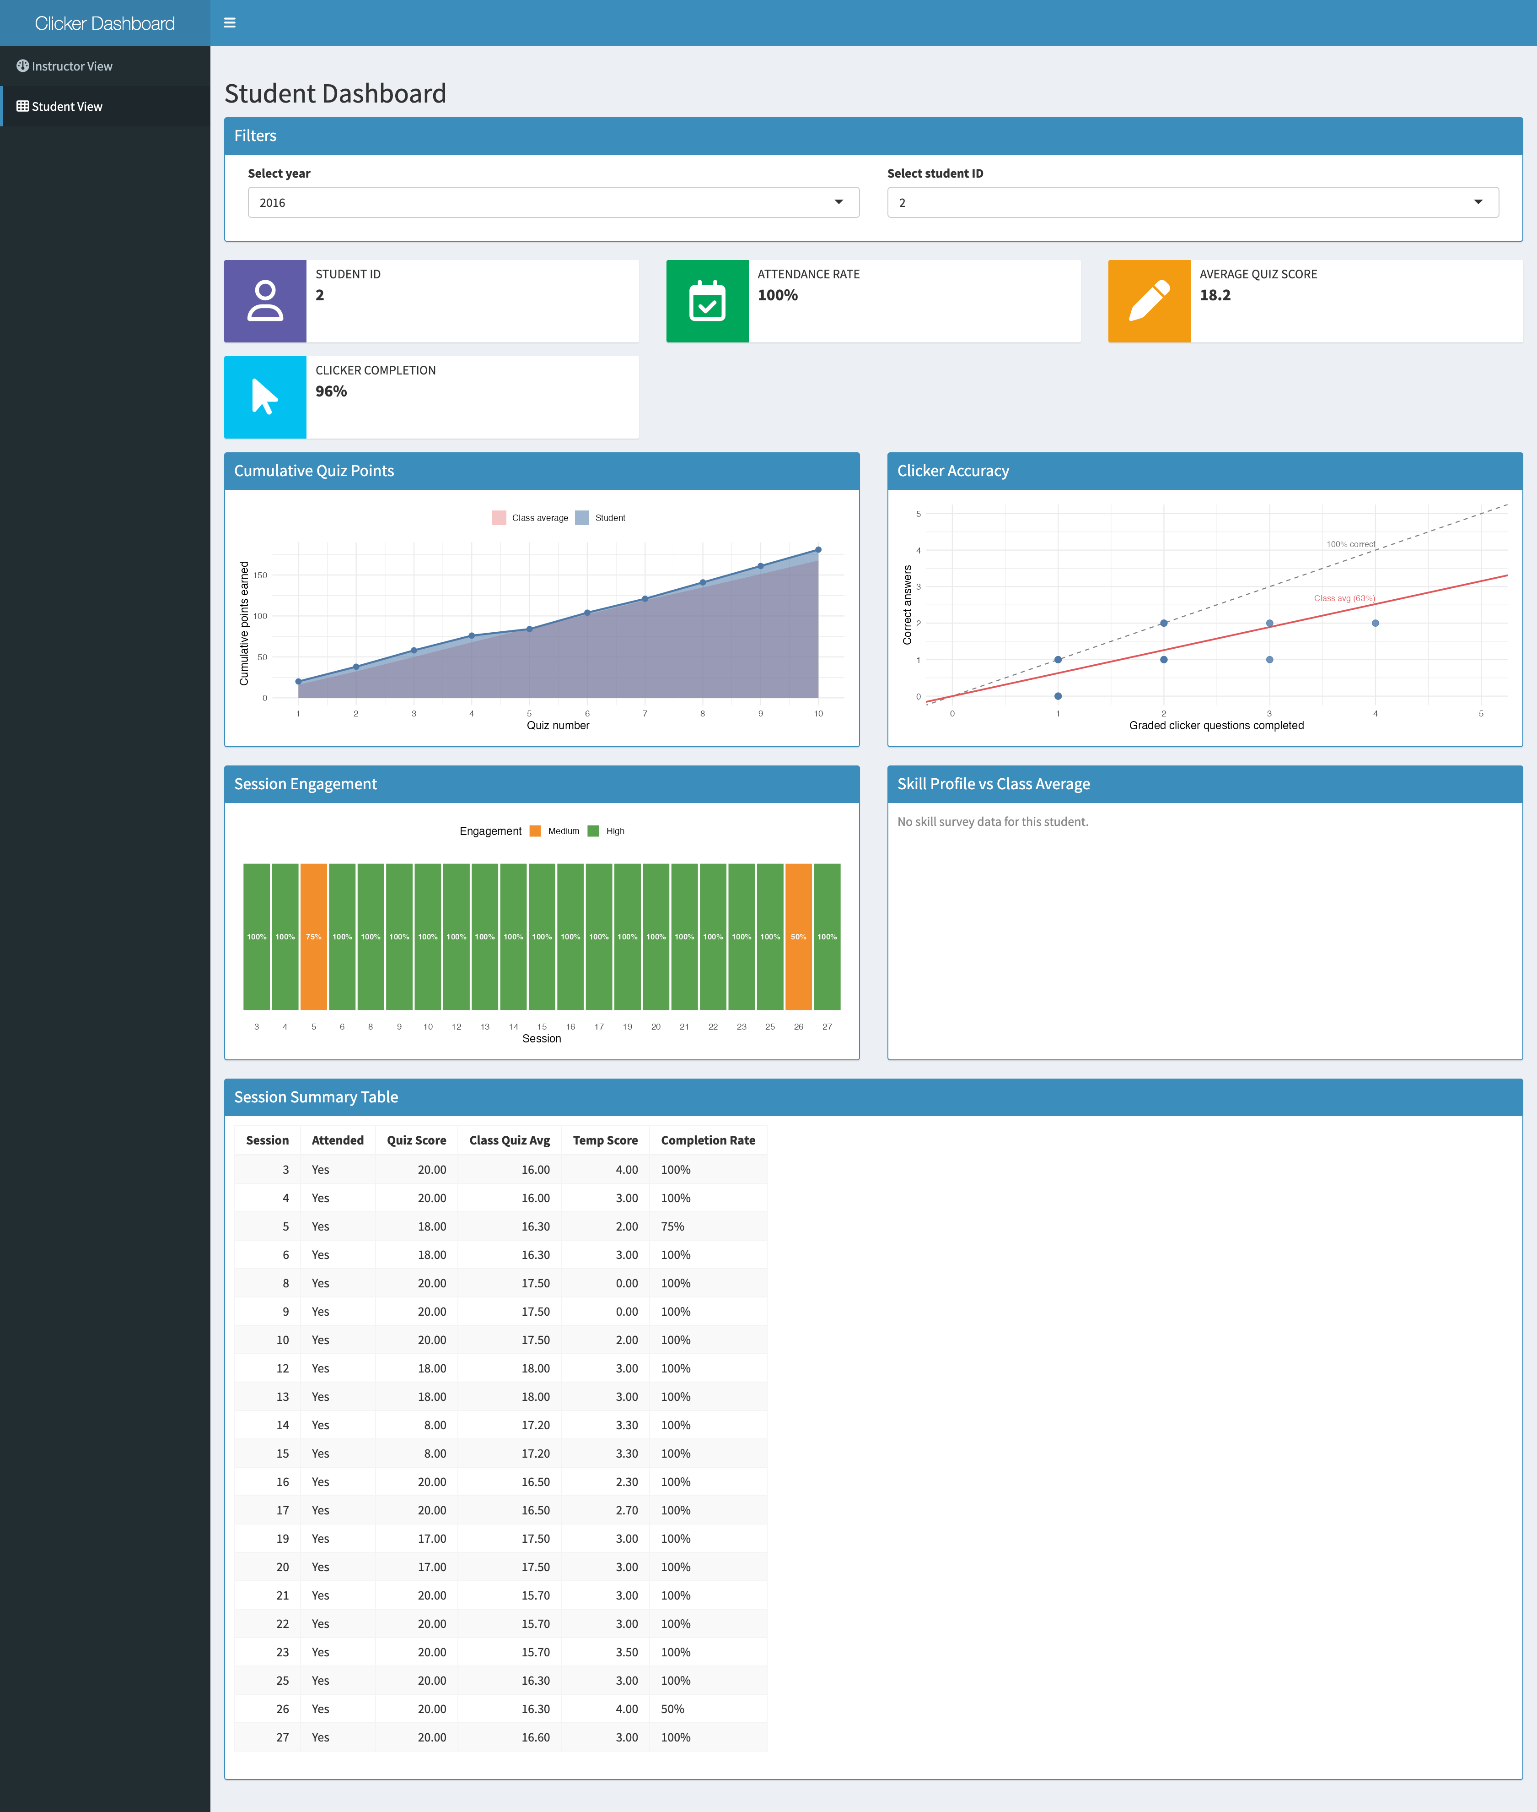
Student Dashboard Screenshot
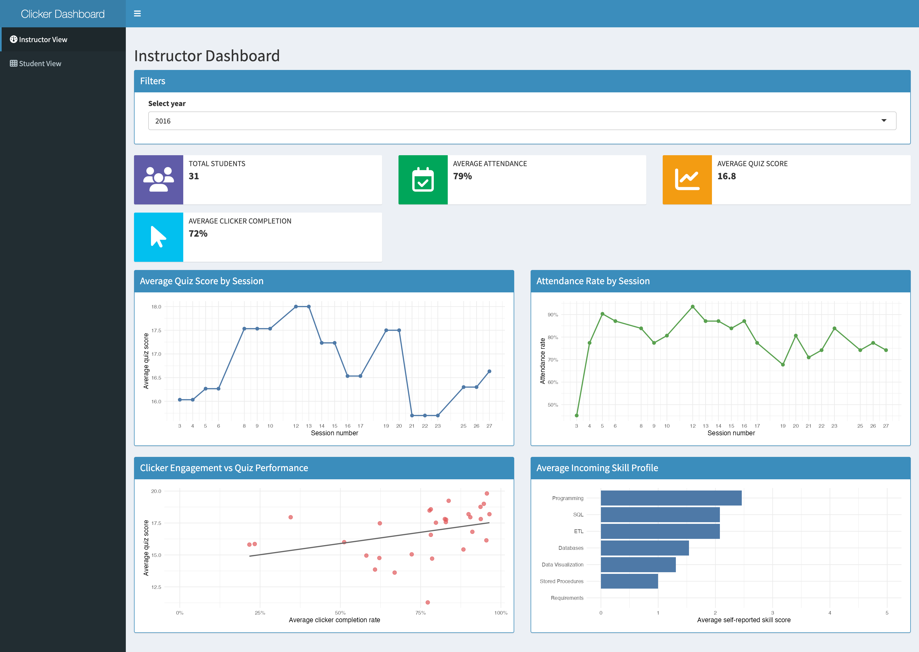
Instructor Dashboard Screenshot
Question 6: Evaluate your group dashboard from the perspective of the instructor (teacher dashboard) and from the perspective of the student (student dashboard). What do you like about it, what would you change or add to it if you had more time?
Reflection for the student dashboard
- What do you like about it?
  - We like that the dashboard is easy to read and gives a full picture of one student’s performance in one place. The top boxes are helpful because they show the main numbers right away, like attendance, average quiz score, and clicker completion. We also think the charts are interesting because they each show something different. The cumulative quiz points chart makes it easy to see progress over time, the clicker accuracy plot gives a nice comparison between effort and correctness, and the skill profile chart is cool because it shows where a student is above or below the class average.
- What would you change or add to it if you had more time?
  - If we had more time, we would make the dashboard even more interactive and polished. We would probably add short text takeaways under each chart so students can understand the main point faster. We would also add hover labels or tooltips so it is easier to read exact values. Another thing we would improve is the session engagement section, because it already shows useful patterns, but we think it could be even clearer with a little more explanation for what counts as high, medium, and low engagement.
- What was the biggest challenge you faced? How did you address it?
  - The biggest challenge was making the dashboard update cleanly for the selected student while keeping the layout simple. We had to connect the year filter and student ID filter to all of the plots, info boxes, and the summary table, and make sure everything changed together. We also had to deal with missing or uneven data in a way that would not break the dashboard. We addressed that by organizing the data ahead of time, using reactive pieces for the selected student, and adding checks so the visuals only show when the needed data is available.
Reflection for the teacher dashboard
- What do you like about it?
  - We like that the information (such as students, attendance, quiz score) are on top because it makes it easier for the professor to see a snapshot of the class. It gives a good summary without needing to interpret any of the graphs. We also really like the scatterplot of clicker engagement vs. quiz performance, since it confirms that students who complete more clicker questions tend to score higher, which is a useful and actionable insight for the instructor.
- What would you change or add to it if you had more time?
  - If we have more time, we should add a color-coded threshold line on the quiz score trend chart, as in marking scores below a certain value in red, so the instructor can easily spot underperforming sessions without having to mentally interpret the y-axis scale. We would also add hover labels or tooltips so it is easier to read exact values.
- What was the biggest challenge you faced? How did you address it?
  - The biggest challenge was aggregating the data at the right level because some visualizations needed session-level summaries while others needed student-level summaries, and the year filter had to flow through all of them consistently. We addressed this by pre-computing separate summary tables (class_by_session, inst_student_summary, class_skills) during data preprocessing, then filtering them based on the selected year.

Estimate time spent
We want to give students an estimate of how much time this homework will take. Please indicate how many hours you spent to complete this homework here.
- We spent 25 hours.

Generative AI usage
As stated in the course syllabus, using generative AI is allowed to help you as you complete this homework. We are interested in how it is being used and whether it is helpful for you.
- How much did you use generative AI (e.g., not at all, some, most, or all the questions) and which one did you use? We did not use generative AI.
- If you used generative AI, how did you use it and was it helpful? N/A

Submit Project
This is the end of the group project. Please Knit to Word (if you run into an issue, you can knit to PDF). The resulting file has to show both the R code and R output. Upload it on Canvas before the due date.

