jhdap's shogi: A user's guide.
Jiayin Huang and Dmitry Andreevich Paramonov

Getting Started:
Unpack all the files into whatever folder you want to run it in. Make sure the resources and the mgci folders are both in that folder. Then, you need to run Shogi.java, using your preferred method of running java, whether from the command line, or via IDE. Then, enjoy.

Goal of the game:
Your goal is to checkmate the opponent's King. This happens when the enemy king is under attack, and none of his possible moves can stop it. You have to take turns.

Movement:
You possess multiple pieces that have different ways of movement. Your pawns can move one space directly in front of them. Your lances can move any number of spaces in front of them, as long as no pesky pieces get in the way. Your knights move 2 forwards and one tile to the side. They can jump over others. Your silver generals and your gold generals have really weird ways of moving. They can both move to any tile in front or diagonally in front of them. The silvers can move diagonally back. The golds can move orthogonally. They can move a distance of one tile at most. Your king can move to any adjacent tile, as long as he doesn't make himself attacked by doing so. Your bishop moves any distance diagonally. The rook is his orthogonal equivalent. By moving onto an enemy piece, you capture it. If the king is under attack, he must be out of attack by the end of your turn. Otherwise, you lose. You can't make a move that leaves your king under attack.

Promotion:
A piece that reaches the last 3 ranks can choose to promote after it moved. A promoted piece moves like a gold general, with the exception of the rooks and bishops, which learn how to move one tile at a 45 degree rotation of their normal movement paths. Gold generals and kings can't promote. If a piece can't possibly move again unless it promotes, it must promote.

Dropping:
Any captured piece can be dropped again on the board. It is dropped in an unprompted way. If it can't move after dropping, it can't be dropped. Pawns can't be dropped in the same column as another pawn. Neither can they be dropped for an instant checkmate.

Interface:
You drag and drop! It's that simple. The developer console can be opened with `. Valid moves are highlighted! When promoting, you are given the option to promote with a choice box that pops up. Upon the game ending, you will be informed!

Dislaimers:
This program does not contain functionality for:
Saving.
Timed games.
Holograms.
Taking over the world.
Becoming Skynet.
Playing against a computer.
Internet play.
And spontaneously creating subway sandwiches.

Images:
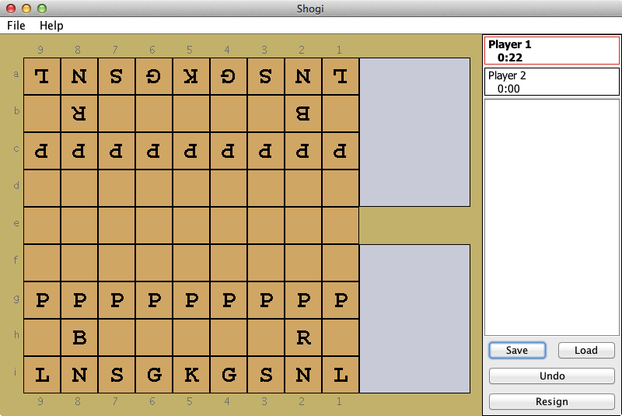A board at the start of a game.

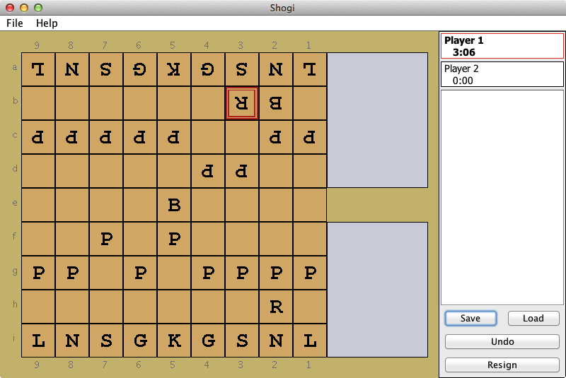A board a few moves in.

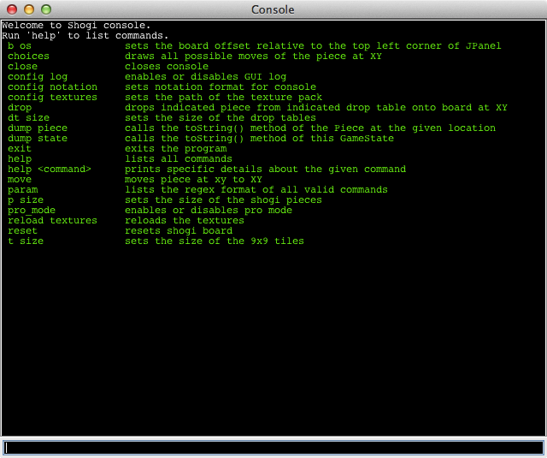The debugger console, when opened with “`”.

