**SCREENSHOTS**

**Ask for Number of Players**

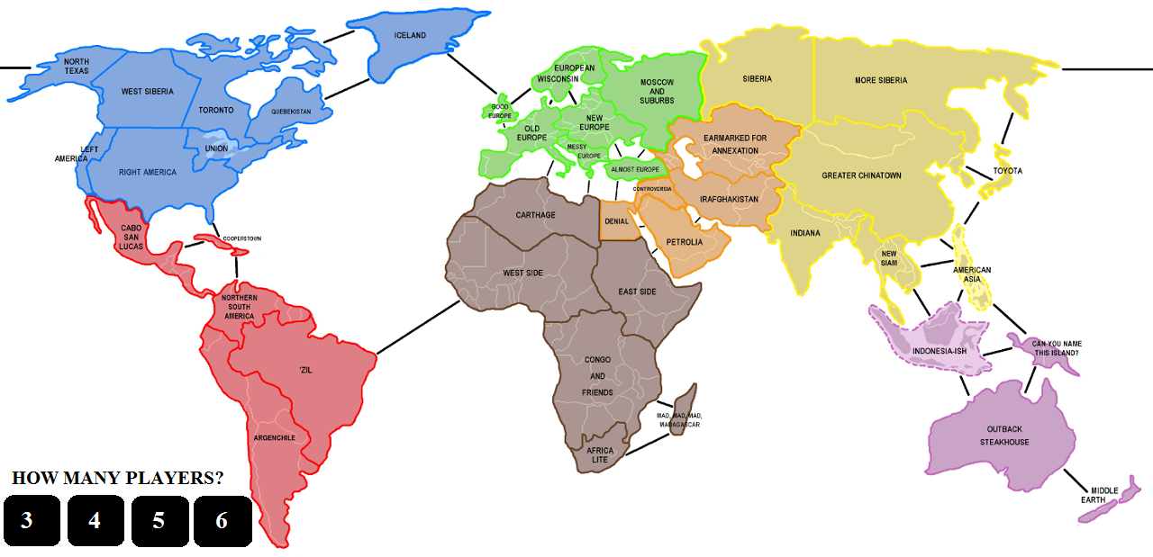

**Choosing Colour of Army**

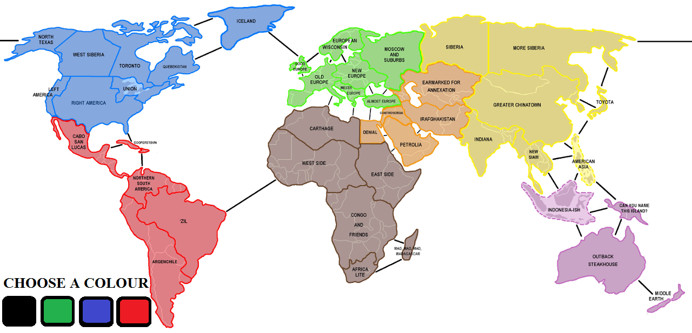

**After Placing of Armies**

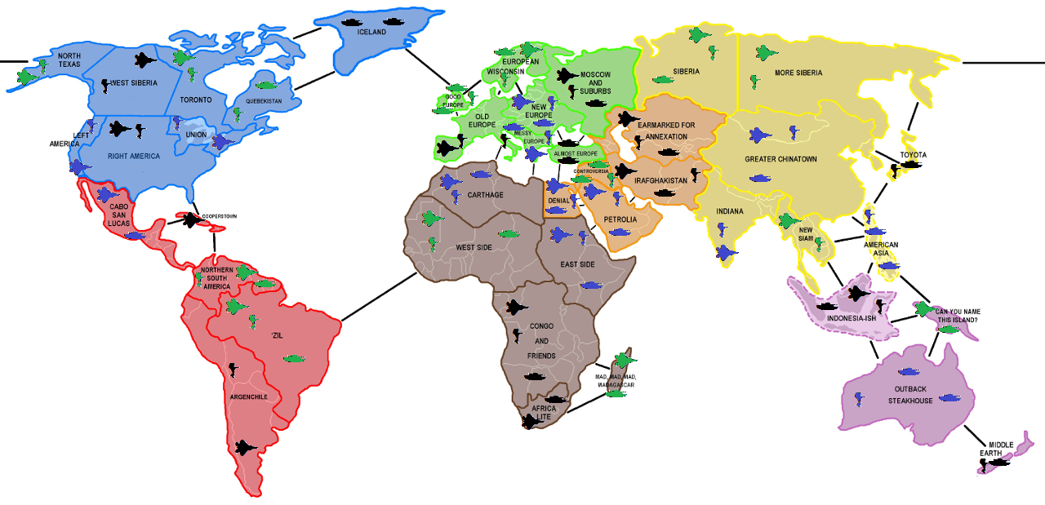

**During Attack**

