INDEPENDENT WORK 1
Extending Project Architecture using
Java Collection Framework (JCF)
Student | Davlet Beishenbekov
Group | COMCIF-25

1. Domain and continuity with the previous work
This project extends the previous Music Playlist Manager. The original domain classes and behavior are retained: abstract Track, Song, Podcast, Audiobook, Playable, Downloadable, Playlist, PlaybackHistory, PlaylistManager and PlaylistExporter. Existing validation, duration formatting, royalty calculation, playback, downloading and type-specific methods remain available.
The architecture is extended with immutable UUID business keys, repositories, role-based users and playback requests. A playlist stores a set of tracks; the same track may belong to several playlists. Playback history is composition-owned by its playlist.

2. Java Collection Framework components
JCF element | Purpose in the project
List / ArrayList | Registries of tracks, playlists and users; ordered playback history.
Set / LinkedHashSet | Unique tracks in a playlist; unique members in category and role indexes.
Map / HashMap | UUID-to-entity primary-key indexes; category-to-track and role-to-user indexes.
Queue / PriorityQueue | Playback requests: higher priority first; sequence number guarantees FIFO for equal priorities.
Comparable / Comparator | Natural track order plus four reusable custom sort strategies.
The repositories return defensive copies of their lists and sets. Internal collection state is changed through the service layer rather than by callers.

3. equals(), hashCode(), Comparable and Comparator
Each entity uses an immutable UUID as its unique business key. Track implements final equals() and hashCode() methods, inherited by Song, Podcast and Audiobook. Playlist, User, PlaybackRequest and PlaybackHistory also compare by their own UUID. This keeps hash-based collection behavior stable when titles, names or other mutable attributes change.
Track implements Comparable<Track> with natural order by title, artist and UUID. TrackComparators defines BY_TITLE, BY_ARTIST_THEN_TITLE, BY_DURATION_DESC and BY_PLAY_COUNT_DESC.

4. Service layer and synchronized CRUD
PlaylistManager coordinates TrackRepository, PlaylistRepository, UserRepository and the request queue. Service methods are synchronized. Track update replaces the object in the registry, updates the category index and replaces references in all playlists while preserving their order and the existing play-count statistic. Track deletion removes the track from the registry, category index, playlists and pending requests. User deletion also cancels that user’s pending requests.
The manager supports track and playlist lookup, filtering by artist/category/name, playlist creation/renaming/deletion, adding and removing tracks from playlists, and user registration/update/removal. The queue and repository indexes are updated together through the manager.

5. Role-based request workflow
- LISTENER: submits a playback request for an existing playable track. The request stores the listener ID, track ID, priority, submission time and a monotonic sequence number.
- OPERATOR: processes the next request through PriorityQueue.poll(). The track is played, the request becomes PROCESSED, and the history of each playlist containing the track is updated.
- A listener can cancel their own pending request; an operator can cancel any pending request. Requests with equal priority are ordered by an increasing sequence number, guaranteeing FIFO order.

6. Analytics and exception handling
The service reports library track count, total playlist entries, total library duration, estimated royalties, category counts and track counts per playlist. Invalid values, duplicate IDs, missing entities and unauthorized role actions are handled with IllegalArgumentException, IllegalStateException, NoSuchElementException or Optional results, depending on the operation.

7. Complexity of key operations
Operation | Expected complexity
UUID lookup in HashMap | O(1) average
HashMap / HashSet add or remove | O(1) average
PriorityQueue offer / poll | O(log n)
Sort n tracks | O(n log n)
Artist search without a dedicated index | O(n)
Indexed category lookup | O(1) bucket lookup + O(k) result copy

8. Updated UML class architecture
The diagram shows the original track hierarchy, playlist composition/aggregation, user roles, request queue and repository indexes introduced for the JCF assignment.
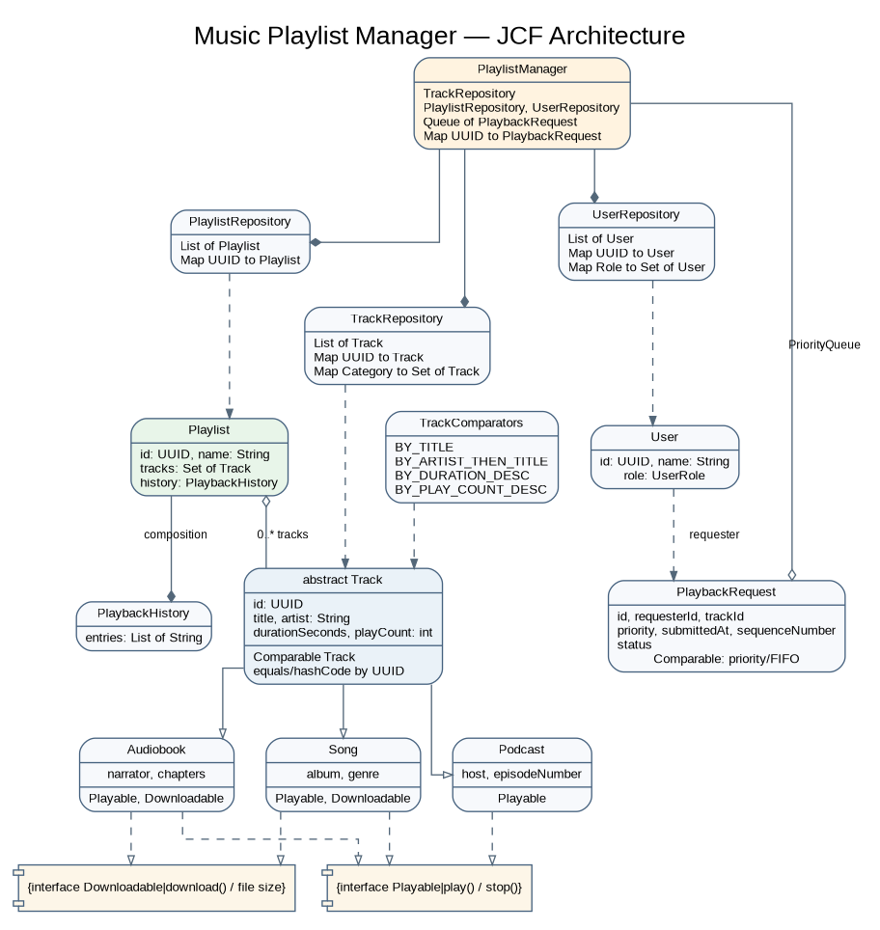
Figure 1. Music Playlist Manager — JCF architecture overview
The editable PlantUML source is provided separately at uml/music-playlist-manager.puml.

9. Program execution evidence
The screenshots below were generated from the actual console output of musicplaylist.Main after compiling the Java source with javac. They demonstrate indexing, sorting, queue processing, synchronized updates/deletions and analytics.
Execution output 1
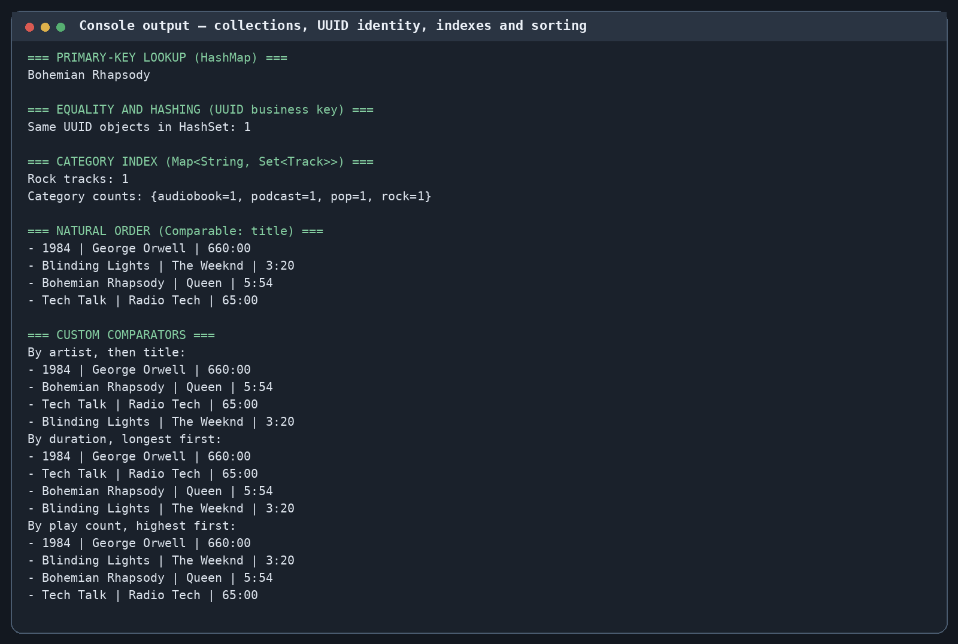
Execution output 2
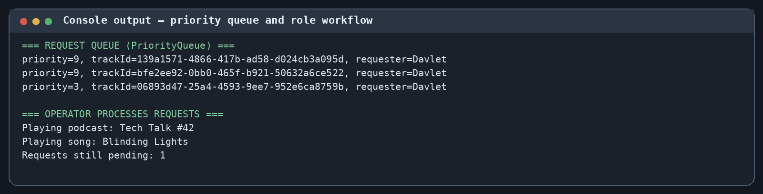
Execution output 3


