Bulletproof Bias? Considering the Type of Data in Common Proportion of Variance Effect Sizes

|  |
| --- |
| Erin M. Buchanan1 & John E. Scofield1 |
|  |
| 1 Missouri State University |
|  |

# Author note

Erin M. Buchanan, Department of Psychology, Missouri State University; John E. Scofield, Department of Psychology, Missouri State University. Both authors contributed equally to the creation of all parts of this manuscript.

Correspondence concerning this article should be addressed to Erin M. Buchanan, 901 S National, Springfield, MO, 65897. E-mail: [erinbuchanan@missouristate.edu](mailto:erinbuchanan@missouristate.edu)

# Abstract

As effect sizes gain ground as important indicators of practical significance and as a meta-analytic tool, we must critically understand their limitations and biases. This project expands on research by Okada (2013), which highlighted the positive bias of eta squared and suggested the use of omega squared or epsilon for their lack of bias. These variance overlap measures were examined for potential bias in different data scenarios (i.e. truncated and Likert type data) to elucidate differences in bias from previous research. We found that data precision and truncation affected effect size bias, often lowering the bias in eta squared. This work expands our understanding of bias on variance overlap measures and allows researchers to make an informed choice about the type of effect to report given their research study. Implications for sample size planning and power are also discussed.

*Keywords:* bias, eta, omega, epsilon

Word count:

# Bulletproof Bias? Considering the Type of Data in Common Proportion of Variance Effect Sizes

## Null Hypothesis Significance Testing

Null hypothesis significance testing (NHST) has dominated the social sciences for the past century, and currently, a blend of the Fisher and Neyman-Pearson methods are taught and practiced in psychological research (Gigerenzer, 2004). However, the sole use of NHST can be inadequate in terms of statistical inference (Kirk, 2003). Statistical reform is slow, hindering growth in the use of effect sizes (A. Fritz, Scherndl, & Kuhberger, 2013; C. O. Fritz, Morris, & Richler, 2012), confidence intervals, or even error bars on graphs (Cumming & Finch, 2005; Cumming et al., 2007). While a detailed discussion of the criticisms of NHST is outside the scope of this article (Kruschke, 2010; Loftus, 1996; Wagenmakers, 2007), we briefly discuss a few key issues to highlight the necessity of alternative means of estimation, namely effect sizes and their confidence intervals. The assumption of the truth of null hypotheses is erroneous, as they can be falsified with large enough sample sizes (Cohen, 1990; Tukey, 1991). Two comparisons in the real world are always, to some degree, different. A continual increase in sample size will eventually lead to the rejection of the null hypothesis. As Cohen (1990) says, "if the null hypothesis is always false, what's the big deal about rejecting it?" (pg. 1308).

As Kirk (2003) describes, the use of NHST does not actually provide answers to the pivotal questions surrounding researchers today. NHST tells us the probability of obtaining observed, or more extreme data, assuming that the null hypothesis is true (Kruschke, 2011). NHST does not expound on the probability of a research hypothesis being correct, begetting a series of misinformed reject-this to accept-that type of reasoning for supporting research hypotheses. Another criticism of NHST lies with the encouragement of a dichotomous decision-making paradigm (i.e. reject, do not reject). *p*-values, a central component of dichotomous decision-making, are defined as the probability that data is equal to, or more extreme than its observed value, given the null hypothesis is true (Cohen, 1990; Wagenmakers, 2007). However, *p*-values are often misunderstood and misused (Cumming, 2014; Gigerenzer, 2004). *p*-values are sometimes assumed to indicate of the size or strength of an effect (i.e., suggesting that *p* < .001 is *very* significant), and questionable research practices, such as *p*-hacking (Simmons, Nelson, & Simonsohn, 2011) can lead to artificially significant results and Type I errors. Effects are dichotomized into significant and non-significant, without shedding light on the practical importance of findings. Parametric NHST is also sensitive to the violations of statistical assumptions, given the common occurrence of non-normal data in some phenomena (Tabachnick & Fidell, 2012). Even with recent suggestions to move the $α$ criterion to a lower threshold, such as *p* < .005 (Benjamin et al., 2017), this shift does not ultimately solve inherent problems with *p*-values and misguided interpretations. Research hypotheses should not be merely centered on dichotomous decision criteria and *p*-values, but should consider the magnitude, or practical significance, of scientific phenomena (Kirk, 2003; Thompson, 2007).

## Effect Size

Effect sizes are argued to be as, or more, important indicators of statistical inference than the sole reliance on NHST (Cumming, 2014; Rosenthal & Rubin, 1994). Lakens (2013) describes effect sizes as "the most important outcome of empirical studies" (pg. 1). Effect sizes add the ability to interpret the practical importance of a phenomenon, centered in the context of the research field, alongside or in place of statistical significance (Cohen, 1994). Additionally, effect sizes are integral to meta-analyses and *a priori* power analysis planning. Even though Wilkinson (1999) and the newest style guide manuals have heavily suggested the use of effect sizes, C. O. Fritz et al. (2012) and A. Fritz et al. (2013) have shown that report rates of effect sizes are still low. The current literature shows a renewed interest in effect sizes, as Google Scholar searches indicate a slew of publications on effect size and meta-analysis in recent years. While effect sizes have been suggested as an integral tool of statistical inference, specific characteristics of multiple effect sizes are still under scrutiny, with Kirk (2003) noting the development of more than seventy separate effect size indices.

The majority of effect size estimates can be binned into two families. The *d* family is generally based on mean differences, whereas the *r* family is based on the association strength of proportion of variance explained by manipulated factors (K. Kelley & Preacher, 2012; Maxwell & Delaney, 2004). This article will focus on proportion of variance effect sizes, specifically, as previous research on the distribution of the *d* family has inspired this work (Cumming, 2014; Smithson, 2001). Eta squared ($η^{2}$), a proportion of variance effect size, is the most common effect size reported alongside ANOVAs, even though $R^{2}$ utilizes the same formula (Grissom & Kim, 2005; Matsumoto, Kim, & Grissom, 2011). $η^{2}$ is calculated from the sum of squares associated with the effect and the sum of squares associated with the error term in a sample, which is interpreted as a point-estimate for the population (Cumming, 2014; Pearson, 1905).

Effect sizes, however, are not all created equally, as sample-based effect sizes can overestimate population effects. Maxwell and Delaney (2004) describe this bias as the likelihood of sample means inevitably deviating from population means, due to sampling variability. The positive bias of $η^{2}$ has been widely recognized, due to its reliance with least-squares methods associated with *t*-tests and ANOVA designs, as well as with sampling error variability across different studies (Shieh, 2008; Skidmore & Thompson, 2011, 2012; Snyder & Lawson, 1993; Stevens, 1992; Thompson, 2006, 2007; Yin & Fan, 2001). Multiple bias-correcting formulas have been established to help "shrink", or adjust, the bias from the population and sample effect size estimates (Olkin & Pratt, 1958; Raju, Bilgic, Edwards, & Fleer, 1999; Stuart, Ord, & Arnold, 1994), and Yin and Fan (2001) provide detailed discussion of these formulas and their implementation. Bias-correcting formulas developed for $η^{2}$ are not examined further here because these formulas correct for a general assumption of positive bias, whereas positive bias was a central question to our current investigation.

Epsilon squared ($ϵ^{2}$) was proposed by T. L. Kelley (1935), offering an alternative, less biased effect size measure. $ϵ^{2}$ adjusts for positive bias by correcting the numerator in the formula of $η^{2}$. This correction occurs by subtracting the mean square error from the sum of squares treatment (Olejnik & Algina, 2000). Omega squared ($ω^{2}$), introduced by Hays (1963), takes this adjustment a step further, by not only subtracting the mean square error in the numerator, but subtracting the mean square error from the sum of squares total in the denominator as well (Olejnik & Algina, 2000). Carroll and Nordholm (1975), however, noted that $ϵ^{2}$ and $ω^{2}$ yield similar ranges of effect sizes. While the use of $ω^{2}$ and $ϵ^{2}$ can reduce sampling variability evident in $η^{2}$, some have argued that these effect size adjustments do not eliminate bias entirely (Keselman, 1975; Maxwell & Delaney, 2004; Okada, 2013, 2017; Olejnik & Algina, 2000). Maxwell and Delaney (2004) note that typical differences between $ω^{2}$ and $η^{2}$ estimates fall within .02 of each other, while O’Grady (1982) argued that $ω^{2}$ may also occasionally lead to an underestimation of population effect size estimates.

$ω^{2}$, like every other effect size estimate, is not without its limitations. First, $ω^{2}$ may be computationally difficult to calculate, especially in complex designs, and even textbooks that discuss $ω^{2}$ detail this limitation (A. Field, Miles, & Field, 2012). For meta-analytic purposes, $ω^{2}$ generally cannot be computed because of reliance on sum of squares and mean squared error values, which have no translatable estimate formula from the *F*-statistic like $η^{2}$. Using $ω^{2}$ may be inappropriate in designs where sample sizes across groups are unequal, as the model in which $ω^{2}$ was derived assumes a balanced design (Olejnik & Algina, 2000; Vaughan & Corballis, 1969). However, Carroll and Nordholm (1975) noted that $ω^{2}$ estimations with unequal *n* negligibly affected estimates, unless combined with heterogeneous variances.

## Overall Limitations and Bias

Each effect size includes aspects in regards to its use in scientific research, as well as limitations in its interpretation. This paper focuses on the bias, standard deviation, and standard error of each effect to expand on previous research by Okada (2013). Fern and Monroe (1996) outlined that proportion of variance effect sizes should be interpreted depending on the type of research design used, whether treatments were manipulated between- or within-subjects, and whether experiments contained more than one factor. Researchers should consider elements, such as measurement reliability, heterogeneity of variance, the range of treatment manipulations, and the type of scale used before assigning a value of importance to a given effect size estimate. Large sample sizes increase accuracy of effect size estimation, as smaller sample sizes are associated with larger standard errors. This limitation is especially prevalent with the combination of small sample sizes and heterogeneous variances (Carroll & Nordholm, 1975). Others have commented that sample-based estimates have higher sampling errors with small *n* (Maxwell & Delaney, 2004; Thompson, 2007), and that differences in effect sizes, such as $η^{2}$, $ω^{2}$, and $ϵ^{2}$, tend to converge as sample size substantially increases (Maxwell, Camp, & Arvey, 1981).

Several previous studies have examined the interplay between bias, standard deviation, and standard error, mostly focusing on sample size and effect size as variables of interest. Keselman (1975) ran 1,000 simulations of ANOVAs and determined that $ω^{2}$ estimates were closer to the population effect than both $ϵ^{2}$ and $η^{2}$. $ω^{2}$ has been advocated as the "nearly unbiased" estimator of the population effect, wherein $ω^{2}$ has less bias than $ϵ^{2}$, leaving $η^{2}$ as the most biased (Grissom & Kim, 2005; Matsumoto et al., 2011). However, $ω^{2}$ can be negatively (i.e. underestimate) biased, as originally found in Carroll and Nordholm (1975) and replicated in O’Grady (1982). Okada (2013) extended these results by comparing all three effect sizes across sample size and mean variability by simulating 1,000,000 one-way fixed effect ANOVAs with four treatment levels. While Okada used 1,000,000 simulations, many researchers have concluded that far fewer simulations can achieve an adequate attenuation of sampling variability (Fan, Felsovalyi, Sivo, & Keenan, 2001; Robey & Barcikowski, 1992; Skidmore & Thompson, 2012).

Results from Okada (2013) revealed that, $ϵ^{2}$, not $ω^{2}$, held the least bias across *n*. $ω^{2}$ did, however, outperform both $ϵ^{2}$ and $η^{2}$ in standard error. $η^{2}$ did have the lowest standard deviation, but Okada notes that $η^{2}$ performed poorly considering both bias and standard error. Okada concluded with a firm cautionary warning that researchers should not use $η^{2}$, as it incorrectly overestimates the population effect across sample, inversely related to sample size. Skidmore and Thompson (2012) also investigated the performance of these effect sizes, considering common statistical assumption violations like heterogeneity, and found similar results as previous simulation studies (Carroll & Nordholm, 1975; Keselman, 1975; Okada, 2013). Even though these studies have focused on slightly different facets of bias in one-way between-subjects ANOVA, a common theme has emerged. Even with bias decreasing as an additive function of both an increase in population effect size and sample size (Maxwell & Delaney, 2004), conclusions from these studies remain the same: $η^{2}$ should not be used. This conclusion is intriguing, largely because $η^{2}$ is readily presented among statistical software packages (e.g. SPSS, R, JASP) and continues to be the most most commonly reported effect size for ANOVA type designs (Lakens, 2013).

## Purpose of Current Study

The purpose of the current study is to examine these important conclusions regarding the use of $η^{2}$, as well as examining the type of data used in research design and its effects on the performance of $η^{2}$, $ϵ^{2}$, and $ω^{2}$. We first established a confidence interval of bias, standard deviation, and standard error to use as a criterion for judging changes in these variables. Second, we examined the effect of data type on bias, standard deviation, and standard error. Last, for the data type manipulations that significantly change bias, standard deviation, or standard error, we calculated this change across a large range of effect sizes (i.e. nearly zero to very large). This analysis demonstrates the effect of the bias, standard deviation, or standard error change with more precision than previous work binning effect sizes into small, medium, or large magnitudes.

# Method

## Simulations

Okada (2013) included *R* syntax in his publication, which allowed us to replicate and extend his work. First, we found it crucial to explain the underlying assumptions and formulas used in this replication, as a means to increase the reproducibility of the current project. Population effect size is calculated by creating a sum of squares for between group differences from the grand mean:

$$SS_{between}=\frac{Σ(\overline{X_{i}}−\overline{X})^{2}}{N_{groups}}$$

and then estimating group error with an average of group variances. In this formula, $\overline{X_{i}}$ indicates each proposed group mean, while $\overline{X}$ is the proposed grand average of group means. Population eta is then calculated by creating a ratio of $SS_{between}$ and $SS_{error}$, analogous to the full $η^{2}$ formula:

$$η_{pop}^{2}=\frac{SS_{between}}{SS_{between}+SS_{error}}.$$

$SS_{error}$ is calculated by averaging all proposed group variances. Specifically, we used standard deviations of one to match previous simulations, but this point for calculation of $η_{pop}^{2}$ from *R* syntax should be clarified for interested parties (i.e., the previous syntax included a value of one, while this value is calculated from group variances and should not be a set number). The value of one in the denominator is an expected average of group variances, which is approximately one in these examples. This value should be changed for simulations with heterogeneity or other proposed standard deviations.

Bias is estimated by calculating the average simulated $η^{2}$ values and subtracting the $η_{pop}^{2}$ estimate. This value represents the effect size deviation from the population, wherein positive numbers represent an inflation of effect size due to manipulated variables, while negative numbers indicate a reduction in effect size estimates, compared to population values. Standard deviation (SD) and root mean squared error (standard error; RMSE) of the effect size are simple adjustments of the traditional standard deviation formula:

$$
SD = \sqrt\frac{\Sigma (\eta^2_{i} - \bar{\eta^2})^2} {N_{sims}}
$$

and:

$$
RMSE = \sqrt\frac{\Sigma (\eta^2_{i} - \eta^2_{pop})^2} {N_{sims}}.
$$

Here, sample SD is calculated by squaring the difference between the estimated $η_{i}^{2}$ for each simulation from the mean $\overline{η^{2}}$ of that sample size. RMSE estimates the standard error by squaring the differences of estimated $η_{i}^{2}$ for each simulation from the $η_{pop}^{2}$. Both formulas use the population sample size estimator ($N_{sims}$) in the denominator, rather than degrees of freedom (i.e., $N_{sims}$- 1).

## Manipulated Variables

Using the cited simulation code, we manipulated several factors independently to determine the effects of data type on bias, SD, and RMSE of variance overlap effect sizes. Methodologically, we examined the number of simulations first in *R*. For data types, we varied the number of decimals, type of means, and truncation/skew of the data. In all simulations testing these variables, we used the largest variability condition from Okada (2013) (i.e. means 0.0, 0.0, 1.2, 1.2) because it showed the largest bias, SD, and RMSE effects. Each simulation was tested across sample size values and effect size types found in Okada (2013). The *R* code from our study can be found at <http://osf.io/urd8q> in an *R* markdown file that shows the simulation and graph code inline with this manuscript.

# Results

## Confidence Intervals

Previous research on the suggested number of simulations is mixed. We chose 1,000 simulations for our study. This option may be practical for researchers in terms of computation times and access to various types of computers researchers may have. Results using 1,000 simulations are remarkably similar to Okada's simulations using 1,000,000 iterations. All simulation bias, SD, and RMSE values can be found online at <http://osf.io/urd8q>. From one hundred iterations of 1,000 simulations, 95% confidence intervals were calculated by taking the 2.5% and 97.5% values (i.e. values ranked 2 and 3 were averaged or values 97 and 98 were averaged). These scores are represented in Figure 1 marked as the grey area. Confidence intervals are very small around average scores, indicating a reasonable range of values to be found. The confidence interval calculated here was used to determine how bias, SD, and RMSE changed across data type manipulations.

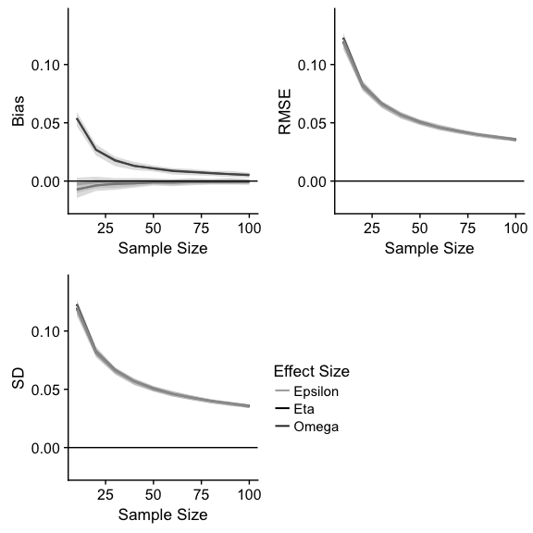

Figure 1 Replication of Okada (2013) bias, SD, and RMSE for the largest variability condition. Effect size values are presented for average simulations alongside Okada scores. Shaded gray area represents 95% confidence interval around these values.

## Precision of the Dependent Variable

We also explored the effect of the type of dependent variable on bias, RMSE, and SD, starting with the precision of the dependent variable. *rnorm()* calculates random numbers to 16 decimal places. With computer assisted data collection, some phenomena may be calculated with more precision (i.e. more decimals), but it is unlikely that all data is collected with a large number of significant digits. Additionally, if researchers use Likert type data, it is possible that dependent variables may be captured in whole numbers. We simulated 1,000 datasets and within each round, we calculated bias, RMSE, and SD on the same data, rounding values from 0 to 15 decimals. After examining this data, only very small changes were apparent through one decimal (i.e. 1-15 decimals do not show differences larger than .001), and therefore, we only present results from rounding to the least precision, zero decimals. The complete dataset and code for both of these simulations are presented online at <http://osf.io/urd8q>.

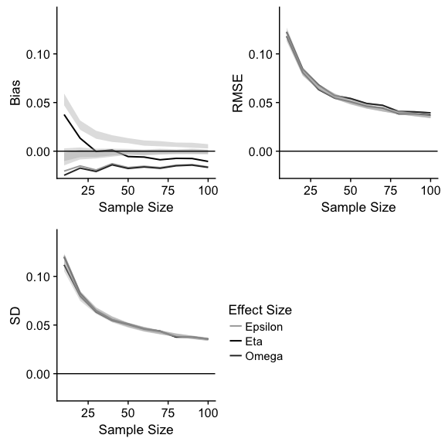

Figure 2 Bias, SD, and RMSE values of zero decimal dependent variables. Shaded gray area represents 95% confidence interval around these values.

As seen in Figure 2, rounding the dependent variable to zero decimals had a stark effect on the bias found in each of the effect sizes. All three were downwardly affected, that is, using less precise dependent variables resulted in less upwardly biased effect sizes. In fact, both $ω^{2}$ and $ϵ^{2}$ were completely negatively biased, and $η^{2}$ showed a negative bias after sample sizes approximately *n* = 40. These values average 0.012 outside the comparison CI created in the first stage of this paper, which is traditionally considered a small effect size for variance overlap measures (Cohen, 1992). RMSE values were increased for $ω^{2}$ and $ϵ^{2}$ across most *n* values over 50, averaging 0.002 over the comparison CI. However, the SD for each effect size was unaffected by the rounding to whole numbers. We do not suggest that researchers should use less precise dependent variables; however, it is important to consider that rounded data effect sizes may be under-representing their population data.

## Type of Dependent Variable and Data Skew

Given that Likert data is generally represented as whole numbers, we examined the effect of Likert type dependent variables may indirectly change effect sizes. Often, Likert scales are criticized for their non-normal distributions (Bishop & Herron, 2015), where participants will choose only the ends of the scale. Therefore, in this set of simulations we first examined the effect of simply shifting the estimated sample means over to 2, 2, 3.2, and 3.2 to mimic a floor effect on a traditional 1-7 style scale. 1,000 simulations indicated no large differences from the comparison study (part one of this paper), and therefore, all data and graphs are presented online for the interested reader. After confirming that we did not see changes by shifting away from a standard normal distribution, we then simulated 1,000 datasets with adjusted means that were truncated. This procedure rounded all values less than one to one, and all values over seven down to seven. In each of these simulation tests, we only manipulated one variable, and therefore, the data in this test were otherwise not rounded (i.e. precision was set to default decimals).

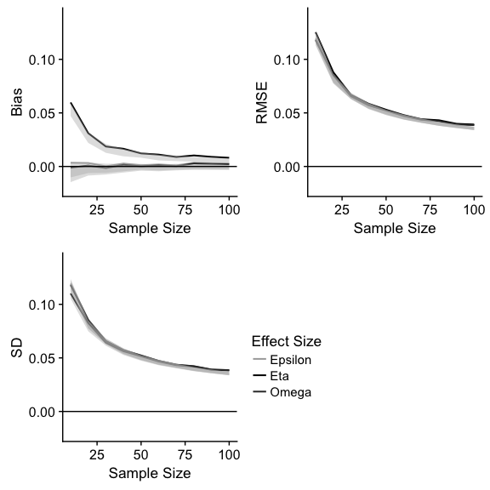

Figure 3 Bias, SD, and RMSE values for truncated Likert style dependent variables. Shaded gray area represents 95% confidence interval around these values.

This simulation set showed the opposite effect of rounding, namely that bias was increased with truncated data, especially at low *n* (10) and upper *n* (above 60), with an average of 0.001 increase outside the confidence interval. RMSE and SD were similarly increased 0.001 for all effect sizes at both low (*n* = 20) and high (*n* = 80+) ends. Figure 3 includes the graphs of these results.

## Changes Across Effect Size

In summary, our simulations showed that several aspects of the data change the bias and variance of effect sizes compared to a population parameter. These simulations were calculated on the largest effect from the Okada (2013) to show the greatest possible differences, and the population effect size was set to .265. In this section, we expand the original research and our findings to a range of effect sizes. The simulation code was modified to start with a very small effect size, .012, and increase to a very large effect size, .679. We achieved this range by creating a mean vector that started with zero and each subsequent mean was increased by a decimal additive. This decimal additive started at 0.10 and increased to 1.30 in 0.05 increments. Therefore, the first mean vector was (0, 0.1, 0.2, 0.3) and the last mean vector was (0.0, 1.3, 2.6, 3.9). This procedure increased the population effect size estimate approximately .02 to .04 at a time. The upper end of the range of possible effect sizes estimated was chosen so that the effects of Likert truncation could be examined by starting means at 2.0 and staying within a range of 1-7.

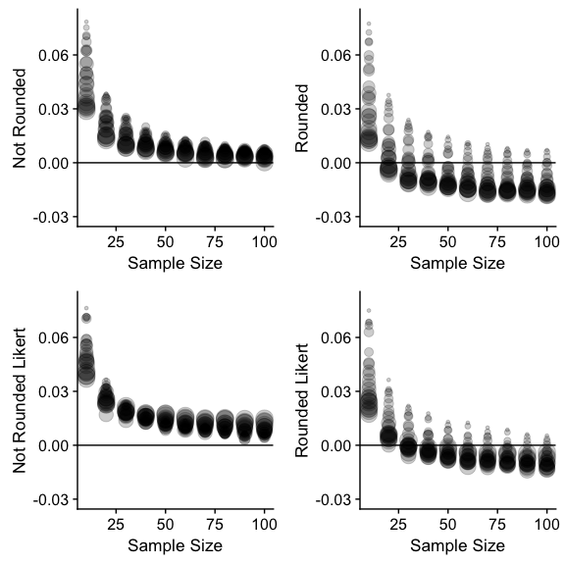

Figure 4 Bias values for eta squared for regular and truncated Likert data (top and bottom) that has been not been rounded or rounded to whole numbers (left and right). Circle size indicates population eta squared values, wherein small dots are small effect sizes and large dots are large effect sizes.

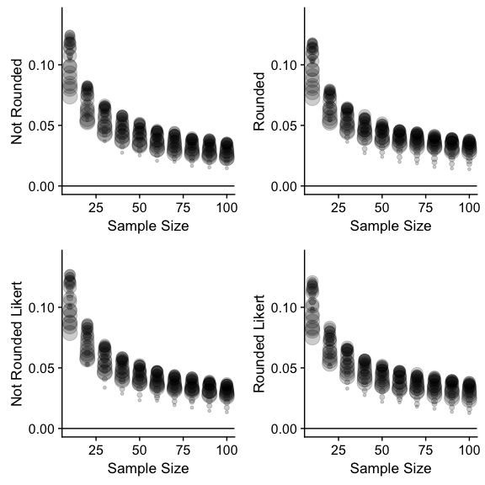

Figure 5 RMSE values for eta squared for regular and truncated Likert data (top and bottom) that has been not been rounded or rounded to whole numbers (left and right). Circle size indicates population eta squared values, wherein small dots are small effect sizes and large dots are large effect sizes.

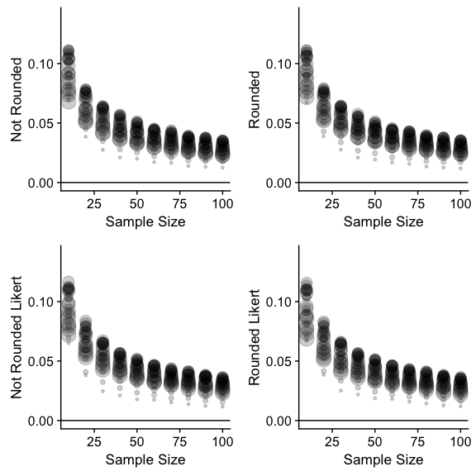

Figure 6 SD values for eta squared for regular and truncated Likert data (top and bottom) that has been not been rounded or rounded to whole numbers (left and right). Circle size indicates population eta squared values, wherein small dots are small effect sizes and large dots are large effect sizes.

Because of the complexity of this data, only $η^{2}$ values were plotted to show the effect of rounding and truncation across a large range of effect sizes. Interested readers can change code in Rmarkdown document to view $ω^{2}$ and $ϵ^{2}$. Figure 4 indicates the bias of $η^{2}$, and the effect of rounding was wider spread across the range of sample size, while non-rounded data converges across sample size. Truncated Likert data showed a similar pattern with slightly less spread than regular data, as well as a slight upward increase in bias, as shown above. Figure 5 portrays the subtle effect of rounding and truncation increasing values at the low and high ends of sample size. A new finding shown here was that RMSE appears to be lowest at low and high population effect sizes peaking at $M_{NZ}$ = 0.27, $M_{RZ}$ = 0.32, $M_{NL}$ = 0.28, and $M_{RL}$ = 0.35 (with the subscript N for not rounded data, R for rounded data, Z for normal data, and L for truncated Likert data). SD calculation shown in Figure 6 displays the same pattern with similar average peak values: $M_{NZ}$ = 0.29, $M_{RZ}$ = 0.32, $M_{NL}$ = 0.33, and $M_{RL}$ = 0.29.

## Sample Size Planning

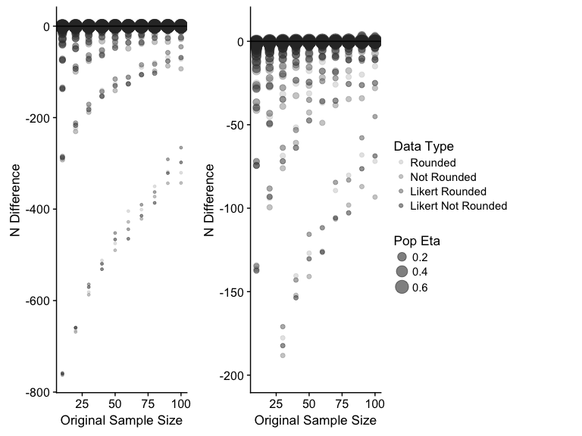

Figure 7 Sample size differences estimated for 80% power for found versus population effect sizes. Negative values indicate an underestimation of sample size needed to detect a significant effect. Circle size indicates population eta squared values, wherein small dots are small effect sizes and large dots are large effect sizes. The left panel indicates the full range of the data, while the right panel is zoomed in to show the effects at larger population values.

This research primarily focused on the the effects of changing dependent variables on bias estimates for variance overlap effect sizes. Generally, $η^{2}$ is biased at smaller sample sizes and less biased at larger effect sizes, while $ω^{2}$ and $ϵ^{2}$ are generally slightly negatively biased. The type of dependent data, rounded and truncated, can decrease or increase that bias. These values become practically important for sample size planning for future studies. Therefore, we calculated the sample size necessary to attain 80% power with an $α$ of .05 using the *pwr* library (Champely, 2016) for both the population and observed $η^{2}$ values for the data calculated in the last section. We focused on $η^{2}$ because of its popularity among researchers, and the differences in bias were apparent across sample size. Figure 7 indicates the proposed sample size difference between population and observed $η^{2}$ across original sample size. The left panel includes the full range of population $η^{2}$, while the right panel zooms in to larger population $η^{2}$ values. All four data types (rounded versus not, Likert versus not) are included in different gray shades, but these estimates are very similar, especially around zero sample size differences. The main takeaway from this graph is the extreme underestimation of suggested sample size at small effect sizes, as they are often the most biased (see Figure 4). The average underestimation was close to 30 participants for each type of dependent variable: $M_{NZ}$ = -32.60, *SD* = 106.26; $M_{RZ}$ = -29.25, *SD* = 103.95; $M_{NL}$ = -31.86, *SD* = 105.01; $M_{RL}$ = -28.29, *SD* = 102.60. The minimum values (largest underestimation) were large for small population effect sizes: *NZ* = -762.95; *RZ* = -761.54; *NL* = -760.06; *RL* = -758.20. The maximum values indicated that sample size is only overestimated in rounded data only: *NZ* = -0.01; *RZ* = 2.36; *NL* = -0.29; *RL* = 3.45. Therefore, while effect sizes may not be quite as biased as originally believed, sample size planning was still negatively affected, and it may be prudent to estimate a higher sample size in order to achieve 80% power.

# Discussion

Effect sizes are an integral part of statistical inference and are now included in the majority of guidelines for statistical reporting (Cumming, 2014). While the APA Task Force commentary nearly 20 years ago (Wilkinson, 1999) has sparked new areas of focus centering on effect sizes, characteristics of different effect sizes have not been as thoroughly explored. $η^{2}$ has dominated research reporting (Lakens, 2013), even though alternatives such as $ω^{2}$ and $ϵ^{2}$ are available and are reportedly better indices of variable overlap (Okada, 2013). $η^{2}$ has been reported to hold a positive bias due to sampling error variability and its dependence on the least-squares method (Shieh, 2008; Skidmore & Thompson, 2011, 2012; Snyder & Lawson, 1993; Stevens, 1992; Thompson, 2006, 2007; Yin & Fan, 2001). As sample means deviate from population means, sample based effect sizes deviate from population effects as well (Maxwell & Delaney, 2004). Carroll and Nordholm (1975) noted that this positive bias is especially prevalent with small *n* and heterogeneous variance in combination. Even though bias-correcting formulas have been proposed to adjust for this bias, a common theme has emerged that $η^{2}$ should be avoided in exchange for less biased effect sizes, like $ω^{2}$.

The current paper followed upon Okada (2013), looking at bias, standard deviation, and standard error for these variance overlap effect size measures. The purpose of the current paper was also to examine the conclusions regarding the utilization of $η^{2}$, as well as examining the type of data used in a given research design to note any changes in performance across $η^{2}$, $ϵ^{2}$, and $ω^{2}$. We used 1,000 simulations for our study, which was sufficient to replicate the various effects of bias, standard deviation, and standard error from Okada (2013). Simulation lines in found in Figure 1 are also nearly indistinguishable across all dependent variables.

For different types of data, we manipulated the number of decimals (precision of the data), the type of means, and the truncation/skew of simulated data to examine its effects on effect size performance. For each of these, we manipulated one factor at a time, to retain comparability to our confidence intervals created from the first set of simulations. Rounding to zero decimals had an apparent effect on the bias found in all effect sizes, in a downward fashion. Interestingly, we found that less precision of the data resulted in less biased effect sizes, especially after sample sizes for each group crossed 40. This result is in stark contrast to the perception and mantra that $η^{2}$ is *always* biased, and the use of $ω^{2}$ and $ϵ^{2}$ here would be less biased, but potentially very conservative. The precision of the data may play an important role in understanding if estimates of effect from previous research are useful for thinking of sample size estimation and power.

The next step was to examine Likert style data. As noted earlier, Likert scales can be criticized for the potential of non-normal or skewed distributions (Bishop & Herron, 2015). After showing that the location of the scale (i.e. shifting the means up two points) did not make a difference in results, we simulated skew by truncating the simulated data. This manipulation showed an opposite effect of rounding. Bias was shown to increase when using truncated data, especially at the tails of sample size (*n* = 10, and *n* > 60). RMSE and SD were found to follow the same pattern. These findings were also expanded to consider a range of effect size magnitudes. Figures 5-7 indicate the interactive nature of sample size, population effect size, and choice of data type. Likert scales are still overwhelmingly popular in scientific research, and previous research has mostly focused on the debate of the type (i.e. parametric) of statistics to perform on these scale (Carifio & Perla, 2008; Knapp, 1990). Here, we demonstrated that choosing these scales can have both and upward and downward bias on effect size depending on the exact scenario the researcher is faced with. However, even as we explored the bias of effect sizes, power analyses showed that we are still underestimating the number of participants needed for adequately powering our studies.

This conversation about effect size is extremely timely, given the focus on reproducible science (Nosek et al., 2015) and understanding researcher degrees of freedom (Simmons et al., 2011). Albers and Lakens (2017) recently shared a preprint examining how the bias of effect sizes and the use of pilot studies can have a confounding effect when estimating sample sizes for well-powered studies. They conclude that the bias of $η^{2}$, as well as *follow-up bias* (i.e. the desire to only explore pilot studies that worked well with larger effects) can create under powered full studies, a significant problem the psychological field has faced in recent years (Bakker, Hartgerink, Wicherts, & van der Maas, 2016). While suggestions from Benjamin et al. (2017) regarding a change in statistical significance criterions might be a viable short-term solution, a bigger problem persists regarding widespread misinterpretation of significance versus strength of effects. As a result, a more in depth examination of effect sizes, its interpretations, and the characteristics in which sample based effects might hold levels of bias is critical. Our simulations indicate this effect is more complicated than a simple understanding of an always positively biased $η^{2}$. An awareness of the type of data researchers use, and ultimately the characteristics of our research design and analysis, is an important step toward a better understanding of the practical importance of psychological effects, and that the effect of data choice should be considered when estimating sample size, considering meta-analyses, or simply interpreting effect sizes.

# References

Albers, C. J., & Lakens, D. (2017). When power analyses based on pilot data are biased: Inaccurate effect size estimators and follow-up bias. *PsyArxiv*, *July 13*, 1–37. doi:[10.17605/OSF.IO/B7Z4Q](https://doi.org/10.17605/OSF.IO/B7Z4Q)

Bakker, M., Hartgerink, C. H. J., Wicherts, J. M., & van der Maas, H. L. J. (2016). Researchers’ intuitions about power in psychological research. *Psychological Science*, *27*(8), 1069–1077. doi:[10.1177/0956797616647519](https://doi.org/10.1177/0956797616647519)

Benjamin, D. J., Berger, J. O., Johannesson, M., Nosek, B. A., Wagenmakers, E.-J., Berk, R., & Johnson, V. E. (2017). Redefine statistical significance. *PsyArxiv*, (July 22), 1–18. doi:[10.17605/OSF.IO/MKY9J](https://doi.org/10.17605/OSF.IO/MKY9J)

Bishop, P. A., & Herron, R. L. (2015). Use and misuse of the Likert item responses and other ordinal measures. *International Journal of Exercise Science*, *8*(3), 297–302.

Carifio, J., & Perla, R. (2008). Resolving the 50-year debate around using and misusing Likert scales. *Medical Education*, *42*(12), 1150–1152. doi:[10.1111/j.1365-2923.2008.03172.x](https://doi.org/10.1111/j.1365-2923.2008.03172.x)

Carroll, R. M., & Nordholm, L. A. (1975). Sampling characteristics of Kelley’s $ϵ$ and Hay’s $ω$. *Educational and Psychological Measurement*, *35*(3), 541–554. doi:[10.1177/001316447503500304](https://doi.org/10.1177/001316447503500304)

Champely, S. (2016). pwr: Basic functions for power analysis. R package version 1.2-0. Retrieved from <https://cran.r-project.org/package=pwr>

Cohen, J. (1990). Things I have learned (so far). *American Psychologist*, *45*(12), 1304–1312. doi:[10.1037//0003-066X.45.12.1304](https://doi.org/10.1037//0003-066X.45.12.1304)

Cohen, J. (1992). A power primer. *Psychological Bulletin*, *112*(1), 155–159. doi:[10.1037//0033-2909.112.1.155](https://doi.org/10.1037//0033-2909.112.1.155)

Cohen, J. (1994). The earth is round (p < .05). *American Psychologist*, *49*(12), 997–1003. doi:[10.1037//0003-066X.49.12.997](https://doi.org/10.1037//0003-066X.49.12.997)

Cumming, G. (2014). The new statistics: Why and how. *Psychological Science*, *25*(1), 7–29. doi:[10.1177/0956797613504966](https://doi.org/10.1177/0956797613504966)

Cumming, G., & Finch, S. (2005). Inference by eye: Confidence intervals and how to read pictures of data. *American Psychologist*, *60*(2), 170–180. doi:[10.1037/0003-066X.60.2.170](https://doi.org/10.1037/0003-066X.60.2.170)

Cumming, G., Fidler, F., Leonard, M., Kalinowski, P., Christiansen, A., Kleinig, A., … Wilson, S. (2007). Statistical reform in psychology. *Psychological Science*, *18*(3), 230–232. doi:[10.1111/j.1467-9280.2007.01881.x](https://doi.org/10.1111/j.1467-9280.2007.01881.x)

Fan, X., Felsovalyi, A., Sivo, S. A., & Keenan, S. C. (2001). *SAS for Monte Carlo studies: A guide for quantitative researchers*. Cary, NC: SAS Institute.

Fern, E. F., & Monroe, K. B. (1996). Effect-size estimates: Issues and problems in interpretation. *Journal of Consumer Research*, *23*(2), 89–105. doi:[10.1086/209469](https://doi.org/10.1086/209469)

Field, A., Miles, J., & Field, Z. (2012). *Discovering statistics using R*. Thousand Oaks, CA: Sage.

Fritz, A., Scherndl, T., & Kuhberger, A. (2013). A comprehensive review of reporting practices in psychological journals: Are effect sizes really enough? *Theory & Psychology*, *23*(1), 98–122. doi:[10.1177/0959354312436870](https://doi.org/10.1177/0959354312436870)

Fritz, C. O., Morris, P. E., & Richler, J. J. (2012). Effect size estimates: Current use, calculations, and interpretation. *Journal of Experimental Psychology: General*, *141*(1), 2–18. doi:[10.1037/a0024338](https://doi.org/10.1037/a0024338)

Gigerenzer, G. (2004). Mindless statistics. *The Journal of Socio-Economics*, *33*(5), 587–606. doi:[10.1016/j.socec.2004.09.033](https://doi.org/10.1016/j.socec.2004.09.033)

Grissom, R. J., & Kim, J. J. (2005). *Effect sizes for research: A broad practical approach*. Mahwah, NJ: Erlbaum.

Hays, W. L. (1963). *Statistics for psychologists*. New York, NY: Holt, Rinehart, Winston.

Kelley, K., & Preacher, K. J. (2012). On effect size. *Psychological Methods*, *17*(2), 137–52. doi:[10.1037/a0028086](https://doi.org/10.1037/a0028086)

Kelley, T. L. (1935). An unbiased correlation ratio measure. *Proceedings of the National Academy of Sciences*, *21*, 554–559. doi:[10.1073/pnas.21.9.554](https://doi.org/10.1073/pnas.21.9.554)

Keselman, H. J. (1975). A monte carlo investigation of three estimates of treatment magnitude: Epsilon squared, eta squared, and omega squared. *Canadian Psychological Review/Psychologie Canadienne*, *16*(1), 44–48. doi:[10.1037/h0081789](https://doi.org/10.1037/h0081789)

Kirk, R. E. (2003). The importance of effect magnitude. In S. F. Davis (Ed.), *Handbook of research methods in experimental psychology* (pp. 83–105). Oxford, UK.: Blackwell Publishing Ltd. doi:[10.1002/9780470756973.ch5](https://doi.org/10.1002/9780470756973.ch5)

Knapp, T. R. (1990). Treating ordinal scales as interval scales. *Nursing Research*, *39*(2), 121–123. doi:[10.1097/00006199-199003000-00019](https://doi.org/10.1097/00006199-199003000-00019)

Kruschke, J. K. (2010). What to believe: Bayesian methods for data analysis. *Trends in Cognitive Sciences*, *14*(7), 293–300. doi:[10.1016/j.tics.2010.05.001](https://doi.org/10.1016/j.tics.2010.05.001)

Kruschke, J. K. (2011). Introduction to special section on Bayesian data analysis. *Perspectives on Psychological Science*, *6*(3), 272–273. doi:[10.1177/1745691611406926](https://doi.org/10.1177/1745691611406926)

Lakens, D. (2013). Calculating and reporting effect sizes to facilitate cumulative science: A practical primer for t-tests and ANOVAs. *Frontiers in Psychology*, *4*. doi:[10.3389/fpsyg.2013.00863](https://doi.org/10.3389/fpsyg.2013.00863)

Loftus, G. R. (1996). Psychology will be a much better science when we change the way we analyze data. *Psychological Science*, *5*(6), 161–171. doi:[10.1111/1467-8721.ep11512376](https://doi.org/10.1111/1467-8721.ep11512376)

Matsumoto, D., Kim, J. J., & Grissom, R. J. (2011). Effect sizes in cross-cultural research. In D. Matsumoto & van de V. F. J. R. (Eds.), *Cross-cultural research methods in psychology*. New York, NY: Cambridge University Press.

Maxwell, S. E., & Delaney, H. D. (2004). *Designing experiments and analyzing data: A model comparison perspective* (2nd ed.). Mahwah, NJ: Lawrence Erlbaum Associates.

Maxwell, S. E., Camp, C. J., & Arvey, R. D. (1981). Measures of strength of association: A comparative examination. *Journal of Applied Psychology*, *66*(5), 525–534. doi:[10.1037/0021-9010.66.5.525](https://doi.org/10.1037/0021-9010.66.5.525)

Nosek, B. A., Alter, G., Banks, G. C., Borsboom, D., Bowman, S. D., Breckler, S. J., … Yarkoni, T. (2015). Promoting an open research culture. *Science*, *348*(6242), 1422–1425. doi:[10.1126/science.aab2374](https://doi.org/10.1126/science.aab2374)

Okada, K. (2013). Is omega squared less biased? A comparison of three major effect size indices in one-way anova. *Behaviormetrika*, *40*(2), 129–147. doi:[10.2333/bhmk.40.129](https://doi.org/10.2333/bhmk.40.129)

Okada, K. (2017). Negative estimate of variance-accounted-for effect size: How often it is obtained, and what happens if it is treated as zero. *Behavior Research Methods*, *49*(3), 979–987. doi:[10.3758/s13428-016-0760-y](https://doi.org/10.3758/s13428-016-0760-y)

Olejnik, S., & Algina, J. (2000). Measures of effect size for comparative studies: Applications, interpretations, and limitations. *Contemporary Educational Psychology*, *25*(3), 241–286. doi:[10.1006/ceps.2000.1040](https://doi.org/10.1006/ceps.2000.1040)

Olkin, I., & Pratt, J. W. (1958). Unbiased estimation of certain correlation coefficients. *The Annals of Mathematical Statistics*, *29*(1), 201–211. doi:[10.1214/aoms/1177706717](https://doi.org/10.1214/aoms/1177706717)

O’Grady, K. E. (1982). Measures of explained variance: Cautions and limitations. *Psychological Bulletin*, *92*(3), 766–777. doi:[10.1037/0033-2909.92.3.766](https://doi.org/10.1037/0033-2909.92.3.766)

Pearson, K. (1905). *Mathematical contributions to the theory of evolution: XIV. On the general theory of skew correlations and nonlinear regression*. London, UK: Dulau.

Raju, N. S., Bilgic, R., Edwards, J. E., & Fleer, P. F. (1999). Accuracy of population validity and cross-validity estimation: An empirical comparison of formula-based, traditional empirical, and equal weights procedures. *Applied Psychological Measurement*, *23*(2), 99–115. doi:[10.1177/01466219922031220](https://doi.org/10.1177/01466219922031220)

Robey, R. R., & Barcikowski, R. S. (1992). Type I error and the number of iterations in Monte Carlo studies of robustness. *British Journal of Mathematical and Statistical Psychology*, *45*(2), 283–288. doi:[10.1111/j.2044-8317.1992.tb00993](https://doi.org/10.1111/j.2044-8317.1992.tb00993)

Rosenthal, R., & Rubin, D. B. (1994). The counternull value of an effect size: A new statistic. *Psychological Science*, *5*(6), 329–334. doi:[10.1111/j.1467-9280.1994.tb00281.x](https://doi.org/10.1111/j.1467-9280.1994.tb00281.x)

Shieh, G. (2008). Improved shrinkage estimation of squared multiple correlation coefficient and squared cross-validity coefficient. *Organizational Research Methods*, *11*(2), 387–407. doi:[10.1177/1094428106292901](https://doi.org/10.1177/1094428106292901)

Simmons, J. P., Nelson, L. D., & Simonsohn, U. (2011). False-positive psychology: Undisclosed flexibility in data collection and analysis allows presenting anything as significant. *Psychological Science*, *22*(11), 1359–1366. doi:[10.1177/0956797611417632](https://doi.org/10.1177/0956797611417632)

Skidmore, S. T., & Thompson, B. (2011). Choosing the best correction formula for the Pearson R2 effect size. *The Journal of Experimental Education*, *79*(3), 257–278. doi:[10.1080/00220973.2010.484437](https://doi.org/10.1080/00220973.2010.484437)

Skidmore, S. T., & Thompson, B. (2012). Bias and precision of some classical ANOVA effect sizes when assumptions are violated. *Behavior Research Methods*, *45*(2), 536–546. doi:[10.3758/s13428-012-0257-2](https://doi.org/10.3758/s13428-012-0257-2)

Smithson, M. (2001). Correct confidence intervals for various regression effect sizes and parameters: The importance of noncentral distributions in computing intervals. *Educational and Psychological Measurement*, *61*(4), 605–632. doi:[10.1177/00131640121971392](https://doi.org/10.1177/00131640121971392)

Snyder, P., & Lawson, S. (1993). Evaluating results using corrected and uncorrected effect size estimates. *The Journal of Experimental Education*, *61*(4), 334–349. doi:[10.1080/00220973.1993.10806594](https://doi.org/10.1080/00220973.1993.10806594)

Stevens, J. (1992). *Applied multivariate statistics for the social sciences* (2nd ed.). Hillsdale, NJ: Erlbaum.

Stuart, A., Ord, J. K., & Arnold, S. (1994). *Kendall’s advanced theory of statistics: Distribution theory*. New York, NY: Halsted Press.

Tabachnick, B. G., & Fidell, L. S. (2012). *Using multivariate statistics* (6th ed.). Boston, MA: Pearson.

Thompson, B. (2006). Research synthesis: Effect sizes. In J. L. Green, G. Camilli, & P. B. Elmore (Eds.), *Handbook of complementary methods in education research*. Mahwah, NJ: Erlbaum.

Thompson, B. (2007). Effect sizes, confidence intervals, and confidence intervals for effect sizes. *Psychology in the Schools*, *44*(5), 423–432. doi:[10.1002/pits.20234](https://doi.org/10.1002/pits.20234)

Tukey, J. W. (1991). The philosophy of multiple comparisons. *Statistical Science*, *6*(1), 100–116. doi:[10.1214/ss/1177011945](https://doi.org/10.1214/ss/1177011945)

Vaughan, G. M., & Corballis, M. C. (1969). Beyond tests of significance: estimating strength of effects in selected ANOVA designs. *Psychological Bulletin*, *72*(3), 204–213. doi:[10.1037/h0027878](https://doi.org/10.1037/h0027878)

Wagenmakers, E.-J. (2007). A practical solution to the pervasive problems of p values. *Psychonomic Bulletin & Review*, *14*(5), 779–804. doi:[10.3758/BF03194105](https://doi.org/10.3758/BF03194105)

Wilkinson, L. (1999). Statistical methods in psychology journals: Guidelines and explanations. *American Psychologist*, *54*(8), 594–604. doi:[10.1037/0003-066X.54.8.594](https://doi.org/10.1037/0003-066X.54.8.594)

Yin, P., & Fan, X. (2001). Estimating R2 shrinkage in multiple regression: A comparison of different analytical methods. *The Journal of Experimental Education*, *69*(2), 203–224. doi:[10.1080/00220970109600656](https://doi.org/10.1080/00220970109600656)