Linguistic Changes in Foreign Policy Discourse

Kayla N. Jordan

Erin M. Buchanan

Missouri State University

**Abstract**

In an ever-changing world of foreign relations, understanding how world leaders process and interpret events will be useful in predicting potential official reactions. The focus of the current study is on the U.S. Congress, who, despite the power they can exert on world politics, is an understudied population. Language, more specifically word frequency in congressional speeches, is one way to measure how people approach situations. Therefore, I examined speeches on foreign policy issues to U.S. relations with Iraq to elucidate Congressional thinking. Using the Linguistic Inquiry and Word Count (LIWC) developed by (Pennebaker, Booth, & Francis, 2007), the linguistic constructs of complex thinking, cognitive processing, and psychological distancing, were examined with nonparametric regression to determine if language changed over time in response to real world events. The constructs of categorical thinking, honesty, and status were examined to determine if party differences changed over time. Changes were found in complex thinking and psychological distancing, with the majority of changes happening around 9-11 and the Arab Spring. A few major party differences in honesty and status will also be discussed.

*Keywords*: language, politics, foreign policy, party differences, congressional discourse

Linguistic Changes in Foreign Policy Discourse

The foreign policy of any nation has far-reaching consequences both domestically and abroad. Foreign policy encompasses the choices a nation makes in relation to entities outside the nation (Kaufman, 2010). Numerous studies have sought to elucidate the role of the executive (Crichlow, 2005; Dyson, 2008; Dyson & Preston, 2006) in creating policy and the attitudes of the public toward those policies (Cohrs & Moschner, 2002; McCleary, Nalls, & Williams, 2009; Sahar, 2010). Few studies, however, have examined the role of the legislature in shaping foreign policy. This dearth is unfortunate, as the U.S. Congress has the power to declare war, limit the military engagement, and to control defense spending (Phelps & Boylan, 2002). Congress also reflects public opinion. Ansolabehere and Jones (2010) found that, generally, citizens have accurate perceptions of how their congressmen and women are voting and that approval of congressmen and women is influenced by how well their voting aligns with their constituencies’ preferences. Hence, the focus of this study will be on the U.S. Congress due to its importance in shaping policy.

As it is difficult to conduct typical studies with politicians, the language they produce is often used to draw conclusions about their attitudes and behaviors in research. One problem with many of these studies is size of their sample. Due to the time-consuming nature of linguistic studies, small groups of texts, such as all the statements by one president or one year of congressional speeches, are typically used; thus, restricting the conclusions which can be drawn to one person or time period. Automatic content analysis, such a tabulation of word frequencies, allows for much larger samples of language to be analyzed. However, studies that use this procedure often examine a limited set of topics or policies that politicians address. To expand the literature, the current study will use a type of word analysis to explore more complex constructs, such as honesty and aggression in language. In this study, I seek to use word frequency analysis to understand U.S. congressmen and women’s positions and attitudes toward U.S. foreign policy with Iraq.

**Language**

Language is at the heart of politics. Politicians release daily press statements to their constituencies, give speeches on the floor of Congress, and engage in debate with others at committee hearings. All discourse is composed of two types of words: content and function. Content words reflect the substance of the discourse; these words convey ideas. Function words reflect the style of the discourse; these words reflect how the ideas are being conveyed. Categories of function words include pronouns and prepositions, whereas categories of content words can include concepts (nouns, adjectives) such as *money* and *death* (Pennebaker, 2011). The Linguistic Inquiry and Word Count software (LIWC; Pennebaker, Chung, Ireland, Gonzales, & Booth, 2007) was developed to analyze language for these types words by computing word frequencies for words in 82 language categories. See Table 1 for categories and examples.

Pennebaker and King (1999) conducted several studies to establish the reliability and validity of the LIWC and to explore how language is related to larger psychological constructs. Using language samples from three different sources (psychiatric patients, college students, and psychological researchers), they found the overall reliability of the 82 categories to be .59. In a separate experiment, they discovered analyzed the most reliable categories with a factor analysis revealing four psychological constructs: Immediacy, Making Distinctions, The Social Past, and Rationalization. Whereas language categories give information about the frequency of word use, these constructs indicate different language styles reflecting underlying psychological processes. See Table 2 for formulas used to derive these factors. Pennebaker and King (1999) followed up on these initial studies to determine how these language factors related to motivation, personality, and demographic variables. They found that Immediacy positively correlated with classroom participation, neuroticism, and agreeableness and negatively correlated with need for achievement, openness to experience, SAT verbal scores, and need for cognition. Making Distinctions was found to be positively correlated with classroom participation and negatively correlated with need for affiliation, extraversion, conscientiousness, and positive affect.

In a study of blogs following 9-11, Cohn, Mehl, and Pennebaker (2004) utilized similar constructs using the word categories of the LIWC. Cognitive processing is reflected in the use of words such as *think* and *because* and indicates the level to which the writer or speaker seeks to understand and organize their thoughts. This concept is similar to the language factor, Rationalization, found in Pennebaker and King (1999) except cognitive processing does not account for emotion. Psychological distancing is a measure of the difference of the use of articles and longer words and the use of first-person singular pronouns, discrepancy words such as *would* and *could*, and present tense verbs. High levels of psychological distancing indicate an abstract and rational thought process whereas low levels of psychological distancing indicate a personal and experience-based thought process. Psychological distancing is the opposite of the Immediacy factor found by Pennebaker and King (1999). Cohn et al. (2004) examined more than 1,000 blogs from an online journal site over a period of time which spanned several months before and after 9-11 and found that cognitive processing and psychological distancing increased in the two weeks following 9-11. After those two weeks, cognitive processing declined below baseline levels, and psychological distancing persisted for the entire six weeks of the study following 9-11. Furthermore, they found that even blogs, which did not focus on the events of 9-11, still demonstrated these language changes to a lesser extent.

Pennebaker (2011) studied the language of terrorist groups to determine if language could predict aggression. Nearly 300 language samples were gathered from four Arabic extremist groups, two of which had committed violent terrorist attacks. In addition to the categories of the LIWC, Pennebaker also examined categorical thinking and complex thinking. See Table 2 for the computational formulas of these constructs. Categorical thinking represents a distant and static style of speaking or writing compared to a more fluid or dynamic style. Complex thinking indicated an intellectual or elaborate way of speaking or writing and represents the Making Distinctions factor found by Pennebaker and King (1999). Pennebaker (2011) found that the violent terrorist groups had less categorical thinking and less cognitive complexity. Overall, the language differences between violent and nonviolent terrorist groups suggested violent groups were more personal and charismatic whereas nonviolent groups were more intellectual.

**Politics and Foreign Policy**

As the purpose of this study is to explore changes in political discourse, it is important to discuss how changes in the political environment can impact the behavior of politicians, which includes their language. The research in this area generally focuses on executives (presidents and prime ministers) and foreign ministers. Leudar, Marsland, and Nekvapil (2004) studied the language of George Bush, Tony Blair, and Osama bin Laden following 9-11. They found that all three individuals used language to establish an *us* versus *them* dichotomy to rationalize past events and orient future actions. Bush and Blair identified *us* versus *them* distinctions based on social, moral, and political grounds, whereas bin Laden made these distinctions using religious grounds. Dyson (2008) examined British prime ministers parliamentary responses to foreign policy questions from 1945-2008 for cognitive complexity markers within their language use. Words which indicated high cognitive complexity include *apparently*, *approximately*, and *otherwise*; low cognitive complexity words included *absolute*, *all*, and *overwhelming.* Dyson found differences between prime ministers and differences in variation such that some prime ministers were consistent in their complexity while other prime ministers seem to vary their cognitive complexity over time.

Dyson and Preston (2006) conducted a similar study to examine how the cognitive complexity of four U.S. presidents (Truman through Johnson) related to their use of historical analogy in the foreign policy statements. High complexity presidents (Eisenhower and Kennedy) were more likely to use sophisticated historical analogies and cross-cultural analogies than low complexity presidents (Truman and Johnson). Crichlow (2005) studied the policy preferences of U.S. foreign ministers for specific policy decisions. He found that conflict-oriented policy preferences were correlated with ministers’ distrust and belief in events ruled by chance while cooperative-oriented policy preferences were correlated with belief that others will be cooperative, belief in the stability of the future, and greater perception of control. With the exception of the belief that others will be cooperative, these relationships remain significant even when controlling for the level of provocation. To demonstrate the importance of ministers’ policy preferences, Crichlow found that the ministers’ policy preference was positively correlated with the official policy. Together, these studies demonstrate personal characteristics of executives, including their language use, can illuminate foreign policy preferences.

In addition to politician influence, public attitudes of foreign policy are an important area of investigation. Friese, Fishman, Beatson, Sauerwein, and Rip (2009) portrayed that the relationship between political orientation and support for the Iraq War was mediated by the participant’s attribution of responsibility for the war. Participants who were led to believe that the U.S. lied about Iraq’s possession of weapons of mass destruction (WMDs) were less likely to support the war than those lead to believe that Iraq did posses WMDs. Sahar (2010) studied attributions of responsibility for the war in Afghanistan and the Iraq War denoting three major types of attributions: U.S. foreign policy in the Middle East, resentment of American successes, and terrorist personal traits. She then examined how these attributions related to patriotism, perceived threat, and support for war. In a 2001 sample, blind patriotism, which represents loyalty to one’s nation regardless of other factors, was positively correlated with the resentment attribution, perceived threat, support for the war in Afghanistan, and belief in the success of the War on Terror, and negatively correlated with the U.S. foreign policy attribution. Constructive patriotism positively correlated with all three attributions and perceived threat. In a 2005 sample, the correlations with blind patriotism remained the same except that the resentment attribution no longer correlated with blind patriotism. Constructive patriotism positively correlated with the U.S. foreign policy and terrorist traits attributes and negatively correlated with support for the Iraq War. Over time, blind patriotism, perceived threat, support for the war in Afghanistan, belief in success decreased while attributions of U.S. responsibility for the wars increased.

Cohrs and Moschner (2002) studied German students’ attitudes toward the Kosovo War and found that general attitudes toward war, which consisted of diffuse political support (conceptually similar to blind patriotism), militarism, and authoritarianism, positively correlated with support for the war in Kosovo. They also found evidence of a confirmation bias, such that those who were against the war selectively sought out information which reinforced those attitudes. McCleary et al. (2009) conducted a similar study of American college students’ attitudes toward the Iraq War, and discovered that blind patriotism strongly predicted support for the war while militarism and concern for national security predicted support to a lesser extent. Constructive patriotism and concern for civil liberties predicted opposition to the war.

Though the research on legislatures is much less extensive, a couple studies have looked at factors involved in legislatures’ foreign policy preferences, primarily the U.S. Congress. Kriner and Shen (2014) studied political discourse and voting in the U.S. House of Representatives pertaining to the Iraq War. They found that, for Democrats, antiwar rhetoric positively correlated with the number of war casualties from their districts. Furthermore, as the number of casualties from their district increased, Democrats were more likely to vote against war measures. Grimmer (2009) examined the press releases from U.S. Senators in 2007 to demonstrate how language could illuminate their political priorities. He found that committee leaders tend to focus on topics related to their committees, that senators focus on topics important to their home districts, and that senators from the same state have more similar priorities than senators from different states. While these two studies how language of legislative bodies can be examined, neither of these studies has examined linguistic styles in the legislature, which will be the focus of the current study.

Studying political language can be useful in predicting policy position and voting amongst politicians demonstrated by the following studies. Laver, Benoit, and Garry (2003) studied political discourse from the British, Irish, and German parliaments. Using reference texts that provided clear examples of different policy positions, they were able to predict policy positions of other political texts. For example, they found that politicians favoring less central control of education and health care used the word *choice* more often, while politicians favoring more central control referenced the *benefits* of central planning. Slapin and Proksch (2008) conducted a similar study which incorporated changes in positions over time using a liberal-conservative continuum. Using German political party manifestos over a span of 15 years, they found that their estimates of policy positions correlated highly with other methods of estimated policy positions such as hand-coding methods and expert surveys. Zirn and Stuckenschmidt (2014) used similar methods in a study of German politics to determine which members of a political coalition were assigned ministry positions. By comparing the linguistic similarity between each party’s manifesto and the coalition agreement, they were able to correctly classify 74% of the party assignment compared to 47% for a traditional hand-coding method. Together these studies demonstrate the usefulness of language to understand political policies. In a similar vein, the current study will focus on linguistic constructs to examine how real world events can influence policy preferences over time.

**Events in U.S. Foreign Relations**

Iraq, Iran, and North Korea were named as the “axis of evil” by George W. Bush in 2002, and with Iraq, in particular, the U.S. has a long and rich history of both cooperative and conflictual relations. For these reasons, U.S. relations with Iraq was the focus of the current study. While the history of U.S foreign relations with Iraq is exceedingly complex, the purpose of the proceeding section is to provide a timeline of events to which to compare the results of our analyses. Furthermore, as the U.S. Congress is the focus of the current study, this timeline focuses on the U.S. point of view.

**Iraq.** In the mid to late 1990s, the U.S. took a harsh stance against Iraq for its violations of international laws and numerous human rights abuses.(Henriksen, 2012). In March 1998, the U.S. Senate passed a resolution calling for an international criminal tribunal against Iraq for numerous human rights abuses, and in August, Congress passed a law urging the U.S. President to take *appropriate action* against Iraq for violation of international law. By the end of the year, President Clinton authorized air strikes against Iraq deemed Operation Desert Fox (Brigham, 2014). The terrorist attacks of 9-11 greatly impacted U.S. foreign policy toward the Middle East. War hawks in the White House, such as Dick Cheney and Donald Rumsfeld, pushed for action based on reports suggesting developments of WMDs in Iraq. British intelligence confirming these reports, later found to be incorrect, was a major impetus for the U.S. invasion of Iraq in March 2003 (Henriksen, 2012).

Following the onset of military presence in Iraq, several important events in the war are worth noting. The first is that by May of 2003, President Bush announced the end of major combat operations in Iraq. However, in August 2003, insurgents bombed the United Nations headquarters in Baghdad killing 22 and prompting the withdrawal of several UN organizations (Bergen, 2011). In 2004, support for the war waned as the mistreatment of Iraqi prisoners became public knowledge and as doubt was raised about the veracity of the intelligence information about the Iraqi possession of WMDs – the major justification for the war ("U.S. Foreign Policy Timeline," 2008). In January 2005, a new Iraqi government was elected; however, the election was highly contested by the Iraqi Sunnis (Bergen, 2011). Then, in January 2007, President Bush authorized more military personnel to be sent to Iraq and in May of 2007, Congress approved an increase in funding for the war ("U.S. Foreign Policy Timeline," 2008). In November 2008, a timeline was set for the withdrawal of troops from Iraq, and in December 2011, U.S. troops officially withdrew from Iraq (Brigham, 2014).

**Purpose and Hypotheses**

The purpose of this study is to examine linguistic changes in the foreign policy discourse in Congress pertaining to U.S. relations with Iraq. Specifically, I will explore changes in language reflecting metalinguistic constructs in response to major events in foreign relations such as missile launches and major human rights violations.

*Hypothesis 1*: Complex thinking, cognitive processing, categorical thinking, and psychological distancing will increase following acts of aggression perpetrated by Iraq.

**Method**

**Data Collection**

Data were collected using the Congressional Record, which is an online archive of speeches on the floor of both chambers of Congress available through U.S. Government Printing Office. The archive is organized by year, month, day, and chamber of Congress. For each day and chamber, a file exists for each debate/speech for that day. Each file could have one or multiple speakers. Files with multiple speakers are typically debates on specific legislation, such as the Authorization for the Use of Military Force in Iraq. Each file is given a title that specifies the subject of the speech/debate. These titles were scanned for the keywords *Iraq, Iran,* and *North Korea.* These files were downloaded as pdfs or text files.

**Sample**

**Senate.**  A total of 943 Senate speeches were collected from the Congressional Record available online through the U.S. Government Publishing Office. Speeches were made by 138 senators over the years 1998 – 2013. The average word count for the speeches was 1418.54 (*SD* = 1062.57). Democrats made 515 of the speeches, and Republicans delivered 425 of the speeches with 3 speeches by an Independent senator. The average time in office was 17.90 years (*SD* = 11.03).

**House of Representatives.** From the House of Representatives, 3315 speeches were gathered from the Congressional Record. Speeches were made by 563 congressmen and women between 1998 – 2013. The average word count was 745.82 (*SD* = 942.81). Democrats gave 2004 speeches, and Republicans gave 1311. The average time in office was 10.57 years (*SD* = 8.34).

**Data Processing**

Speech files were then processed to create a readable LIWC format, and each file only contained one speaker, day, and region combination. Cleaned files included no labels or long quotes, and obvious spelling errors were corrected. Word frequency analysis was then conducted for each file using the LIWC. Further information about each speaker was collected and added to the dataset. This information included each speaker’s party affiliation, the years they have been in Congress, and the state they represented.

**Metalinguistic Constructs.** From the categories included in the LIWC analysis, metalinguistic constructs were calculated: complex thinking, categorical thinking, cognitive processing, and psychological distancing. See Table 2 for formulas for these constructs. These constructs are computed by first calculating the *z* (standardized) scores of the each separate word category, then calculating the formulas provided in Table 2. Therefore, the values for the overall constructs can be interpreted as *z* scores, which sets a construct score of 0 to the average level of that construct across the sample. Construct scores from -2 to 2 represent an average range of scores that 95% of the speeches would typically fall into. Construct scores less than -2 or greater than 2 represent speeches significantly lower or higher than average.

**Results**

**Data Analytic Plan**

**Function estimation*.*** The proposed hypotheses focused on changes in language over a 15-year span of time. As shown in the attached figures, the trend of linguistic constructs was not linear during this time period. Therefore, nonparametric regression with smoothing splines was used to define the function by estimating the regression line at each point around a given interval. The width of this interval, referred to as the smoothing parameter or *h*, can be estimated either subjectively, by choosing a value resulting in a smooth curve, or objectively, by using automatic methods such as cross-validation. Basically, the value of *h* is the interval over which the function estimates each point on the regression line (Bowman, 2006; Faraway, 2006). For the current study, *h* was calculated for each individual model. These *h* values ranged from 34 to 210 meaning that each point was estimated based on the average of speeches over a month to nearly a year depending on the model. The current analyses were conducted using the *sm* package in R (Bowman & Azzalini, 2014). Regression analyses were carried out using the *sm.regression* function and the smoothing parameters were estimated using *hcv* cross-validation function.

**Hypothesis Analysis*.*** Using the regression line, estimated linguistic construct scores were analyzed to determine when significant changes in speech patterns occurred. Constructs are *z*-scored, and therefore, the differences between time points or parties were compared a *zdifference*of 2.71 (Bonferroni corrected *α* = .003 for 15 analyses).

**Hypothesis 1**

**Complex Thinking.** Figure 1 contains the overall regression line for changes in complex thinking over time in discourse pertaining to U.S. foreign policy toward Iraq with separate lines for Democrats and Republicans. As indicated in Table 3, the first wave of changes in categorical thinking was found from March 2000 through October 2001. These changes were not significantly different during March and September, but as shown in Figure 1, Republicans and Democrats diverged dramatically in April 2001 (*zdifference =* 3.83). This difference persisted through October 2001 (*zdifference =* 3.75) indicating that Democrats were using significantly more complex thinking during this time period. One limitation to these analyses is smaller speech numbers during these time periods. The second wave of changes occurred from 2010 to 2013, as shown in Table 3. During this time, major party differences emerged. Early in 2011 and 2013, Democrats displayed more complex thinking (2011: *zdifference* = 2.86; 2013: *zdifference* = 4.17). Early in 2013, however, this trend switched with Republicans displaying marginally more complex thinking (*zdifference* = 2.26).

Figure 2 contains regression line for changes in complex thinking in speeches about Iran and North Korea. The same trends existed in discourse about Iran and North Korea. The first set of changes occurred from 2000 to 2004. Major party differences emerged from late 2001 until late 2004. These differences ranged from *zdifference* = 2.12 in 2003 to *zdifference* = 6.16 in 2002. Throughout this time period, Democrats displayed higher levels of complex thinking than Republicans. The second wave of changes occurred in the period of 2010 to 2013 with complex thinking decreasing over this time period. No significant party differences emerged during this time.

**Cognitive Processing.** Figure 3 displays the changes in cognitive processing in the congressional discourse pertaining to Iraq with separate lines for Democrats and Republicans. The overall level of cognitive processing changed very little over time (Table 3). However, significant party difference emerged in July 1998 (*zdifference* = 4.28) with Democrats displaying more cognitive processing. Figure 4 shows changes in cognitive processing in congressional discourse about Iran and North Korea. Over the time studied here, minor changes occurred; however, the overall level of cognitive processing never varied more than one point away from the mean of 0. Likewise, party differences over time never exceeded 2.20 points.

**Psychological Distancing.** Figure 5 displays changes in psychological distancing in discourse about Iraq. Only one wave of changes occurred for psychological distancing from 1998 to 2000. Over the rest of the time studies, distancing remained unchanged and party differences were small to non-existent. Figure 6 shows changes in discourse pertaining to Iran and North Korea. As shown in Table 3, psychological distancing varied widely throughout the time period under study. Furthermore, large party differences were also apparent throughout most of the time period. Through 1999 and 2000, Democrats were less distant (August 1999: *zdifference* = 3.86; October 2000: *zdifference* = 3.61). In 2001, Democrats became much more distant (*zdifference* = 9.86). Throughout 2002, Democrats returned to being less distant (*zdifference* = 4.36). In 2004, Democrats became more distant once again (*zdifference* = 5.29). Party differences waned from 2005-2009. In July 2010, party difference increased again with Democrats became more distant (*zdifference* = 3.36), whereas in December 2010, Republicans were more distant (*zdifference* = 5.72).

**Categorical Thinking.** Figure 7 displays party differences in categorical thinking over time for foreign policy discourse about Iraq. Throughout the time period, party differences were relatively small. The largest party differences occurred in March 2010 (*zdifference* = 2.48) where Democrats used more categorical thinking and in July 2013 (*zdifference* = 2.00) where Republicans used more categorical thinking. Figure 8 shows party differences in categorical thinking for discourse about Iran and North Korea. The largest party differences occurred in January 2004 (*zdifference* = 3.01) wherein Democrats used more categorical thinking, and January 2011 (*zdifference* = 3.28) switched to where Republicans used more categorical thinking.

**Discussion**

Results indicated that, instead of acts of aggression impacting congressional language, larger world events appeared to have the most impact (contrary to Hypothesis 1). For Iraq, changes were expected from 2002 to 2008 as those are when most acts of aggression by Iraq occurred as well as most major developments of American military operations took place. Instead, major fluctuations were seen in complex thinking and psychological distancing in 2000 and 2001. Specifically, in 2000, complex thinking increased while psychological distancing decreased. Then, those trends reversed in 2001 albeit complex thinking increased again in October 2001. Given the timing, these changes seem unrelated to any event in foreign affairs; however, these changes do seem to line up with the 2000 U.S. presidential election. Operation Desert Fox and the issues arising from increasingly hostile relations with Iraq could also have influenced these changes. The changes in complex thinking later in 2001 were likely due to 9-11. Additionally, changes were also observed in complex thinking and cognitive processing from 2010-2013. These changes were likely indirectly influenced by the Arab Spring, whose rebellions created concern for uprisings and conflicts with Iran and Iraq which could have destabilized both nations.

Overall, three events were potential candidates that may have impacted congressional foreign policy discourse: the 2000 election, 9-11, and the Arab Spring. Preceding the 2000 election, complex thinking increased, attributable to candidates working to foment a cogent policy towards Iraq where action might have been necessary. Psychological distancing decreased during this time, wherein candidates would have been forming policies of engagement for these issues. After the election, complex thinking decreased and psychological distancing increased indicating a more abstract, but less elaborate way of thinking. Following 9-11, complex thinking increased, indicating members of Congress engaging and planning a response to the catastrophe. Psychological distancing decreased, wherein members of Congress were forced to engage rather than withdraw.

Congressional language was highly variable, changing quickly and often. However, these changes do seem to have some connection to real world events, and these changes could help us to understand how decision makers are responding psychologically, and possibly officially, to these events. For example, as Operation Desert Fox was happening, there was a decrease in psychological distancing in discourse about Iraq. This was followed by an increase in distancing and an increase then decrease in complex thinking. While more study would be necessary to understand these relationships, it is possible that higher levels of distancing and lower levels of complex thinking could signal a desire to deescalate a potential conflict. Policy makers could be using simple, abstract language to show there is insufficient justification for responding aggressively to a foreign relations event. If this is the case, then policy makers could be shown ways in which they could help to deescalate conflict before they start. This is just one example, and hopefully, with further study, language could reveal more ways to benefit policy makers in making better decisions.

References

Ansolabehere, S., & Jones, P. E. (2010). Constituents’ responses to congressional roll-call voting. *American Journal of Political Science, 54*(3), 583-597. doi: 10.1111/j.1540-5907.2010.00448.x

Bergen, P. L. (2011). *The longest war: The enduring conflict between America and al-Qaeda*. New York, NY: Free Press.

Bond, G. D., & Lee, A. Y. (2005). Language of lies in prison: linguistic classification of prisoners' truthful and deceptive natural language. *Applied Cognitive Psychology, 19*(3), 313-329. doi: 10.1002/acp.1087

Bowman, A. W. (2006). Comparing nonparametric surfaces. *Statistical Modeling, 6*, 279-299.

Bowman, A. W., & Azzalini, A. (2014). Smoothing methods for nonparametric regression and density estimation (R version 2.2-5.4 ed.).

Brigham, R. K. (Ed.). (2014). *The United States and Iraq since 1990: A brief history with documents*. Malden, MA: Wiley-Blackwell.

Caprioli, M., & Trumbore, P. F. (2005). Rhetoric versus reality: Rogue states in interstate conflict. *Journal of Conflict Resolution, 49*(5), 770-791. doi: 10.1177/0022002705279335

Cohn, M. A., Mehl, M. R., & Pennebaker, J. W. (2004). Linguistic markers of psychological change surrounding September 11, 2001. *Psychol Sci, 15*(10), 687-693. doi: 10.1111/j.0956-7976.2004.00741.x

Cohrs, J., & Moschner, B. (2002). Antiwar knowledge and generalized political attitudes as determinants of attitude toward the Kosovo War. *Peace and Conflict: Journal of Peace Psychology, 8*(2), 139-155.

Crichlow, S. (2005). Psychological influences on the policy choices of secretaries of state and foreign ministers. *Cooperation and Conflict, 40*(2), 179-205. doi: 10.1177/0010836705047583

Dyson, S. (2008). Text annotation and the cognitive architecture of political leaders: British prime ministers from 1945–2008. *Journal of Information Technology & Politics, 5*(1), 7-18. doi: 10.1080/19331680802149624

Dyson, S., & Preston, T. (2006). Individual characteristics of political leaders and the use of analogy in foreign policy decision making. *Political Psychology, 27*(2), 265-288. doi: 10.1111/j.1467-9221.2006.00006.x

Faraway, J. J. (2006). *Extending the linear model with R: Generalized linear, mixed effects, and nonparametric regression models*. Boca Raton, FL: Taylor & Francis.

Fernandez, I., Paez, D., & Pennebaker, J. W. (2009). Comparison of expressive writing after the terrorist attacks of September 11th and March 11th. *International Journal of Clinical Health & Psychology, 9*(1), 89-103.

Friese, M., Fishman, S., Beatson, R., Sauerwein, K., & Rip, B. (2009). Whose fault is it anyway? Political orientation, attributions of responsibility, and support for the war in Iraq. *Social Justice Research, 22*(2-3), 280-297. doi: 10.1007/s11211-009-0095-2

Grimmer, J. (2009). A bayesian hierarchical topic model for political texts: Measuring expressed agendas in Senate press releases. *Political Analysis, 18*(1), 1-35. doi: 10.1093/pan/mpp034

Henriksen, T. H. (2012). *America and the rogue states*. New York, NY: Palgrave McMillan.

Kaufman, J. P. (2010). *A concise history of U.S. foreign policy*. Lanham, MD: Rowman & Littlefield.

Kriner, D., & Shen, F. (2014). Responding to war on Capitol Hill: Battlefield casualties, congressional response, and public support for the War in Iraq. *American Journal of Political Science, 58*(1), 157-174. doi: 10.1111/ajps.12055

Laver, M., Benoit, K., & Garry, J. (2003). Extracting policy positions from political texts using words as data. *The American Political Science Review, 97*(2), 311-331. doi: 10.1017/s0003055403000698

Leudar, I., Marsland, V., & Nekvapil, J. (2004). On membership categorization: ‘Us’, ‘them’ and‘doing violence’ in political discourse. *Discourse and Society, 15*(2), 243-266. doi: 10.1177/0957926504041019

McCleary, D. F., Nalls, M. L., & Williams, R. L. (2009). Antiwar knowledge and generalized political attitudes as determinants of attitude toward the Kosovo War. *Journal of Political and Military Sociology, 37*(1), 77-94.

Newman, M. L., Pennebaker, J. W., Berry, D. S., & Richards, J. M. (2003). Lying words: Predicting deception from linguistic styles. *Personality and Social Psychology Bulletin, 29*, 665-675. doi: 10.1177/0146167203029005010

Pennebaker, J. W. (2011). Using computer analyses to identify language style and aggressive intent: The secret life of function words. *Dynamics of Asymmetric Conflict, 4*(2), 92-102. doi: 10.1080/17467586.2011.627932

Pennebaker, J. W., Booth, R. E., & Francis, M. E. (2007). Linguistic inquiry and word count: LIWC2007: Operator’s manual. Austin, TX. Retrieved from LIWC.net

Pennebaker, J. W., Chung, C. K., Ireland, M., Gonzales, A., & Booth, R. J. (2007). The development and psychometric properties of LIWC2007. [Software manual]. Austin, TX. Retrieved from [www.liwc.net](http://www.liwc.net)

Pennebaker, J. W., & King, L. A. (1999). Linguistic styles: Language use as an individual difference. *J Pers Soc Psychol, 77*(6), 1296-1312.

Phelps, G. A., & Boylan, T. S. (2002). Discourses of war: The landscape of congressional rhetoric. *Armed Forces & Society (0095327X), 28*(4), 641-667.

Sahar, G. (2010). Patriotism, attributions for the 9/11 attacks, and support for war: Then and now. *Basic and Applied Social Psychology, 30*(3), 189-197. doi: 10.1080/01973530802374956

Slapin, J. B., & Proksch, S. O. (2008). A scaling model for estimating time-series party positions from texts. *American Journal of Political Science, 52*(3), 705-722. doi: 10.1111/j.1540-5907.2008.00338.x

Tausczik, Y., Faasse, K., Pennebaker, J. W., & Petrie, K. J. (2012). Public anxiety and information seeking following the H1N1 outbreak: blogs, newspaper articles, and Wikipedia visits. *Health Commun, 27*(2), 179-185. doi: 10.1080/10410236.2011.571759

Tausczik, Y., & Pennebaker, J. W. (2009). The psychological meaning of words: LIWC and computerized text analysis methods. *Journal of Language and Social Psychology, 29*(1), 24-54. doi: 10.1177/0261927x09351676

U.S. Foreign Policy Timeline. (2008). *International Debates, 6*(7), 3-8.

Zirn, C., & Stuckenschmidt, H. (2014). Multidimensional topic analysis in political texts. *Data & Knowledge Engineering, 90*, 38-53. doi: 10.1016/j.datak.2013.07.003

Table 1

*LIWC Categories and Examples*

|  |  |
| --- | --- |
| Constructs | Examples |
| **Pronouns** | |
| First person singular | I, me, mine |
| First person plural | we, us, our |
| Second person | you, your |
| Third person singular | she, him |
| Third person plural | they, their |
| **Verbs** | |
| Past tense | went, had |
| Present tense | is, does |
| Future tense | Will |
| **Other** | |
| Adverbs | very, really, quickly |
| Articles | a, an, the |
| Prepositions | to, with, above |
| Conjunctions | and, but, whereas |
| Negations | no, not, never |
| Quantifiers | few, many, much |
| **Social-Emotional** | |
| Social processes | talk, they |
| Positive emotion | love, nice |
| Negative emotion | hurt, hate |
| Constructs | Examples |
| **Cognitive** **Mechanisms** | |
| Insight | think, know |
| Causation | because, effect |
| Discrepancy | should, would |
| Tentative | maybe, perhaps |
| Certainty | always, never |
| Inhibition | block, stop |
| Inclusive | with, include |
| Exclusive | but, without |
| **Personal Concerns** | |
| Achievement | hero, win |
| Money | cash, owe |
| Religion | church, mosque |
| Death | bury, kill |
| **Relativity** | |
| Motion | arrive, go |
| Space | down, in |
| Time | end, until |

*Note*. These categories were selected from the larger LIWC output offerings as the most common categories used in research.

Table 2

*Metalinguistic Construct Formulas*

|  |  |  |
| --- | --- | --- |
| Construct | Formula | Reference |
| Categorical thinking | articles + prepositions + big words – verbs | Pennebaker (2011) |
| Complex thinking | exclusive + conjunctions + words/sentence + negations + insight + cause-inclusive | Pennebaker (2011) |
| Cognitive processing | insight + causation | Cohn, Mehl, and Pennebaker (2004) |
| Psychological distancing | articles + big words - I-words – discrepancy – present tense verbs | Cohn et al. (2004) |

*Note.* The formulas listed are based on the z scores of the LIWC categories percentage of the document.

Table 3

*Construct z-scores over time*

|  |  |  |  |
| --- | --- | --- | --- |
| Country | Construct | 2000s | 2010s |
| Iraq | Complex Thinking | March 2000 (1.36)  September 2000 (4.61)  April 2001 (4.56)  October 2001 (-0.66) | March 2010 (-1.39)  February 2011 (1.65)  January 2012 (-2.03) |
| Cognitive Processing | July 1998 (0.60)  October 1999 (.50)  October 2001 (-0.83)  June 2002 (0.50) | May 2012 (-0.66)  January 2013 (-2.30) |
| Psychological Distancing | March 1998 (1.33)  May 2000 (-7.84)  November 2000 (-3.68) | none |

*Note*. Overall *z*-scores for each time point are presented in parentheses.

*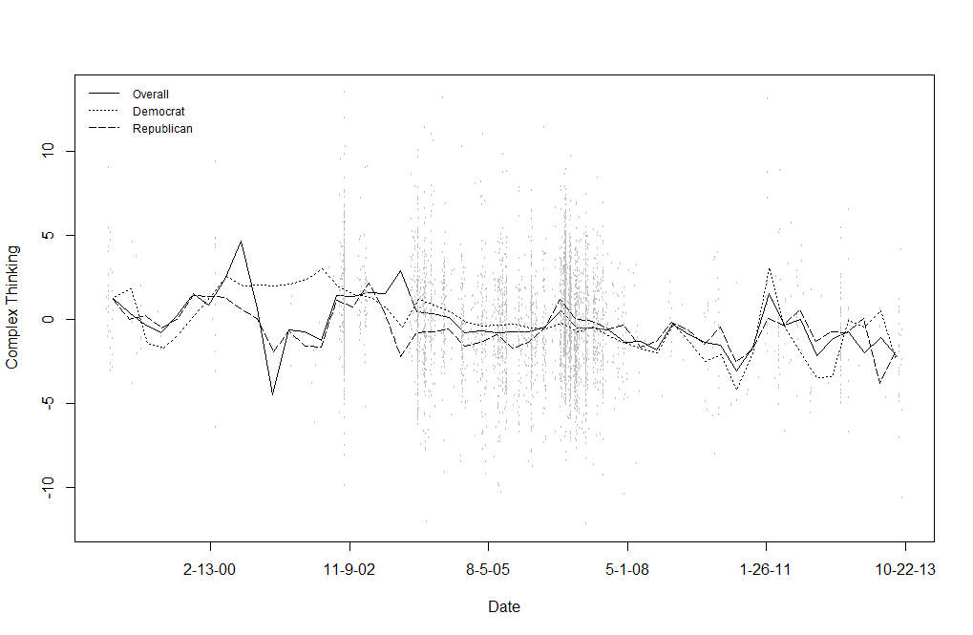Figure 1*. Changes in complex thinking in congressional speeches about U.S. foreign policy with Iraq over time. Points represent individual speeches given.

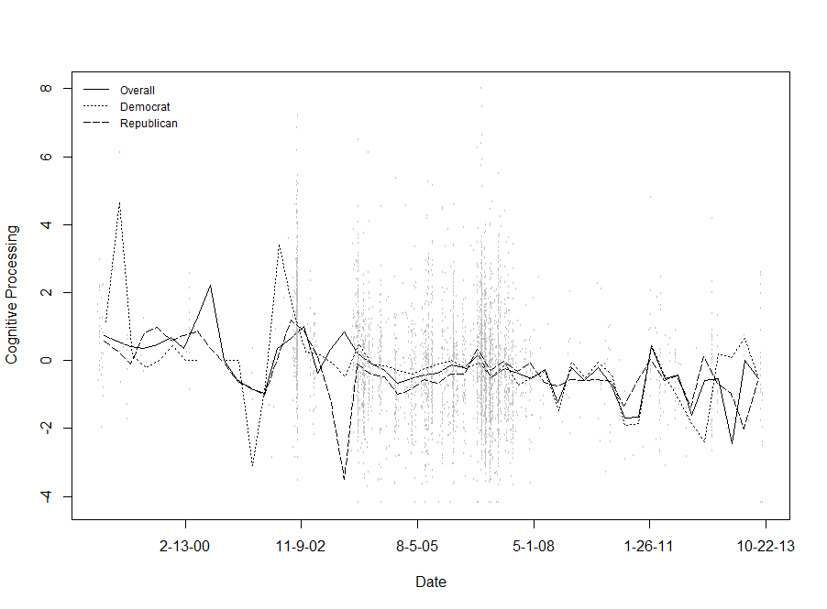

*Figure 3*

Changes in cognitive processing in congressional speeches about U.S. foreign policy with Iraq over time. Points represent individual speeches given.

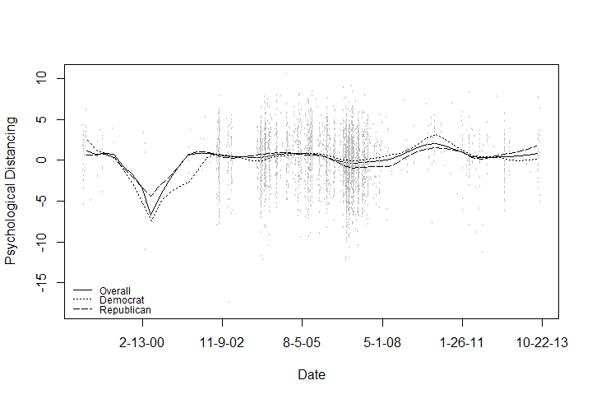 *Figure 5*

Changes in psychological distancing in congressional speeches about U.S. foreign policy with Iraq over time. Points represent individual speeches given.

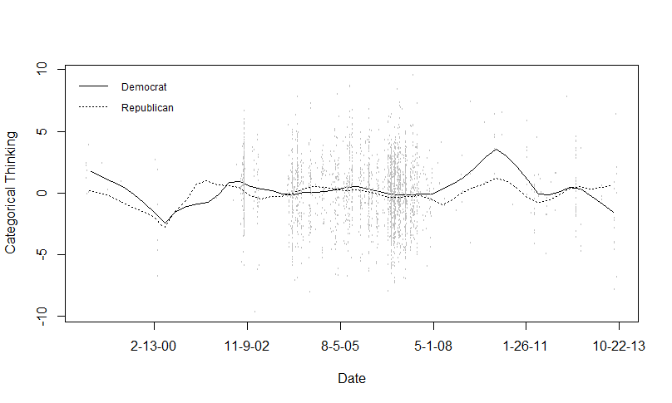

*Figure 7*

Party differences in categorical thinking in congressional speeches about U.S. foreign policy with Iraq over time. Points represent individual speeches given.