Team Science: Examination of Factors Associated with Citation Metrics
Kelly Cuccolo¹, Jordan Wagge², John E. Edlund³, & Erin M. Buchanan⁴
¹ Independent Researcher
² Avila University
³ Rochester Institute of Technology
⁴ Harrisburg University of Science and Technology

Author note
The authors thank the Elsevier Research Team for their help in coding for this project. Publication meta-data was provided through a grant obtained from Elsevier’s International Center for the Study of Research (ICSR) which provided access to meta-data collected by Elsevier.
The authors made the following contributions. Kelly Cuccolo: Conceptualization, Writing - Original Draft Preparation, Writing - Review & Editing; Jordan Wagge: Conceptualization, Writing - Original Draft Preparation, Writing - Review & Editing; John E. Edlund: Conceptualization, Writing - Original Draft Preparation, Writing - Review & Editing; Erin M. Buchanan: Conceptualization, Writing - Original Draft Preparation, Writing - Review & Editing, Analysis, Visualization.
Correspondence concerning this article should be addressed to Erin M. Buchanan, 326 Market St., Harrisburg, PA 17101. E-mail: ebuchanan@harrsiburgu.edu

Abstract
Scientific collaboration, often measured through co-authorship, has grown in many disciplines and is frequently linked to increased citation rates. However, it remains unclear which disciplines have seen the greatest growth in collaboration and how this growth relates to article-level metrics. Moreover, little is known about how team demographics (e.g., h-index, gender, number of institutions) interact with team size to shape research impact. Understanding these dynamics is essential given their influence on hiring, tenure, and the broader scientific ecosystem. Using metadata from Elsevier’s International Center for the Study of Research (ICSR) Lab, we examined collaboration trends across disciplines and their associations with citation outcomes. Team size increased over time, with variation by discipline, and was positively associated with citation counts. Gender effects on citation rates varied by authorship order and discipline, indicating a complex relationship between gender and impact. Greater institutional and geographic diversity were linked to citation advantages. Last authors’ h-indices were especially predictive of impact, particularly when self-citations were excluded. These findings highlight how evolving patterns of collaboration influence research visibility and underscore the importance of considering team composition in evaluations of scientific output.
Keywords: collaboration, publication, citation rates, authorship

Team Science: Examination of Factors Associated with Citation Metrics
Scientific collaboration (i.e., co-authorship) has been increasing in many fields of study, such as biomedical sciences (Papatheodorou et al., 2008), medicine (Weeks et al., 2004), and psychology (Zafrunnisha, N., & Reddy, V. P., 2010). Notably, scientific collaboration is one factor that may positively influence article metrics (e.g., citation rates, Larivière et al., 2015; Wuchty et al., 2007), although the extent of this effect may vary by field (e.g., physics, Hinnant et al., 2012). Within scientific collaboration, additional characteristics of the authorship team may exert influence on these metrics. Authorship team diversity is a key factor to be considered when looking at the impact of collaboration on article metrics. Author diversity, broadly speaking, has been associated with positive outcomes such as publication in high-impact factor journals, rates of citations, and funding (Freeman & Huang, 2015; Nichols, 2014). It is important to note that author diversity can be conceptualized along a continuum of factors such as gender, physical location (e.g., United States, Brazil), institutional affiliation, discipline, and rank. Evidence suggests the impact of international collaboration, rank, and gender on article metrics in fields such as sport science research (Wang et al., 2015), physics (Hinnant et al., 2012), and psychology (Geraci et al., 2015), respectively, but a gap exists in which the accumulation of these factors over time and across disciplines has not yet been addressed. As such, this project aims to understand: 1a.) What is the pattern of team size distribution within various disciplines over time, 1b.) is team size related to article impact?, and 2.) What characteristics of team composition have the greatest influence on article metrics?

Question 1. What is the pattern of team size distribution within various disciplines over time, and is team size related to article impact?
Science is becoming increasingly collaborative; evidence for this trend includes an increase in co-authored peer-reviewed publications (compared to single-authored) as well as initiatives, calls, and funding opportunities for collaborative research from both private and public/government sectors (Wuchty et al., 2007). Further, some argue that scientific collaboration and large interdisciplinary/international teams are needed to effectively address modern societal questions and problems (Samarasekera, 2009). Indeed, team size (i.e., number of co-authors) has been increasing in recent years across various disciplines (Papatheodorou et al., 2008), including science and engineering, social sciences, and arts and humanities (Wuchty et al., 2007). While some research suggests an overall trend toward collaboration (Wuchty et al., 2007), these findings do not appear to apply to all disciplines equally.
Within the natural/physical sciences, subdisciplines vary in their collaborative growth. For instance, the average team size in physics has doubled over the last 45 years, whereas for mathematics, the growth appears slower - with the average team size rising from 1.22 to 1.85. Grossman (2002) corroborates this effect, noting that for mathematics, the average number of collaborators has grown since the 1940s, with 1 in 8 papers having 2+ authors. On the other hand, a review of four major musculoskeletal science journals noted approximately a doubling in the number of co-authors on a publication (3.67–7.3) over the last 30 years (Russell et al., 2019). Likewise, biology has noted decreases in single-authored papers across specific subareas (e.g., Ecology, Genetics, Zoology, and Botany, Nabout et al., 2015).
Among the social sciences, a pattern of increasingly collaborative authorship emerges. For example, sociology has reported increases in both collaboration and the average number of authors per publication during the period from 1935 to 2005 (Hunter & Leahey, 2008). Specific publication outlets in psychology (e.g., Journal of Applied Psychology, Kozlowski et al., 2017) have seen increases in co-authored and decreases in solo-authored papers. Specific subfields of psychology have also noted similar changes in authorship trends (e.g., industrial-organizational psychology, De Meuse et al., 2014). Various branches of business, such as economics (Rath & Wohlrabe, 2016) and finance (Gaunt, 2014) have also noted increases in co-authorship.
Practically speaking, collaboration might offer important benefits to authors, as the number of authors appears to be associated with article impact (i.e., citation rates). Among publications indexed in the annual volumes of the Web of Knowledge™ in 2007, single-author papers received an average of 2.91 citations while multi-author papers exhibited an average of 5.39 (Thijs et al., 2015); this difference was consistent when examining citation averages from 1998 to 2007. Further probing this relationship, it appears that the number of citations increases with the number of authors, up to a point (approx. 20 authors) after which the relationship becomes inconsistent. As such, collaboration may be rewarded by increased impact.
While most of the available research points to a positive relationship between collaboration and citations, the available research tends to examine manuscripts published in a narrow time frame (e.g., ten years, Abu & Verma, 2019), and often looks at fields in isolation, specific journals (De Meuse et al., 2014), and/or specific geographical regions (Leifeld et al., 2017). As such, it is unclear how various disciplines have embraced collaboration over time and whether there has been any associated impact.

Question 2. What characteristics of team composition have the greatest influence on article metrics?
Although several disciplines report increases in co-authorship over the past several decades, it is important to ask the question of who is publishing, and with whom. Generally speaking, despite increases in women’s representation in academia, women still are underrepresented when it comes to publishing co- and solo-authored papers (Jagsi et al., 2006). In addition to authoring a smaller proportion of published work, research suggests women are also less likely to hold prominent authorship positions (Rigg et al., 2012; West et al., 2013). For example, women are underrepresented regarding publishing articles in specific areas of medicine (Cushman, 2022; Süßenbacher et al., 2017), STEM fields (e.g., mathematics, Mihaljević-Brandt et al., 2016), and social sciences (Bonham & Stefan, 2017; Mihaljević-Brandt et al., 2016), although the extent of these differences vary by subfield (e.g., computational biology, as compared to biology in general, Bonham & Stefan, 2017). Interestingly, women are less likely to collaborate with previous co-authors compared to men (Zeng et al., 2016); although it is not clear why this is the case, it could have important implications for their careers as novel teams tend to produce higher-impact work (Katzenbach & Smith, 2003).
Furthermore, women are less likely to receive credit for their contributions to empirical and scholarly work (Ross et al., 2022). A growing body of research suggests that contributions by women to peer-reviewed publications are often perceived as less valuable than those authored by men. After controlling for the year of publication, publication outlet, focus, theoretical framework, methodology, tenure status, and institutional affiliation, women were still cited less than men (Maliniak et al., 2013). Relevant to this manuscript is the body of research examining the association between gender and citation rates. Previous work has noted that in specific fields, men are less likely to cite women’s work and work authored by women typically receives fewer citations overall (Cameron et al., 2016; Hutson, 2002). This difference in the likelihood of accumulating citations could influence a researchers’ impact (Rezek et al., 2011), which is often considered important for career advances.
One objective measure of a scholar’s output and impact is the “h-index” (Hirsch, 2005). The h-index combines the number of articles published with the number of citations received for those articles. This approach attempts to balance high-impact articles with the number of articles published. Specifically, the h-score is the number of articles (X) that receive X citations. The h-index is one of the most widely used and accepted measures of a scholar’s impact (Crespo & Simoes, 2019). Fields such as psychology have observed gender differences pertaining to h-indices that favor men. Women professors have a significantly lower h-index than men, with a difference of approximately four points. After controlling for the year of first publication, gender shares approximately 2.6% of the variance with h-index (Geraci et al., 2015). This effect was examined relative to mean salaries for full professors, and practically translated to an astounding effect of $13,100 a year difference between men and women (Geraci et al., 2015).
Notable is that the calculation of h-indices may be particularly biased by self-citations and years without publication. Higher rates of citations received by men were partially explained by high rates of self-citation which altered scores up to 14 extra h-index points. Women also engaged in self-citation, although less so, and only impacting their h-index by up to 5 points (Cameron et al., 2016). It is important to note that there is evidence of increasing equity between genders in certain fields; in international relations, for example, the gap between men’s and women’s manuscript submissions and publications are narrowing, and there appears to be no significant relationship between gender and citation count (Østby et al., 2013). Although there are alternatives to the h-index that account for self-citations (e.g., the b-index, Brown, 2009), the h-index is popular and generally accepted as a robust bibliometric tool.
Given the arguments regarding the necessity of scientific collaboration and large international teams to address modern societal questions and problems (Samarasekera, 2009), it may be intuitive that institutional and geographical diversity is on the rise. One source notes an increase in Psychology articles that have the presence of both a U.S. author and at least one international co-author (Kliegl & Bates, 2011). Similar increases in the fraction of internationally co-authored papers (i.e., ratio of co-authored articles with international institutions to the total number of co-authored articles with domestic and international institutions) were noted in other scientific disciplines, such as mathematics, biology, medicine, and engineering (Coccia & Wang, 2016). However, while it appears most fields are increasing international engagement, applied fields (especially medical sciences) have higher rates of growth (Coccia & Bozeman, 2016).
Collaboration involving those outside of one’s home institution and country may significantly impact article metrics, which may be one reason for the increasing rates of international collaboration. For instance, for UK institutions indexed in the Science Citation Index between 1981 and 1994, collaboration within one’s home university or country resulted in a small increase in average impact (0.75 citations) whereas collaboration outside of one’s home country resulted in a more moderate increase [1.6 citations; Katz and Hicks (1997)]. Indeed, both well-established and young institutions benefit from international collaboration as evidenced by a citation per paper increase when the authorship team is international (Khor & Yu, 2016). This benefit is corroborated by the observation that international co-authorship publications are over-represented in the ESI global top 10 % highly cited publications relative to all journal publications from the same institution (Khor & Yu, 2016). Indeed, article impact in terms of citations per paper seems to be greatest for those manuscripts with multiple domestic and international collaborators, and the smallest for those with no institutional collaboration.
However, this trend may not be consistent across fields, journals, and/or countries, and warrants further investigation (Hinnant et al., 2012; e.g., physics, Rousseau & Ding, 2016). For example, international collaboration generally increases citation rates in the field of sports science, but the extent of this effect varies by which countries are collaborating (Wang et al., 2015). Collaboration between the United States and Canada, for instance, produced a mean citation rate greater than the domestic mean observed citation rate of each country respectively, whereas collaboration between the United Kingdom and Greece produced a mean citation rate that was lower than the domestic mean observed citation rate of each country respectively. Furthermore, when examining the benefits of international collaboration on citation count for American authors publishing in the top three interdisciplinary journals (Proceedings of the National Academy of Sciences [PNAS], Nature, and Science), there is an increased citation rate for international collaboration when compared to American-only authored papers (Rousseau & Ding, 2016). It is important to note that this effect was the result of a significant increase in citation rate for international papers published in PNAS only. When examining each journal independently, no benefit of international collaboration was found for Science or Nature. Given the accelerated growth of international collaboration across various fields over time (Coccia & Bozeman, 2016; Walsh & Maloney, 2007), it is increasingly important to understand the influence of this diversity on article metrics.
The majority of work examining team characteristics and article metrics have focused on a specific field (Hinnant et al., 2012), and/or a limited/restricted number of team characteristics (e.g., size, Wuchty et al., 2007). Empirical data comparing the impact of diverse/multiple team characteristics on article metrics within a given field is limited (Grossman, 2002; Hinnant et al., 2012; Nabout et al., 2015; Wang et al., 2015; Weeks et al., 2004). Along a similar vein, empirical data comparing the impact of team characteristics on article metrics across fields is also limited (for notable exceptions, Larivière et al., 2015; Wuchty et al., 2007). Comparing outcomes within and across fields can allow for an increased understanding of these fields’ scientific culture. Practically, understanding factors associated with an article’s impact can be important for researchers’ outreach, as well as planning for the job market and tenure review.

Method

Ethics Information
All of the data for this manuscript is drawn from peer-reviewed journals. All of the extracted meta-data from the individual publications are de-identified in the database. As such, per US Federal Guidelines, this research is not subject to human ethics review boards (§46.101, (b) (4)).

Design
This study was an archival data investigation into scholarly publication records using Elsevier’s curated database Scopus. This study was conducted through access to Elsevier’s International Center for the Study of Research Lab (ICSR; https://www.elsevier.com/icsr). The ICSR is designed to support researchers in their empirical study of meta-science on large datasets using the Databricks platform running Apache Spark architecture for big-data analyses. Through ICSR, researchers can access full publication metadata from Scopus including article metrics, author(s), and affiliation information. Scopus is a global database of abstracts and citations containing a wide representation of content, including articles, books, and conference proceedings (Boyle & Sherman, 2006). Scopus contains over 80 million entries from 1788 to present curated by a team of experts to ensure quality metadata and inclusion of appropriate publications. All variables extracted from this dataset are described below.

Variables.
Article characteristics included the year of publication, number of authors (team size), and discipline. Discipline will be defined at the All Science Journal Classification (ASJC; https://service.elsevier.com/app/answers/detail/a_id/15181/supporthub/scopus/) using the five global subject area codes (Health, Physical, Life, Social Sciences, and Multidisciplinary). Metric characteristics included citation count (the number of times an article was cited within the current data snapshot) and weighted citations. Field-weighted citations indicated the number of citations in the last five years. We excluded articles within the last five years for the field-weighted citation counts to ensure consistency for this variable.
Author characteristics included affiliation country, affiliation/institution, h-index, gender, and gender ratio. We transformed affiliation countries into a count variable of the number of unique countries. Similarly, we transformed affiliation/institutions into a count of the number of different affiliations across authors. We used the h-index of the first and last authors for each article, with and without self-citation. Last, Elsevier has noted that their inferred gender column has a 97% accuracy, and we used the inferred gender of the first and last authors for each article. From this variable, we additionally calculated the gender ratio (number of inferred male / total authors) as a single variable for each article.

Sampling Plan.
While Scopus includes articles from 1788 to present, we limited our sample to journal articles published from 1970 until present. Scopus indicates that articles from 1970 to present include reference information, which will be required to calculate several of the above mentioned variables. Only journal articles from this time period will be included sampled at a rate of 25% of eligible articles. We will include the analysis date to indicate the data available at the time of analysis. We originally included all articles from 1970 and forward. Due to computational constraints, we randomly sampled 25% of eligible articles during this time span to constrain the run time of our code and the memory necessary to calculate h-index. It is important to note that we did not calculate h-index on the randomly sampled dataset. These values were calculated on the full data and then merged with the randomly sampled data to ensure h-indices were appropriate for authors on the randomly sampled data.

Power.
Given the large size of the Scopus dataset, all analyses are expected to achieve the required 95% power. Analyses using the pwr library (Champely et al., 2017) indicated that planned regressions have the ability to detect effects at $R^{2}$ < .00001 at 95% power using a 95% confidence interval.

Analysis Plan

Data Availability.
While we cannot provide access to the full dataset because it is only accessible through access granted by Elsevier, we will provide our analysis code via GitHub and the Open Science Framework. Persons interested in replicating or extending the current work can do so through using the ICSR lab Databricks platform. ICSR has stated to the paper’s authors that they will guarantee access to researchers who want to follow up or reproduce our results.

Code Availability.
We were allowed to use a small subset of cases (1%) to create the analysis code for the proposed research questions. This code and output are available at https://osf.io/g4qnp/ and https://github.com/doomlab/big_team_size. Our study was preregistered at https://osf.io/j63fd, which includes an update due to deviations from the original plan. The code used to create this manuscript with the papaja package (Aust et al., 2022) can be found online as well.

Data Screening.
Missing data was excluded for the analyses in which the data was missing only. We assumed all data is accurate. In all analyses, we examined the cell counts for each categorical variable to collapse small cell sizes (i.e., n < 5). No articles will be considered an outlier, as all publication data was expected to be part of the population.
In each relevant analysis, we examined for multicollinearity of the IVs, as team size may positively correlate with count variables calculated in later research questions. If values are multicollinear, r > .90, we planned to note these correlations and only use one of the proposed variables. No values reached this criteria for the five subject areas. The size of the dataset implied the assumption of normality. In our analyses, a linear trend was the main focus of interest, and we did not note any non-linear trends. Last, nearly all scatter plots indicated heteroscedasticity. Please see Appendix A for further details.

Decision Criteria.
The large sample size was expected to indicate all predictors significant at the traditional p value criterion. For individual predictors, we used the 95% confidence intervals of the slope to indicate if the effect is non-zero (i.e., the confidence interval does not include zero rounded to three decimals). The difference between effects will be determined by examining the confidence intervals of $R^{2}$ to three decimal places calculated with the MBESS library (Kelley, 2022). If they do not overlap, we will state that they are different.

Research Questions.
All analyses were performed using pyspark (PySpark Documentation PySpark 3.3.0 Documentation, n.d.) within the Databricks system. Visualization and presentation of analyses were included using R (R Core Team, 2022), dplyr (Wickham et al., 2020), rio (Becker et al., 2021), tidyr (Wickham, 2020), patchwork (Pedersen, 2020), and ggplot2 (Wickham, 2016).
Research Question 1a: What is the pattern of team size distribution within various disciplines over time?
We first calculated the mean, median, and interquartile range of team size by subject area. We did not explicitly compare discipline intercepts in a post hoc format with any form of test. Instead, we present visualizations to display the distribution and their interquartile range for readers to examine.
In order to determine if team sizes change overall across time, we used a linear model of team size predicted by year of publication in which each article was only represented once, regardless of discipline. We examined if the confidence interval of the slope parameter was different from zero to determine if the predictor was significant. Last, we calculated each subject area’s slope and confidence interval using a linear model of team size predicted by year of publication. Again, we provide these slopes in a visualization for readers to examine with no official post hoc comparison. While a multilevel model would allow us to embed all disciplines within one model, no pyspark multilevel model implementation exists to model data at this scale.
Research Question 1b: Is team size related to article impact?
For this research question, we examined the impact of team size on article publication metrics for impact. Our hypothesis was that team size impacts article metrics (non-directional). We ran these analyses once for each dependent variable of citation count and weighted citation five-year count. We calculated the mean, median, and interquartile range of each publication metric by discipline. We provide visualizations of these values instead of comparing them directly.
To determine the impact of team size on publication metrics, we used a linear model of publication metrics predicted by time of publication (covariate) and team size. We included time as a covariate, as we expected that older articles would potentially have more or different metrics because they have been around longer to cite. We examined if the confidence interval of the team size slope parameter was different from zero. Last, we calculated the slope for team size for each subject area separately. We visualized these differences and the confidence intervals.
Research Question 2: What characteristics of team composition have the greatest influence on article metrics?
For this research question, we continued to use the model from the previous research question and added other article metrics to determine their contribution to the model. Our hypothesis was that each variable impacts the metrics variables (non-directional). Each author independent variable will be modeled separately and compared using confidence intervals as described above to determine which variable had the strongest impact on publication metrics.
Using the linear model from the previous research question, we added each author independent variable (affiliation country count, affiliation/institution count, h-index, gender (male versus female), and gender ratio) in separate models to calculate their slope. We determined if these slopes were important by examining if their confidence interval was greater than zero. We examined the effects of each author metric separately. When examining first and/or last author information, the single author paper presents a unique problem because they are both first and last authors. Therefore, these cannot be included in the same model. In order not to use the same variance twice, single author papers will be treated as first author only, and missing data for last author analyses. If these were included in the same model, all single author papers would be dropped, which would bias the results. We will then compare each overall $R^{2}$ to determine if their confidence intervals overlap. This analysis was used to indicate which author variable provided the most predictive information (since all other covariates are the same for each analysis, only the author variable is different). Last, we calculated each author independent variable separated by subject area and then visualized those $R^{2}$ and confidence intervals for each variable.

Results

Research Question 1a: What is the pattern of team size distribution within various disciplines over time?

Descriptive Statistics.
Figure 1 displays the mean, standard deviation, median, and interquartile range for each subject area. The median was generally five to six authors, except for the social sciences, which had a median of three authors per manuscript. Mean values were generally from four to nine authors, with the most variability in team size for the physical sciences.
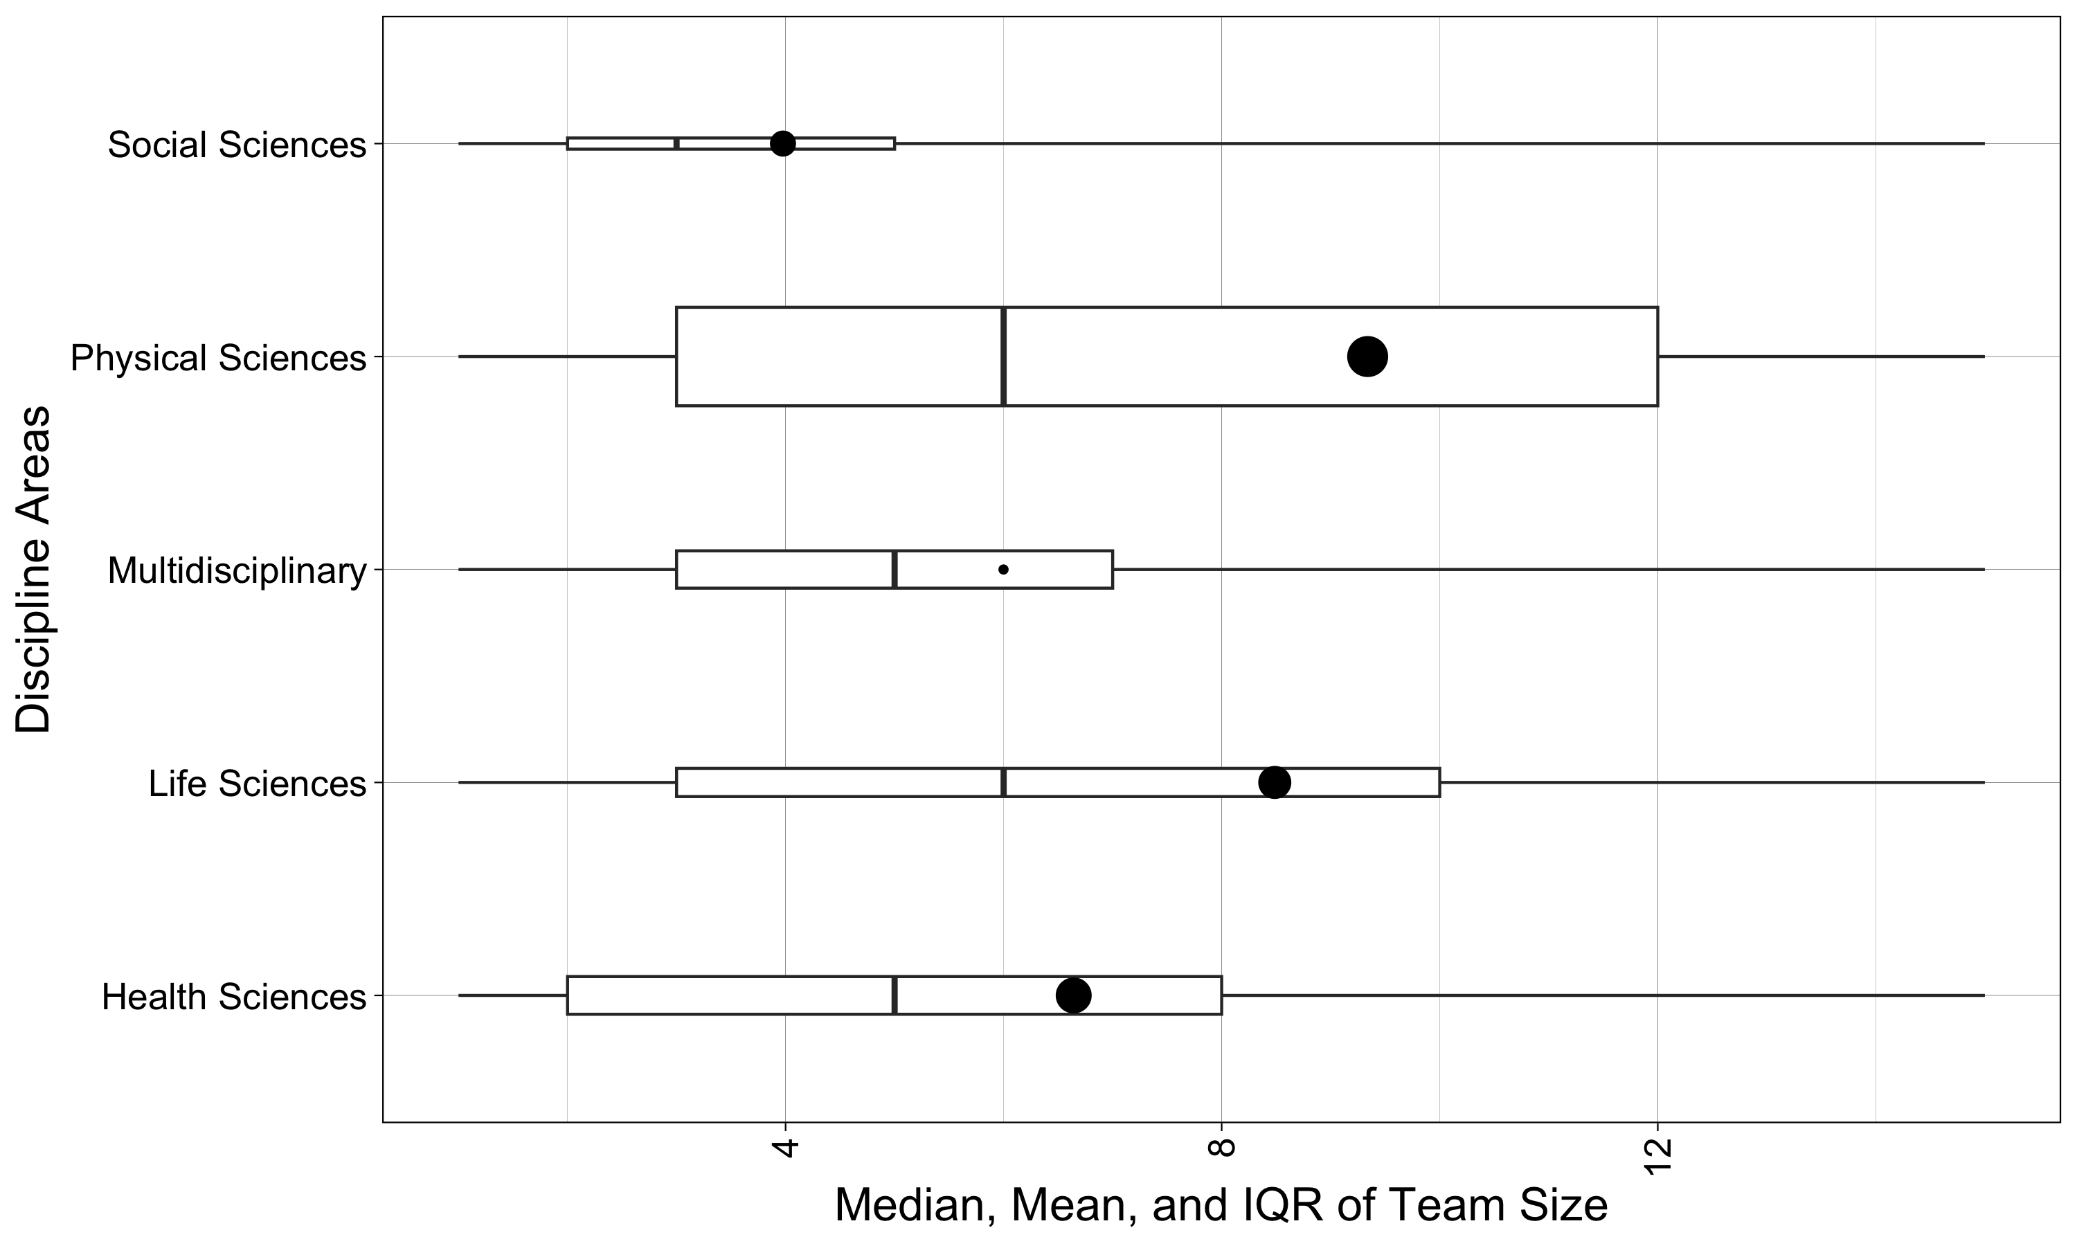
Figure 1. Boxplot of team size by subject areas. The boxplot represents the median (middle bar), the interquartile range (box), and the mean (dot) for each subject area. The plot was capped at 15 for visualization purposes. The size of the mean point represents the sample size of the number of articles used within the calculation. The size of the box represents the standard deviation of the mean for team size (i.e., larger boxes indicate more variance in the team size).

Model Statistics.
The regression analysis for team size predicting year was different from zero, b = 0.08, 95% CI [0.08, 0.08]. This result indicated that team size increases across time, wherein overall team sizes are likely to increase by at least one author every 13 years. Figure 3 shows the results by subject area. All subject area coefficients were greater than zero, where health and life sciences were similar, physical sciences had the highest team size growth, and social sciences had the lowest. The coefficients are presented with their 95% confidence interval in Appendix A.

Research Question 1b: Is team size related to article impact?

Descriptive Statistics Citation Count.
Figure 2 displays the mean, standard deviation, median, and interquartile range for the citation counts and five-year citation count statistics. Multidisciplinary papers appear to have the highest median and mean citation counts, followed by life and physical sciences, and then social and health sciences. The pattern of results is similar for both overall citation counts and five-year citation counts.
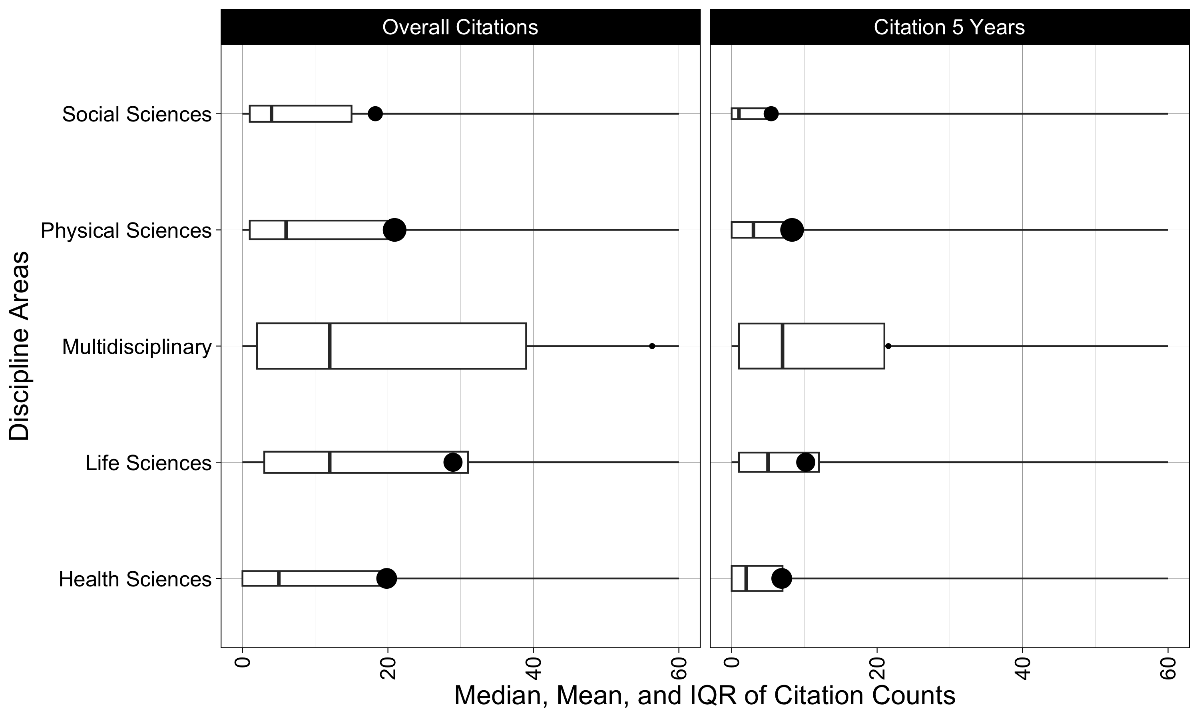
Figure 2. Boxplot of citation counts by subject area. The boxplot represents the median (middle bar), the interquartile range (box), and the mean (dot) for overall citations and five year citation count. The plot was capped at 60 citations for visualization purposes. The size of the mean point represents the sample size of the number of articles used within the calculation. The size of the box represents the standard deviation of the mean for citation count (i.e., larger boxes indicate more variance in the citation counts).

Model Statistics.
Team size was used to predict citation count, while controlling for year, which was different from zero, b = 0.12, 95% CI [0.12, 0.13]. Five year citations had a similar result, b = 0.11, 95% CI [0.11, 0.11]. These results indicated that approximately 10 extra authors resulted in at least one more citation count. The bottom of Figure 3 shows the results by subject area. Each subject area showed a coefficient greater than zero, but the overall effect size for the physical sciences was not different from zero. Multidisciplinary and social sciences showed the largest effects and coefficients, followed by life and health sciences. Each additional team member could represent up to two extra citations for research manuscripts. The coefficients are presented with their 95% confidence interval in Appendix A.
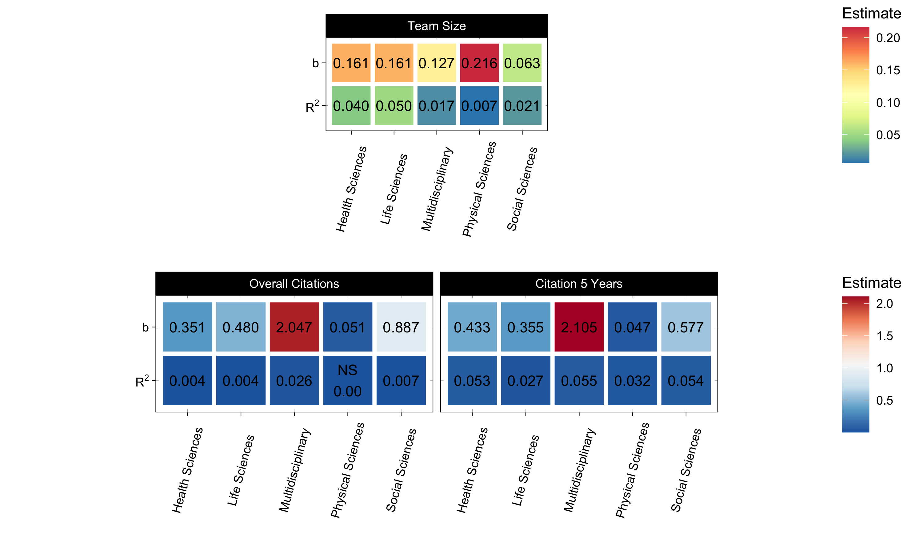
Figure 3. Heatmap of results for coefficients of team size predicting year (top), and team size predicting citation counts while controlling for year (bottom). The effect sizes are also presented for comparison across subject areas.

Research Question 2: What characteristics of team composition have the greatest influence on article metrics?

Model Statistics Overall.
Each author variable was added to the previous model of team size and year predicting citation counts and five-year citation counts. Appendix A includes the coefficients for each of the author variables and dependent variable combinations. Figure 4 displays both the coefficients and effect sizes for each independent and dependent variable combination. All coefficients and effect sizes were different from zero. In general, all effects were positive, with one exception (gender percent). Increasing numbers of countries and/or institutions would correspond to increasing numbers of citations with a stronger effect for more countries than institutions. h-index increases for first or last author increased the number of overall citations. Papers received more citations if the first or last author was male, but the effect was stronger if the first author was male. Last, the only negative predictor was the percent of males included on a manuscript (as compared to female, unknown, and missing values). As the overall proportion of males increased, the number of citations decreased. The coefficients indicate that the effects for each of these variables is stronger (i.e., higher b values) for overall citations, but the effect sizes indicate more variance accounted for when explaining five-year citation rates.
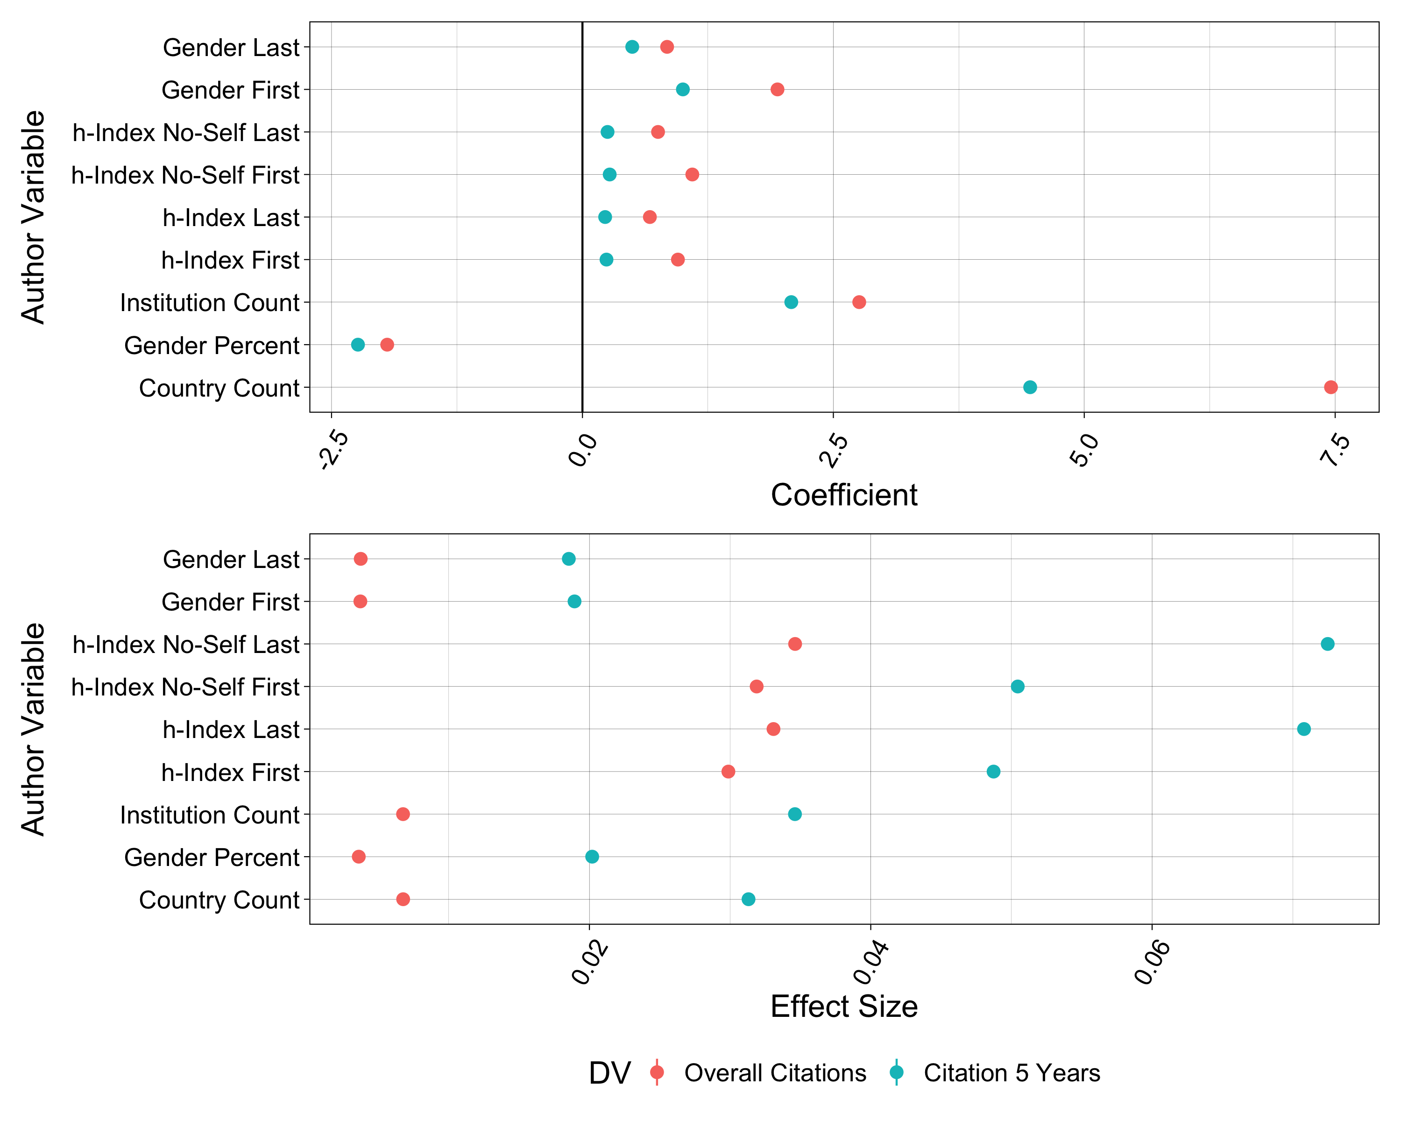
Figure 4. Author variable coefficients (top) and effect sizes (bottom) predicting citation counts and five year citation counts. 95% confidence intervals are displayed but are very narrow due to large sample size. Appendix A includes all exact values for reference.
Last, these analyses were separated by subject area. Figure 6 displays the coefficients, and Figure 5 portrays the $R^{2}$ effect sizes for each independent and dependent variable combination. All coefficients and effect sizes were non-zero using our confidence interval criterion. Appendix A includes exact coefficients and effect sizes for each of the author variables and dependent variable combinations. We will examine the patterns of interest below.
Gender. These results indicate different effects for gender from the overall statistics. Multidisciplinary statistics for gender are always negative when examining male versus female first and last authors. This result indicates that female authors often see higher citation counts than male authors. The life sciences split into positive and negative - papers receive more citations, with a female author in last place, while male authors in the first author slot receive more citations. All other gender comparisons are positive, resulting in male-authored papers receiving more citations. Gender percentage is also split between negative and positive coefficients. The social sciences largely drive this effect, wherein papers with larger proportions of male authors receive significantly fewer citations. Health sciences also included negative gender percent predictions. Interestingly, the physical sciences showed a negative effect for the proportion of males on five-year citation rates, but a positive effect on overall citation rates. The life sciences and multidisciplinary subject areas were both positive effects.
Country and Institution. Country and institution counts both increased the number of citations. These effects were always larger for the overall citations than the five-year citation counts; however, the effect sizes were again always larger for five-year citation models than overall citation models.
h-index. The general pattern for h-index effects were positive with larger effects for no-self citations versus including self-citations and first author versus last author. Multidisciplinary papers and the social sciences also tended to have the largest increase in citation counts when authors with higher h-indices were included on a manuscript. These coefficients were generally stronger for overall citations, but again, the effect sizes were often larger for five-year citation patterns.
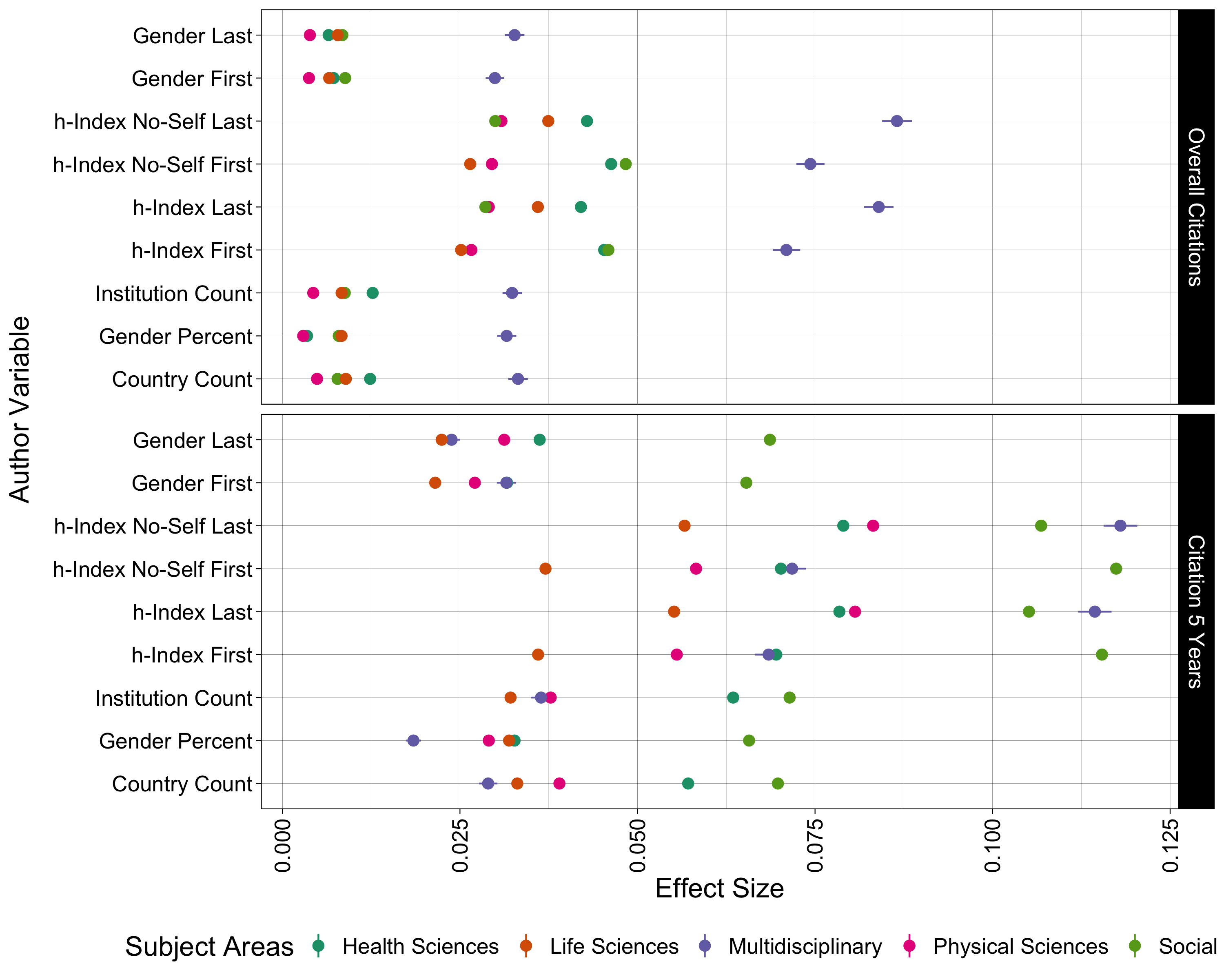
Figure 5. Author variable coefficients predicting citation counts and five year citation counts separated by subject area. 95% confidence intervals are displayed but are very narrow due to large sample size. Appendix A includes all exact values for reference.
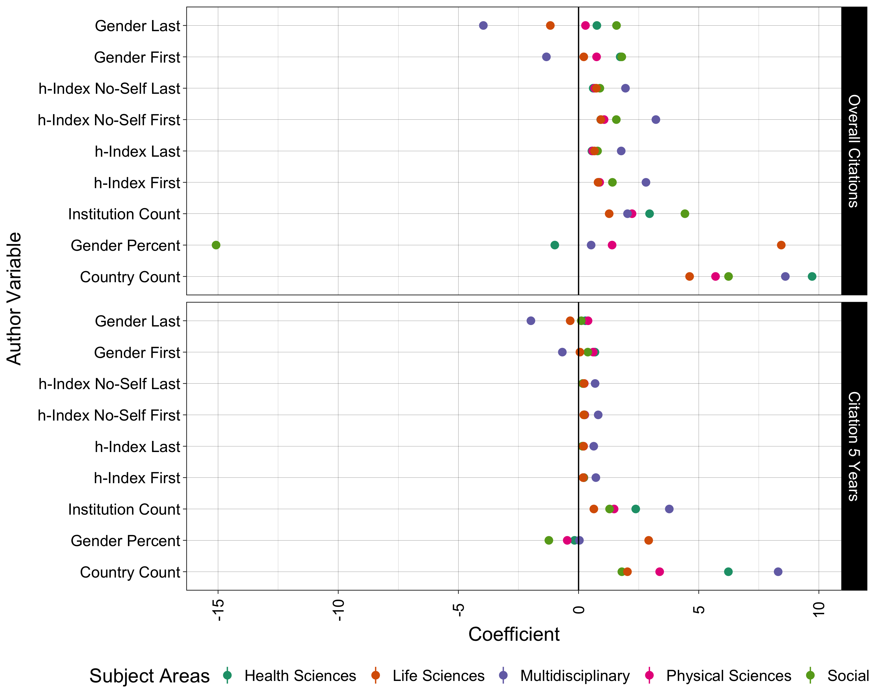
Figure 6. Author variable coefficients predicting citation counts and five year citation counts separated by subject area. 95% confidence intervals are displayed but are very narrow due to large sample size. Appendix A includes all exact values for reference.

Discussion

Question 1. What is the pattern of team size distribution within various disciplines over time, and is team size related to article impact?
The first research question in this paper addressed the pattern of team size distribution within various disciplines over time and the relationship between team size and article impact. Our findings indicate a consistent increase in team size across disciplines, corroborating previous research on the expansion of scientific collaboration (Larivière et al., 2015; Wuchty et al., 2007). The trend was most pronounced in the physical sciences, aligning with reports of a substantial rise in team sizes in physics and musculoskeletal science over the past few decades (Nabout et al., 2015; Russell et al., 2019). Notably, the social sciences exhibited the lowest median number of authors per manuscript, a trend that may reflect long-standing disciplinary norms favoring single or small team authorship (Henriksen, 2016).
Similarly, while growth was seen in the social sciences, this discipline had the lowest median number of authors per manuscript. In psychology, for example, this may be due to the long periods of solo-author dominance, followed by a rise in teams of two and, recently teams of three [at least based on specific journal metrics; Kozlowski et al. (2017)]. Henriksen (2016) notes that co-authorship has grown in the social sciences between 1980 and 2013, but the median number of authors per article remains low relative to other disciplines. Interestingly, Paul-Hus et al. (2020) explain that while co-authorship remains low in the social sciences, when taking acknowledgments into consideration, the total number of contributors more closely resembles that found in other disciplines. Looking at authorship and acknowledgment trends concurrently may represent an important area of future research that illuminates authorship norms among various disciplines and guides conversations about crediting. Despite this variation, the broader increase in co-authorship aligns with the the necessity of interdisciplinary and large-scale collaborations to address complex scientific challenges (Samarasekera, 2009). These trends may be influenced by funding opportunities favoring collaborative efforts, the need for diverse expertise in tackling intricate research questions, and the growing complexity of modern scientific inquiry.
Our analysis also confirms a positive association between team size and article impact, as measured by citation counts, reinforcing previous findings that collaborative works tend to garner more citations (Thijs et al., 2015; Wuchty et al., 2007). One potential explanation is the increased dissemination of collaborative research through multiple authors’ networks, leading to broader recognition and citation. Furthermore, larger teams may contribute to higher-quality research outputs due to collective expertise, improving the robustness and credibility of findings (Larivière et al., 2015). However, while the relationship between team size and citations appears generally positive, it is not necessarily linear. Prior studies have suggested that citation benefits plateau beyond a certain threshold (e.g., approximately 20 authors), indicating diminishing returns for excessively large teams (Sharma, 2021). Future research should explore potential moderators, such as discipline-specific authorship norms and the role of team leadership in fostering impactful collaborations.

Question 2. What characteristics of team composition have the greatest influence on article metrics?

Gender.
Gender composition emerged as a significant factor influencing citation rates, though its effects varied by discipline. This variable exhibited a nuanced relationship with citation counts, which may reflect disciplinary norms regarding authorship position, scientific networks, gender biases, systemic inequities in academia, and other unknown factors. Consistent with prior research, our results indicate that male-dominated authorship teams tend to receive fewer citations in social sciences and health sciences, whereas in some disciplines, particularly the life sciences, male first authors were associated with higher citation counts (Maliniak et al., 2013; West et al., 2013). These findings suggest that gender biases in citation practices persist, with previous studies demonstrating that work authored by women is systematically under-cited, particularly in fields historically dominated by male researchers (Cameron et al., 2016).
In the life sciences, papers received more citations when there was a female author in the last place and male authors in the first spot. These findings may reflect the various authorship norms for life sciences subdisciplines, wherein the weight of one’s contributions is associated with particular authorship positions. In all other instances, male-authored papers received more citations. This aligns with previous research that highlights the systematic devaluation of women’s peer-reviewed contributions and research that is considered feminine (Ni et al., 2021) or that focuses on women’s issues (Mirin, 2021). Another possible explanation for the observed disparities is the tendency for women to engage in broader collaboration networks, which may enhance the visibility of their work (Zeng et al., 2016). However, systemic barriers, including inequitable crediting of contributions and biases in authorship order conventions, may still limit women’s perceived impact (Ross et al., 2022). Moreover, prior research suggests that gender gaps in citation rates may be exacerbated by self-citation practices, as men are more likely to cite their previous work, thereby inflating their citation metrics (Hutson, 2002).

Institution and Country.
Our findings highlight the citation advantages associated with institutional and geographic diversity. Collaboration across institutions and national borders was positively associated with citation counts, reinforcing prior studies indicating that international co-authorship enhances article visibility and impact (Katz & Hicks, 1997; Khor & Yu, 2016). Notably, multidisciplinary teams and collaborations spanning multiple countries yielded the highest citation rates, likely reflecting the increasing recognition of global, cross-disciplinary perspectives in addressing scientific challenges (Coccia & Wang, 2016). These results align with the argument that international collaborations facilitate access to diverse expertise and resources, enhancing research quality and its subsequent impact (Kliegl & Bates, 2011).
Beyond increased citation impact, international collaborations can also contribute to a more comprehensive and innovative approach to research questions by integrating diverse methodological perspectives and theoretical frameworks (Coccia & Bozeman, 2016). The exchange of ideas across different scientific traditions and institutional structures can lead to the development of novel insights and more rigorous analytical approaches (Wang et al., 2015). Additionally, researchers engaged in international partnerships may benefit from greater access to funding opportunities, as many governmental and private organizations prioritize collaborative, multinational research initiatives (Walsh & Maloney, 2007). However, challenges such as differences in institutional policies, language barriers, and variations in research infrastructure may also shape the effectiveness of these collaborations. Future research should examine how these structural and logistical factors impact collaboration outcomes and whether specific disciplines are more adept at leveraging international partnerships for research advancement.

h-Index.
The positive association between h-index and citation counts was evident across all disciplines, with stronger effects observed for last authors compared to first authors. This finding suggests that senior researchers with established publication records tend to attract more citations, potentially due to their reputation and extensive academic networks (Geraci et al., 2015). Interestingly, the relationship between h-index and citation count was more pronounced when self-citations were excluded, implying that high-impact researchers benefit from external validation rather than self-referential practices (Leimu & Koricheva, 2005). This highlights the importance of distinguishing between genuine academic influence and self-reinforcing citation behaviors when assessing scholarly impact. Additionally, scholars with higher h-indices may have greater access to institutional resources, mentorship opportunities, and visibility in high-impact journals, further compounding their influence on citation metrics. Future research should explore how variations in h-index across disciplines and career stages affect long-term scholarly impact.
The limitations of h-index as a universal metric must also be acknowledged. Since it does not account for field-specific citation norms, early-career researchers, or that those publishing in niche areas may be at a disadvantage. Alternative bibliometric indicators, such as the i10-index or g-index, may provide complementary insights into scholarly impact by addressing some of these limitations. Moreover, as open-access publishing continues to rise, its potential impact on citation disparities linked to h-index should be explored further.

Conclusion and Future Directions
In summary, our study underscores the growing prominence of scientific collaboration and its implications for research impact. While team size and interdisciplinary partnerships contribute positively to citation metrics, gender representation, and institutional diversity also play critical roles in shaping scholarly influence. These findings carry important implications for research evaluation, funding allocation, and institutional policies aimed at fostering equitable and impactful scientific collaboration. Future research should further investigate the causal mechanisms underlying these relationships, particularly in addressing potential biases in authorship recognition and citation practices. Additionally, exploring the intersectionality of gender, institutional affiliation, and career stage could provide a more nuanced understanding of how different factors collectively influence research visibility and impact. As the scientific enterprise continues to evolve, ensuring equitable and inclusive collaboration practices will be essential for maximizing the reach and significance of academic contributions.

References
Abu, K. S., & Verma, S. (2019). Authorship trends and collaborative patterns on annals of library and information studies. Library Philosophy and Practice, 1–11. https://au-ezproxy1.avila.edu/login?url=https://www.proquest.com/scholarly-journals/authorship-trends-collaborative-patterns-on/docview/2216882917/se-2
Aust, F., Barth, M., Diedenhofen, B., Stahl, C., Casillas, J. V., & Siegel, R. (2022). Papaja: Prepare american psychological association journal articles with r markdown. https://CRAN.R-project.org/package=papaja
Becker, J., Chan, C., Chan, G. C., Leeper, T. J., Gandrud, C., MacDonald, A., Zahn, I., Stadlmann, S., Williamson, R., Kennedy, P., Price, R., Davis, T. L., Day, N., Denney, B., & Bokov, A. (2021). Rio: A swiss-army knife for data i/o. https://cran.r-project.org/web/packages/rio/
Bonham, K. S., & Stefan, M. I. (2017). Women are underrepresented in computational biology: An analysis of the scholarly literature in biology, computer science and computational biology. PLOS Computational Biology, 13(10), e1005134. https://doi.org/10.1371/journal.pcbi.1005134
Boyle, F., & Sherman, D. (2006). Scopus: The product and its development. The Serials Librarian, 49(3), 147–153.
Brown, R. J. C. (2009). A simple method for excluding self-citation from the h -index: the b -index. Online Information Review, 33(6), 1129–1136. https://doi.org/10.1108/14684520911011043
Cameron, E. Z., White, A. M., & Gray, M. E. (2016). Solving the Productivity and Impact Puzzle: Do Men Outperform Women, or are Metrics Biased? BioScience, 66(3), 245–252. https://doi.org/10.1093/biosci/biv173
Champely, S., Ekstrom, C., Dalgaard, P., Gill, J., Weibelzahl, S., Anandkumar, A., Ford, C., Volcic, R., & De Rosario, H. (2017). Pwr: Basic functions for power analysis.
Coccia, M., & Bozeman, B. (2016). Allometric models to measure and analyze the evolution of international research collaboration. Scientometrics, 108(3), 1065–1084. https://doi.org/10.1007/s11192-016-2027-x
Coccia, M., & Wang, L. (2016). Evolution and convergence of the patterns of international scientific collaboration. Proceedings of the National Academy of Sciences, 113(8), 2057–2061. https://doi.org/10.1073/pnas.1510820113
Crespo, N., & Simoes, N. (2019). Publication Performance Through the Lens of the h-index: How Can We Solve the Problem of the Ties? Social Science Quarterly, 100(6), 2495–2506. https://doi.org/10.1111/ssqu.12696
Cushman, M. (2022). Women Authorship in Cardiovascular Science: A Call to Track and Report to Achieve Equity. Journal of the American Heart Association, 11(5), e025456. https://doi.org/10.1161/JAHA.122.025456
De Meuse, K. P., Tang, K. Y., & Feil, J. (2014). A critical analysis of topical content and authorship trends in applied psychology. TIP: The Industrial-Organizational Psychologist, 51(4).
Freeman, R. B., & Huang, W. (2015). Collaborating with People Like Me: Ethnic Coauthorship within the United States. Journal of Labor Economics, 33(S1), S289–S318. https://doi.org/10.1086/678973
Gaunt, C. (2014). Accounting and Finance : authorship and citation trends. Accounting & Finance, 54(2), 441–465. https://doi.org/10.1111/acfi.12061
Geraci, L., Balsis, S., & Busch, A. J. B. (2015). Gender and the h index in psychology. Scientometrics, 105(3), 2023–2034. https://doi.org/10.1007/s11192-015-1757-5
Grossman, J. W. (2002). Patterns of collaboration in mathematical research. SIAM News, 35(9), 8–9.
Henriksen, D. (2016). The rise in co-authorship in the social sciences (19802013). Scientometrics, 107(2), 455–476. https://doi.org/10.1007/s11192-016-1849-x
Hinnant, C. C., Stvilia, B., Wu, S., Worrall, A., Burnett, G., Burnett, K., Kazmer, M. M., & Marty, P. F. (2012). Author-team diversity and the impact of scientific publications: Evidence from physics research at a national science lab. Library & Information Science Research, 34(4), 249–257. https://doi.org/10.1016/j.lisr.2012.03.001
Hirsch, J. E. (2005). An index to quantify an individual’s scientific research output. Proceedings of the National Academy of Sciences, 102(46), 16569–16572. https://doi.org/10.1073/pnas.0507655102
Hunter, L., & Leahey, E. (2008). Collaborative Research in Sociology: Trends and Contributing Factors. The American Sociologist, 39(4), 290–306. https://doi.org/10.1007/s12108-008-9042-1
Hutson, S. R. (2002). Gendered Citation Practices in American Antiquity and Other Archaeology Journals. American Antiquity, 67(2), 331–342. https://doi.org/10.2307/2694570
Jagsi, R., Guancial, E. A., Worobey, C. C., Henault, L. E., Chang, Y., Starr, R., Tarbell, N. J., & Hylek, E. M. (2006). The “Gender Gap” in Authorship of Academic Medical Literature A 35-Year Perspective. New England Journal of Medicine, 355(3), 281–287. https://doi.org/10.1056/NEJMsa053910
Katz, J. S., & Hicks, D. (1997). How much is a collaboration worth? A calibrated bibliometric model. Scientometrics, 40(3), 541–554. https://doi.org/10.1007/BF02459299
Katzenbach, J. R., & Smith, D. K. (2003). The wisdom of teams: Creating the high-performance organization. HarperBusiness Essentials.
Kelley, K. (2022). MBESS: The MBESS r package. https://CRAN.R-project.org/package=MBESS
Khor, K. A., & Yu, L.-G. (2016). Influence of international co-authorship on the research citation impact of young universities. Scientometrics, 107(3), 1095–1110. https://doi.org/10.1007/s11192-016-1905-6
Kliegl, R., & Bates, D. (2011). International collaboration in psychology is on the rise. Scientometrics, 87(1), 149–158. https://doi.org/10.1007/s11192-010-0299-0
Kozlowski, S. W. J., Chen, G., & Salas, E. (2017). One hundred years of the Journal of Applied Psychology: Background, evolution, and scientific trends. Journal of Applied Psychology, 102(3), 237–253. https://doi.org/10.1037/apl0000192
Larivière, V., Gingras, Y., Sugimoto, C. R., & Tsou, A. (2015). Team size matters: Collaboration and scientific impact since 1900. Journal of the Association for Information Science and Technology, 66(7), 1323–1332. https://doi.org/10.1002/asi.23266
Leifeld, P., Wankmüller, S., Berger, V. T. Z., Ingold, K., & Steiner, C. (2017). Collaboration patterns in the German political science co-authorship network. PLOS ONE, 12(4), e0174671. https://doi.org/10.1371/journal.pone.0174671
Leimu, R., & Koricheva, J. (2005). What determines the citation frequency of ecological papers? Trends in Ecology & Evolution, 20(1), 28–32. https://doi.org/10.1016/j.tree.2004.10.010
Maliniak, D., Powers, R., & Walter, B. F. (2013). The Gender Citation Gap in International Relations. International Organization, 67(4), 889–922. https://doi.org/10.1017/S0020818313000209
Mihaljević-Brandt, H., Santamaría, L., & Tullney, M. (2016). The Effect of Gender in the Publication Patterns in Mathematics. PLOS ONE, 11(10), e0165367. https://doi.org/10.1371/journal.pone.0165367
Mirin, A. A. (2021). Gender disparity in the funding of diseases by the u.s. National institutes of health. Journal of Women’s Health, 30(7), 956–963. https://doi.org/10.1089/jwh.2020.8682
Nabout, J. C., Parreira, M. R., Teresa, F. B., Carneiro, F. M., Cunha, H. F. da, Souza Ondei, L. de, Caramori, S. S., & Soares, T. N. (2015). Publish (in a group) or perish (alone): the trend from single- to multi-authorship in biological papers. Scientometrics, 102(1), 357–364. https://doi.org/10.1007/s11192-014-1385-5
Ni, C., Smith, E., Yuan, H., Larivière, V., & Sugimoto, C. R. (2021). The gendered nature of authorship. Science Advances, 7(36), eabe4639. https://doi.org/10.1126/sciadv.abe4639
Nichols, L. G. (2014). A topic model approach to measuring interdisciplinarity at the National Science Foundation. Scientometrics, 100(3), 741–754. https://doi.org/10.1007/s11192-014-1319-2
Østby, G., Strand, H., Nordås, R., & Gleditsch, N. P. (2013). Gender Gap or Gender Bias in Peace Research? Publication Patterns and Citation Rates for Journal of Peace Research , 1983-2008. International Studies Perspectives, 14(4), 493–506. https://doi.org/10.1111/insp.12025
Papatheodorou, S. I., Trikalinos, T. A., & Ioannidis, J. P. A. (2008). Inflated numbers of authors over time have not been just due to increasing research complexity. Journal of Clinical Epidemiology, 61(6), 546–551. https://doi.org/10.1016/j.jclinepi.2007.07.017
Paul-Hus, A., Mongeon, P., Sainte-Marie, M., & Larivière, V. (2020). Who are the acknowledgees? An analysis of gender and academic status. Quantitative Science Studies, 1(2), 582–598. https://doi.org/10.1162/qss_a_00036
Pedersen, T. L. (2020). Patchwork: The composer of plots. https://CRAN.R-project.org/package=patchwork
PySpark documentation PySpark 3.3.0 documentation. (n.d.). https://spark.apache.org/docs/latest/api/python/
R Core Team. (2022). R: A language and environment for statistical computing. https://www.R-project.org/
Rath, K., & Wohlrabe, K. (2016). Recent trends in co-authorship in economics: evidence from RePEc. Applied Economics Letters, 23(12), 897–902. https://doi.org/10.1080/13504851.2015.1119783
Rezek, I., McDonald, R. J., & Kallmes, D. F. (2011). Is the h-index predictive of greater NIH funding success among academic radiologists? Academic Radiology, 18(11), 1337–1340. https://doi.org/10.1016/j.acra.2011.06.017
Rigg, L. S., McCarragher, S., & Krmenec, A. (2012). Authorship, Collaboration, and Gender: Fifteen Years of Publication Productivity in Selected Geography Journals. The Professional Geographer, 64(4), 491–502. https://doi.org/10.1080/00330124.2011.611434
Ross, M. B., Glennon, B. M., Murciano-Goroff, R., Berkes, E. G., Weinberg, B. A., & Lane, J. I. (2022). Women are Credited Less in Science than are Men. Nature. https://doi.org/10.1038/s41586-022-04966-w
Rousseau, R., & Ding, J. (2016). Does international collaboration yield a higher citation potential for US scientists publishing in highly visible interdisciplinary Journals? Journal of the Association for Information Science and Technology, 67(4), 1009–1013. https://doi.org/10.1002/asi.23565
Russell, A. F., Loder, R. T., Gudeman, A. S., Bolaji, P., Virtanen, P., Whipple, E. C., & Kacena, M. A. (2019). A Bibliometric Study of Authorship and Collaboration Trends Over the Past 30 Years in Four Major Musculoskeletal Science Journals. Calcified Tissue International, 104(3), 239–250. https://doi.org/10.1007/s00223-018-0492-3
Samarasekera, I. V. (2009). Universities need a new social contract. Nature, 462(7270), 160–161. https://doi.org/10.1038/462160a
Sharma, K. (2021). Team size and retracted citations reveal the patterns of retractions from 1981 to 2020. Scientometrics, 126(10), 8363–8374. https://doi.org/10.1007/s11192-021-04125-4
Süßenbacher, S., Amering, M., Gmeiner, A., & Schrank, B. (2017). Gender-gaps and glass ceilings: A survey of gender-specific publication trends in Psychiatry between 1994 and 2014. European Psychiatry, 44, 90–95. https://doi.org/10.1016/j.eurpsy.2017.03.008
Thijs, B., Costas, R., & Glänzel, W. (2015). Multi-authorship and citation advantage, a mythical relationship. https://doi.org/10.13140/RG.2.1.4052.5920
Walsh, J. P., & Maloney, N. G. (2007). Collaboration Structure, Communication Media, and Problems in Scientific Work Teams. Journal of Computer-Mediated Communication, 12(2), 712–732. https://doi.org/10.1111/j.1083-6101.2007.00346.x
Wang, L., Thijs, B., & Glänzel, W. (2015). Characteristics of international collaboration in sport sciences publications and its influence on citation impact. Scientometrics, 105(2), 843–862. https://doi.org/10.1007/s11192-015-1735-y
Weeks, W. B., Wallace, A. E., & Kimberly, B. C. S. (2004). Changes in authorship patterns in prestigious US medical journals. Social Science & Medicine, 59(9), 1949–1954. https://doi.org/10.1016/j.socscimed.2004.02.029
West, J. D., Jacquet, J., King, M. M., Correll, S. J., & Bergstrom, C. T. (2013). The Role of Gender in Scholarly Authorship. PLoS ONE, 8(7), e66212. https://doi.org/10.1371/journal.pone.0066212
Wickham, H. (2016). ggplot2: Elegant graphics for data analysis. Springer-Verlag New York. https://ggplot2.tidyverse.org
Wickham, H. (2020). Tidyr: Tidy messy data. https://CRAN.R-project.org/package=tidyr
Wickham, H., François, R., Henry, L., & Kirill Müller. (2020). Dplyr: A grammar of data manipulation. https://CRAN.R-project.org/package=dplyr
Wuchty, S., Jones, B. F., & Uzzi, B. (2007). The increasing dominance of teams in production of knowledge. Science, 316(5827), 1036–1039. https://doi.org/10.1126/science.1136099
Zafrunnisha, N., & Reddy, V. P. (2010). Citation analysis of ph.d theses in psychology: A quantitative analysis. https://www.indianjournals.com/ijor.aspx?target=ijor:pjolis&volume=5&issue=1&article=010
Zeng, X. H. T., Duch, J., Sales-Pardo, M., Moreira, J. A. G., Radicchi, F., Ribeiro, H. V., Woodruff, T. K., & Amaral, L. A. N. (2016). Differences in Collaboration Patterns across Discipline, Career Stage, and Gender. PLOS Biology, 14(11), e1002573. https://doi.org/10.1371/journal.pbio.1002573

(APPENDIX) Appendix

Appendix A

Data Screening.
You can find these results by going to 01_prereg and opening team_science_analysis.html. We ran these analyses on our first pilot code. They are more detailed than the second analysis code (i.e., we could pinpoint specific subareas within the final five areas analyzed), so we used the smaller analyses for data screening. The results are summarized here.
Multicollinearity.
By searching for stat.corr within the code, you can find the correlations with there are multiple independent variables within a regression analysis. They are usually printed at the bottom of a scatter plot. The correlations for research question 1 were all very low rs from .02 to .30. The correlations for research question 2 were similarly low with two exceptions: r ~ .50-.53 for team size and number of countries and r ~ .71-74 for team size and institution count. Given the number of countries and institutions can only be as high as the number of authors, these values are not surprising. Further, they did not meet our exclusion criteria of r > .90 overall. Institution count for Earth Sciences correlated with team size at r ~ .902-.908 but no other values were found. Given the more generalized subject areas, the average r for these two variables was considered ok for use for the category that includes Earth Sciences.
Linearity and Homoscedasticity.
By plotting the standardized residuals versus the predicted values, we examined for linearity (looking for curved patterns of dots) and homoscedasticity (looking for unequal spreads of dots on Y for each value of X). Each of these is shown in the scatter plots in the attached preregistration output noted above. You can view these plots, but an example is provided below. No graphs indicated curved relationships, but all graphs indicated some form of heteroscedasticity.
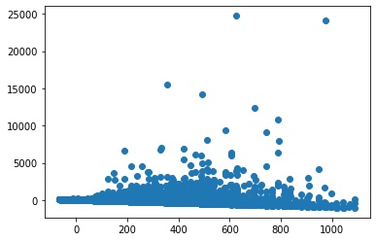

Research Question 1a.
Table 1
Model Coefficients and Confidence Intervals for RQ1a
Area | $b$ | $SE$ | LL | UL | $R^{2}$ | LL | UL
Overall | 0.08 | 0.00 | 0.08 | 0.08 | 0.00 | 0.00 | 0.00
Health Sciences | 0.16 | 0.00 | 0.16 | 0.16 | 0.04 | 0.04 | 0.04
Physical Sciences | 0.22 | 0.00 | 0.21 | 0.22 | 0.01 | 0.01 | 0.01
Multidisciplinary | 0.13 | 0.00 | 0.12 | 0.13 | 0.02 | 0.02 | 0.02
Social Sciences | 0.06 | 0.00 | 0.06 | 0.06 | 0.02 | 0.02 | 0.02
Life Sciences | 0.16 | 0.00 | 0.16 | 0.16 | 0.05 | 0.05 | 0.05

Research Question 1b.
Table 2
Model Coefficients and Confidence Intervals for RQ1b
Area | DV | $b$ | $SE$ | LL | UL | $R^{2}$ | LL | UL
Overall | Overall Citations | 0.12 | 0.00 | 0.12 | 0.13 | 0.00 | 0.00 | 0.00
Overall | Citation 5 Years | 0.11 | 0.00 | 0.11 | 0.11 | 0.02 | 0.02 | 0.02
Health Sciences | Overall Citations | 0.35 | 0.00 | 0.35 | 0.36 | 0.00 | 0.00 | 0.00
Health Sciences | Citation 5 Years | 0.43 | 0.00 | 0.43 | 0.44 | 0.05 | 0.05 | 0.05
Physical Sciences | Overall Citations | 0.05 | 0.00 | 0.05 | 0.05 | 0.00 | 0.00 | 0.00
Physical Sciences | Citation 5 Years | 0.05 | 0.00 | 0.05 | 0.05 | 0.03 | 0.03 | 0.03
Multidisciplinary | Overall Citations | 2.05 | 0.05 | 1.95 | 2.14 | 0.03 | 0.02 | 0.03
Multidisciplinary | Citation 5 Years | 2.11 | 0.02 | 2.06 | 2.15 | 0.06 | 0.05 | 0.06
Social Sciences | Overall Citations | 0.89 | 0.01 | 0.86 | 0.91 | 0.01 | 0.01 | 0.01
Social Sciences | Citation 5 Years | 0.58 | 0.00 | 0.57 | 0.58 | 0.05 | 0.05 | 0.05
Life Sciences | Overall Citations | 0.48 | 0.01 | 0.47 | 0.49 | 0.00 | 0.00 | 0.00
Life Sciences | Citation 5 Years | 0.36 | 0.00 | 0.35 | 0.36 | 0.03 | 0.03 | 0.03

Research Question 2.
Table 3
Model Coefficients and Confidence Intervals for RQ2
Area | IV | DV | $b$ | $SE$ | LL | UL | $R^{2}$ | LL | UL
Overall | Country Count | Overall Citations | 7.46 | 0.04 | 7.38 | 7.54 | 0.01 | 0.01 | 0.01
Overall | Country Count | Citation 5 Years | 4.46 | 0.01 | 4.43 | 4.49 | 0.03 | 0.03 | 0.03
Overall | Institution Count | Overall Citations | 2.76 | 0.01 | 2.73 | 2.79 | 0.01 | 0.01 | 0.01
Overall | Institution Count | Citation 5 Years | 2.08 | 0.01 | 2.07 | 2.09 | 0.03 | 0.03 | 0.03
Overall | Gender Percent | Overall Citations | -1.95 | 0.11 | -2.17 | -1.72 | 0.00 | 0.00 | 0.00
Overall | Gender Percent | Citation 5 Years | -2.24 | 0.03 | -2.30 | -2.17 | 0.02 | 0.02 | 0.02
Overall | h-Index First | Overall Citations | 0.95 | 0.00 | 0.95 | 0.96 | 0.03 | 0.03 | 0.03
Overall | h-Index First | Citation 5 Years | 0.24 | 0.00 | 0.24 | 0.24 | 0.05 | 0.05 | 0.05
Overall | h-Index No-Self First | Overall Citations | 1.09 | 0.00 | 1.09 | 1.10 | 0.03 | 0.03 | 0.03
Overall | h-Index No-Self First | Citation 5 Years | 0.27 | 0.00 | 0.27 | 0.27 | 0.05 | 0.05 | 0.05
Overall | Gender First | Overall Citations | 1.94 | 0.05 | 1.85 | 2.03 | 0.00 | 0.00 | 0.00
Overall | Gender First | Citation 5 Years | 1.00 | 0.01 | 0.97 | 1.03 | 0.02 | 0.02 | 0.02
Overall | h-Index Last | Overall Citations | 0.67 | 0.00 | 0.67 | 0.67 | 0.03 | 0.03 | 0.03
Overall | h-Index Last | Citation 5 Years | 0.23 | 0.00 | 0.23 | 0.23 | 0.07 | 0.07 | 0.07
Overall | h-Index No-Self Last | Overall Citations | 0.75 | 0.00 | 0.75 | 0.76 | 0.03 | 0.03 | 0.03
Overall | h-Index No-Self Last | Citation 5 Years | 0.25 | 0.00 | 0.25 | 0.25 | 0.07 | 0.07 | 0.07
Overall | Gender Last | Overall Citations | 0.84 | 0.05 | 0.74 | 0.95 | 0.00 | 0.00 | 0.00
Overall | Gender Last | Citation 5 Years | 0.50 | 0.02 | 0.46 | 0.53 | 0.02 | 0.02 | 0.02
Health Sciences | Country Count | Overall Citations | 9.72 | 0.06 | 9.59 | 9.84 | 0.01 | 0.01 | 0.01
Health Sciences | Country Count | Citation 5 Years | 6.23 | 0.03 | 6.18 | 6.29 | 0.06 | 0.06 | 0.06
Health Sciences | Institution Count | Overall Citations | 2.95 | 0.02 | 2.92 | 2.99 | 0.01 | 0.01 | 0.01
Health Sciences | Institution Count | Citation 5 Years | 2.38 | 0.01 | 2.36 | 2.40 | 0.06 | 0.06 | 0.06
Health Sciences | Gender Percent | Overall Citations | -0.99 | 0.20 | -1.38 | -0.60 | 0.00 | 0.00 | 0.00
Health Sciences | Gender Percent | Citation 5 Years | -0.17 | 0.06 | -0.29 | -0.04 | 0.03 | 0.03 | 0.03
Health Sciences | h-Index First | Overall Citations | 0.84 | 0.00 | 0.83 | 0.84 | 0.05 | 0.04 | 0.05
Health Sciences | h-Index First | Citation 5 Years | 0.22 | 0.00 | 0.22 | 0.22 | 0.07 | 0.07 | 0.07
Health Sciences | h-Index No-Self First | Overall Citations | 0.92 | 0.00 | 0.92 | 0.93 | 0.05 | 0.05 | 0.05
Health Sciences | h-Index No-Self First | Citation 5 Years | 0.24 | 0.00 | 0.24 | 0.24 | 0.07 | 0.07 | 0.07
Health Sciences | Gender First | Overall Citations | 1.73 | 0.05 | 1.63 | 1.83 | 0.01 | 0.01 | 0.01
Health Sciences | Gender First | Citation 5 Years | 0.68 | 0.02 | 0.65 | 0.72 | 0.03 | 0.03 | 0.03
Health Sciences | h-Index Last | Overall Citations | 0.56 | 0.00 | 0.55 | 0.56 | 0.04 | 0.04 | 0.04
Health Sciences | h-Index Last | Citation 5 Years | 0.17 | 0.00 | 0.17 | 0.17 | 0.08 | 0.08 | 0.08
Health Sciences | h-Index No-Self Last | Overall Citations | 0.61 | 0.00 | 0.61 | 0.61 | 0.04 | 0.04 | 0.04
Health Sciences | h-Index No-Self Last | Citation 5 Years | 0.19 | 0.00 | 0.19 | 0.19 | 0.08 | 0.08 | 0.08
Health Sciences | Gender Last | Overall Citations | 0.76 | 0.06 | 0.65 | 0.88 | 0.01 | 0.01 | 0.01
Health Sciences | Gender Last | Citation 5 Years | 0.28 | 0.02 | 0.24 | 0.32 | 0.04 | 0.04 | 0.04
Physical Sciences | Country Count | Overall Citations | 5.70 | 0.06 | 5.58 | 5.82 | 0.00 | 0.00 | 0.00
Physical Sciences | Country Count | Citation 5 Years | 3.37 | 0.02 | 3.34 | 3.41 | 0.04 | 0.04 | 0.04
Physical Sciences | Institution Count | Overall Citations | 2.23 | 0.03 | 2.17 | 2.28 | 0.00 | 0.00 | 0.00
Physical Sciences | Institution Count | Citation 5 Years | 1.48 | 0.01 | 1.46 | 1.50 | 0.04 | 0.04 | 0.04
Physical Sciences | Gender Percent | Overall Citations | 1.39 | 0.17 | 1.07 | 1.72 | 0.00 | 0.00 | 0.00
Physical Sciences | Gender Percent | Citation 5 Years | -0.47 | 0.05 | -0.56 | -0.38 | 0.03 | 0.03 | 0.03
Physical Sciences | h-Index First | Overall Citations | 0.88 | 0.00 | 0.87 | 0.88 | 0.03 | 0.03 | 0.03
Physical Sciences | h-Index First | Citation 5 Years | 0.22 | 0.00 | 0.22 | 0.22 | 0.06 | 0.06 | 0.06
Physical Sciences | h-Index No-Self First | Overall Citations | 1.06 | 0.00 | 1.06 | 1.07 | 0.03 | 0.03 | 0.03
Physical Sciences | h-Index No-Self First | Citation 5 Years | 0.26 | 0.00 | 0.26 | 0.26 | 0.06 | 0.06 | 0.06
Physical Sciences | Gender First | Overall Citations | 0.75 | 0.05 | 0.66 | 0.84 | 0.00 | 0.00 | 0.00
Physical Sciences | Gender First | Citation 5 Years | 0.61 | 0.01 | 0.58 | 0.64 | 0.03 | 0.03 | 0.03
Physical Sciences | h-Index Last | Overall Citations | 0.59 | 0.00 | 0.58 | 0.59 | 0.03 | 0.03 | 0.03
Physical Sciences | h-Index Last | Citation 5 Years | 0.21 | 0.00 | 0.21 | 0.21 | 0.08 | 0.08 | 0.08
Physical Sciences | h-Index No-Self Last | Overall Citations | 0.67 | 0.00 | 0.67 | 0.67 | 0.03 | 0.03 | 0.03
Physical Sciences | h-Index No-Self Last | Citation 5 Years | 0.24 | 0.00 | 0.24 | 0.24 | 0.08 | 0.08 | 0.08
Physical Sciences | Gender Last | Overall Citations | 0.29 | 0.05 | 0.18 | 0.40 | 0.00 | 0.00 | 0.00
Physical Sciences | Gender Last | Citation 5 Years | 0.39 | 0.02 | 0.36 | 0.43 | 0.03 | 0.03 | 0.03
Multidisciplinary | Country Count | Overall Citations | 8.60 | 0.47 | 7.68 | 9.53 | 0.03 | 0.03 | 0.03
Multidisciplinary | Country Count | Citation 5 Years | 8.30 | 0.23 | 7.85 | 8.76 | 0.03 | 0.03 | 0.03
Multidisciplinary | Institution Count | Overall Citations | 2.04 | 0.16 | 1.72 | 2.35 | 0.03 | 0.03 | 0.03
Multidisciplinary | Institution Count | Citation 5 Years | 3.78 | 0.08 | 3.62 | 3.93 | 0.04 | 0.03 | 0.04
Multidisciplinary | Gender Percent | Overall Citations | 0.52 | 2.14 | -3.67 | 4.71 | 0.03 | 0.03 | 0.03
Multidisciplinary | Gender Percent | Citation 5 Years | 0.04 | 0.80 | -1.53 | 1.60 | 0.02 | 0.02 | 0.02
Multidisciplinary | h-Index First | Overall Citations | 2.80 | 0.03 | 2.74 | 2.87 | 0.07 | 0.07 | 0.07
Multidisciplinary | h-Index First | Citation 5 Years | 0.72 | 0.01 | 0.70 | 0.74 | 0.07 | 0.07 | 0.07
Multidisciplinary | h-Index No-Self First | Overall Citations | 3.22 | 0.03 | 3.15 | 3.29 | 0.07 | 0.07 | 0.08
Multidisciplinary | h-Index No-Self First | Citation 5 Years | 0.82 | 0.01 | 0.80 | 0.84 | 0.07 | 0.07 | 0.07
Multidisciplinary | Gender First | Overall Citations | -1.34 | 0.72 | -2.75 | 0.08 | 0.03 | 0.03 | 0.03
Multidisciplinary | Gender First | Citation 5 Years | -0.68 | 0.28 | -1.22 | -0.13 | 0.03 | 0.03 | 0.03
Multidisciplinary | h-Index Last | Overall Citations | 1.77 | 0.02 | 1.74 | 1.81 | 0.08 | 0.08 | 0.09
Multidisciplinary | h-Index Last | Citation 5 Years | 0.63 | 0.01 | 0.62 | 0.64 | 0.11 | 0.11 | 0.12
Multidisciplinary | h-Index No-Self Last | Overall Citations | 1.95 | 0.02 | 1.92 | 1.99 | 0.09 | 0.08 | 0.09
Multidisciplinary | h-Index No-Self Last | Citation 5 Years | 0.69 | 0.01 | 0.68 | 0.70 | 0.12 | 0.12 | 0.12
Multidisciplinary | Gender Last | Overall Citations | -3.96 | 0.82 | -5.58 | -2.35 | 0.03 | 0.03 | 0.03
Multidisciplinary | Gender Last | Citation 5 Years | -1.98 | 0.35 | -2.66 | -1.30 | 0.02 | 0.02 | 0.03
Social Sciences | Country Count | Overall Citations | 6.24 | 0.17 | 5.91 | 6.57 | 0.01 | 0.01 | 0.01
Social Sciences | Country Count | Citation 5 Years | 1.80 | 0.03 | 1.74 | 1.87 | 0.07 | 0.07 | 0.07
Social Sciences | Institution Count | Overall Citations | 4.43 | 0.09 | 4.24 | 4.61 | 0.01 | 0.01 | 0.01
Social Sciences | Institution Count | Citation 5 Years | 1.29 | 0.02 | 1.25 | 1.33 | 0.07 | 0.07 | 0.07
Social Sciences | Gender Percent | Overall Citations | -15.08 | 0.39 | -15.85 | -14.32 | 0.01 | 0.01 | 0.01
Social Sciences | Gender Percent | Citation 5 Years | -1.24 | 0.07 | -1.38 | -1.10 | 0.07 | 0.07 | 0.07
Social Sciences | h-Index First | Overall Citations | 1.41 | 0.00 | 1.40 | 1.42 | 0.05 | 0.05 | 0.05
Social Sciences | h-Index First | Citation 5 Years | 0.21 | 0.00 | 0.21 | 0.21 | 0.12 | 0.11 | 0.12
Social Sciences | h-Index No-Self First | Overall Citations | 1.57 | 0.01 | 1.56 | 1.58 | 0.05 | 0.05 | 0.05
Social Sciences | h-Index No-Self First | Citation 5 Years | 0.23 | 0.00 | 0.23 | 0.23 | 0.12 | 0.12 | 0.12
Social Sciences | Gender First | Overall Citations | 1.80 | 0.09 | 1.62 | 1.97 | 0.01 | 0.01 | 0.01
Social Sciences | Gender First | Citation 5 Years | 0.38 | 0.02 | 0.35 | 0.42 | 0.07 | 0.06 | 0.07
Social Sciences | h-Index Last | Overall Citations | 0.79 | 0.00 | 0.78 | 0.80 | 0.03 | 0.03 | 0.03
Social Sciences | h-Index Last | Citation 5 Years | 0.16 | 0.00 | 0.16 | 0.16 | 0.11 | 0.10 | 0.11
Social Sciences | h-Index No-Self Last | Overall Citations | 0.89 | 0.00 | 0.88 | 0.89 | 0.03 | 0.03 | 0.03
Social Sciences | h-Index No-Self Last | Citation 5 Years | 0.17 | 0.00 | 0.17 | 0.18 | 0.11 | 0.11 | 0.11
Social Sciences | Gender Last | Overall Citations | 1.58 | 0.10 | 1.38 | 1.77 | 0.01 | 0.01 | 0.01
Social Sciences | Gender Last | Citation 5 Years | 0.11 | 0.02 | 0.08 | 0.15 | 0.07 | 0.07 | 0.07
Life Sciences | Country Count | Overall Citations | 4.62 | 0.09 | 4.45 | 4.79 | 0.01 | 0.01 | 0.01
Life Sciences | Country Count | Citation 5 Years | 2.03 | 0.03 | 1.97 | 2.10 | 0.03 | 0.03 | 0.03
Life Sciences | Institution Count | Overall Citations | 1.27 | 0.04 | 1.20 | 1.35 | 0.01 | 0.01 | 0.01
Life Sciences | Institution Count | Citation 5 Years | 0.64 | 0.02 | 0.61 | 0.67 | 0.03 | 0.03 | 0.03
Life Sciences | Gender Percent | Overall Citations | 8.43 | 0.26 | 7.93 | 8.93 | 0.01 | 0.01 | 0.01
Life Sciences | Gender Percent | Citation 5 Years | 2.92 | 0.08 | 2.76 | 3.07 | 0.03 | 0.03 | 0.03
Life Sciences | h-Index First | Overall Citations | 0.81 | 0.00 | 0.81 | 0.82 | 0.03 | 0.02 | 0.03
Life Sciences | h-Index First | Citation 5 Years | 0.19 | 0.00 | 0.19 | 0.19 | 0.04 | 0.04 | 0.04
Life Sciences | h-Index No-Self First | Overall Citations | 0.93 | 0.00 | 0.92 | 0.93 | 0.03 | 0.03 | 0.03
Life Sciences | h-Index No-Self First | Citation 5 Years | 0.22 | 0.00 | 0.21 | 0.22 | 0.04 | 0.04 | 0.04
Life Sciences | Gender First | Overall Citations | 0.22 | 0.06 | 0.09 | 0.34 | 0.01 | 0.01 | 0.01
Life Sciences | Gender First | Citation 5 Years | 0.06 | 0.02 | 0.01 | 0.10 | 0.02 | 0.02 | 0.02
Life Sciences | h-Index Last | Overall Citations | 0.66 | 0.00 | 0.66 | 0.67 | 0.04 | 0.04 | 0.04
Life Sciences | h-Index Last | Citation 5 Years | 0.20 | 0.00 | 0.20 | 0.21 | 0.06 | 0.05 | 0.06
Life Sciences | h-Index No-Self Last | Overall Citations | 0.74 | 0.00 | 0.74 | 0.74 | 0.04 | 0.04 | 0.04
Life Sciences | h-Index No-Self Last | Citation 5 Years | 0.23 | 0.00 | 0.23 | 0.23 | 0.06 | 0.06 | 0.06
Life Sciences | Gender Last | Overall Citations | -1.17 | 0.07 | -1.32 | -1.03 | 0.01 | 0.01 | 0.01
Life Sciences | Gender Last | Citation 5 Years | -0.35 | 0.03 | -0.40 | -0.29 | 0.02 | 0.02 | 0.02

We originally planned on using the 27 subfields within the ASJC. However, we updated our preregistration to use only five of the larger subfields due to computational constraints.

