Who does big team science?

Erin M. Buchanan1 & Savannah C. Lewis2

1 Harrisburg University of Science and Technology

2 University of Alabama

Author note

Erin M. Buchanan is a Professor of Cognitive Analytics at Harrisburg University of Science and Technology. Savannah C. Lewis is a graduate student at the University of Alabama.

Thank you to Dwayne Lieck for providing an extensive list of large scale projects for this manuscript.

The authors made the following contributions. Erin M. Buchanan: Conceptualization, Data curation, Formal Analysis, Methodology, Project administration, Visualization, Writing – original draft, Writing – review & editing; Savannah C. Lewis: Conceptualization, Data curation, Methodology, Project administration, Writing – original draft, Writing – review & editing.

Correspondence concerning this article should be addressed to Erin M. Buchanan, 326 Market St., Harrisburg, PA 17101. E-mail: [ebuchanan@harrisburgu.edu](mailto:ebuchanan@harrisburgu.edu)

Abstract

This paper will examine the nature of publications in Big Team Science (BTS) - large-scale collaborations between multiple researchers at multiple institutions. As interest in BTS increases, it is useful to explore who is currently involved in BTS projects to determine diversity in both research subject and researcher representation. The types of publication outlets, number of publications, and subject areas of publication will be presented to summarize the publications in BTS. Information about authors included in BTS will be presented including career length, numbers of publications/impact variables, education, and affiliation. Last, we will explore the representation of geopolitical regions by examining affiliation location to explore the impact of BTS on the de-WEIRD movement to diversify researcher representation.

*Keywords:* big team, science, authorship, credit

*Word count:* X

Who does big team science?

According to the Oxford English dictionary, collaboration is two or more people working together to achieve a certain goal (OED, 2016). Collaboration in scientific endeavors involves multiple researchers at (potentially) multiple institutions to communicate and work together to advance knowledge in their chosen field. Collaboration can manifest uniquely in each project dependent on the skill sets, hypotheses, and perspectives of collaborators. While collaboration is not new in science, the current interest of “big team science” is increasing (Coles et al., 2022; Forscher et al., 2020; N. Stewart et al., 2017). Big team science projects and/or organizations utilize and run on large-scale collaboration to ensure that diverse populations and ideas are brought into research projects, which in turn allows for more reliability and generalizability in the results and method of the study. For this study, Big Team Science (BTS) will be defined as a collaboration of ten or more authors from at least ten different institutions.

BTS appears to be increasing as a result of two sources: 1) increasing globalization and technology that allows for real-time interdisciplinary research, and 2) increasing interest in reproducibility, replication, and generalizability (Maxwell et al., 2015; Nelson et al., 2018; Zwaan et al., 2018). Technological advances have provided easier ways to collaborate with people who are from other universities and countries through document sharing platforms (e.g., Google, GitHub, and the Open Science Framework), video chatting platforms (e.g., Zoom, Microsoft Teams), and messaging and project management platforms (e.g., Slack, Trello, when2meet, etc.). The credibility movement seems to suggest that by having both collaborations that span across the globe and subfield of psychology, age groups, and education levels should help to drive psychological science in the path of better materials, reliability, generalizability and more robust sample size in a study (Auspurg & Brüderl, 2021; LeBel et al., 2018; Nosek & Lakens, 2014b).

The credibility movement was originally defined by a focus on large scale replications using in collaborative environments (Vazire et al., 2022). Generally, the movement has been driven by early career researchers (i.e., those who are within five years of their first appointment) (Maizey & Tzavella, 2019); however, there are no large meta-scientific investigations on this specific topic to date. Potentially, the lack of investigation is tied to the newness of the large-scale research in many fields, as it is only in recent years that publications like the Open Science Collaboration (Open Science Collaboration, 2015), Many Labs Collaborations (Buttrick et al., 2020; Ebersole et al., 2020, 2016; Klein et al., 2022; for example, Klein et al., 2018; Mathur et al., 2020; Skorb et al., 2020) or the first papers from the Psychological Science Accelerator (Bago et al., 2022; Dorison et al., 2022; Jones et al., 2021; Legate et al., 2022; Moshontz et al., 2018; Wang et al., 2021). Generally, the researcher incentive for replication was low: journals often prioritize “novel” or new results which led to rejection of replication manuscripts and publication bias (Franco et al., 2014; Hubbard & Armstrong, 1997; Nosek et al., 2012), the “failure” to replicate was often placed on the replication team as “bad science” rather than a careful consideration of publication biases and (potential) questionable research practices (Ioannidis, 2015; Klein et al., 2022; Maxwell et al., 2015), and why should someone want to spend time and resources on an answer we already “know” (Isager et al., 2021a, 2021b)?

However, the success and interest in the large-scale reproducibility projects (Errington et al., 2021; Open Science Collaboration, 2015), paired with the meta-scientific publications focusing on researcher practices and incentive structures (John et al., 2012; Silberzahn et al., 2018) led to a change in journal guidelines and incentives for researchers interested in participating in large-scale replication studies (Grahe, 2014; Kidwell et al., 2016; Mayo-Wilson et al., 2021; Nosek et al., 2015). For example, the support for Registered Reports, papers accepted before the data has been collected (Nosek & Lakens, 2014a; S. Stewart et al., 2020), and entire sub-sections of journals devoted to only replication studies (e.g., *Nature, Royal Society Open Science, Advances in Methods and Practices in Psychological Science*) has allowed researchers to invest in projects that they know should be published when the project is complete. Further, the implementation of the Transparency and Openness Guidelines (Nosek et al., 2015) and the Contributor Role Taxonomy (CRediT) system (Allen et al., 2019) have pushed journals and researchers to promote more open, inclusive publication practices.

The credibility movement has been mirrored by the calls for diversification or de-WEIRDing (e.g., Western, Educated, Industrialized, Rich, and Democratic) scientific research (Henrich et al., 2010; Newson et al., 2021; Rad et al., 2018) by improving representation in research samples. Like the large-scale studies in Physics (“A Philosophical Case for Big Physics,” 2021; Castelnovo et al., 2018) and Biology (Collins et al., 2003), the social sciences struggle to represent the breadth of humanity across both researcher and population characteristics. Now, grassroots organizations, such as the Psychological Science Accelerator (Moshontz et al., 2018), ManyBabies (<https://manybabies.github.io/>), NutNet (<https://nutnet.org/>), and DRAGNet (<https://dragnetglobal.weebly.com/>) can begin to tackle these issues by recruiting research labs from all over the globe to provide diversity in geographic, linguistic, and researcher representation. Publications have examined the global understanding of morality, face processing, COVID-19 information signaling, and more (Bago et al., 2022; Dorison et al., 2022; Jones et al., 2021; Legate et al., 2022; Van Bavel et al., 2022; Wang et al., 2021). While these organizations and one-time groups for BTS studies have provided an incredible wealth of data for the scientific community, we do not yet know exactly *who* is involved with, and benefits from, the BTS and credibility movement. Publications on BTS generally explore challenges, lessons learned, and the need for BTS (Coles et al., 2022; Forscher et al., 2020).

Therefore, the goal of this manuscript is to examine the *people* involved in BTS projects. We specifically expect to examine ICSR’s Research Themes of inclusivity, research careers, and research globalization. As we examine these themes, it will bring new knowledge of how BTS projects impact each theme and field of study. We see an increase in interest and publications in BTS but we do not yet know if this uptick in large-scale projects has diversified the *people* involved in BTS. While a few publications have noted that BTS appears to be early career researchers (Maizey & Tzavella, 2019), no one has systematically investigated this perception. Further, it is unclear if the focus of de-WEIRDing science has only focused on the representation of the research participants or if it has also improved the representation of researchers outside of North America and Europe. Last, who runs these BTS projects? Do we see an increase in diversity for the authors who generally receive the most credit for these projects (i.e., first several author(s) and last author)? As hiring and promoting practices often place a heavy weight on publications and especially “influential” publications, it becomes necessary to critically examine the representation present in authorship in BTS projects.

# Potential Outlets

We will aim for high impact broad scope journals such as *Science*, *Nature* or *Nature Human Behaviour*. Other journals would include review publications within psychology to compare the social sciences to other sciences: *Perspectives in Psychological Science*, *Psychological Bulletin*, *Psychological Review*, or *Current Directions in Psychological Science*.

# Research Questions

* Research Question 1: What publication sources publish big team science papers?
* Research Question 2: What are the types of articles that are being published in big team science?
* Research Question 3: Who is involved in big team science?

For each of these research questions, we will examine the overall results of all big team research projects, and examine for change in result trends across years of publication. Below we detail our methods and the ICSR/Scopus data to answer these questions, along with examples of the statistical results we expect to report in the manuscript. We began this project with data using Google Scholar and ORCID information. These sources were severely limited in their scope and breadth, as they are often curated with automatic processes or self-entered data, and we believe that access to Scopus and ICSR would allow us to accurately portray the BTS movement and its impact on diversity across many fields. The novelty of this project is that it would focus on all of published works, rather than a specific subfield (like Psychology) and give a lens into global representation in science that would otherwise not be achieved with open-source databases.

# Method

## Publications

We have defined **BTS publications** as publications with at least 10 authors at 10 different institutions that were published in peer-reviewed journals or had posted a full paper pre-print. We will use data from 1970 and forward in the publications (ani) database, as it is noted online that this time period includes cited references for calculation of several of our variables described below. We will analyze our results based on the big four subject areas: Physical Sciences, Health Sciences, Social Sciences, and Life Sciences. We filtered the database to include articles, articles in press, business articles, conference papers, data papers, preprints, and surveys using Elsevier’s classification system.

## Data Curation

### RQ1: Publisher Information..

Using these criteria, we will extract the following information for publication sources: the name of the publication (source title), subject area (both the large four subject areas and the smaller four digit all science journal classification ASJC codes). We will examine journal impact using the Source Normalized Impact per Paper from the journal (sources) database.

### RQ2: Publication Information..

For each publication of the identified BTS publications, we will analyze the full four digit ASJC subject areas codes for each of the larger four subject areas and the keywords present for these publications.

### RQ3: Author Information..

The author list will then be extracted from each publication. Next, we will use the author (au) and affiliation (af) array to curate a list of all publications and author information included in BTS papers. We will use these two arrays with the publication array to calculate the variables described below.

***Career Length***. Career length for each author will be defined as the year of the first publication listed for each author.

***Institution and Geopolitical Region*** . We will use the affiliation ids and country to gather information about the places of education and/or employment for authors. Country will likely be binned into United Nation Region, Sub-Region, or smaller clusters for analyses.

***Education***. We will also collect degree information from the author table.

***Types of Publications***. We will gather information from the publication type variable for each author publication to present information about the types of papers BTS authors publish.

***Publication Metrics***. For each author, we will calculate the total number of publications, and the h-index. The h-index represents the highest *h* number of publications that have at least *h* citations.

## Data analysis

### RQ1: Publisher Information..

To present results on this research question, we will analyze:

* Number of articles for inclusion: total, separated by four subject areas, presenting graphics of the number of publication across time total

*Number of articles*. The total number of articles included in this analysis was 13581 including 10685 Health Sciences articles, 6151 Physical Sciences articles, 543 Social Sciences articles, and 7686 Life Sciences articles. Articles could be classified into multiple categories. Figure X shows the number of articles published across time for each of the four large subject areas.

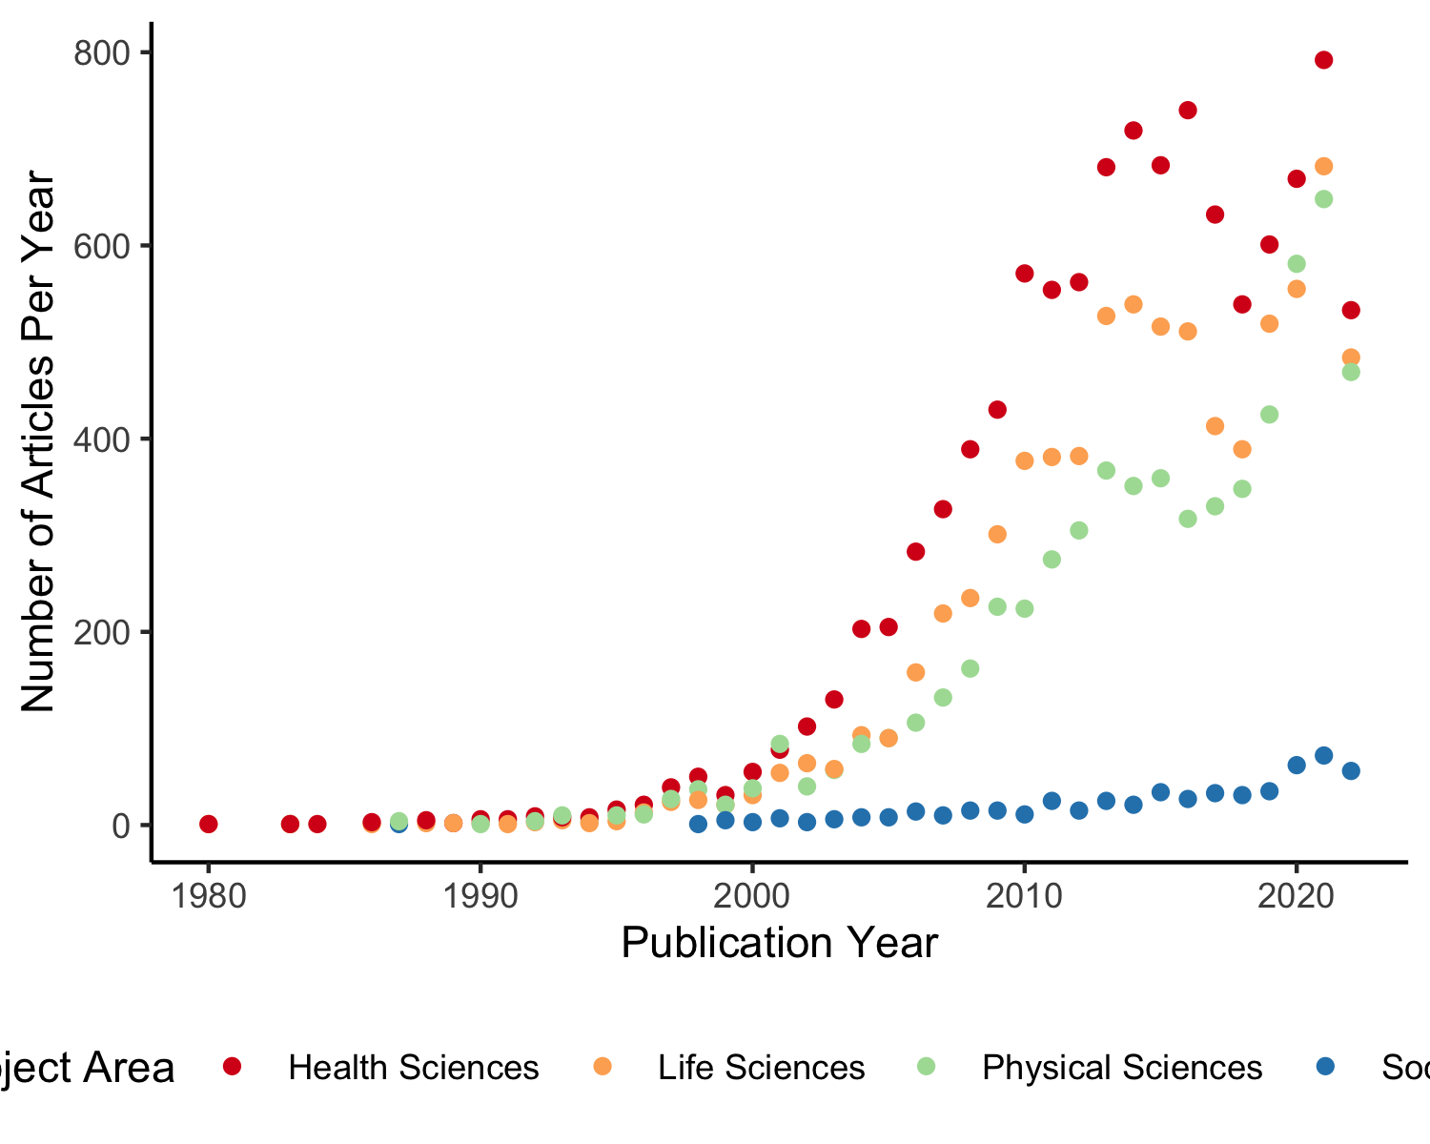

*Figure* *1.*  Number of big-team science publications separated by four large subject areas across years.

* Number of distinct journals within each of the four subject areas

*Number of journals*. The number of distinct journals big team science articles were published in was 2534 with 1472 journals in Health Sciences, 641 journals in Physical Sciences, 206 journals in Social Sciences, and 1024 journals in Life Sciences. The descriptive statistics for the Source Normalized Impact per Paper is presented in Table X. For comparison, the SNIP descriptive statistics for all papers is shown in Table X.

Table 1: Big-Team Science SNIP Values

| Subject Area | M | SD | Minimum | Median | Maximum |
| --- | --- | --- | --- | --- | --- |
| Health Sciences | 4.40 | 7.18 | 0.00 | 2.08 | 173.93 |
| Physical Sciences | 1.73 | 1.34 | 0.16 | 1.28 | 30.40 |
| Social Sciences | 2.20 | 2.14 | 0.02 | 1.60 | 30.40 |
| Life Sciences | 2.52 | 2.04 | 0.02 | 1.74 | 12.62 |

Table 2: All Journal Articles SNIP Values

| Subject Area | M | SD | Minimum | Median | Maximum |
| --- | --- | --- | --- | --- | --- |
| Health Sciences | 2.13 | 4.21 | 0.00 | 1.44 | 173.93 |
| Physical Sciences | 1.48 | 1.10 | 0.00 | 1.26 | 30.40 |
| Social Sciences | 1.98 | 1.41 | 0.00 | 1.66 | 30.40 |
| Life Sciences | 1.53 | 1.23 | 0.00 | 1.24 | 19.07 |

### RQ2: Publication Information..

For each publication, we will examine:

* The totals of the number of articles published within the smaller subject area classifications. We will visualize these differences to show the areas of interest for each of the four large subject areas.

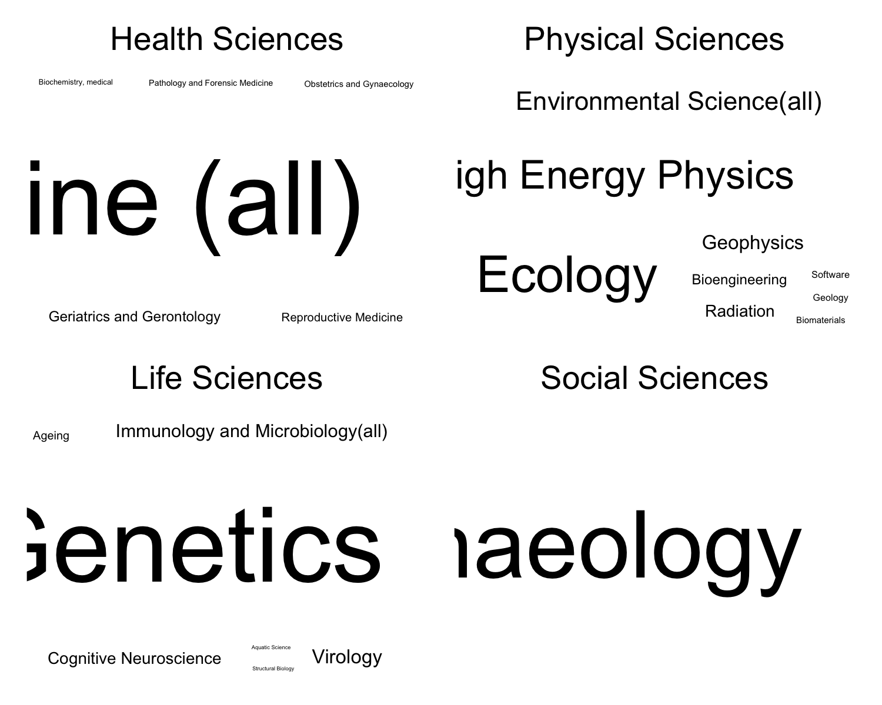

*Figure* *2.*  Journal Areas for Big-Team Science Publications by Subject Area

* The keywords present in the publications data overall to identify trends and common themes in the publications for the four subject areas using visualizations (wordclouds) to depict the common keywords.

## Warning in grid.Call(C_textBounds, as.graphicsAnnot(x$label), x$x, x$y, :  
## conversion failure on 'deepgen™' in 'mbcsToSbcs': dot substituted for <e2>

## Warning in grid.Call(C_textBounds, as.graphicsAnnot(x$label), x$x, x$y, :  
## conversion failure on 'deepgen™' in 'mbcsToSbcs': dot substituted for <84>

## Warning in grid.Call(C_textBounds, as.graphicsAnnot(x$label), x$x, x$y, :  
## conversion failure on 'deepgen™' in 'mbcsToSbcs': dot substituted for <a2>

## Warning in grid.Call(C_stringMetric, as.graphicsAnnot(x$label)): font metrics  
## unknown for Unicode character U+2122  
  
## Warning in grid.Call(C_stringMetric, as.graphicsAnnot(x$label)): font metrics  
## unknown for Unicode character U+2122

## Warning in grid.Call(C_stringMetric, as.graphicsAnnot(x$label)): conversion  
## failure on 'deepgen™' in 'mbcsToSbcs': dot substituted for <e2>

## Warning in grid.Call(C_stringMetric, as.graphicsAnnot(x$label)): conversion  
## failure on 'deepgen™' in 'mbcsToSbcs': dot substituted for <84>

## Warning in grid.Call(C_stringMetric, as.graphicsAnnot(x$label)): conversion  
## failure on 'deepgen™' in 'mbcsToSbcs': dot substituted for <a2>

## Warning in grid.Call(C_textBounds, as.graphicsAnnot(x$label), x$x, x$y, :  
## conversion failure on 'deepgen™' in 'mbcsToSbcs': dot substituted for <e2>

## Warning in grid.Call(C_textBounds, as.graphicsAnnot(x$label), x$x, x$y, :  
## conversion failure on 'deepgen™' in 'mbcsToSbcs': dot substituted for <84>

## Warning in grid.Call(C_textBounds, as.graphicsAnnot(x$label), x$x, x$y, :  
## conversion failure on 'deepgen™' in 'mbcsToSbcs': dot substituted for <a2>

## Warning in grid.Call(C_stringMetric, as.graphicsAnnot(x$label)): font metrics  
## unknown for Unicode character U+2122  
  
## Warning in grid.Call(C_stringMetric, as.graphicsAnnot(x$label)): font metrics  
## unknown for Unicode character U+2122

## Warning in grid.Call(C_stringMetric, as.graphicsAnnot(x$label)): conversion  
## failure on 'deepgen™' in 'mbcsToSbcs': dot substituted for <e2>

## Warning in grid.Call(C_stringMetric, as.graphicsAnnot(x$label)): conversion  
## failure on 'deepgen™' in 'mbcsToSbcs': dot substituted for <84>

## Warning in grid.Call(C_stringMetric, as.graphicsAnnot(x$label)): conversion  
## failure on 'deepgen™' in 'mbcsToSbcs': dot substituted for <a2>

## Warning in grid.Call(C_textBounds, as.graphicsAnnot(x$label), x$x, x$y, :  
## conversion failure on 'deepgen™' in 'mbcsToSbcs': dot substituted for <e2>

## Warning in grid.Call(C_textBounds, as.graphicsAnnot(x$label), x$x, x$y, :  
## conversion failure on 'deepgen™' in 'mbcsToSbcs': dot substituted for <84>

## Warning in grid.Call(C_textBounds, as.graphicsAnnot(x$label), x$x, x$y, :  
## conversion failure on 'deepgen™' in 'mbcsToSbcs': dot substituted for <a2>

## Warning in grid.Call(C_stringMetric, as.graphicsAnnot(x$label)): font metrics  
## unknown for Unicode character U+2122  
  
## Warning in grid.Call(C_stringMetric, as.graphicsAnnot(x$label)): font metrics  
## unknown for Unicode character U+2122

## Warning in grid.Call(C_stringMetric, as.graphicsAnnot(x$label)): conversion  
## failure on 'deepgen™' in 'mbcsToSbcs': dot substituted for <e2>

## Warning in grid.Call(C_stringMetric, as.graphicsAnnot(x$label)): conversion  
## failure on 'deepgen™' in 'mbcsToSbcs': dot substituted for <84>

## Warning in grid.Call(C_stringMetric, as.graphicsAnnot(x$label)): conversion  
## failure on 'deepgen™' in 'mbcsToSbcs': dot substituted for <a2>

## Warning in grid.Call(C_textBounds, as.graphicsAnnot(x$label), x$x, x$y, :  
## conversion failure on 'deepgen™' in 'mbcsToSbcs': dot substituted for <e2>

## Warning in grid.Call(C_textBounds, as.graphicsAnnot(x$label), x$x, x$y, :  
## conversion failure on 'deepgen™' in 'mbcsToSbcs': dot substituted for <84>

## Warning in grid.Call(C_textBounds, as.graphicsAnnot(x$label), x$x, x$y, :  
## conversion failure on 'deepgen™' in 'mbcsToSbcs': dot substituted for <a2>

## Warning in grid.Call(C_stringMetric, as.graphicsAnnot(x$label)): font metrics  
## unknown for Unicode character U+2122  
  
## Warning in grid.Call(C_stringMetric, as.graphicsAnnot(x$label)): font metrics  
## unknown for Unicode character U+2122

## Warning in grid.Call(C_stringMetric, as.graphicsAnnot(x$label)): conversion  
## failure on 'deepgen™' in 'mbcsToSbcs': dot substituted for <e2>

## Warning in grid.Call(C_stringMetric, as.graphicsAnnot(x$label)): conversion  
## failure on 'deepgen™' in 'mbcsToSbcs': dot substituted for <84>

## Warning in grid.Call(C_stringMetric, as.graphicsAnnot(x$label)): conversion  
## failure on 'deepgen™' in 'mbcsToSbcs': dot substituted for <a2>

## Warning in grid.Call.graphics(C_text, as.graphicsAnnot(x$label), x$x, x$y, :  
## conversion failure on 'deepgen™' in 'mbcsToSbcs': dot substituted for <e2>

## Warning in grid.Call.graphics(C_text, as.graphicsAnnot(x$label), x$x, x$y, :  
## conversion failure on 'deepgen™' in 'mbcsToSbcs': dot substituted for <84>

## Warning in grid.Call.graphics(C_text, as.graphicsAnnot(x$label), x$x, x$y, :  
## conversion failure on 'deepgen™' in 'mbcsToSbcs': dot substituted for <a2>

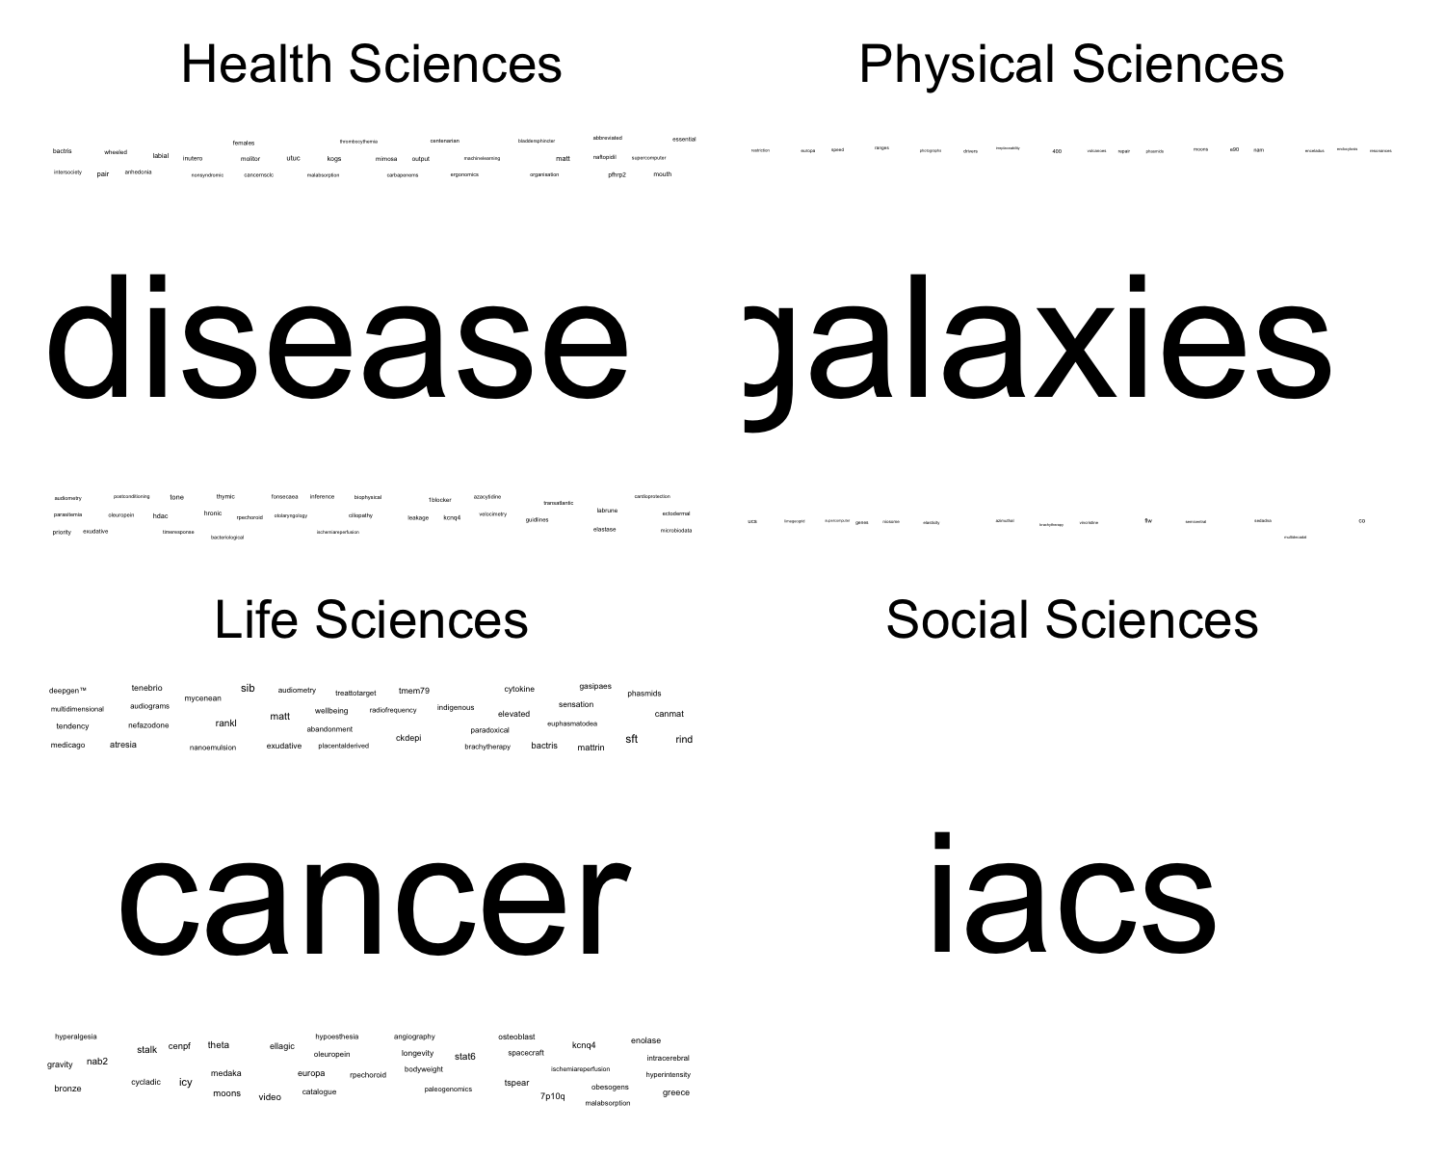

*Figure* *3.*  Keyword Analysis for Each of the Four Subject Areas.

### RQ3: Authors..

We will first present:

* The total number of unique authors

The total number of unique authors across all publications was 257536.

* Statistics (mean, standard deviation, minimum, maximum, median) on the number of authors included on publications.

The mean number of authors per publication was *M* = 49.90 (*SD* = 207.01, *Med* = 19) with a range of 10 to 5155.

* We will present visualizations of these results across time.

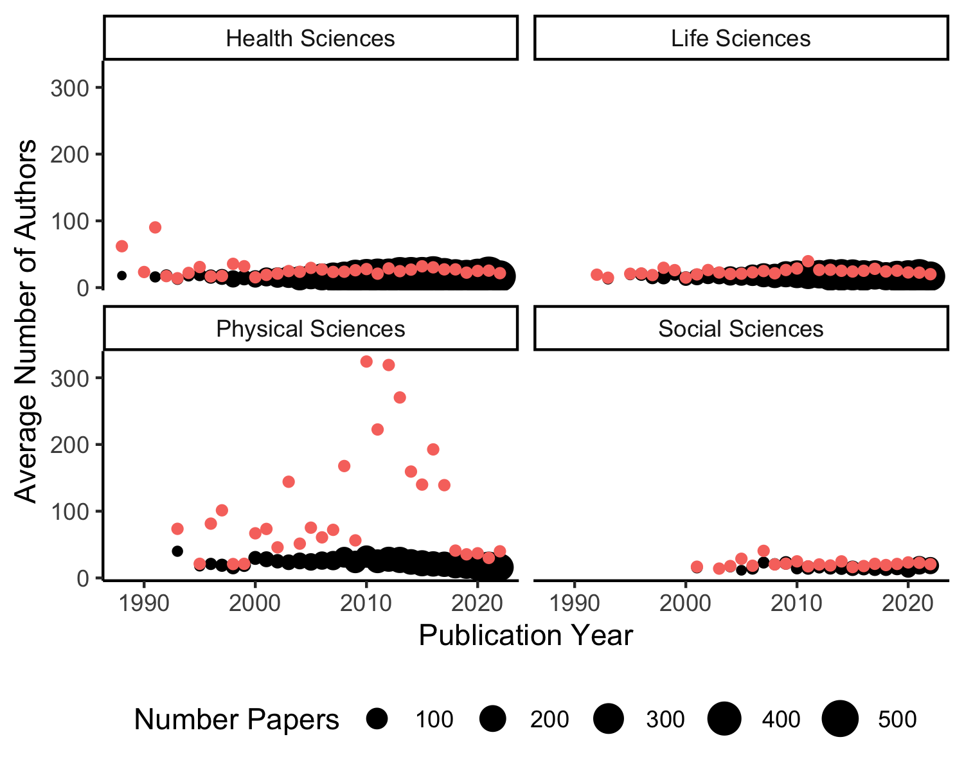

*Figure* *4.*  Number of authors included on big-team science papers per year by subject area. Colored dots indicate the mean number of authors, while the black dots represent the median number of authors. The size of the black dots indicate the number of papers in that year.

We will use the 95% confidence interval to make all claims of predictors or effects different zero. The confidence interval that does not include zero would be considered different from zero (to four decimal places). We make no directional predictions.

***Career Length***.

* We will create a visualization of the trend and variance of researcher career length across publication years.

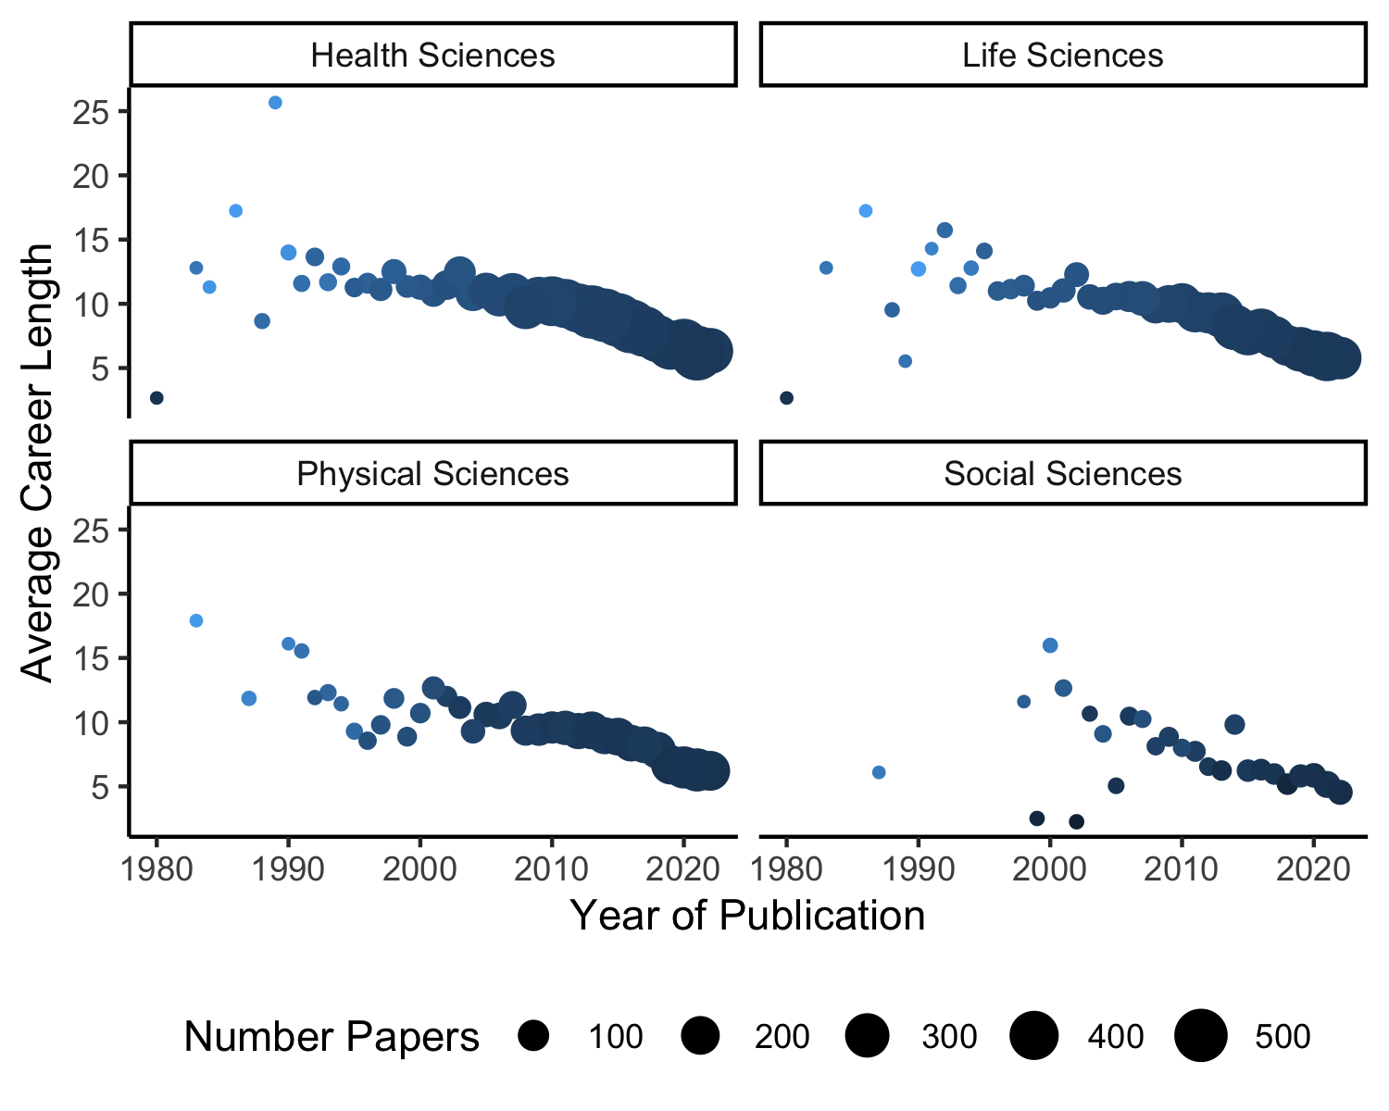

*Figure* *5.*  Average career length for big-team science authors. Larger dots indicate more papers for each estimation. Lighter colored dots mean less variability in author career length, while darker dots mean more variability in career length.

* To analyze trends over time, we will calculate the average career length for each publication (i.e., average the author career length to create one score for each paper) and run a regression analysis using career length to predict year of publication. In order to show variance between individuals, we calculate the standard deviation of career length for each publication and run a regression analysis using this variance representation to predict publication year. These two variables will be used together.
* Negative slopes would indicate more young scholars in later years (i.e., lower average career length as time increases). Positive slopes would indicate older scholars in later years (i.e., higher average career length as time increases).
* Negative slopes imply that variability decreases over the years, so the average career length is more homogeneous. Positive slopes imply that variability increases over the years, so the average career length is varied across individuals (lots of different types of scholars).
* These analyses will be completed separately for each of the four large subject areas.

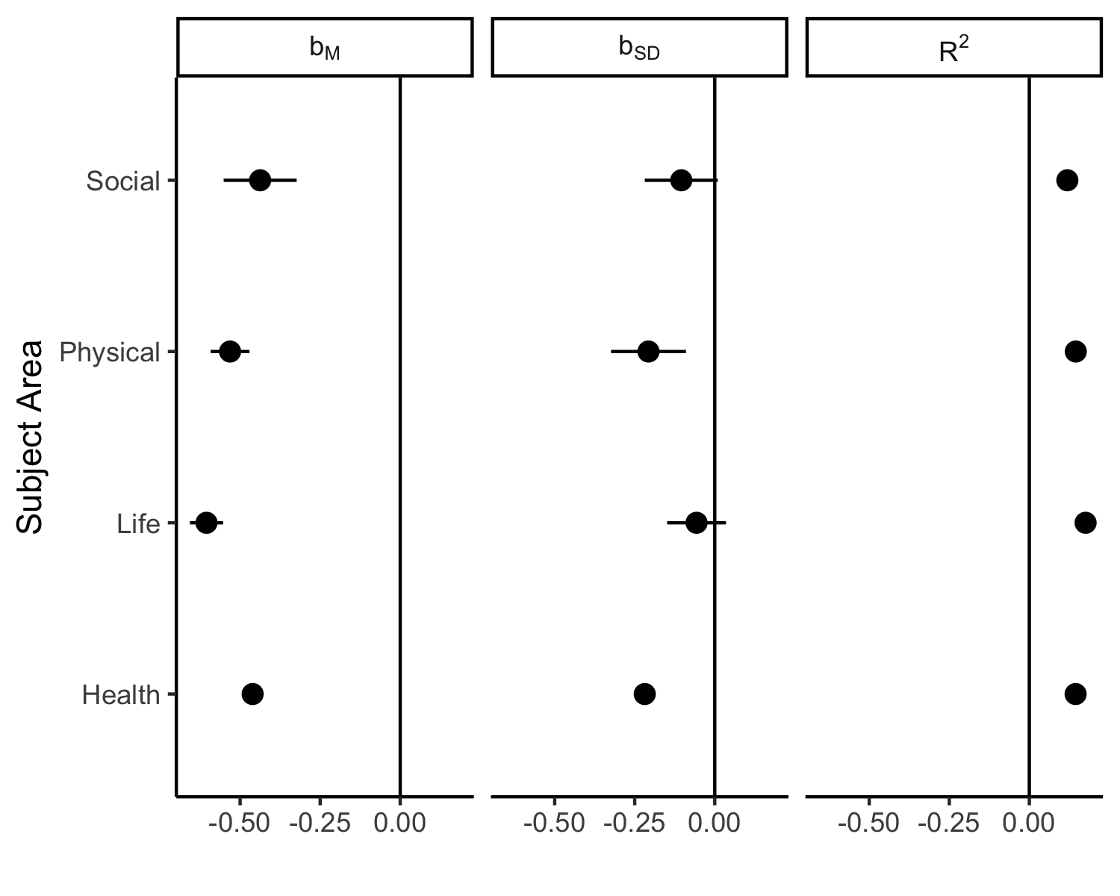

*Figure* *6.*  Coefficient values for the average career length, variance in career length, and the effect size for each model predicting year of publication.

***Institution***.

* We will summarize the number of affiliation ids present in BTS publications by subject area and visualize these results across time. These visualizations will be presented separately for each of the four subject areas.

The total number of unique affiliation across all papers was 35114.

## Warning: Groups with fewer than two data points have been dropped.  
## Groups with fewer than two data points have been dropped.  
## Groups with fewer than two data points have been dropped.

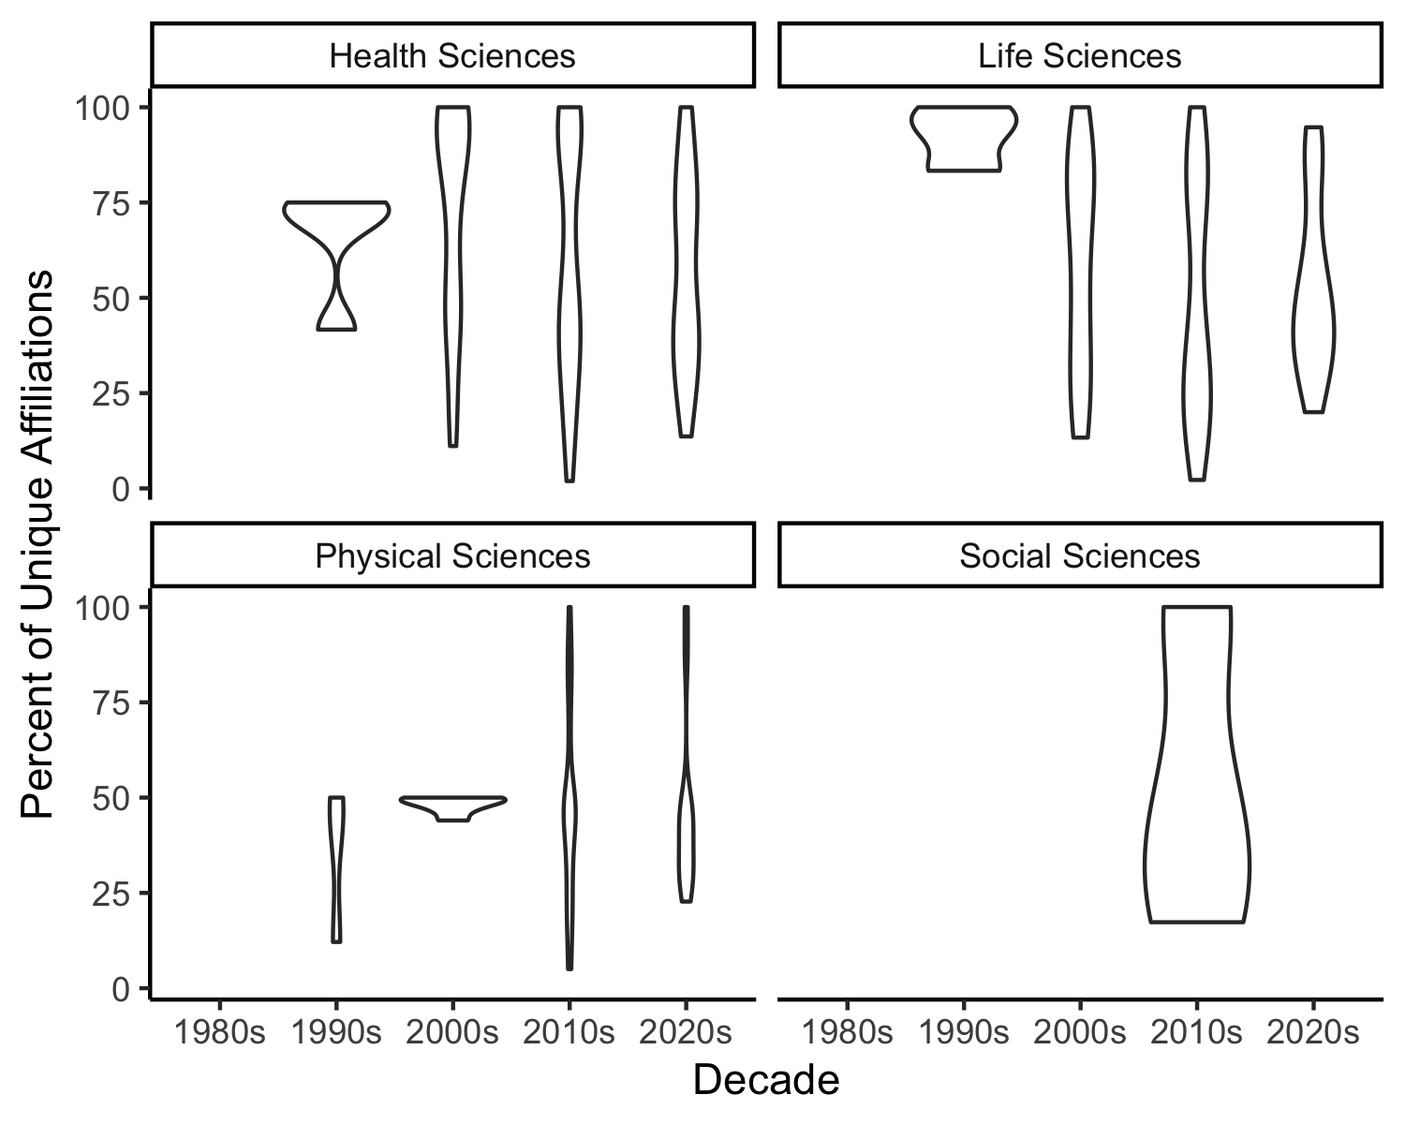

*Figure* *7.*  Number of unique institutions involved in big-team science papers across decades.

***Education***.

We will summarize the general education categories of individuals at the time of publication, along with a summary for change over time.

Figure out how messy this is for text processing requirements  
For each publication, plot of proportion of doctorates across time - if the number is going down, we are involving more diverse types of people (assuming that doctorates are "normal" academics/researchers)  
We will only perform this analysis if the proportion of information avaliable is over 50%.

|  |  |
| --- | --- |
| d egrees | count |
| F7FA46   null   MD   PhD M D, PhD   M.D.   Dr.   MSc   MPH  Prof., PhD Ph.D. MS MD PhD MD. Prof. MD Prof. PhD BS Prof BA M.D., Ph.D. MD, MPH | 656440 8190 3879 1267 1002 490 461 368 349 348 330 285 279 266 239 232 220 196 191 158 |

***Types of Publications***.

* We will summarize the coded types of publications for individuals.

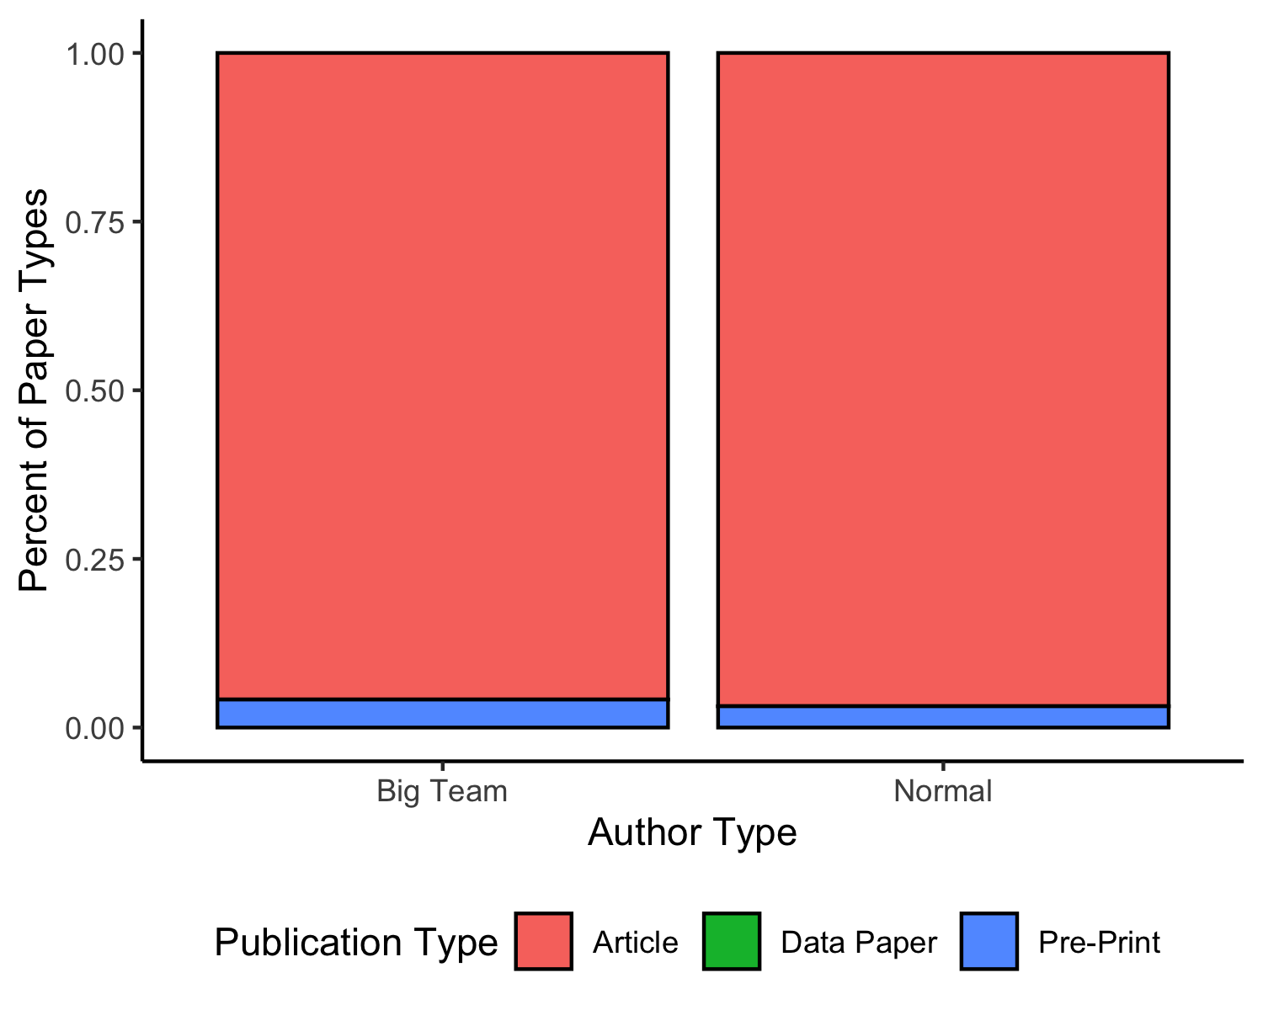

*Figure* *8.*  Types of publications for big-team science and all authors.

***Publication Metrics***.

* We will report descriptive statistics on the total number of publications and h-index for individuals overall.
  + Do this for each unique person and report averages
  + Do this for each publication and create an average for each publication

The average number of publications by authors on big team sciences papers is *M* = 4.45 (*SD* = 6.90). The publication counts were averaged across authors for each publication, and then these average publication counts were averaged across publications *M* = 7.58 (*SD* = 5.80). The average variability (i.e., the average standard deviation with authors of a manuscript) with publication counts of a paper was $M_{SD}$ = 7.14 ( $SD_{SD}$ = 5.10).

The same process was completed with *h*-index for each author and publication. The average *h*-index for authors overall was *M* = 14.24 (*SD* = 43.80, *Med* = 2.00). The average *h*-index for publications was *M* = 28.14 (*SD* = 38.01), and the variability of *h*-index across manuscripts was $M_{SD}$ = 36.43 ( $SD_{SD}$ = 46.47, $Med_{Med}$ = 5.00).

* Next, we will use the same analyses described in the career length section to analyze trends over time. An increasing slope over time indicates that individuals who are publishing more are more represented in BTS over time (i.e., increasing numbers of scholars with higher publication rates), while a negative slope indicates more researchers with less publications.
* A positive slope for standard deviation indicates increasing variance over time (i.e., more diversity in the individual publication rates), while a negative slope would indicate less diversity in researchers over time. While publication rates do not represent value as a researcher, they are often used in hiring and promotion decisions, and we will use this variable as a proxy to gauge the diversity in scholars represented in big teams.
* We will separate these by each of the four subject areas.

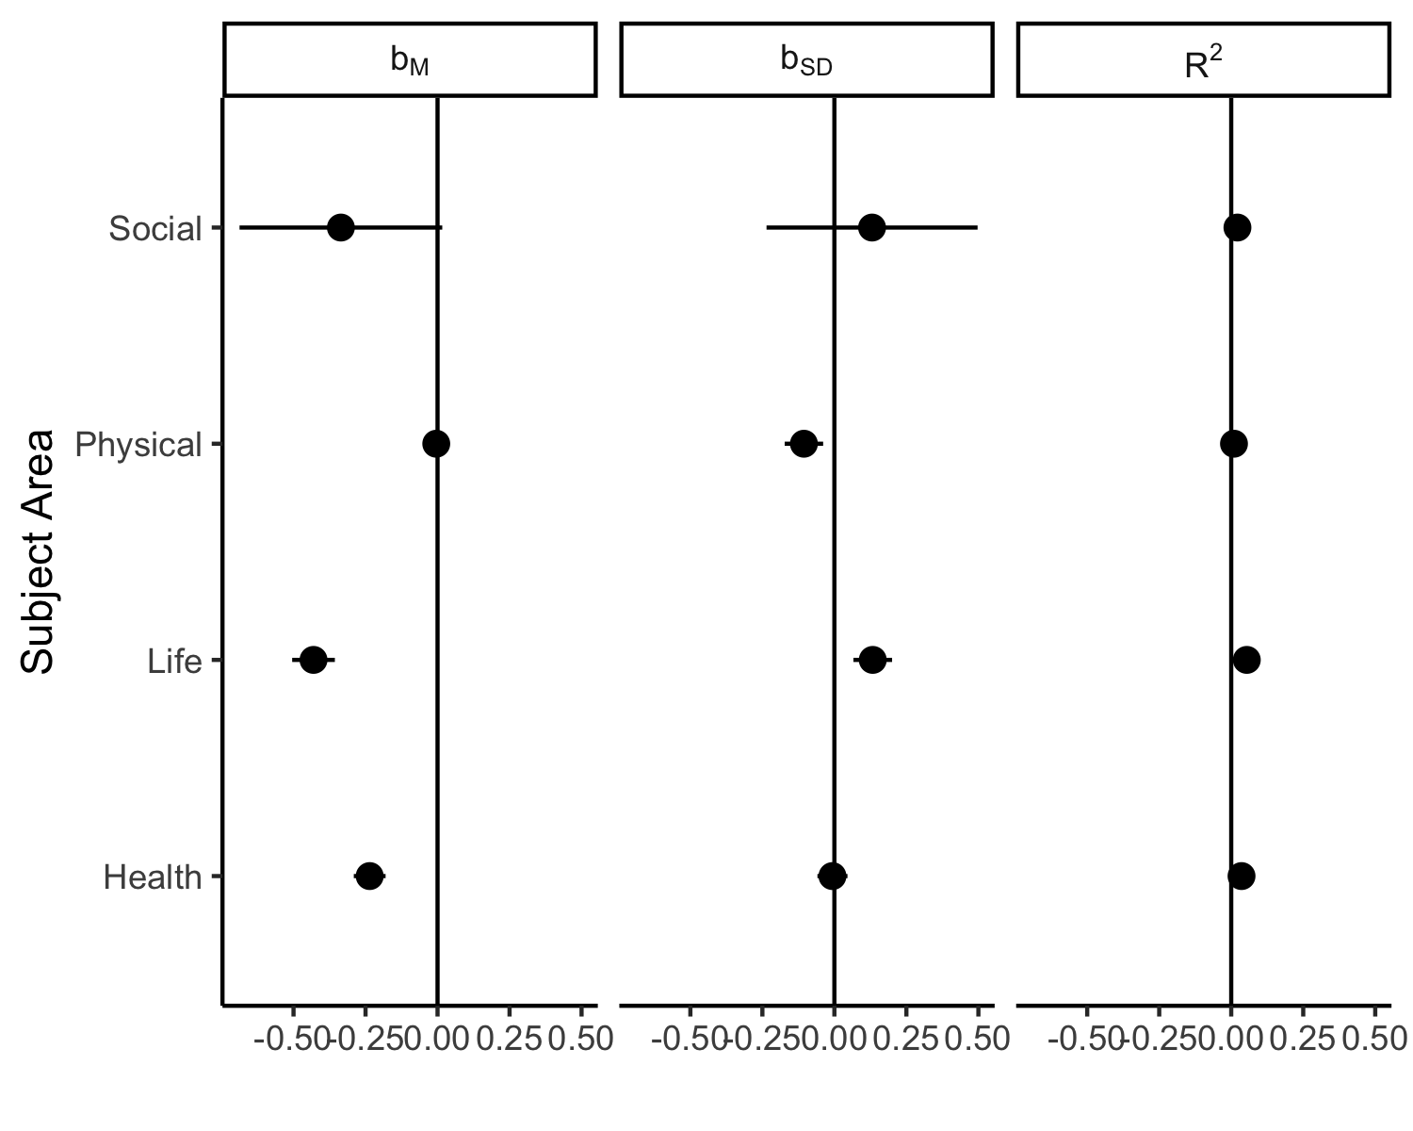

*Figure* *9.*  Coefficient values for the publication totals, variance in publication totals, and the effect size for each model predicting year of publication.

***Geopolitical Regions***.

* We will present visualizations of the country information listed for authors, and we will discuss the areas of world in which authors generally come from, as well as the lowest representation of authors.

## Warning in countrycode_convert(sourcevar = sourcevar, origin = origin, destination = dest, : Some values were not matched unambiguously: ANT, EUE, TWN  
  
## Warning in countrycode_convert(sourcevar = sourcevar, origin = origin, destination = dest, : Some values were not matched unambiguously: ANT, EUE, TWN

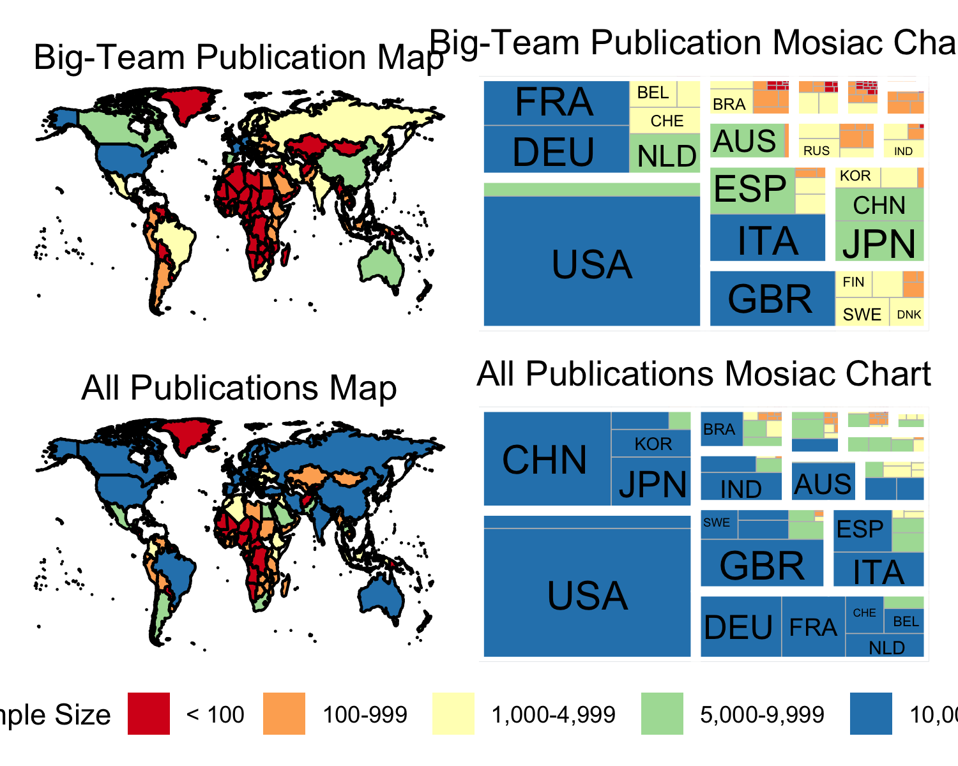

*Figure* *10.*  Geopolitical regions represented in big-team science publications versus all publications.

* To understand the change in representation diversity, we will summarize the total number of geopolitical regions for each paper. Using a linear model, we will examine if the number of regions present is predicted by the year of publication. Increasing diversity would be represented by a positive slope, while decreasing diversity would be represented by a negative slope.

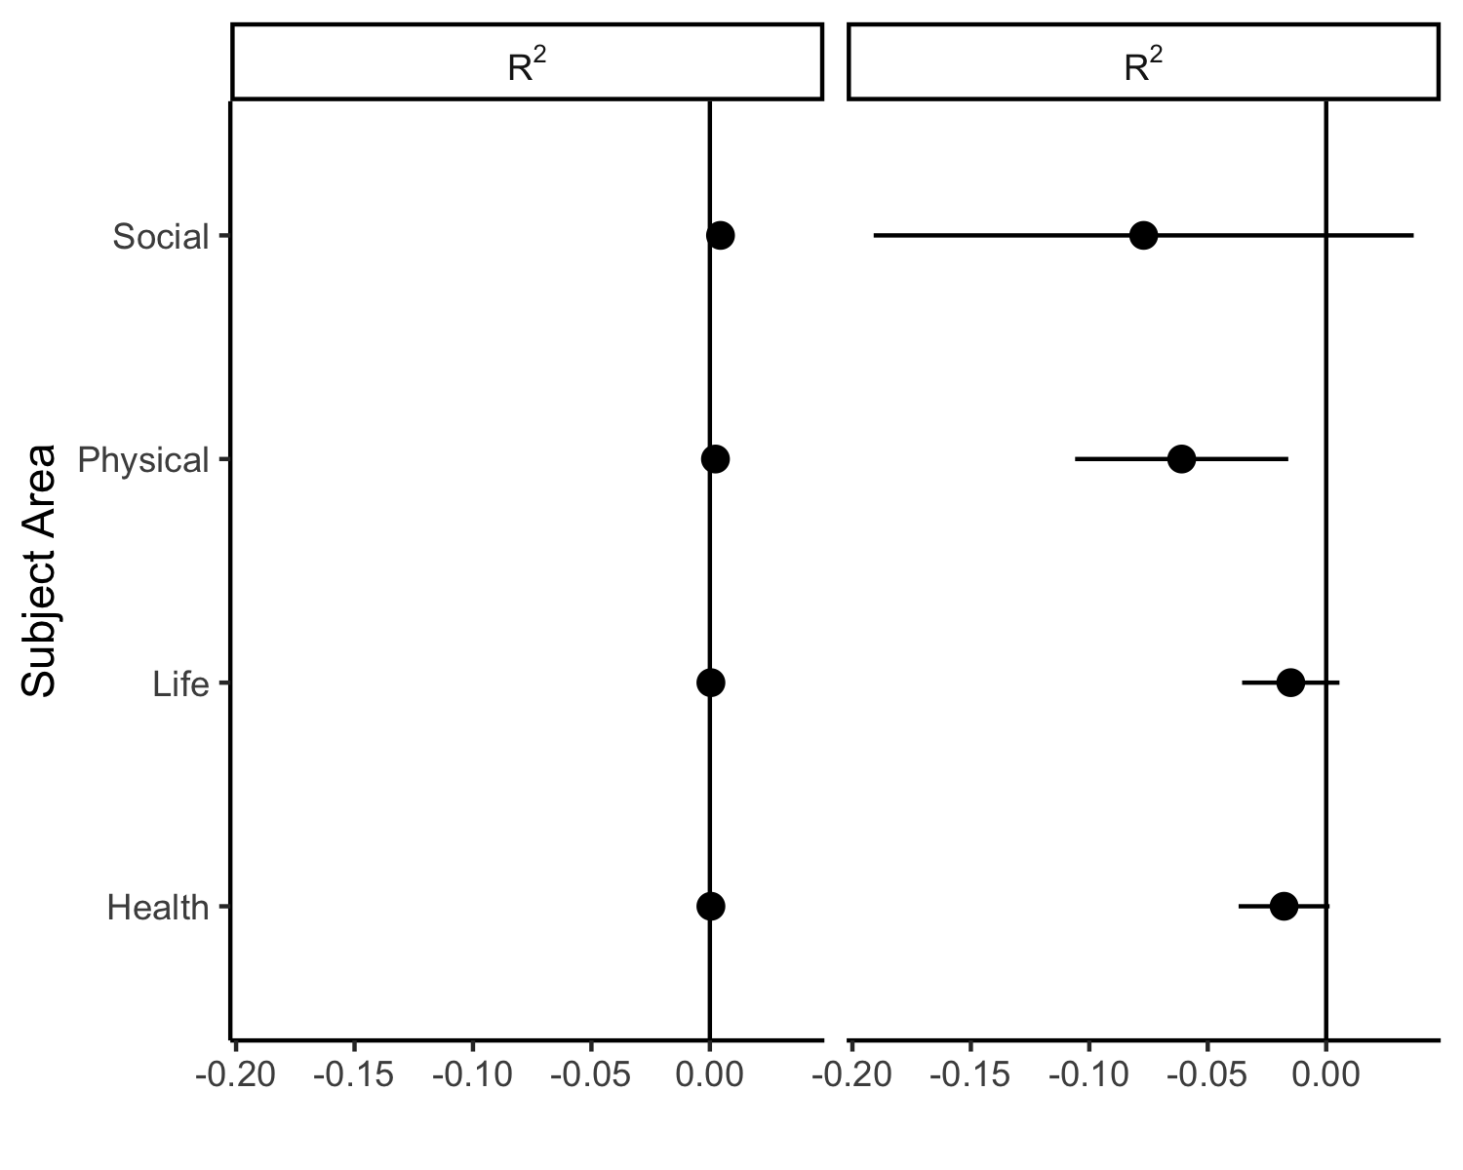

*Figure* *11.*  Number of geopolitical regions and variance in the number of regions represented in big-team science publiactions predicting time and the overall mode effect size.

* Last, we will examine the differences in representation for corresponding author sets versus all other authors. For papers with 10 to 49 authors, we will use the three first authors and the last author to compare against other authors. For 50 to 99 authors, five first authors plus last will be used, and for all papers with more than 100 authors, we will use ten first authors and the last author. We will calculate the frequencies of each of the UN Sub-Regions for first authors versus other authors, converting these values to proportions. Given the expected small sample sizes of these contingency tables, we will group together titles based on the year of publication (assuming at least 5 publications per year, these may be binned by 5-year or smaller increments to increase sample size). For each grouping, we will calculate the effect size of the differences in frequencies comparing first authors to all other authors. Since this data is categorical, we will use Cramer’s *V* to represent the effect size. If the effect size includes zero in its confidence interval, this result will imply that first and all other authors represent the same pattern of UN Sub-Region diversity. Any confidence interval that does include zero represents a difference in diversity.

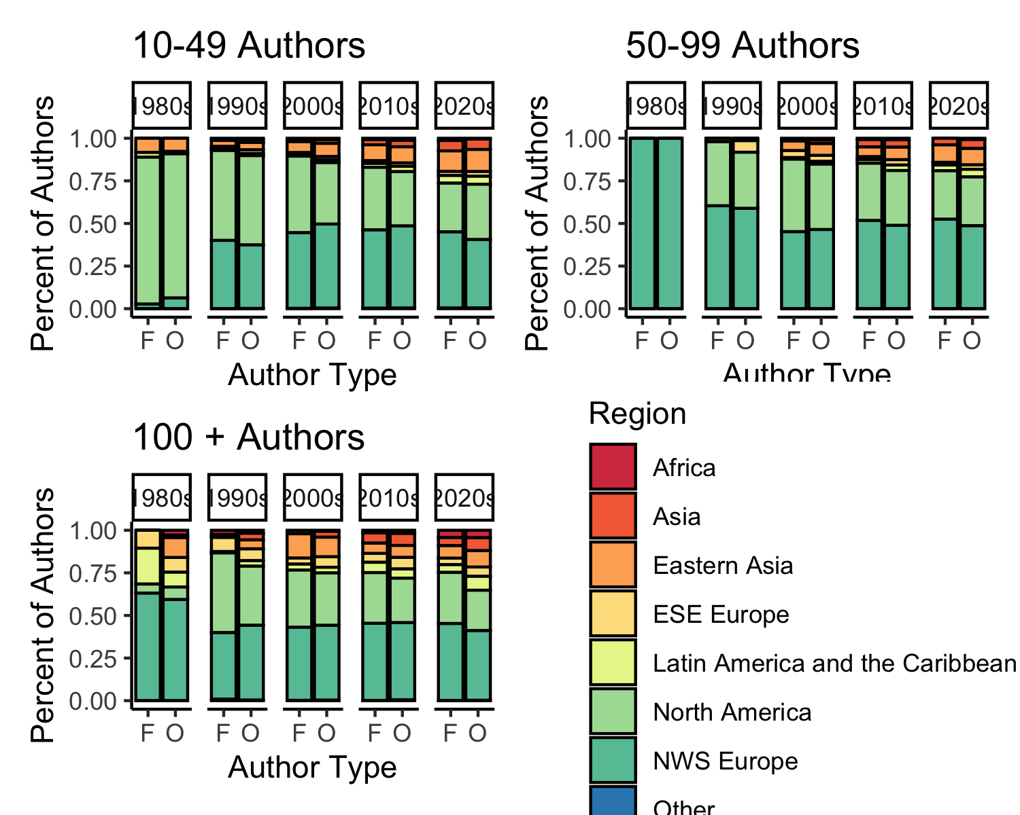

*Figure* *12.*  A comparison of author affiliation geopolitical region across decades.

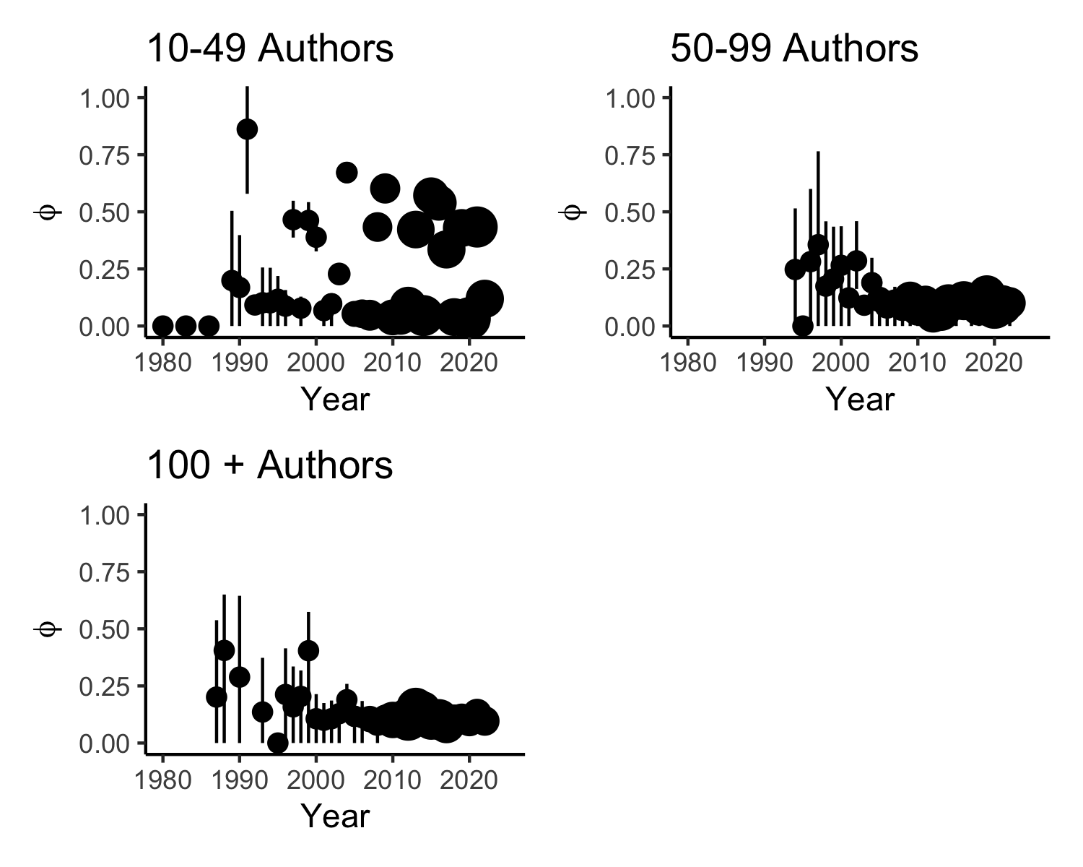

*Figure* *13.*  Effect size of the differences in representation for UN Regions for author affiliations in big-team science papers by year.

# References

A philosophical case for big physics. (2021). *Nature Physics*, *17*(6), 661–661. <https://doi.org/10.1038/s41567-021-01278-0>

Allen, L., O’Connell, A., & Kiermer, V. (2019). How can we ensure visibility and diversity in research contributions? How the Contributor Role Taxonomy (CRediT) is helping the shift from authorship to contributorship. *Learned Publishing*, *32*(1), 71–74. <https://doi.org/10.1002/leap.1210>

Auspurg, K., & Brüderl, J. (2021). Has the credibility of the social sciences been credibly destroyed? Reanalyzing the “many analysts, one data set” project. *Socius : Sociological Research for a Dynamic World*, *7*, 23780231211024420.

Bago, B., Kovacs, M., Protzko, J., Nagy, T., Kekecs, Z., Palfi, B., Adamkovic, M., Adamus, S., Albalooshi, S., Albayrak-Aydemir, N., Alfian, I. N., Alper, S., Alvarez-Solas, S., Alves, S. G., Amaya, S., Andresen, P. K., Anjum, G., Ansari, D., Arriaga, P., … Aczel, B. (2022). Situational factors shape moral judgements in the trolley dilemma in Eastern, Southern and Western countries in a culturally diverse sample. *Nature Human Behaviour*, 1–13. <https://doi.org/10.1038/s41562-022-01319-5>

Buttrick, N. R., Aczel, B., Aeschbach, L. F., Bakos, B. E., Brühlmann, F., Claypool, H. M., Hüffmeier, J., Kovacs, M., Schuepfer, K., Szecsi, P., Szuts, A., Szöke, O., Thomae, M., Torka, A.-K., Walker, R. J., & Wood, M. J. (2020). Many Labs 5: Registered Replication of Vohs and Schooler (2008), Experiment 1. *Advances in Methods and Practices in Psychological Science*, *3*(3), 429–438. <https://doi.org/10.1177/2515245920917931>

Castelnovo, P., Florio, M., Forte, S., Rossi, L., & Sirtori, E. (2018). The economic impact of technological procurement for large-scale research infrastructures: Evidence from the Large Hadron Collider at CERN. *Research Policy*, *47*(9), 1853–1867. <https://doi.org/10.1016/j.respol.2018.06.018>

Coles, N. A., Hamlin, J. K., Sullivan, L. L., Parker, T. H., & Altschul, D. (2022). Build up big-team science. *Nature*, *601*(7894), 505–507. <https://doi.org/10.1038/d41586-022-00150-2>

Collins, F. S., Morgan, M., & Patrinos, A. (2003). The human genome project: Lessons from large-scale biology. *Science*, *300*(5617), 286–290. <https://doi.org/10.1126/science.1084564>

Dorison, C., Lerner, J., Heller, B., Rothman, A., Kawachi, I., Wang, K., Rees, V., Gill, B., Gibbs, N., Ebersole, C., Vally, Z., Tajchman, Z., Zsido, A., Zrimsek, M., Chen, Z., Ziano, I., Gialitaki, Z., Ceary, C., Jang, Y., … Coles, N. (2022). A global test of message framing on behavioural intentions, policy support, information seeking, and experienced anxiety during the COVID-19 pandemic. *Affective Science*. <https://doi.org/10.31234/osf.io/sevkf>

Ebersole, C. R., Atherton, O. E., Belanger, A. L., Skulborstad, H. M., Allen, J. M., Banks, J. B., Baranski, E., Bernstein, M. J., Bonfiglio, D. B. V., Boucher, L., Brown, E. R., Budiman, N. I., Cairo, A. H., Capaldi, C. A., Chartier, C. R., Chung, J. M., Cicero, D. C., Coleman, J. A., Conway, J. G., … Nosek, B. A. (2016). Many Labs 3: Evaluating participant pool quality across the academic semester via replication. *Journal of Experimental Social Psychology*, *67*, 68–82. <https://doi.org/10.1016/j.jesp.2015.10.012>

Ebersole, C. R., Mathur, M. B., Baranski, E., Bart-Plange, D.-J., Buttrick, N. R., Chartier, C. R., Corker, K. S., Corley, M., Hartshorne, J. K., IJzerman, H., Lazarević, L. B., Rabagliati, H., Ropovik, I., Aczel, B., Aeschbach, L. F., Andrighetto, L., Arnal, J. D., Arrow, H., Babincak, P., … Nosek, B. A. (2020). Many Labs 5: Testing Pre-Data-Collection Peer Review as an Intervention to Increase Replicability. *Advances in Methods and Practices in Psychological Science*, *3*(3), 309–331. <https://doi.org/10.1177/2515245920958687>

Errington, T. M., Mathur, M., Soderberg, C. K., Denis, A., Perfito, N., Iorns, E., & Nosek, B. A. (2021). Investigating the replicability of preclinical cancer biology. *eLife*, *10*, e71601. <https://doi.org/10.7554/eLife.71601>

Forscher, P. S., Wagenmakers, E.-J., Coles, N. A., Silan, M. A. A., Dutra, N. B., Basnight-Brown, D., & IJzerman, H. (2020). *The benefits, barriers, and risks of big team science*. <https://doi.org/10.31234/osf.io/2mdxh>

Franco, A., Malhotra, N., & Simonovits, G. (2014). Publication bias in the social sciences: Unlocking the file drawer. *Science*, *345*(6203), 1502–1505. <https://doi.org/10.1126/science.1255484>

Grahe, J. E. (2014). Announcing open science badges and reaching for the sky. *The Journal of Social Psychology*, *154*(1), 1–3. <https://doi.org/10.1080/00224545.2014.853582>

Henrich, J., Heine, S. J., & Norenzayan, A. (2010). The weirdest people in the world? *Behavioral and Brain Sciences*, *33*(2-3), 61–83. <https://doi.org/10.1017/S0140525X0999152X>

Hubbard, R., & Armstrong, J. S. (1997). Publication Bias against Null Results. *Psychological Reports*, *80*(1), 337–338. <https://doi.org/10.2466/pr0.1997.80.1.337>

Ioannidis, J. P. A. (2015). Failure to replicate: Sound the alarm. *Cerebrum: The Dana Forum on Brain Science*, *2015*. <https://www.ncbi.nlm.nih.gov/pmc/articles/PMC4938249/>

Isager, P. M., Aert, R. C. M. van, Bahník, Š., Brandt, M. J., DeSoto, K. A., Giner-Sorolla, R., Krueger, J. I., Perugini, M., Ropovik, I., van ’t Veer, A. E., Vranka, M., & Lakens, D. (2021a). Deciding what to replicate: A decision model for replication study selection under resource and knowledge constraints. *Psychological Methods*. <https://doi.org/10.1037/met0000438>

Isager, P. M., Aert, R. C. M. van, Bahník, Š., Brandt, M. J., DeSoto, K. A., Giner-Sorolla, R., Krueger, J. I., Perugini, M., Ropovik, I., van ’t Veer, A. E., Vranka, M., & Lakens, D. (2021b). Deciding what to replicate: A decision model for replication study selection under resource and knowledge constraints. *Psychological Methods*. <https://doi.org/10.1037/met0000438>

John, L. K., Loewenstein, G., & Prelec, D. (2012). Measuring the Prevalence of Questionable Research Practices With Incentives for Truth Telling. *Psychological Science*, *23*(5), 524–532. <https://doi.org/10.1177/0956797611430953>

Jones, B. C., DeBruine, L. M., Flake, J. K., Liuzza, M. T., Antfolk, J., Arinze, N. C., Ndukaihe, I. L. G., Bloxsom, N. G., Lewis, S. C., Foroni, F., Willis, M. L., Cubillas, C. P., Vadillo, M. A., Turiegano, E., Gilead, M., Simchon, A., Saribay, S. A., Owsley, N. C., Jang, C., … Coles, N. A. (2021). To which world regions does the valencedominance model of social perception apply? *Nature Human Behaviour*, *5*(1), 159–169. <https://doi.org/10.1038/s41562-020-01007-2>

Kidwell, M. C., Lazarević, L. B., Baranski, E., Hardwicke, T. E., Piechowski, S., Falkenberg, L.-S., Kennett, C., Slowik, A., Sonnleitner, C., Hess-Holden, C., Errington, T. M., Fiedler, S., & Nosek, B. A. (2016). Badges to Acknowledge Open Practices: A Simple, Low-Cost, Effective Method for Increasing Transparency. *PLOS Biology*, *14*(5), e1002456. <https://doi.org/10.1371/journal.pbio.1002456>

Klein, R. A., Cook, C. L., Ebersole, C. R., Vitiello, C., Nosek, B. A., Hilgard, J., Ahn, P. H., Brady, A. J., Chartier, C. R., Christopherson, C. D., Clay, S., Collisson, B., Crawford, J. T., Cromar, R., Gardiner, G., Gosnell, C. L., Grahe, J., Hall, C., Howard, I., … Ratliff, K. A. (2022). Many Labs 4: Failure to Replicate Mortality Salience Effect With and Without Original Author Involvement. *Collabra: Psychology*, *8*(1), 35271. <https://doi.org/10.1525/collabra.35271>

Klein, R. A., Vianello, M., Hasselman, F., Adams, B. G., Adams, R. B., Alper, S., Aveyard, M., Axt, J. R., Babalola, M. T., Bahník, Š., Batra, R., Berkics, M., Bernstein, M. J., Berry, D. R., Bialobrzeska, O., Binan, E. D., Bocian, K., Brandt, M. J., Busching, R., … Nosek, B. A. (2018). Many Labs 2: Investigating Variation in Replicability Across Samples and Settings. *Advances in Methods and Practices in Psychological Science*, *1*(4), 443–490. <https://doi.org/10.1177/2515245918810225>

LeBel, E. P., McCarthy, R. J., Earp, B. D., Elson, M., & Vanpaemel, W. (2018). A Unified Framework to Quantify the Credibility of Scientific Findings. *Advances in Methods and Practices in Psychological Science*, *1*(3), 389–402. <https://doi.org/10.1177/2515245918787489>

Legate, N., Nguyen, T., Weinstein, N., Moller, A., Legault, L., Maniaci, M. R., Ebersole, C. R., Adamkovic, M., Adetula, D. G. A., Agesin, B. B., Ahlgren, L., Akkas, H., Almeida, I., Anjum, G., Antoniadi, M., Arinze, A. I., Arvanitis, A., Rana, K., Badalyan, V., … Primbs, M. (2022). A global experiment on motivating social distancing during the COVID-19 pandemic. *Proceedings of the National Academy of Sciences*. <https://doi.org/10.31234/osf.io/n3dyf>

Maizey, L., & Tzavella, L. (2019). Barriers and solutions for early career researchers in tackling the reproducibility crisis in cognitive neuroscience. *Cortex*, *113*, 357–359. <https://doi.org/10.1016/j.cortex.2018.12.015>

Mathur, M. B., Bart-Plange, D.-J., Aczel, B., Bernstein, M. H., Ciunci, A. M., Ebersole, C. R., Falcão, F., Ashbaugh, K., Hilliard, R. A., Jern, A., Kellier, D. J., Kessinger, G., Kolb, V. S., Kovacs, M., Lage, C. A., Langford, E. V., Lins, S., Manfredi, D., Meyet, V., … Frank, M. C. (2020). Many Labs 5: Registered Multisite Replication of the Tempting-Fate Effects in Risen and Gilovich (2008). *Advances in Methods and Practices in Psychological Science*, *3*(3), 394–404. <https://doi.org/10.1177/2515245918785165>

Maxwell, S. E., Lau, M. Y., & Howard, G. S. (2015). Is psychology suffering from a replication crisis?: What does ’failure to replicate’ really mean? *American Psychologist*, *70*(6), 487–498. <https://doi.org/10.1037/a0039400>

Mayo-Wilson, E., Grant, S., Supplee, L., Kianersi, S., Amin, A., DeHaven, A., & Mellor, D. (2021). Evaluating implementation of the transparency and openness promotion (TOP) guidelines: The TRUST process for rating journal policies, procedures, and practices. *Research Integrity and Peer Review*, *6*(1), 9. <https://doi.org/10.1186/s41073-021-00112-8>

Moshontz, H., Campbell, L., Ebersole, C. R., IJzerman, H., Urry, H. L., Forscher, P. S., Grahe, J. E., McCarthy, R. J., Musser, E. D., Antfolk, J., Castille, C. M., Evans, T. R., Fiedler, S., Flake, J. K., Forero, D. A., Janssen, S. M. J., Keene, J. R., Protzko, J., Aczel, B., … Chartier, C. R. (2018). The Psychological Science Accelerator: Advancing Psychology Through a Distributed Collaborative Network. *Advances in Methods and Practices in Psychological Science*, *1*(4), 501–515. <https://doi.org/10.1177/2515245918797607>

Nelson, L. D., Simmons, J., & Simonsohn, U. (2018). Psychology’s renaissance. *Annual Review of Psychology*, *69*(1), 511–534. <https://doi.org/10.1146/annurev-psych-122216-011836>

Newson, M., Buhrmester, M., Xygalatas, D., & Whitehouse, H. (2021). Go WILD, not WEIRD. *Journal for the Cognitive Science of Religion*, *6*(1-2). <https://doi.org/10.1558/jcsr.38413>

Nosek, B. A., Alter, G., Banks, G. C., Borsboom, D., Bowman, S. D., Breckler, S. J., Buck, S., Chambers, C. D., Chin, G., Christensen, G., Contestabile, M., Dafoe, A., Eich, E., Freese, J., Glennerster, R., Goroff, D., Green, D. P., Hesse, B., Humphreys, M., … Yarkoni, T. (2015). Promoting an open research culture. *Science*, *348*(6242), 1422–1425. <https://doi.org/10.1126/science.aab2374>

Nosek, B. A., & Lakens, D. (2014a). Registered Reports: A Method to Increase the Credibility of Published Results. *Social Psychology*, *45*(3), 137–141. <https://doi.org/10.1027/1864-9335/a000192>

Nosek, B. A., & Lakens, D. (2014b). A method to increase the credibility of published results. *Social Psychology*, *45*(3), 137141.

Nosek, B. A., Spies, J. R., & Motyl, M. (2012). Scientific Utopia: II. Restructuring Incentives and Practices to Promote Truth Over Publishability. *Perspectives on Psychological Science*, *7*(6), 615–631. <https://doi.org/10.1177/1745691612459058>

OED. (2016). *Collaboration* (Vol. 3). Oxford University.

Open Science Collaboration. (2015). Estimating the reproducibility of psychological science. *Science*, *349*(6251), aac4716–aac4716. <https://doi.org/10.1126/science.aac4716>

Rad, M. S., Martingano, A. J., & Ginges, J. (2018). Toward a psychology of homo sapiens: Making psychological science more representative of the human population. *Proceedings of the National Academy of Sciences*, *115*(45), 11401–11405. <https://doi.org/10.1073/pnas.1721165115>

Silberzahn, R., Uhlmann, E. L., Martin, D. P., Anselmi, P., Aust, F., Awtrey, E., Bahník, Š., Bai, F., Bannard, C., Bonnier, E., & others. (2018). Many analysts, one data set: Making transparent how variations in analytic choices affect results. *Advances in Methods and Practices in Psychological Science*, *1*(3), 337356.

Skorb, L., Aczel, B., Bakos, B. E., Feinberg, L., Hałasa, E., Kauff, M., Kovacs, M., Krasuska, K., Kuchno, K., Manfredi, D., Montealegre, A., Pękala, E., Pieńkosz, D., Ravid, J., Rentzsch, K., Szaszi, B., Schulz-Hardt, S., Sioma, B., Szecsi, P., … Hartshorne, J. K. (2020). Many Labs 5: Replication of van Dijk, van Kleef, Steinel, and van Beest (2008). *Advances in Methods and Practices in Psychological Science*, *3*(3), 418–428. <https://doi.org/10.1177/2515245920927643>

Stewart, N., Chandler, J., & Paolacci, G. (2017). Crowdsourcing samples in cognitive science. *Trends in Cognitive Sciences*, *21*(10), 736–748. <https://doi.org/10.1016/j.tics.2017.06.007>

Stewart, S., Rinke, E. M., McGarrigle, R., Lynott, D., Lunny, C., Lautarescu, A., Galizzi, M. M., Farran, E. K., & Crook, Z. (2020). *Pre-registration and registered reports: A primer from UKRN*. <https://doi.org/10.31219/osf.io/8v2n7>

Van Bavel, J. J., Cichocka, A., Capraro, V., Sjåstad, H., Nezlek, J. B., Pavlović, T., Alfano, M., Gelfand, M. J., Azevedo, F., Birtel, M. D., Cislak, A., Lockwood, P. L., Ross, R. M., Abts, K., Agadullina, E., Aruta, J. J. B., Besharati, S. N., Bor, A., Choma, B. L., … Boggio, P. S. (2022). National identity predicts public health support during a global pandemic. *Nature Communications*, *13*(1), 517. <https://doi.org/10.1038/s41467-021-27668-9>

Vazire, S., Schiavone, S. R., & Bottesini, J. G. (2022). Credibility Beyond Replicability: Improving the Four Validities in Psychological Science. *Current Directions in Psychological Science*, *31*(2), 162–168. <https://doi.org/10.1177/09637214211067779>

Wang, K., Goldenberg, A., Dorison, C. A., Miller, J. K., Uusberg, A., Lerner, J. S., Gross, J. J., Agesin, B. B., Bernardo, M., Campos, O., Eudave, L., Grzech, K., Ozery, D. H., Jackson, E. A., Garcia, E. O. L., Drexler, S. M., Jurković, A. P., Rana, K., Wilson, J. P., … Moshontz, H. (2021). A multi-country test of brief reappraisal interventions on emotions during the COVID-19 pandemic. *Nature Human Behaviour*, *5*(8), 1089–1110. <https://doi.org/10.1038/s41562-021-01173-x>

Zwaan, R. A., Etz, A., Lucas, R. E., & Donnellan, M. B. (2018). Making replication mainstream. *Behavioral and Brain Sciences*, *41*, e120. <https://doi.org/10.1017/S0140525X17001972>