姓名： 01057160 聶竣朗 01057162 黃偉棟

1.

* 1. 10
  2. 10%
  3. d 0.00147

2.

Packet switching is the method of breaking down information into smaller chunks known as packets, and transmitting the packets across the network. Circuit switching reserves a certain bandwidth for the duration of communication.

|  | Advantages | Disadvantages |
| --- | --- | --- |
| Packet Switching | Can allow more users in any given time. | Queueing delays and packet losses might occur when the output buffer is congested. |
| Circuit Switching | The data path is fixed and will not change during transmission. | Setup cost is high.  More links will result in more bandwidth needed. |

3.

[Traceroute Online with Network Map | Tactical Network Testing (traceroute-online.com)](https://traceroute-online.com/)

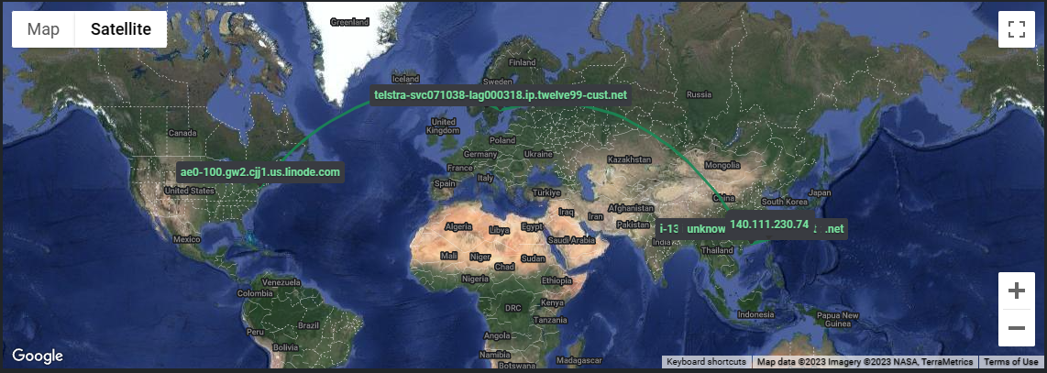

| Direction | Path | Reason |
| --- | --- | --- |
| USA - Sweden | Havfrue / AEC-2 | Connects the USA to Sweden , with Norway being the intermediate. |
| Sweden - Hong Kong | N0r5ke Viking 2 | Norway has access to a path to Asia, so Sweden has to pass through Norway beforehand. |
|  | FLAG Europe - Asia | Norway to Hong Kong. |
| Hong Kong - Taiwan | EAC C2C | This route connects Hong Kong and Taiwan. |

4.

No idea what is the max bandwidth given by the hostel, but my results came in at 11 Mbps. The result is not equal to the given bandwidth could be due to apps running in the back during the test, and affecting the results.

5.

A certain license, CCNP, is needed for some job postings. Some might need high proficiency in SQL or database languages in order to manage databases. English proficiency, which isn’t too related to computer networking, was also needed for some jobs.