
High Availability and Disaster Recovery Configurations for IBM Tivoli Application Dependency Discovery Manager

Document version 1.0

Andrzej Wrobel(andrzej.wrobel@pl.ibm.com)

Table of Contents
1 Introduction 3
2 Target Audience 3
3 Architecture 3
4 Configuration 5
1 OS user management 5
2 Files Replication 5
3 Database setup - DB2 6
HADR setup 6
HADR requirements 7
HADR Considerations 7
4 Oracle 10
5 Change History table 10
6 Database backup & restore 11
7 Service IP Configuration 11
5 Maintenance 13
6 Troubleshooting 13
DbInit service fails to start 13
Starting TADDM Client from Servers Summary fails 14
7 Notices 15

Introduction
This document helps you to deploy IBM Tivoli Application Dependency Discovery Manager (TADDM) on Streaming mode deployment in a High Availability (HA) configuration. This document describes:
- Steps necessary to install and configure components of TADDM in a highly available environment

Target Audience
This document is intended for engineers responsible for installing highly available TADDM on Streaming mode deployment. To understand the configuration procedures documented here, it is highly recommended that the users get familiar with:
- TADDM installation and administration
- Linux administration

Architecture
shows the architecture of key components:
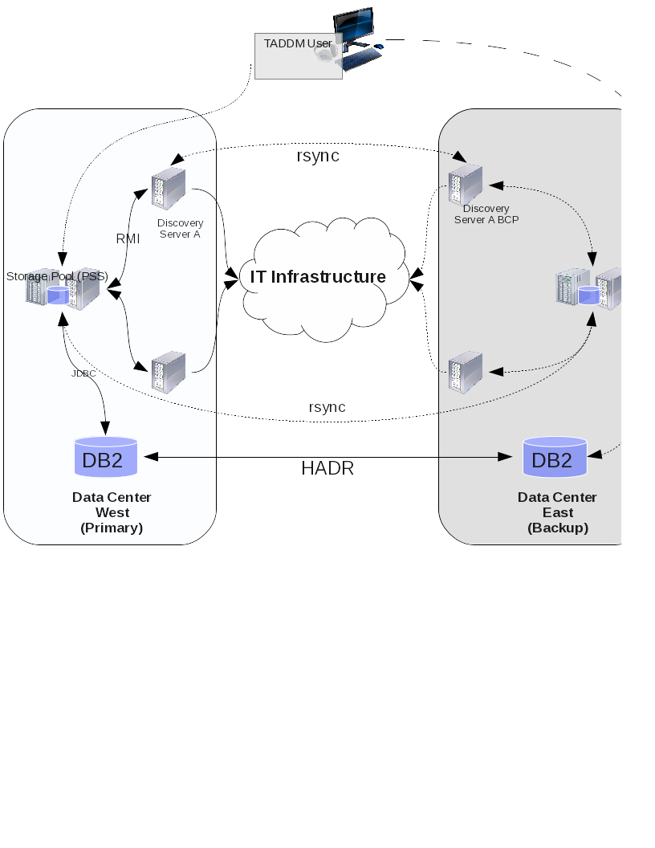

Configuration

OS user management
All systems that are part of the Streaming Mode topology needs to have the same user and group that owns and runs TADDM processes. If possible reuse same UID between systems. Also make sure the user have the same location of home directory. This helps with any troubleshooting.

Files Replication
Replication of files between components is done by rsync mechanism. Each component has a peer device in backup Data Center.
Primary Storage Server (PRI)→ Primary Storage Server (BCP)
Storage Server (PRI)→ Storage Server (BCP)
Discovery Server X (PRI) → Discovery Server X (BCP)

Command that is used for synchronizing files on Linux Operating System
rsync -avzhe ssh --include='*/' --exclude dist/log/* --exclude
dist/log/agents/* --exclude dist/log/services/* --exclude
dist/log/sensors/* --exclude dist/log/tomcat/* --exclude
dist/var/dwitem/config/* --exclude dist/var/dwitem/result/* --exclude
dist/var/dwitem/seed/* --exclude dist/var/viewmgr/graph/* --exclude
dist/var/viewmgr/tree/* --exclude dist/var/dwitem/config/* --exclude
dist/external/apache-tomcat/logs/*
user@<primary component IP>:/opt/IBM/taddm/ /opt/IBM/taddm/

rsync -avzhe ssh user@<primary component IP>:/etc/init.d/collation /etc/init.d

Note: If anchors and gateways from Primary Site are not reused by Backup Site than above command exclude needs to contain additional entries:
--exclude dist/etc/gateway.properties
--exclude dist/etc/anchor.properties

Command needs to be run on Backup Server.
The replication frequency can be daily unless user performs a lot of changes to sensor or product configuration files
Important: For any Fixpack or major version upgrade files replication needs to be disabled until maintenance tasks are completed on Primary Data Center.

Database setup - DB2
The database is one of the most critical components of IBM Tivoli Application Discovery Dependency Manager. It provides the option of using IBM DB2 or Oracle as the backend. Bringing down the database will disrupt TADDM application. Running new discoveries or viewing the data is not available when database is not running. Therefore having High Availability for this component is critical. This document focus on high availability topology using IBM DB2 High Availability and Disaster Recovery (HADR).

It is assumed that the DB2 is already installed and configured for IBM TADDM.
For this topology DB2 was installed on two separate servers. The first server
performed the role of the primary IBM TADDM database, the
secondary server was the standby database. This data was kept synchronized
using HADR mechanism.

HADR setup
The HADR feature provides a highly available solution for database failure.
HADR protects against data loss by replicating data changes from the primary
database to the secondary database.
All changes that take place at the primary database are written to the DB2 logs.
These logs are shipped to the secondary database server, where the log records
are replayed to the local copy of the database. This ensures that the data on the
primary and secondary database are in a synchronized state. The secondary
server is always in the rollforward mode, in the state of near readiness, so the
takeover to the standby server is fast.
HADR uses dedicated TCP/IP communication ports and a heartbeat to track the
current state of the replication. If the standby database is up to date with the
primary database, it is known as a HADR peer state.

If the primary database fails, then the HADR takeover by force operation
converts the standby database to the new primary database. After the old
primary database comes back online, you can return both servers to their original
roles.

HADR requirements
The following requirements must be in place to set up HADR:
The operating system version and patch level must be the same on the
primary and standby database server. For a short duration during the rolling
upgrade they may be different, but use caution.
The DB2 version, level and bit size (32-bit or 64-bit) must be identical on the
primary and standby database server.
The primary and standby database must have the same name. This means
that the two databases cannot be on the same server.
A reliable TCP/IP interface must be available between the HADR servers.
The database layout including the bufferpool sizes, tablespace name, size
and type, and log space must be identical on the primary and secondary
database servers.

Note: Topology developed during this exercise uses Windows Server 2008 SP2 with DB2 Advanced Enterprise Server 10.1 Fixpack 4 on both nodes. However the database Operating System and DB2 version can be different as long as it is supported by TADDM and allows for setting HADR mechanism.

HADR Considerations
The following parameters should be considered for the HADR setup and adjusted
according to the needs:
AUTORESTART
Consider setting this db cfg parameter to OFF , when the HADR database is
configured with Automatic Client Reroute (ACR). Leave AUTORESTART to ON for
non-HADR environments.
LOGINDEXBUILD
This db cfg parameter should be set to ON so that index creation, recreation,
or reorganization on the tables are logged on the primary database and
replayed on the secondary database.
HADR_PEER_WINDOW
This is used to ensure data consistency. If the value is set to greater than
zero, the HADR database pair continues to behave as though they are in the
peer state, for the configured time in case the connection is lost between the
two databases.
The advantage of configuring the peer window is a lower risk of transaction
loss during multiple or cascading failures. The disadvantage of configuring the
peer window is that transactions on the primary database will take longer or
time out when the primary database is in the peer window waiting for the
connection to the standby database or for the peer window to expire.
This parameter must be adjusted according to the needs of your environment.
HADR_TIMEOUT
This db cfg parameter specifies the time in seconds that the DB2 HADR
database waits for response from the other database before it considers the
communication to have failed and closes the connection.
This parameter must be adjusted according to the needs of your environment.
SYNCMODE
This db cfg parameter specifies one of the three synchronization modes. The
synchronization modes indicate how log writing is managed between the
primary and secondary servers. These modes apply only when the HADR is
in the peer state. The valid values are:
– SYNC (Synchronous)
This mode provides the greatest protection against transaction loss, and
using it results in the longest transaction response time among the three
modes.
– NEARSYNC (Near synchronous)
While this mode has a shorter transaction response time than
synchronous mode, it also provides slightly less protection against
transaction loss.
– ASYNC (Asynchronous)
This mode has the highest chance of transaction loss if the primary
system fails. It also has the shortest transaction response time among the
three modes.
– SUPERASYNC (Super Async)
This mode ensures that the transaction can never be blocked or
experience elongated response times due to network interruption or
congestion, thereby allowing transactions to be processed more quickly.
In our example we used the value of SYNC for the parameter.

Information: For more information about the HADR synchronization
modes, refer to:
http://publib.boulder.ibm.com/infocenter/db2luw/v9/topic/com.ibm.db2.udb.admin.doc/doc/c0011724.htm

HADR Setup

Set the required database configuration parameters.
If archive logging is not configured already, then update the LOGRETAIN and
LOGARCHMETH1 parameters by running the following commands:

db2 update db cfg for DB2_DBNAME using LOGARCHMETH1 LOGRETAIN

Set the LOGINDEXBUILD parameter so that the index creation and
reorganization operations are logged by running the following command:

db2 update db cfg for DB2_DBNAME using LOGINDEXBUILD ON

Tip: Check the database Rollforward pending status issuing the
db2 get db cfg for DB2_DBNAME |grep "Rollforward pending"
command

Oracle
If your environment uses Oracle as a database platform, high availability options
are available that are compatible with TADDM. More information about Oracle RAC with TADDM
can be found at:

http://www-01.ibm.com/support/knowledgecenter/SSPLFC_7.2.2/com.ibm.taddm.doc_7.2.2/InstallGuide/t_cmdb_install_oracle_rac.html?lang=en

Change History table
During TADDM first start the database tables are created. By default two change_history_table columns are created with “NOT LOGGED” option which save space of transaction log or archive log. It can lead to many issues in HADR configuration. Access to those columns after stand-by becomes primary can cause errors or the rows are being filled with zero bits. This is valid for 7.2.2 release or earlier. Future releases can have more columns that have “NOT LOGGED” options. For more information contact IBM support.
Below are the steps that need to be performed after TADDM is installed on primary-site.
- Stop all TADDM components (Discovery Servers, Storage Servers, Primary Storage Server).
- If this operation is being done on environment that already has multiple entries in change history table do clean up by running following SQL:
truncate table change_history_table IMMEDIATE;
- Modify columns and copy values (execute with correct username for schema) by creating file alter_table.sql with following content:
ALTER TABLE change_history_table RENAME COLUMN old_value TO B_old_value;
ALTER TABLE change_history_table RENAME COLUMN new_value TO B_new_value;
ALTER TABLE change_history_table ADD COLUMN old_value CLOB(1M);
ALTER TABLE change_history_table ADD COLUMN new_value CLOB(1M);
UPDATE change_history_table set old_value = B_old_value; -- required if table is not empty potential problem with transaction log size if table is big
UPDATE change_history_table set new_value = B_new_value; -- required if table is not empty potential problem with transaction log size if table is big
ALTER TABLE change_history_table DROP COLUMN B_old_value;
ALTER TABLE change_history_table DROP COLUMN B_new_value;

- Run the script
db2 -tf alter_table.sql
- Two columns were dropped so we need to run reorg
db2 REORG TABLE change_history_table

Database backup & restore
After change history table is corrected perform following steps to backup and restore Database.
- Back up the database on the primary node by running the following
command. The database backup should be an offline backup, which means
no user connections are allowed on the database.
db2 backup database DB2_DBNAME to BACKUP_PATH

- Transfer the backup image to the secondary node.
- Restore the database on the secondary server by running the following
command. The standby database must be in the Rollforward pending mode.
db2 restore database DB2_DBNAME from BACKUP_PATH taken at
BACKUP_TIMESTAMP replace history file

Service IP Configuration
To allow components to failover and this process be transparent to TADDM components associated hostnames are reused in pirmary and standby environments. This documents assume mapping of IP addresses to the same hostname through /etc/hosts file

- /etc/hosts file from TADDM components in Primary Data Center:
192.168.1.11 pss.kraklab.pl.ibm.com pss
192.168.1.12 taddmdbserver.kraklab.pl.ibm.com taddmdbserver
192.168.1.13 discoveryserver.kraklab.pl.ibm.com discoveryserver
192.168.1.14 secondstoragetaddm.kraklab.pl.ibm.com secondstoragetaddm

- /etc/hosts file from TADDM components in Standby Data Centers (same on all of them):
192.168.2.11 pss.kraklab.pl.ibm.com pss
192.168.2.12 taddmdbserver.kraklab.pl.ibm.com taddmdbserver
192.168.2.13 discoveryserver.kraklab.pl.ibm.com secondstoragetaddm
192.168.2.14 secondstoragetaddm.kraklab.pl.ibm.com discoveryserver

PSS collation.properties important settings:

# Set this value if java.net.InetAddress.getCanonicalHostName()
# is unable to determine a hostname. This should be reachable
# from the primary storage server if running in synchronization server deployment. If
# a discovery server or domain server's serverID is changed,
# discovery schedules will be lost.
com.collation.serverID=pss

# Set this value if running in Streaming (not Sync) mode.
# This is the preferred mode for 7.2.1 and beyond.
# Only one database is used for the entire enterprise.
# Storage servers write to the database, while discovery servers
# run discoveries and send data to the storage servers.
# Choices for this value are "DiscoveryServer" or "StorageServer".
com.collation.taddm.mode=StorageServer

com.collation.db.url=jdbc:db2://taddmdbserver:50000/lin114
com.collation.db.archive.url=jdbc:db2://taddmdbserver:50000/lin114
com.collation.db.server=taddmdbserver

Storage Server collation.properties important settings:

# Set this value if java.net.InetAddress.getCanonicalHostName()
# is unable to determine a hostname. This should be reachable
# from the primary storage server if running in synchronization server deployment. If
# a discovery server or domain server's serverID is changed,
# discovery schedules will be lost.
com.collation.serverID=secondstoragetaddm

# Set this value if running in Streaming (not Sync) mode.
# This is the preferred mode for 7.2.1 and beyond.
# Only one database is used for the entire enterprise.
# Storage servers write to the database, while discovery servers
# run discoveries and send data to the storage servers.
# Choices for this value are "DiscoveryServer" or "StorageServer".
com.collation.taddm.mode=StorageServer

# Primary storage server host and port.
# Do not set if this server is the primary storage server.
com.collation.PrimaryStorageServer.host=pss
com.collation.PrimaryStorageServer.port=4160

com.collation.db.url=jdbc:db2://taddmdbserver:50000/lin114
com.collation.db.archive.url=jdbc:db2://taddmdbserver:50000/lin114
com.collation.db.server=taddmdbserver

Discovery Server collation.properties important settings:
# Set this value if java.net.InetAddress.getCanonicalHostName()
# is unable to determine a hostname. This should be reachable
# from the primary storage server if running in synchronization server deployment. If
# a discovery server or domain server's serverID is changed,
# discovery schedules will be lost.
com.collation.serverID=discoveryserver

# Set this value if running in Streaming (not Sync) mode.
# This is the preferred mode for 7.2.1 and beyond.
# Only one database is used for the entire enterprise.
# Storage servers write to the database, while discovery servers
# run discoveries and send data to the storage servers.
# Choices for this value are "DiscoveryServer" or "StorageServer".
com.collation.taddm.mode=DiscoveryServer

# Primary storage server host and port.
# Do not set if this server is the primary storage server.
com.collation.PrimaryStorageServer.host=pss
com.collation.PrimaryStorageServer.port=4160

com.collation.db.url=jdbc:db2://taddmdbserver:50000/lin114
com.collation.db.archive.url=jdbc:db2://taddmdbserver:50000/lin114
com.collation.db.server=taddmdbserver

Such settings allow to rsync collation.properties without any additional post processing of that file.

Maintenance
Applying fixpack or upgrading to newer version requires disabling rsync during upgrade time. It can be enabled again when upgrade is finished on primary site.

Troubleshooting

DbInit service fails to start
Primary Storage Server fails to start due to problems with database (DbInit service has red status in Administrator Console). Check error.log for following message:
SQLCODE: -1768, SQLSTATE: SQLERRMC: 7
TADDM Database configured for HADR data replication, primary and standby servers started out of sequence. TADDM is unable to connect to the primary database and the server process cannot start.
The user will need to issue the following sequence of commands to ensure the primary and standby databases are started correctly.
Log on to the standby DB2 server and run the following command:
db2 start hadr on database <dbname> as standby
Log on to the primary DB2 server and run the following command:
db2 start hadr on database <dbname> as primary
Start the TADDM server processes. TADDM should connect to the database normally and TADDM should resume normal function at this point.

Starting TADDM Client from Servers Summary fails
In Administration pane, TADDM Servers Summary contains a list of all servers that form Streaming Mode deployment. From this window we can navigate to other components of this topology. Due to changes we have made in collation.properties file for serverID's the Host Names contain short names. When selecting and launching one of the components user workstation needs to be able to resolve those names. Otherwise starting browser with fail.
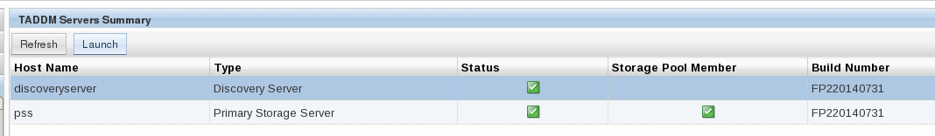

Notices

This information was developed for products and services offered in the U.S.A. IBM may not offer the products, services, or features discussed in this document in other countries. Consult your local IBM representative for information on the products and services currently available in your area. Any reference to an IBM product, program, or service is not intended to state or imply that only that IBM product, program, or service may be used. Any functionally equivalent product, program, or service that does not infringe any IBM intellectual property right may be used instead. However, it is the user's responsibility to evaluate and verify the operation of any non-IBM product, program, or service.
IBM may have patents or pending patent applications covering subject matter described in this document. The furnishing of this document does not give you any license to these patents. You can send license inquiries, in writing, to:
IBM Director of Licensing
IBM Corporation
North Castle Drive
Armonk, NY 10504-1785 U.S.A.
For license inquiries regarding double-byte (DBCS) information, contact the IBM Intellectual Property Department in your country or send inquiries, in writing, to:
Intellectual Property Licensing
Legal and Intellectual Property Law
IBM Japan, Ltd.
1623-14, Shimotsuruma, Yamato-shi
Kanagawa 242-8502 Japan
The following paragraph does not apply to the United Kingdom or any other country where such provisions are inconsistent with local law:
INTERNATIONAL BUSINESS MACHINES CORPORATION PROVIDES THIS PUBLICATION "AS IS" WITHOUT WARRANTY OF ANY KIND, EITHER EXPRESS OR IMPLIED, INCLUDING, BUT NOT LIMITED TO, THE IMPLIED WARRANTIES OF NON-INFRINGEMENT, MERCHANTABILITY OR FITNESS FOR A PARTICULAR PURPOSE.
Some states do not allow disclaimer of express or implied warranties in certain transactions, therefore, this statement might not apply to you.
This information could include technical inaccuracies or typographical errors. Changes are periodically made to the information herein; these changes will be incorporated in new editions of the publication. IBM may make improvements and/or changes in the product(s) and/or the program(s) described in this publication at any time without notice.
Any references in this information to non-IBM websites are provided for convenience only and do not in any manner serve as an endorsement of those websites. The materials at those websites are not part of the materials for this IBM product and use of those websites is at your own risk.
IBM may use or distribute any of the information you supply in any way it believes appropriate without incurring any obligation to you.
Licensees of this program who wish to have information about it for the purpose of enabling: (i) the exchange of information between independently created programs and other programs (including this one) and (ii) the mutual use of the information which has been exchanged, should contact:
IBM Corporation
2Z4A/101
11400 Burnet Road
Austin, TX 78758 U.S.A.
Such information may be available, subject to appropriate terms and conditions, including in some cases payment of a fee.
The licensed program described in this document and all licensed material available for it are provided by IBM under terms of the IBM Customer Agreement, IBM International Program License Agreement or any equivalent agreement between us.
Any performance data contained herein was determined in a controlled environment. Therefore, the results obtained in other operating environments may vary significantly. Some measurements may have been made on development-level systems and there is no guarantee that these measurements will be the same on generally available systems. Furthermore, some measurement may have been estimated through extrapolation. Actual results may vary. Users of this document should verify the applicable data for their specific environment.
Information concerning non-IBM products was obtained from the suppliers of those products, their published announcements or other publicly available sources. IBM has not tested those products and cannot confirm the accuracy of performance, compatibility or any other claims related to non-IBM products. Questions on the capabilities of non-IBM products should be addressed to the suppliers of those products.
All statements regarding IBM's future direction or intent are subject to change or withdrawal without notice, and represent goals and objectives only.
This information is for planning purposes only. The information herein is subject to change before the products described become available.
This information contains examples of data and reports used in daily business operations. To illustrate them as completely as possible, the examples include the names of individuals, companies, brands, and products. All of these names are fictitious and any similarity to the names and addresses used by an actual business enterprise is entirely coincidental.
COPYRIGHT LICENSE:
This information contains sample application programs in source language, which illustrate programming techniques on various operating platforms. You may copy, modify, and distribute these sample programs in any form without payment to IBM, for the purposes of developing, using, marketing or distributing application programs conforming to the application programming interface for the operating platform for which the sample programs are written. These examples have not been thoroughly tested under all conditions. IBM, therefore, cannot guarantee or imply reliability, serviceability, or function of these programs. You may copy, modify, and distribute these sample programs in any form without payment to IBM for the purposes of developing, using, marketing, or distributing application programs conforming to IBM‘s application programming interfaces.
Each copy or any portion of these sample programs or any derivative work, must include a copyright notice as follows:
© (your company name) (year). Portions of this code are derived from IBM Corp. Sample Programs. © Copyright IBM Corp. _enter the year or years_. All rights reserved.
If you are viewing this information in softcopy form, the photographs and color illustrations might not be displayed.
Trademarks
IBM, the IBM logo, and ibm.com are trademarks or registered trademarks of International Business Machines Corporation in the United States, other countries, or both. If these and other IBM trademarked terms are marked on their first occurrence in this information with a trademark symbol (® or ™), these symbols indicate U.S. registered or common law trademarks owned by IBM at the time this information was published. Such trademarks may also be registered or common law trademarks in other countries. A current list of IBM trademarks is available on the web at "Copyright and trademark information" at http://www.ibm.com/legal/copytrade.shtml.
Other company, product, or service names may be trademarks or service marks of others.

