**P354 Project 1: Masses in the Solar System**

Due: Jan. 8

1. The attached table shows position as a function of time telemetered back by the Mariner 35 satellite as it orbited the moon. The coordinate system is in lunar radii with the center of the moon at the origin. First, make a graph of the data to show the entire orbit. Use the data to make your best estimate of the size of the semi-major axis of orbit, the eccentricity of orbit and the mass of the moon. Estimate uncertainty for your value and compare your value to the accepted value for the lunar mass, including a percentage likelihood the two are the same.

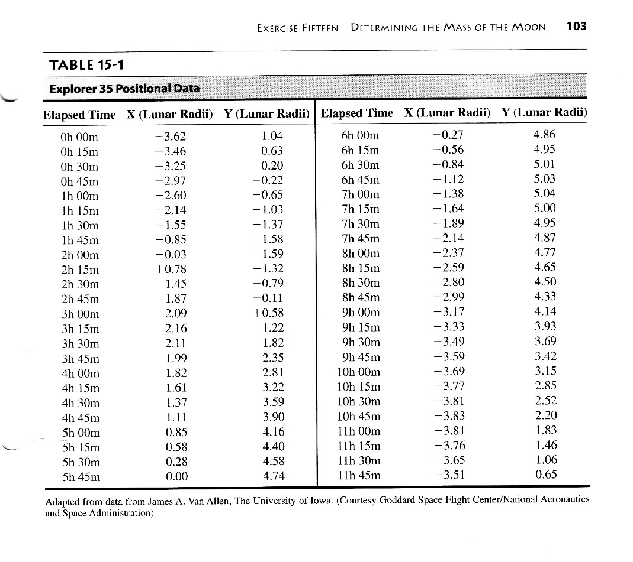

2. Repeat your work for Neptune and Triton, using the images found at <https://www.luther.edu/astronomy/galleries/solar/neptune/triton/>. One can (and likely should) use the image scale and the apparent motion of Neptune against the background stars to determine the distance to and thus diameter of Neptune. In J-term, we must make some concessions to the time available. Assume you have done that work and use the accepted radius of Neptune to determine the center-to-center Neptune/Triton separation. After you have compared your calculated mass to the accepted mass and scratched your head sufficiently, use your result to calculate the Triton orbital parameter (with uncertainty of course) that perhaps you neglected.