In the Events Log, there are certain things that are recorded based on the events that happen throughout a certain shift. Each of the descriptions below describe what to do and where to put certain information. A current form of the events log is always kept on the ED Teams channel under "Shared" so anyone who has access to the channel can modify it.
- Roster - This area should be filled out with the Day and Night shift personnel working to include the 4A's and the 4N's pulling shifts at RAF Mildenhall.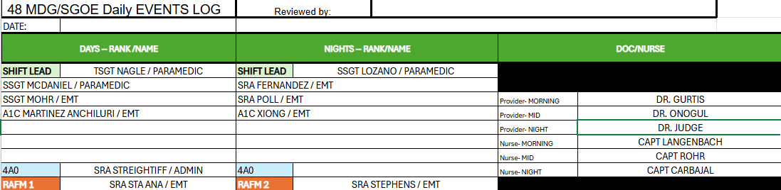
- Patient Statistics - This area is filled with particular statistics over a 24 hour period (two shifts). To get the relevant information, you may have to pull the "Discern Report" from Genesis.
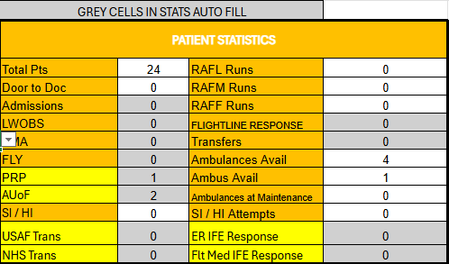
- Reportable Events - This area is for any changes that effect the ED directly or indirectly. It is also used for reminders, changes, important base events, or anything else that the Shift Lead deems important enough to put in.
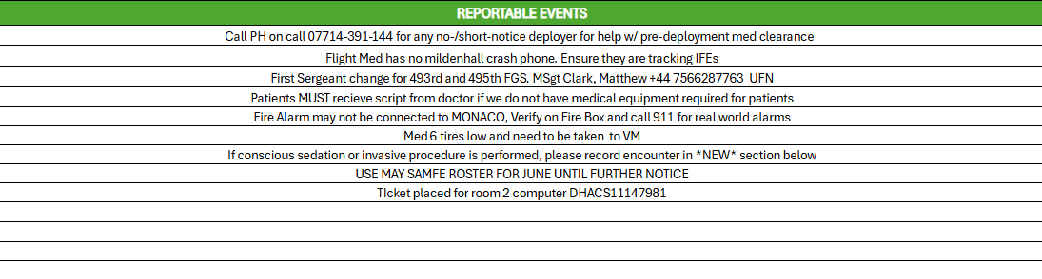
- PRP - This section is used for tracking the specific PRP/AUoF patients that are seen in the 24 hour period. This allows us to recall a specific patient for record keeping purposes.
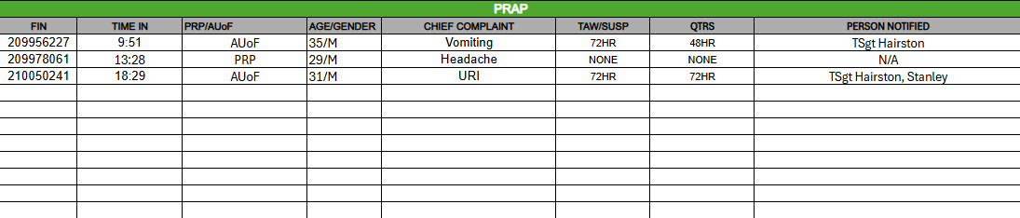
- Admissions - This section tracks any admissions that go to a different unit in the RAF Lakenheath Hospital. This section does NOT include transfers.
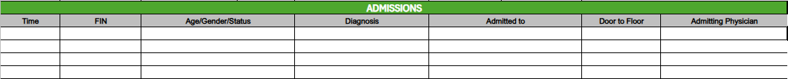
- Ambulance Run/Rapid Response - This section tracks any 911 responses on base along with RRT and Code Blue Responses in the Hospital itself.
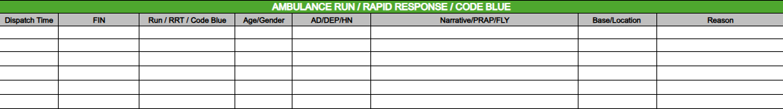
- Transfers - This section tracks any transfers that are taken to an outside facility, whether they are transferred by the RAF Lakenheath ambulance or the NHS system it is recorded here.
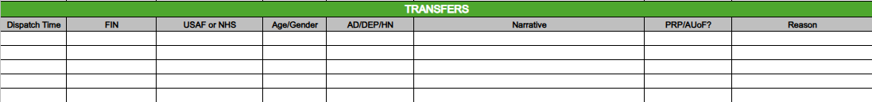
- Flightline Response/IFE/GRE - This tracks our activity on the flightline in response to incidents on the flightline to include In-Flight Emergencies or Ground Emergencies.
- FLY - This tracks the patients we have in a 24 hour period that have a FLY classification.
- AMA/LWOB - This section tracks the patients who have left before being seen by the doctor (LWOB), left against medical advice (AMA), or charts that were entered in error.
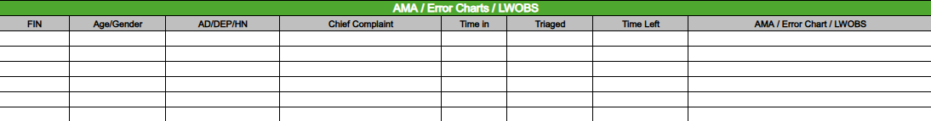
- Universal Protocol & Informed Consent - This section tracks any procedures that have required the signing of consent forms in the ED. Sometimes the forms may be required by a different unit BEFORE the patients move, but this instance should be recorded as well as the forms were still signed IN the ED.
- Matrices Completed - This section tracks if we had to complete any Notification Matrices on the transfer of Active Duty Members out of the hospital.
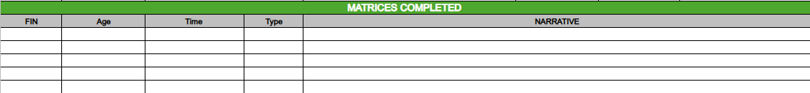
- Daily/Room Checks - This section is a checklist of items that need to be function checked and signed off during the shift. The Room checks assign an individual to take care of a room.
