PROJECT REPORT
JAPANESE COSMETICS CATALOG WEBSITE — JLP VIETNAM
SHUEI TRADING VIETNAM CO., LTD.
August 26, 2026

1. Project Overview
The website showcases a catalog of Japanese domestic cosmetics for customers in Vietnam, with support for multiple languages (Vietnamese / English / Japanese, displayed in Japanese by default). The site does not process online payments — customers place orders via Zalo chat or phone, which reduces payment-related legal risk and keeps operating costs low.
What sets this site apart: every product displays its JAN code and cosmetic registration number so customers can verify authenticity themselves — a clear trust advantage over the unverifiable grey-market goods common elsewhere in the market.

2. Screenshots
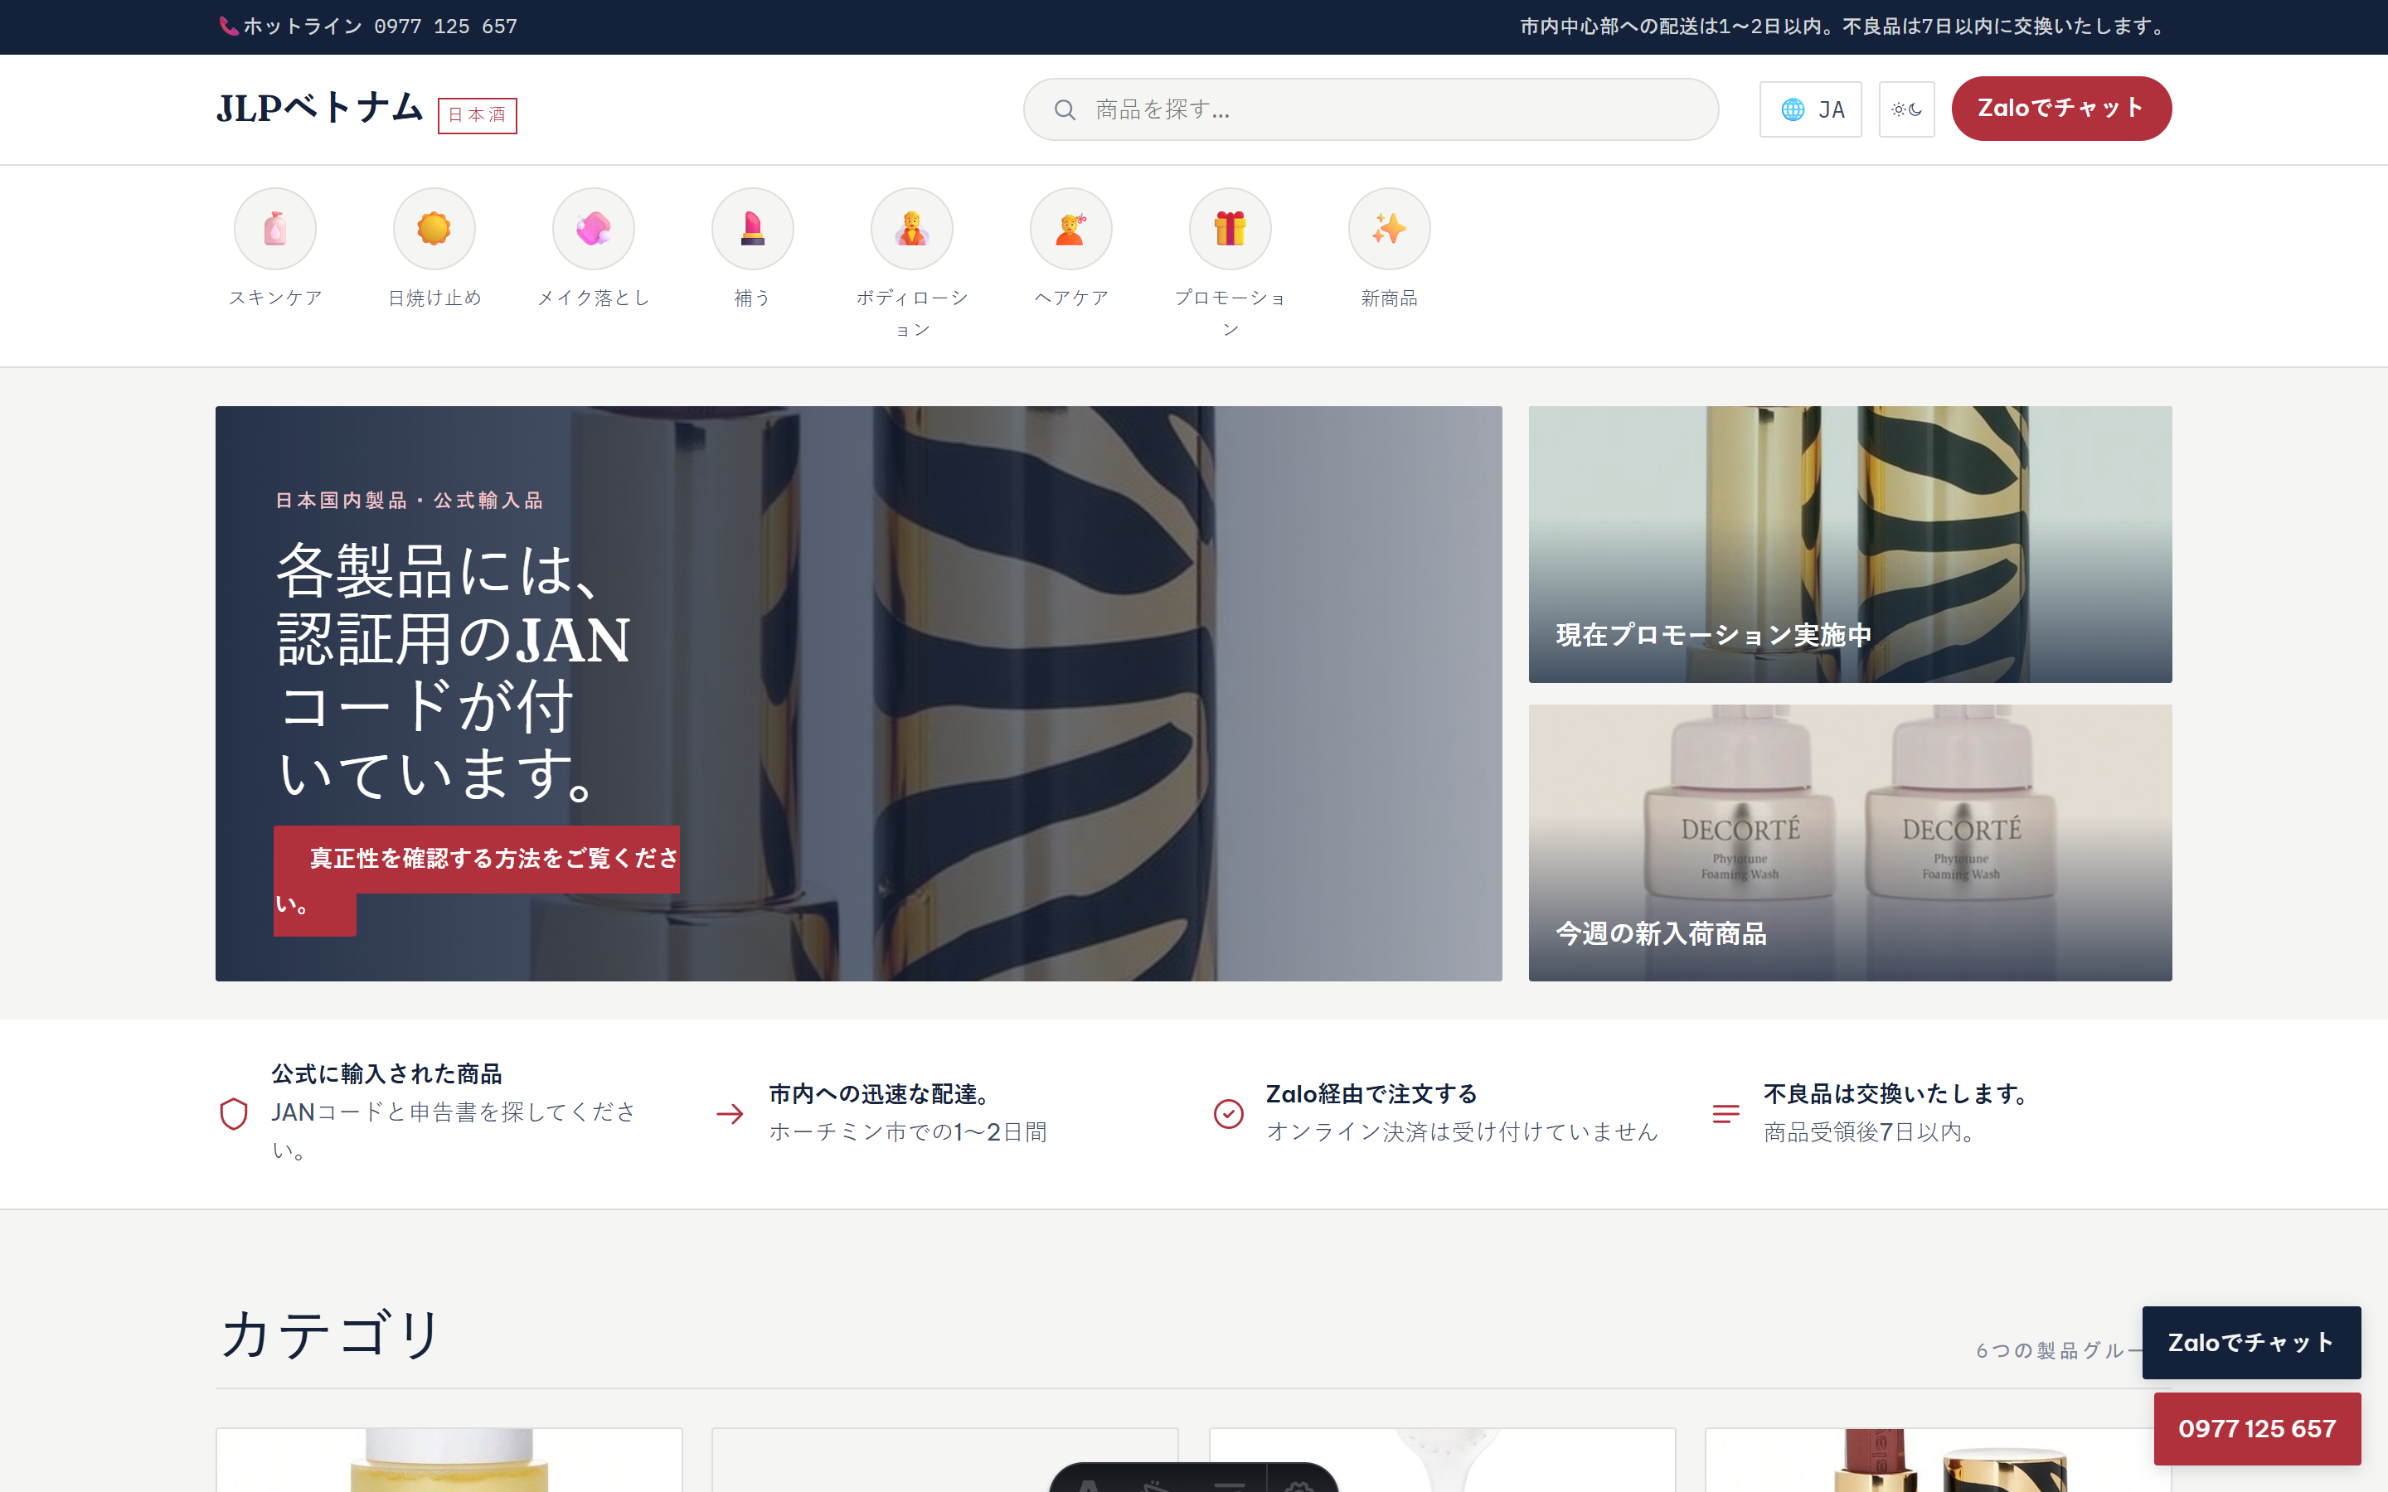
Homepage — animated banner, category showcase, featured products
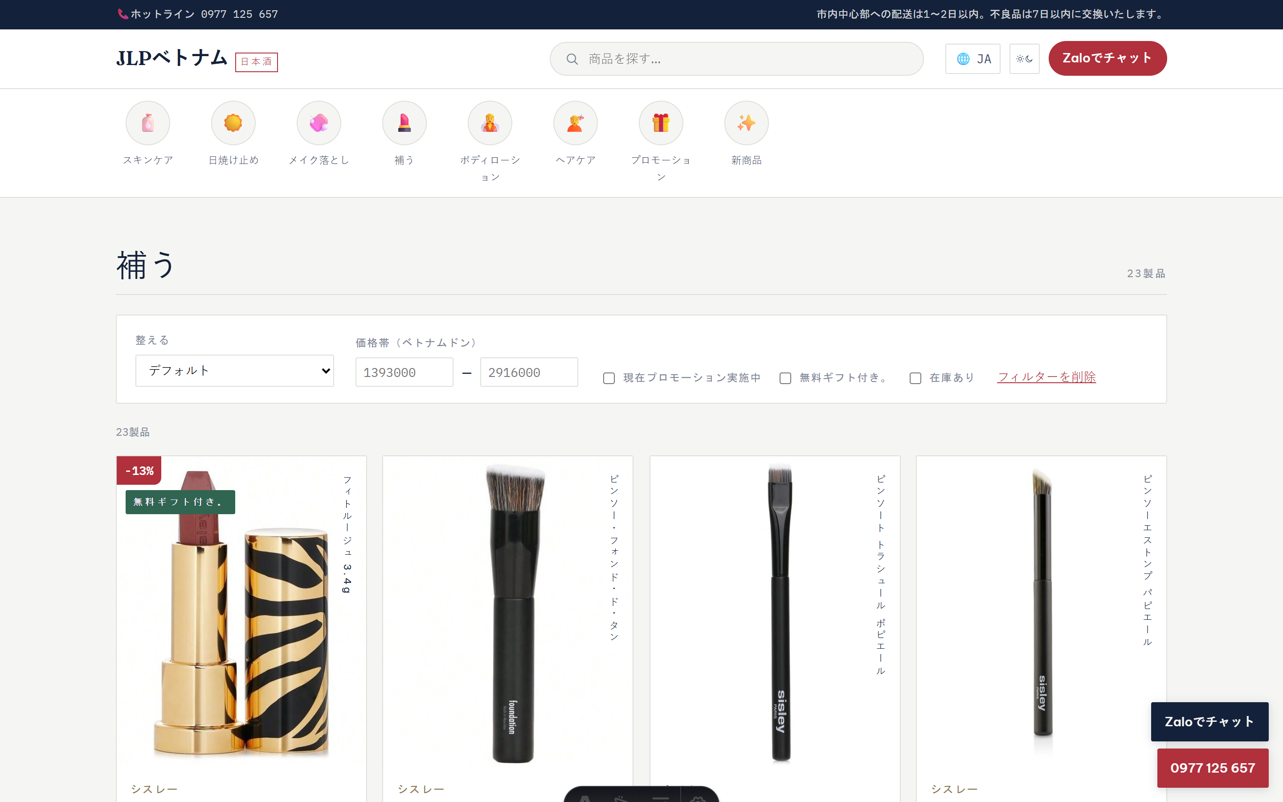
Category page — filter by price, promotion, and stock status
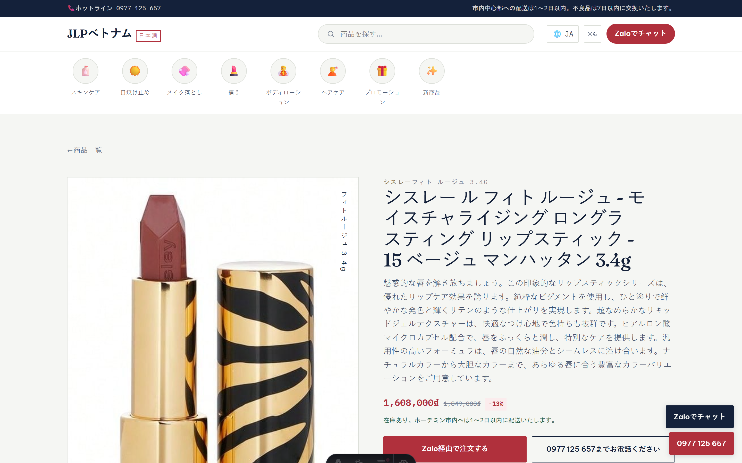
Product detail page — JAN code, registration number, order via Zalo
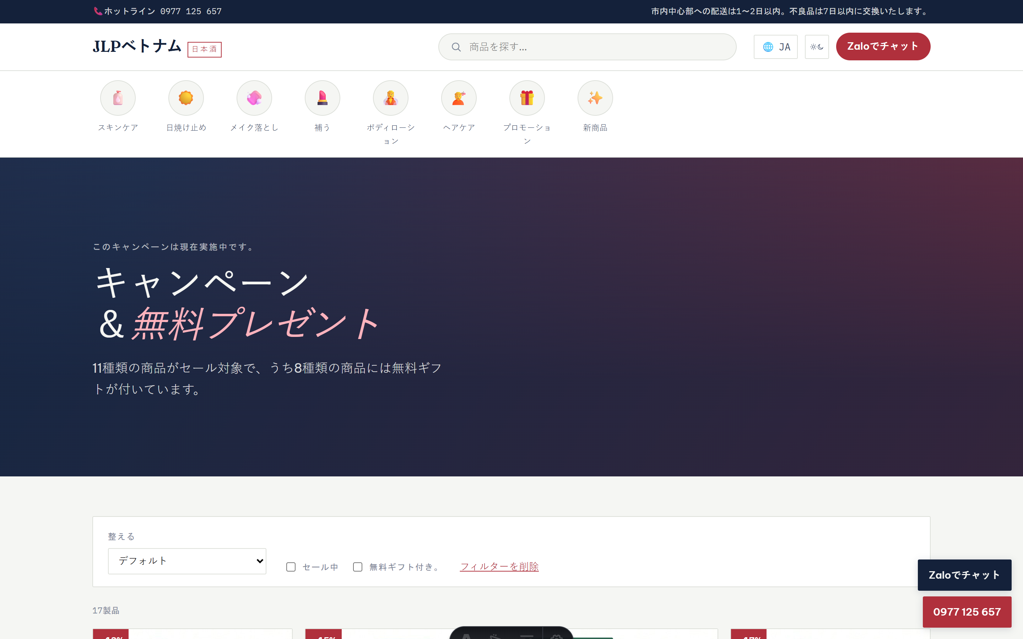
Promotions page
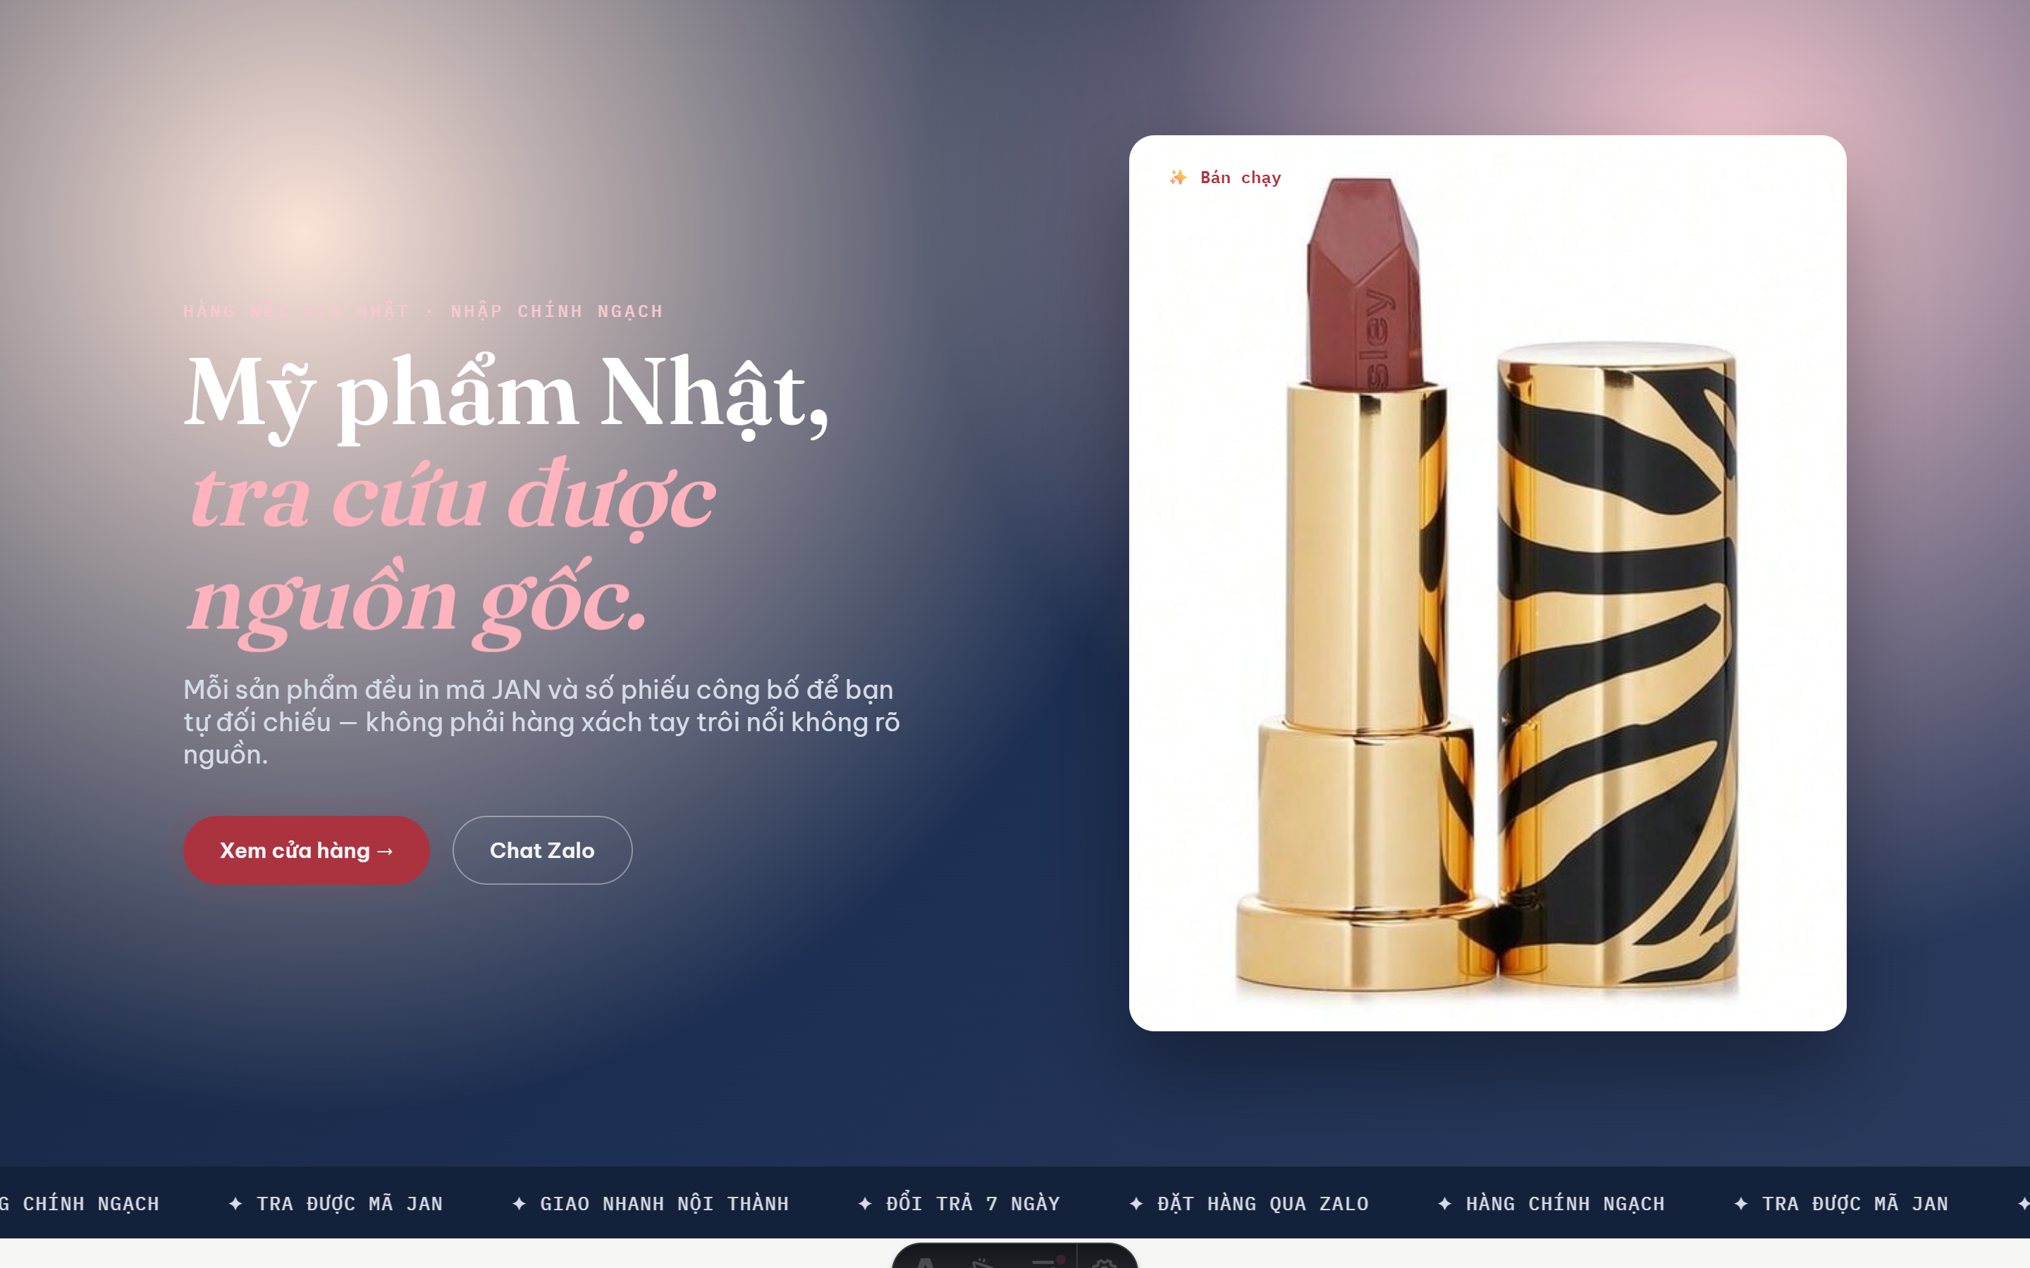
Standalone marketing landing page — for ad campaigns and promotion

3. Current Features
- Dynamic homepage: animated banner, category showcase, featured products, promotions, and new arrivals.
- Category pages: filter by price range, promotion, gift-with-purchase, and stock status; sort by price.
- A dedicated promotions page listing every discounted or gift-bundled product.
- A standalone marketing landing page, suited for ad campaigns and promotional pushes.
- Vietnamese / English / Japanese support — defaults to Japanese as requested; customers can switch language from the header, and their choice is remembered.
- Light / Dark mode.
- Product search directly from the header.
- About and contact pages, with a persistent floating Zalo / call button on every page.
- Product management page (admin only) — this is a key highlight: create, edit, and delete products; manage images, pricing, stock, categories, suitable skin type, and technical specifications for each item.
- Bulk Upload — the system was purpose-built to read supplier Excel files directly in the exact template Mr. Huynh already provides/uses — no format conversion, no manual entry per product. Simply upload the Excel file and the system automatically detects products, assigns categories, converts pricing, and creates products in bulk — a significant time saving for managing a large catalog (tested with close to 100 products imported in a single run, with no hard limit on volume).
- Automatic duplicate detection when re-running a previously imported file, so re-uploading is always safe.

4. Strengths of the Technology in Use
- Fast page loads and strong search-engine friendliness (better SEO), helping customers find products easily through Google.
- Low infrastructure running cost — the platform can be hosted at minimal expense, well suited to long-term growth.
- Scales to a large catalog (thousands of products) without slowing page load times.
- Built on technology trusted by major international e-commerce businesses, backed by a large support community — ensuring long-term stability and security.
- Easy to customize and extend with new features going forward, without having to rebuild from scratch.

5. Future Roadmap Ideas
- Online payment — if the company wants to expand into direct online sales through the website.
- Product reviews & ratings — collect genuine customer reviews and ratings to build further trust.
- Automated advisory chatbot — answer common questions and recommend products based on the customer's skin type.
- Mobile app — serve loyal customers directly and push promotional notifications.
- Loyalty / membership rewards program — encourage repeat purchases.
- Workflow automation — translation, price syncing, promotion alerts — reducing manual workload.
- Sales & analytics reporting — track most-viewed and best-selling products to inform purchasing decisions.
- Cosmetic registration lookup page — linking directly to the Drug Administration's official portal for self-verification.

6. Contact Information Displayed on the Website
SHUEI TRADING VIETNAM CO., LTD.
Address: Room 910-911, 9th Floor, Detech Tower II, 107 Nguyen Phong Sac, Dich Vong Hau Ward, Cau Giay District, Hanoi
Phone: 0977 125 657
The address and phone number were compiled from public business-registry sources — please confirm accuracy before official publication.

