# Software Architecture 2019 - Week 5

## Setting up the tools

### Quick reminder on how to set up git (using GitLab)

1. Clone the project repository ("name of the repo")

2. Create a new project on GitLab

3. In your terminal, move to the newly created folder ("Enter the name of the folder")

4. Link the project to your newly created repository by doing:

git remote add origin <link-to-your-repo>

5. Make your changes, then push to your repository:

git push -u origin master

### Using Source Tree

1. Click **File** >> **Clone / New**

2. Enter the URL below to **Source Path / URL** and choose a **Destination Path** and **Clone** the project.

https://...

### Installing Payara Server

1. Open **NetBeans**
2. Go to **Services** tab on NetBeans

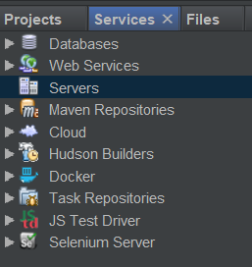

If you don’t see **Services** tab,

click **Window** >> **Reset Windows**

1. Right click on **Servers**
2. Click **Add server**
3. From the server list, choose **Payara Server**
4. Choose an **Installation Location (and make sure there is no space in the installation path)**

Please note, if you remove the Payara Server folder later, you won’t be able to use it anymore.

1. Choose **Local Domain**
2. Below **Choose server to download**, you will see **Download** option, click it and wait for NetBeans to download and install Payara Server. (this will take some time)
3. After it is done, click **Next**
4. Leave the **Domain** as it is (“domain1”), type a user name and password (if you want to)
5. **Finish**

### Starting Payara Server

1. Go to **Services** tab
2. Expand **Servers**, there you should have **Payara Server**
3. Right-click on **Payara Server** and **Start**

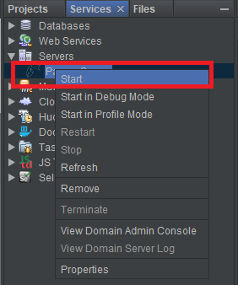

### Opening a project on NetBeans

1. **File** >> **Open Project**

2. Navigate to your project

### Running a project (for EJB exercises)

1. Right-click on the project >> **Run**
2. When you run an EJB project for the first time you will be prompt to select a deployment server. Select **Payara Server** and **Remember in Current IDE Session** or **Remember Permanently**.

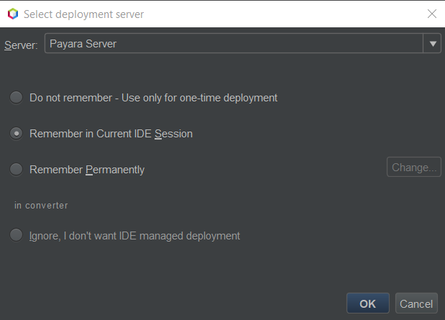

1. NetBeans will run the application and direct you to **localhost:8080/<project_name>**

## Modularity and Unit Testing

## Remote invocation and transactions

## Exercises

1. Project **SimpleUnitTests**

2. EJB Exercises (Everytime you click a module, NetBeans will open the module as a different project. Be patient :))

1. Open **Java EE Tutorials Examples** >> **Modules** >> **ejb** >> **converter**

A simple **stateless session bean** is implemented in the **converter** application.

1. Open **Java EE Tutorials Examples** >> **Modules** >> **ejb** >> **counter**

A simple **singleton bean** is implemented in the **counter** application.