Executive Summary

This report presents a thorough data-driven analysis of Athers Food Inc.'s inventory policies for their most popular product, a healthy canned protein, which accounts for over 80% of their sales. The study aims to identify current demand patterns, evaluate the sustainability of the current inventory policy, and compare it with alternative models such as the Economic Order Quantity (EOQ) model. Furthermore, the report investigates the impact of stockout risks on profits and costs and explores the potential benefits of implementing a more flexible inventory policy.

Key findings from the analysis include:

1: Demand Pattern: The demand for the canned protein follows a negative binomial distribution, with a base daily demand that increases during the holiday season and yearly contracts with new distributors.

2: Current Inventory Policy: Athers Food Inc. maintains a large stock, which has prevented stockouts in the past five years. The company produces in batches, with a 9-day lead time, and stores the inventory in temperature-controlled shelves.

3: Sustainability of the Current Policy: The current inventory policy has experienced losses in profits despite growing revenues. The analysis suggests that if demand trends remain the same and the policy continues, the company might face more challenges related to the loss from the increase of unsatisfied demands.

4: Comparison with EOQ Model: Implementing the EOQ model in previous years (2019-2021) could have led to a more efficient inventory management, with higher profits and lower costs. However, there are trade-offs to consider, such as higher stockout risks and the need for more frequent batch productions.

5: EOQ in 2022: If Athers Food Inc. were to adopt the EOQ model in 2022, it could result in increased profits and reduced costs compared to the current policy. However, the company must take into account potential stockout risks and the impact on customer satisfaction.

6: Stockout Risks Analysis: A detailed examination of the relationship between stockout risks and profits/costs reveals that while minimizing stockouts is important, it should be balanced against the costs associated with holding excess inventory.

7: Flexible Inventory Policy: Implementing a more flexible model, where orders can be placed for any quantity at any time, may provide additional benefits in terms of inventory optimization, cost reduction, and the ability to better adapt to demand fluctuations.

Based on these findings, it is recommended that Athers Food Inc. re-evaluate its current inventory policy and consider adopting alternative approaches, such as the EOQ model or a more flexible inventory policy, to optimize inventory management and enhance overall profitability. The company must carefully assess the trade-offs associated with each approach, particularly regarding stockout risks, and align their inventory policy with their long-term strategic objectives.

Question 1: Identified demand patterns.

After investigating the distribution of demand across three years, we've observed that the demands for both regular (January-October) and peak periods (November-December) align well with the estimated daily demand distributions and growth patterns that the marketing team had previously established. To be more specific, the daily demand for each period can be approximated using a negative binomial distribution with a specific increase in units of demand:

Daily Demand for January-October 2019: ~nbinom(p=0.02, n=5)

Daily Demand for November-December 2019: ~nbinom(p=0.02, n=5) + 70 units increase

Daily Demand for January-October 2020: ~nbinom(p=0.02, n=5) + 10 units increase

Daily Demand for November-December 2020: ~nbinom(p=0.02, n=5) + 80 units increase

Daily Demand for January-October 2021: ~nbinom(p=0.02, n=5) + 20 units increase

These findings suggest that the marketing team's demand distribution and growth predictions are consistent with the observed data, and the negative binomial distribution provides a suitable model for understanding the variations in demand across different time periods.

Upon examining the time series plots which are shown below, we observed that the daily demand exhibits similar characteristics across all three years. From January to October, the demand fluctuates around the red line, which represents the mean demand for that period. Likewise, from November to December, the demand oscillates around the green line, indicating the mean demand for the peak period.

This consistent pattern in the time series plots further reinforces the notion that the marketing team's predictions for demand growth align with the actual data. The clear distinction between regular and peak periods, as well as the stability of demand trends over the years, provides valuable insights for planning and forecasting.

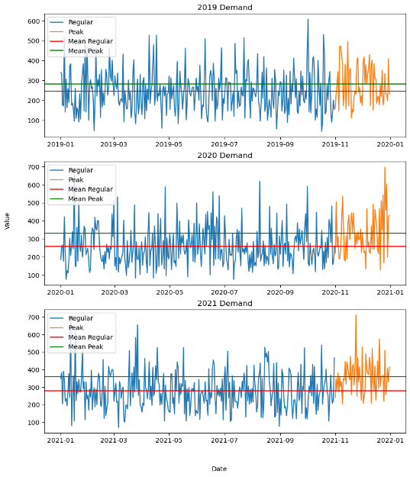

Question 2: Current inventory policy.

We can analyze the company's current ordering policy by examining the inventory differences between consecutive days and daily demand. By doing this, we can identify when new orders are received and subsequently calculate the order quantities. For each day without a new order, the inventory difference should be equal to the daily demand.

Upon examining the dataset, we observe a periodic pattern in the new order arrival dates, which consistently occur on the 10th of every month. This implies that the current ordering policy followed by Athers Food Inc. involves placing an order for a fixed quantity of 8,150 units at the beginning of each month. With a lead time of 9 days, the replenishment of stock takes place on the 10th day.

To further elaborate, the company's current inventory policy can be described as follows:

On the 1st day of each month, Athers Food Inc. places an order for 8,150 units of their healthy canned protein product.

The ordered batch takes 9 days to be produced and delivered, arriving early in the morning on the 10th day.

The company maintains a large stock to avoid stockouts, and the inventory is managed using a periodic ordering system.

The inventory is stored in temperature-controlled shelves, incurring a daily cost of $0.25 per unit for storage and maintenance.

This periodic ordering policy ensures that the company maintains sufficient stock levels to meet demand and prevents stockouts. However, it may lead to higher holding costs due to the large inventory levels, which can negatively impact the company's profits.

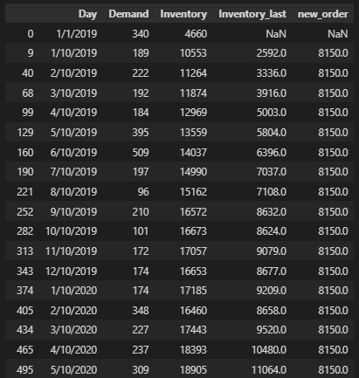

Question 3: Sustainability of current policy in 2022.

The current policy's sustainability is called into question as demand has been steadily increasing over the years. By simulating the demand pattern for 2022, we observe a consistent risk of stock depletion towards the end of each month. While the current policy maintains the same ordering cost with a fixed ordering period and reduces holding costs due to increased demand, the primary source of profit loss stems from unmet demand.

In our model, we simplify this unsatisfied demand by representing it as potential profit that could be earned if the demand was met. However, in reality, continuously failing to meet demand may lead to more severe consequences. These consequences may include the loss of loyal customers, elevated customer churn rate, and a weakened brand reputation in the marketplace.

To develop a more accurate model, it would be beneficial to incorporate and quantify the loss from the perspective of losing future customers and their ongoing needs. This can be achieved by considering factors such as the lifetime value of customers, the potential loss of repeat business, and the impact on customer referrals. Additionally, understanding the competitive landscape and assessing the risk of customers switching to alternative products or suppliers due to stockouts is crucial.

Question 4: Evaluation of EOQ Policy Implementation Performance in 2019-2021.

A few important notes should have been mentioned at the beginning: In the previous analysis, we generated daily demands for 2022 based on the distribution identified in question 1. However, for daily demands in 2019-2021, we opted to use the actual demands provided in the Excel spreadsheet instead of generating new samples. This decision was made to ensure a closer alignment between the analysis and the real-world context, which allows for a more robust evaluation of the EOQ model's effectiveness and applicability to Athers Food Inc.'s inventory management.

Due to the increasing demand as we mentioned in the previous discussion, the current periodic review policy at Athers is no longer sustainable. The company could explore an EOQ (Economic Order Quantity) model as an alternative policy. To determine which policy is more profitable, an EOQ model was constructed and applied to the demand data from 2019 to 2021 for comparison with the current policy.

Given the annual demand for each year from 2019 to 2021, the setup cost of producing a batch of products at $1,200, and the holding cost of $0.25 per unit per day, we can calculate the Economic Order Quantity (EOQ) for each year based on the formula $Q_{opt}=\sqrt{\frac{2DS}{H}}$.

In terms of ROP, it represents the inventory level at which it becomes necessary to place a new order for stock in order to avoid stockouts. Since the lead time is 9 days, a window function is applied to calculate the 95th percentile of the rolling sum of demand for every 9 days, considering both average annual daily demand increase and seasonal daily demand increase. By setting the ROP at the 95th percentile of aggregated 9 days demand, it ensures that inventory levels are sufficient to meet 95% of the demand, thus reducing the likelihood of stockouts.

The table below shows the results for both EOQ and ROP across three years.

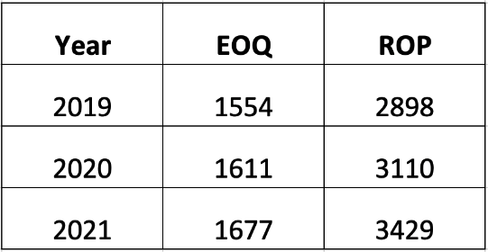

Then, the EOQ policy was implemented on 2019-2021 demand data, where a new order is placed if the expected inventory level falls below the ROP. The expected inventory encompasses both the current inventory and any outstanding orders, irrespective of whether the new orders have arrived or not. This comprehensive view of inventory levels accounts for all available and anticipated stock, allowing for better management of resources and planning for future demand. By taking into account both holding and ordering inventory, the profit for each year was computed and compared against the profit under the current policy, where the result suggests that the EOQ policy could produce $2371674.75 more profit than the current policy in total over the past 3 years. The following table compares the profits generated by using currently and EOQ policies respectively.

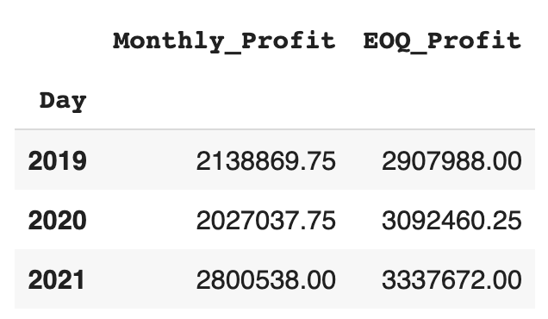

The main reason for this difference in profits is that the current policy of ordering the same amount on the 10th of every month may cause situations where the company is either holding too much inventory which incurs unnecessary holding costs or not enough inventory which leads to stockouts and lost sales, while the EOQ policy considers the trade-off between holding inventory and ordering inventory and determines the optimal order quantity with minimal total inventory cost.

Therefore, the trade-off between the current policy and the EOQ policy is based on finding a balance between inventory holding costs and ordering costs. The current policy may result in higher inventory holding costs due to excess inventory, while the EOQ policy may lead to higher ordering costs due to more frequent orders. Additionally, the EOQ policy is designed to prevent stockouts, which can lead to greater customer satisfaction and lower costs associated with lost sales for the company.

Question 5: Expected profit, costs in 2022 with EOQ.

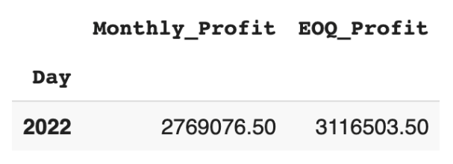

Upon further investigation into the sustainability of the current policy and the EOQ policy, we conducted a comparative analysis by implementing both policies on the predicted 2022 demand and examining their expected profits. The results are summarized in the table above. It reveals that the EOQ policy generates higher expected profits ($3,116,503.50) compared to the current policy ($2,769,076,50).

This finding suggests that the EOQ policy is more profitable and sustainable for managing inventory at Athers Food Inc. By adopting the EOQ policy, the company could potentially optimize its inventory management, leading to increased profits and lower costs associated with holding excess inventory.

Question 6: Analyze profits, costs for varying stockout risks (risk vs. profit/cost plots).

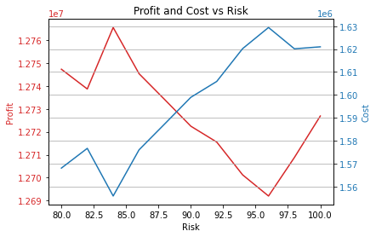

The trends in "risk vs. profit" and "risk vs. cost" reveal a trade-off that companies face in managing their inventory. As the alpha increases, profit increases since potential profit loss decreases. And the costs of holding extra stocks increase. This relationship is logical, as the risk of stockouts leads to lost sales and lower profits, and managing stockouts incurs higher costs such as expedited shipping or emergency production runs.

The turbulence observed in the "risk vs. cost" relationship suggests that there is an optimal level of stockout risk that minimizes costs. At very low levels of stockout risk, maintaining high inventory levels may be more costly than stockouts. At very high levels of stockout risk, the costs of managing stockouts can become too high. Therefore, it is crucial for companies to find the right balance and identify the optimal level of stockout risk that balances inventory costs and stockout management costs.

To create resilient supply chains, companies must make trade-offs between maximizing profits and minimizing costs. By understanding the relationship between risk, profit, and cost, companies can optimize their inventory management and find the optimal level of stockout risk. A resilient supply chain requires a careful balance between these factors to ensure that companies can maintain their profitability while effectively managing inventory and stockouts.

In contrast, when the non-stockout risk is around 2%, a balance is struck between the costs of maintaining inventory levels and managing stockouts. At this point, the inventory level is optimized to meet the demand without incurring excessive costs of storage, handling, and transportation. As a result, the company can maximize its potential profit.

Thus, as the non-stockout risk approaches 0%, the costs associated with maintaining inventory levels begin to outweigh the benefits, leading to lower profits. Conversely, when the stockout risk is at the optimal level, the company can balance maintaining inventory levels and managing stockouts to maximize profits and minimize costs.

Question 7: Flexible model proposal.

We have segmented the year into two distinct periods: the regular period spanning from January to October, and the peak period covering November and December. For each period, we have computed the Economic Order Quantity (EOQ) and Reorder Point (ROP) values, resulting in six distinct data sets that span from 2019 to 2021.

The daily demand increases during the peak period and increases year over year, necessitating changes to the Economic Order Quantity (EOQ) for each period to accommodate the changing demand. By considering these different scenarios, we can improve our model. As evident from the table, the Economic Order Quantity (EOQ) increases with daily demand, leading to corresponding changes in the ROP.

|  |  |  |
| --- | --- | --- |
|  | EOQ (quantity) | ROP |
| 2019_regular | 1534.0 | 2729.5 |
| 2019_peak | 1648.0 | 3056.6 |
| 2020_regular | 1572.0 | 2927.4 |
| 2020_peak | 1783.0 | 3741.2 |
| 2021_regular | 1638.0 | 3166 |
| 2021_peak | 1859.0 | 3681.6 |