**Startup**

Software startup is initiated by a small script called dcai_startup.pro. It can be run from an IDL command line by typing:

@dcai_startup

This script simply wraps a call to DCAI_Control_Main, which is the actual entry point for the control software. The script saves the user from having to call this procedure (with its associated arguments) manually. DCAI_Control_Main takes the following keyword arguments:

settings_file = string name of an IDL procedure (required)

camera_settings = string name of an IDL procedure (required)

external_dll = string name of the external DLL (required)

drivers = string name of an IDL procedure

schedule_script = string name of an IDL procedure

simulate_frames = switch to enable simulation of camera images

Settings file:

The settings file contains information on local directories, site information, filters, etalon parameters, etc. In order to generate a new default settings file, use the following command at an IDL prompt:

dcai_settingswrite, dcai_settingstemplate(), ‘c:\mypath\myfilename.pro’

This will generate an IDL procedure containing some default settings which should then be manually edited. The filename (myfilename) must be a unique IDL procedure name.

Camera settings:

A camera settings file can be generated using the camera interface. This is started by typing the following at an IDL prompt:

andor_camera_driver_gui

Camera settings can be selected interactively from here, and the a settings file generated by clicking on ‘Write Settings to ASC Profile’. Again, the filename selected must be a unique IDL procedure name.

External DLL:

This is the name of the DLL which allows IDL to call hardware-specific functions. It is unlikely that this keyword will need to be changed manually.

Drivers:

This is the name of an IDL procedure which contains code for talking to the hardware other than the camera (e.g. etalon control, motors, etc.). In the case where this is not supplied, the software will still operate, however there will be not actual interaction with the hardware.

Schedule script:

If supplied, the software will start executing commands supplied in the schedule script. This is used for automatic operation.

Simulate:

Setting this keyword (ie, dcai_control_main, /simulate) causes the software to generate synthetic camera images which may be useful during testing. Do not use this switch for normal operation.

On startup, the user is presented with the main console. The console displays information on current instrument operation, a log of completed tasks/commands, and controls for launching new tasks (or ‘plugins’), loading settings and schedule scripts, and interfacing with the camera.

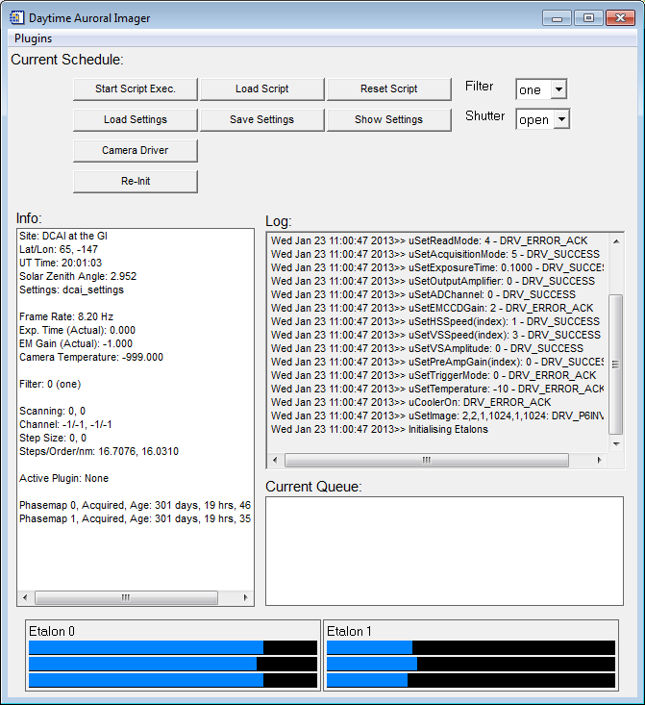

At the top of the display is a menu titled ‘Plugins’. Plugins provide most of the operational functionality, and will be described later.



Below this there is a label:

When operating in automatic mode, the schedule script from which commands are being executed will be displayed here.

Below the schedule script label are the following set of buttons:

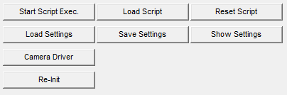

The top row controls schedule script execution. They allow the user to start or stop execution of the current script (Start/Stop Script Exec., the label will change to the applicable action, ‘Start’ or ‘Stop’), load a new script file (Load Script) or reset the script (Reset Script). Resetting a script sends a reset command to the schedule script, which may then perform certain actions.

The second row of buttons controls the settings file, and allows the user to load a new file (Load Settings), save the current setting file (Save Settings) or view the current settings (Show Settings).

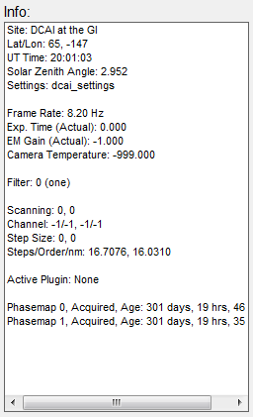In the third row is a button to launch the interactive camera driver (andor_camera_driver_gui), and from there adjust camera settings. Settings changed within the camera driver will persist once the driver window is closed.

The fourth row contains a button (Re-Init) that sends the ‘initialize’ command to the etalon driver.

Below the button controls are three displays. The ‘Info‘ window displays miscellaneous information about the current operation of the instrument. For example, the current site information, lat/lon, solar zenith angle, camera information such as frame rate and exposure time, filter information, the status of any active etalon scans, the currently active plugin (active in the sense that the schedule script is running that plugin) and information on phasemaps acquired from each etalon.

The ‘Log’ window displays a list of recently executed commands and informational messages, and the time at which they occurred. Log messages are also written out to a log file, located in the directory specified by the settings.paths.log variable in the settings file.

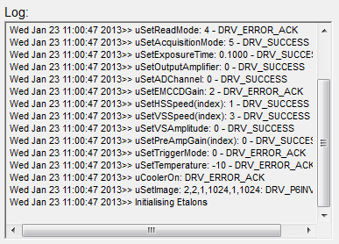

A third display window, titled ‘Current Queue’, is only active when the instrument is operating in automatic mode (that is, when a schedule script is being executed).

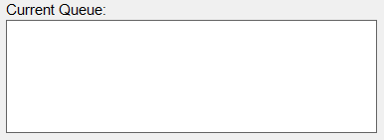

It will display the set of schedule commands that are currently in the queue waiting to be executed. The currently executing command will be highlighted.

At the bottom of the user interface are two panels showing the current status of the etalon leg positions, which are indicated by the blue filled regions.

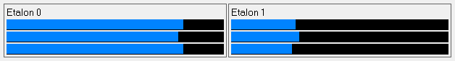

**Setting up for operation**

Before the instrument can be operated effectively, a number of calibration steps need to be performed. These steps will be detailed below.

Viewing Camera Images:

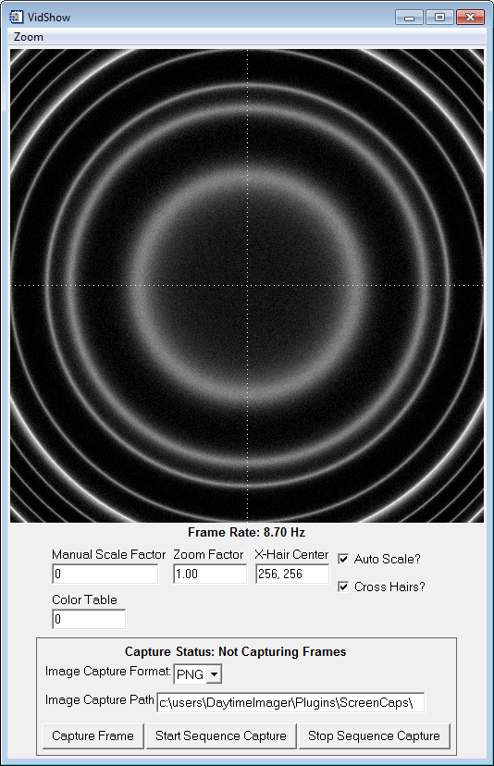The images that are being acquired by the camera can be viewed by clicking on the ‘Plugins’ menu, and then clicking on ‘dcai_vidshow’. The interface shown here (right) will appear.

There are various options here for controlling how the images appear. Image scaling is controlled either by un-checking the ‘Auto Scale?’ check box and entering a scale factor (multiplier) in the box labeled ‘Manual Scale Factor’, or by checking the ‘Auto Scale?’ check-box and allowing IDL to automatically scale the images.

The image can be enlarged by entering a new value in the box labeled ‘Zoom Factor’. Zoom can be reset to 1 by clicking the ‘Zoom’ menu, and then clicking ‘Reset’.

Image color can be changed by selecting a new color table (from IDL’s built-in color tables, a value between 1-39).

The location of the cross-hairs can be changed either by editing the values in the box labeled ‘X-Hair Center’ or by left-clicking on the image.

At the bottom of the display are controls for capturing a sequence of images. For now it is not necessary to explain these controls.

Parallelism:

The first step is to ensure that the plates of each etalon are parallel (note that this is in addition to requiring that the etalons themselves are parallel with respect to each other). Etalon control is handled by the etalon plugin. From the main user interface, click on the ‘Plugins’ menu , then click on ‘dcai_etalon’. The following interface will appear:

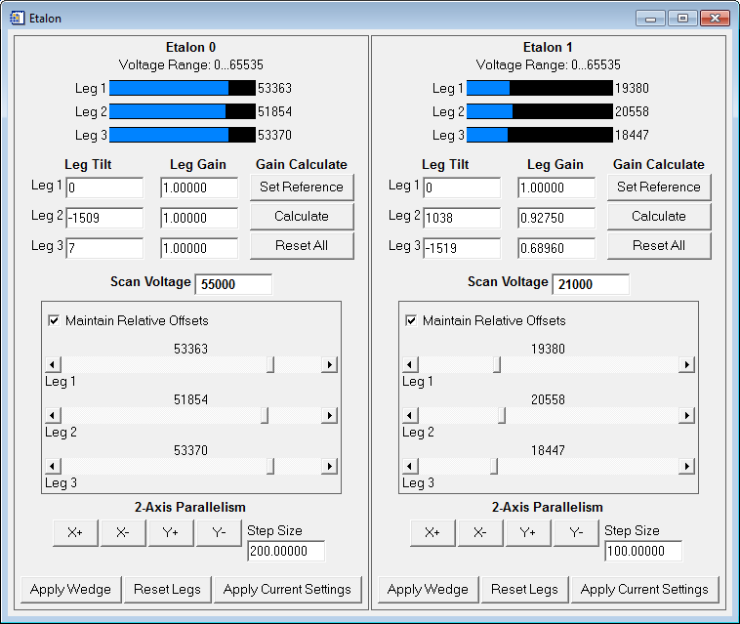

There will be one panel for each etalon, as they are controlled separately within this plugin. Focusing on the left hand panel (corresponding to Etalon 0 in the above image), at the top are the same three etalon leg indicators as appear at the bottom of the main user interface. In addition, the actual digital leg values that are currently set for each leg are also displayed next to the horizontal bars.

Below the leg indicators are a set of numbers which indicate the current tilt of the plates, and the current gain that will be applied to each leg (relative to leg 1) in order to maintain parallelism (this will be explained further below). The gain calculation is performed by the etalon plugin, using the buttons under the heading ‘Gain Calculate’. Again this procedure will be described in more detail below.

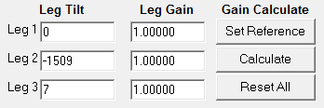

In the middle of the panel are three adjustable sliders, one for each leg, that directly control the digital spacing applied to each leg of the etalon:

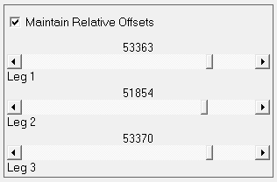

The checkbox at the top labeled ‘Maintain Relative Offsets’ can be used to move all three leg sliders simultaneously. When adjusting each leg individually, make sure you un-check this box.

Below the leg sliders are a set of buttons, under the label ‘2-Axis Parallelism’, which allow the user to adjust the tilt of the etalon plates along two orthogonal axes:

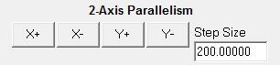

Often it is much simpler to achieve parallelism by adjusting the tilt along these two axes than by controlling each leg individually. The buttons allow to increase/decrease the tilt along the two axes labeled ‘x’ and ‘y’, by an amount indicated in the edit-box labeled ‘Step Size’. Start off with a large step size for coarse adjustment, then decrease the step size as parallelism improves.

At the bottom of the etalon interface are three buttons:



‘Apply Wedge’ sets the leg values on this etalon to those supplied in the settings file variable settings.etalon[0].wedge_voltage. The idea is to allow the user to easily apply a ‘wedge’ to the etalon plates, making them sufficiently non-parallel that the etalon no longer modulates light passing through it. This allows a user to adjust one etalon without the modulation of the other causing confusion.

‘Reset Legs’ sets the digital leg values to the current scan value ( ) plus the etalon tilt.

‘Apply Current Settings’ updates the settings file with the current leg gains and parallel tilts.

Achieving parallelism:

In order to make an etalon parallel, set the instrument up to observe a calibration laser, open the dcai_vidshow plugin, and perform the following steps in the etalon interface:

1. Apply a wedge to the etalon which you are ***not*** attempting to make parallel (if you are making etalon 0 parallel, apply a wedge to etalon 1). To do this, either use the ‘Apply Wedge’ button at the bottom of the interface (if appropriate wedge voltages have been supplied in the settings file) or manually adjust the leg sliders to create a wedge. The interference fringes that can now be seen in the vidshow plugin should be dominated by the modulating effect of the etalon which has ***not*** been wedged.
2. Using the individual leg sliders, move all three leg values to approximately one quarter of the leg range.
3. Using either the individual leg sliders or the 2-axis parallelism controls (recommended), adjust the leg tilts until the interference fringes are nice and sharp and symmetrical.
4. Click the button labeled ‘Apply Current Settings’. This will populate the three ‘Leg Tilt’ boxes.
5. Click the button labeled ‘Set Reference’ under ‘Gain Calculate’. This will set the current leg positions and tilts as the reference when calculating per-leg gains.
6. Using the individual leg sliders, move all three leg values to approximately three quarters of the leg range.
7. Repeat step 3.
8. Click the button labeled ‘Calculate’ under ‘Gain Calculate’. This will populate the three boxes labeled ‘Leg Gain’, which control the gain factor applied to each leg relative to the reference position (set in step 5) in order to maintain parallelism throughout a scan.
9. Finally, click the button ‘Apply Current Settings’ again.
10. Repeat for the second etalon.

Calculating ‘Steps per Order’:

Another necessary piece of calibration information is the number of digital increments that must be applied to a given etalon such that the interference fringes move through one complete order of interference. This value will be referred to as ‘steps per order’. To calculate this value, click on the ‘Plugins’ menu on the main interface, then click on ‘dcai_stepsperorder’. The following window will appear:

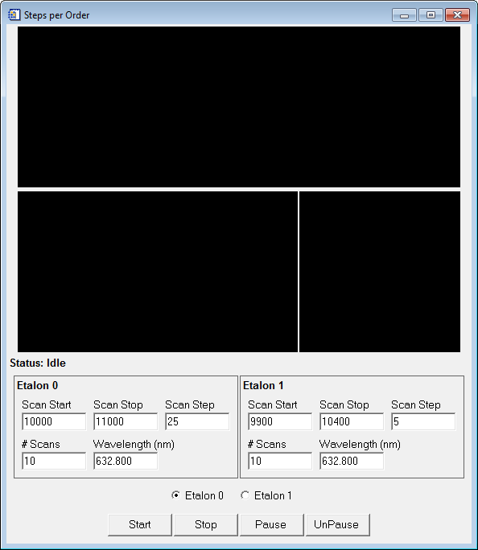

The black panels in the upper half of the window will display information during the steps per order calculation. The important information is all in the lower half of the window. Each etalon will have a box like the one shown below:

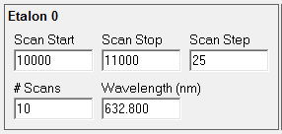

The edit boxes control the way in which the calculation is performed. The calculation works by first taking a reference image at the leg value given by the variable settings.etalon[0].scan_voltage in the settings file (the zero in the variable indicates etalon 0). It then increments the nominal plate separation by the value given in the ‘Scan Start’ edit box. The nominal plate separation is then incremented in steps of ‘Scan Step’, until the total increment has reached the value given in the ‘Scan Stop’ edit box. At each increment, the current camera image is cross-correlated with the reference image. Assuming the total plate increment is more than one order of interference for the etalon, the set of cross-correlation values can then be used to calculate the steps per order value.

‘Scan Start’ is the increment applied to the settings.etalon[0].scan_voltage value before the scan starts. By selecting this value appropriately, it is not necessary to scan over a complete order of interference, instead this value should be chosen (through trial and error) such that after incrementing by this amount relative to settings.etalon[0].scan_voltage, the plate separation has changed by slightly less than one order of interference.

The ‘Scan Stop’ value should also be chosen such that after incrementing by this amount relative to settings.etalon[0].scan_voltage, the plate separation has changed by slightly more than one order of interference. In this way, the steps per order scan will just span the set of leg values (relative to settings.etalon[0].scan_voltage) which correspond to changing the plate separation by one order of interference.

The ‘Scan Step’ value should be chosen such that there are a sufficient number of data points in the final scan to adequately constrain a polynomial curve fitted to those data points. This is best determined through trial and error in conjunction with the ‘Scan Start’ and ‘Scan Stop’ values.

In order to ensure an accurate calculation, the scan can be repeated a number of times, and the results of each subsequent scan will improve the signal-to-noise ratio of the cross-correlation values. The number of scans that will be performed is controlled by the ‘# Scans’ edit box. If you find that the steps per order value is still changing significantly between subsequent scans, this indicates that you should increase the total number of scans performed.

When running the steps per order plugin, be sure that the ‘Wavelength’ edit box contains the correct wavelength for the calibration laser you are viewing.

When the parameters listed above have been set, and you wish to start the scan, use the buttons at the bottom of the interface:

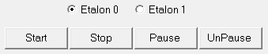

A checkbox allows you to select which etalon you wish to scan (using the corresponding parameters). Click ‘Start’ to begin scanning, ‘Stop’ to stop the current scan and reset the calculation, or ‘Pause’ to simply pause the scan (without resetting). By using the ‘Stop’ button, you can stop a scan, modify some of the scan parameters above, and click start again to quickly converge on the correct scan parameters.

Phase Mapping:

The next step involves observing how the order of interference (or phase) varies across the detector due to modulating effect of each etalon. This process is called ‘phase mapping’, and the resulting map is called a ‘phase map’. A phase map is required from each etalon individually.

On the main console, click on the ‘Plugins’ menu, and then click on ‘dcai_phasemapper’. The following window will appear:

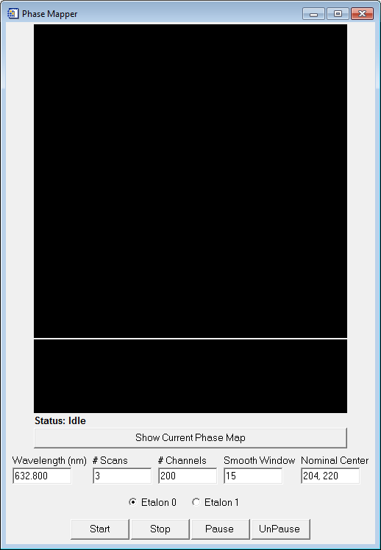

The two black panels at the top will display information during the phase map acquisition, and the ‘Show Current Phase Map’ will display the most recently acquired phase map for the etalon selected by the check boxes:



There are 5 acquisition parameters that need to be set before the phase map can be acquired. These are given by the five edit boxes:



‘Wavelength (nm)’ is the wavelength of the calibration source that is being observed, in units of nanometers.

‘# Scans’ determines how many scans will be co-added to produce the final phase map. This works in a similar way to the ‘steps per order’ calculation – by co-adding the result from multiple scans, a higher signal-to-noise ratio in the resulting map is obtained. Experiment with this number until the resulting phase map is sufficiently smooth.

‘# Channels’ sets the number of times the etalon legs will be incremented during the scan. This affects the spectral resolution, and therefore also affects the accuracy of the resulting phase map. Increasing this number will produce a better phase map, at the expense of a longer acquisition time.

‘Smooth Window’ – after acquiring the phase map, a two-dimensional box-car smoothing is applied to the map. This field controls the width of the smoothing window. Typically, acquired phase maps are very smooth, and this additional smoothing has little effect.

‘Nominal Center’ – the first stage of phase map acquisition produces a map with sharp discontinuities at locations where the order of interference crosses a whole number (an integer). A second stage removes these discontinuities through a process called ‘unwrapping’. In order for this stage to work correctly, the center of the phase map must be known (the center of the interference fringes, in units of pixels). In order to estimate this center position, you can use the vidshow plugin, and left-click the mouse on the image at the center of the interference fringes (it might help to make the central fringe smaller, by adjusting the etalon legs using the etalon plugin). Read off the position from the ‘X-Hair Center’ box.

In addition, prior to starting the phase map acquisition, it is necessary that the etalon which is not selected (by the check boxes) be driven to its ‘wedge’ position, to remove the modulating effect of that etalon. This can be achieved using the etalon plugin, either by clicking the button labeled ‘Apply Wedge’ (assuming wedge values have been properly set in the settings file) or by manually driving the legs using the sliders until the interference fringes due to that etalon have been ‘washed out’.

After setting the above parameters, acquisition can be started (and controlled) using the buttons at the bottom of the window:



Stopping an acquisition and starting again will clear any previous data, re-starting the acquisition from scratch.

Wavelength Calibration:

The final calibration step that needs to be performed is wavelength calibration. This step assigns a wavelength to the center of the interference pattern when both etalons are used to view a calibration source. This ‘central wavelength’ is associated with the current etalon plate separation(s), and is required for acquiring spectra as a function of wavelength (as opposed to acquiring them as a function of scan channel, for which only the phase map and steps per order calibrations are required).

To perform the wavelength calibration, click the ‘Plugins’ menu on the main console, and click on the ‘dcai_scancalibrate’ plugin. The following window will appear:

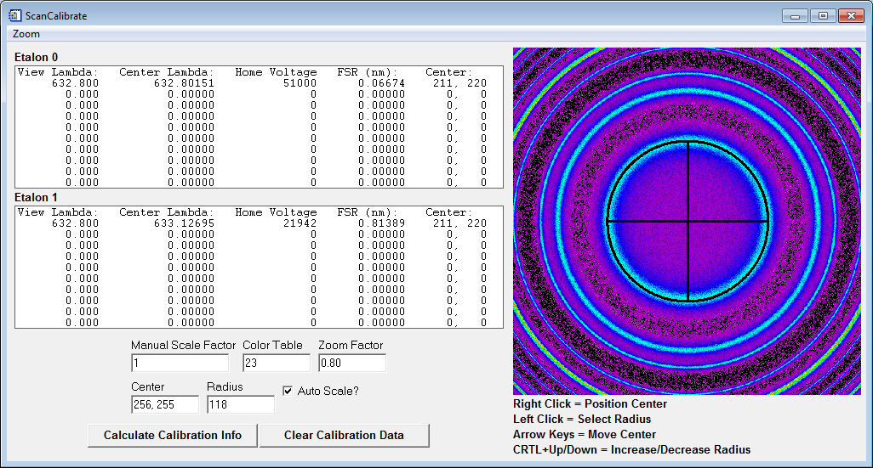

On the left, from the top, are two panels which display information on the calibrations which have already been performed (a given calibration is associated with a viewing wavelength). Information is given for each etalon separately, but not that for a given wavelength, the values in each table correspond to the *same* calibration, they simply result in different values for the different etalons.

Underneath these tables are some controls for adjusting the image display which appears on the right. These controls are similar to those in the vidshow plugin.

In order to perform the calibration, a single interference fringe should appear in the image on the right (the multiple fringes appearing in the image above result from simulated fringes, and are for demonstration only). The idea is to make the black circle (with the cross-hairs inside it) overlap exactly with the interference fringe visible when viewing a particular calibration wavelength. To achieve this, the circle’s center can be moved (by right-clicking on the image, or using the arrow keys) and the radius of the circle can be adjusted (by left-clicking on the image, using the CTRL+Up/Down keys, or by typing a new value into the ‘Radius’ edit box on the left).

Once you have positioned the circle such that it neatly overlaps the brightest part of the interference fringe (all the way around in azimuth), click the button labeled ‘Calculate Calibration Info’:



A prompt will appear asking for the current viewing wavelength. Enter this wavelength (in units of nanometers), press enter, and then click ‘Accept’. The table should then be updated with the new calibration information for the wavelength that you entered.

Should the need arise, all calibration values can be cleared using the button labeled ‘Clear Calibration Data’:



You will then be asked to provide confirmation that you really do wish to clear the data.

**Acquiring Spectra**

Spectral acquisition is controlled by the ‘dcai_spectrum’ plugin. It can be launched from the main console ‘Plugins’ menu. When launched, the following window will appear:

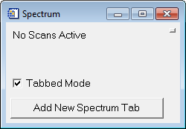

To start a new spectral acquisition, click the ‘Add New Spectrum Tab’ button (by default, all spectral acquisition jobs will be collected under the main ‘Spectrum’ window and displayed in a tabbed interface). After clicking this button, the following window will appear, prompting for information on the type of acquisition you wish to perform:

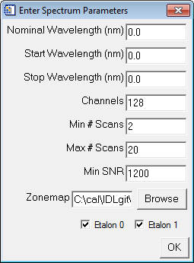

Two different modes of spectral acquisition are supported, ‘wavelength’ mode and ‘scan over one order’ mode (these terms are just descriptive). In both cases, the ‘Nominal Wavelength (nm)’ field must be set, and refers to the nominal wavelength of the emission under investigation (for example, 630.0 nm airglow).

In ‘wavelength’ mode (the required mode for daytime operation) both etalons are scanned synchronously over a wavelength range specified by ‘Start Wavelength (nm)’ and ‘Stop Wavelength (nm)’. To activate this mode, check both etalon check-boxes, and supply a a start and stop wavelength.

In ‘scan over one order’ mode, a scan is performed using only one etalon, and the etalon spacing is scanned through one order of interference. To use this mode, select only one etalon using the check-boxes. No start/stop wavelength is required in this mode.

The remaining fields are:

* ‘Channels’: the number of spectral channels, or, equivalently, the number of plate spacing increments. This sets the spectral resolution of the scan (note this resolution will ultimately be limited by the resolution of the etalon leg controller).
* ‘Min # Scans’: sets the minimum number of scans which will be performed (a single ‘exposure’ comprises a set of spectra, and may itself be made up of a number of etalon scans, in order to improve the signal-to-noise ratio of the spectra).
* ‘Max # Scans’: sets the maximum number of scans that will be performed, regardless of the signal-to-noise ratio that was reached up to that point.
* ‘Min SNR’: this is the minimum average signal-to-noise ratio (across all spectra in a given exposure) that must be reached before the exposure will be considered ‘finished’. The ‘Min/Max # Scans’ fields take precedence over signal-to-noise ratio when determining when to finish an exposure.
* ‘Zonemap’: the ‘zone map’ tells the spectrum plugin how to divide-up the detector (or camera images) into ‘zones’. All of the pixels from a given ‘zone’ contribute to a single spectrum. Thus the zone map determines the number of spectra that are acquired during each exposure. The zone map is specified by a text file (REFERENCE A ZONEMAP SECTION) .

Once these fields have been filled-out, click ‘OK’, and assuming the fields were correctly set, a new tab will appear inside the plugin, the title of which will be the nominal wavelength supplied.

