Deep Convolutional Neural Network & Emotional Learning Based Breast Cancer Detection using Digital Mammography

In this project as extension we have added 2 algorithms such as

1. BRISK Features Extraction: using Brisk algorithm we are extracting BRISK descriptor from images and then training with SVM and ELIEC
2. Extreme Learning Machine (ELM): adding new algorithm called ELM and then training with Brisk features and this combination is giving accuracy closer to 100%

In below screen you can read red colour comments to know about brisk features extraction

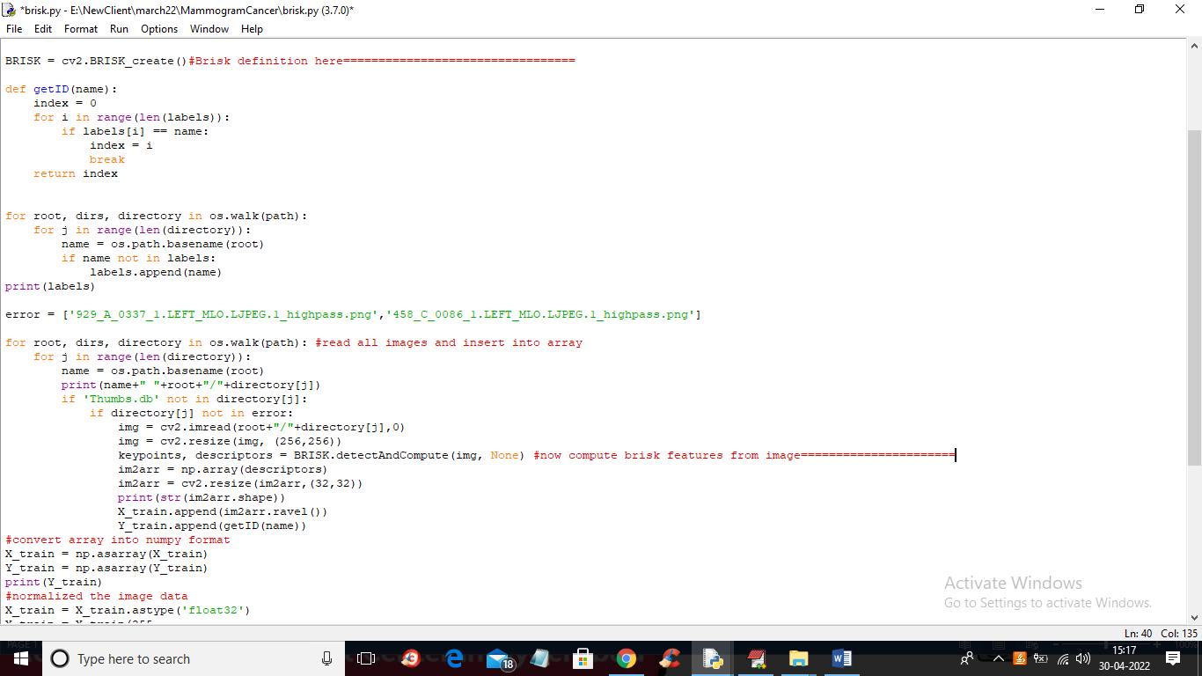

In above screen see red line comments to know about BRISK features extraction and this features will get train with all algorithms.

To run project double click on ‘run.bat’ file to get below screen

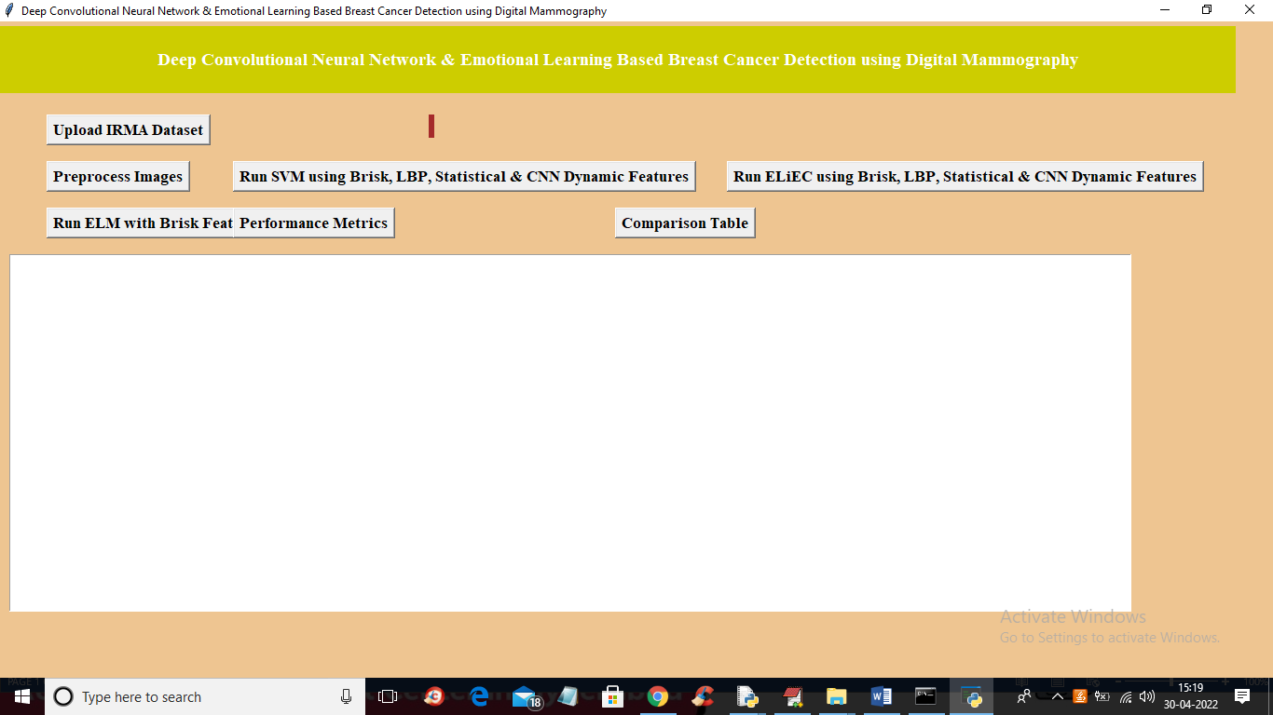

In above screen upload dataset

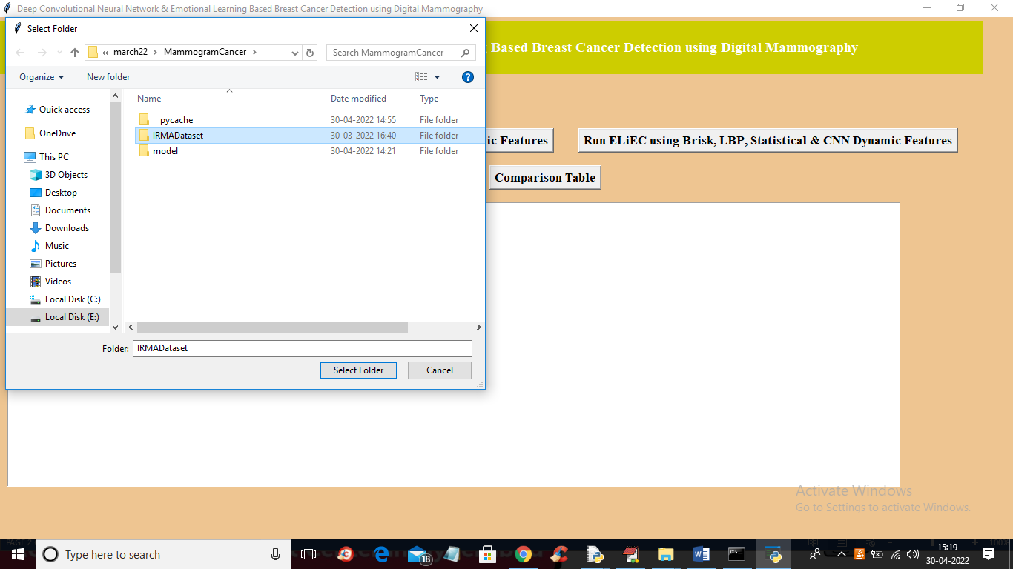

After dataset upload click on preprocess button to get below output

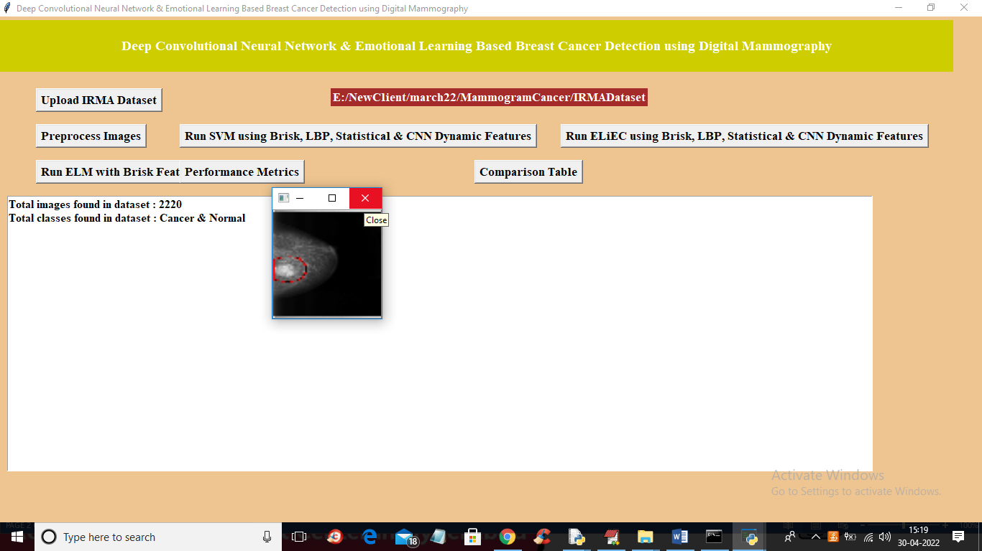

In above screen image processing completed and all features extracted and now click on ‘Run SVM using Brisk, LBP, Statistical & CNN Dynamic Features’ button to train SVM with 4 different features such as Brisk, LBP, CNN and Statistical and get below accuracy

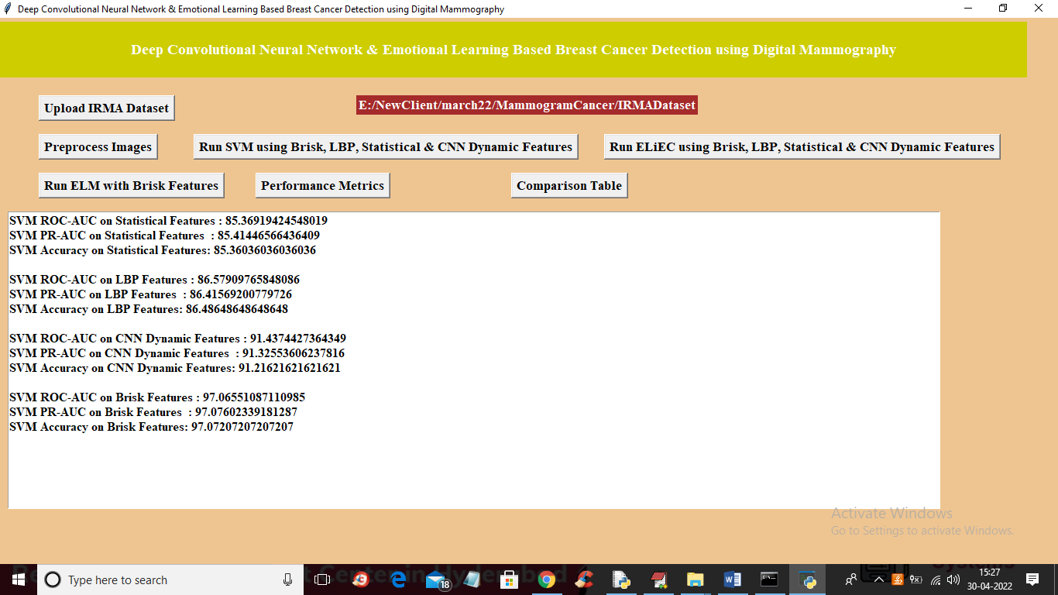

In above screen with BRISK features SVM got 97% accuracy which is higher than any other features. Now click on ‘Run ELiEC using Brisk, LBP, Statistical & CNN Dynamic Features’ button to train ELIEC with all features and get below output

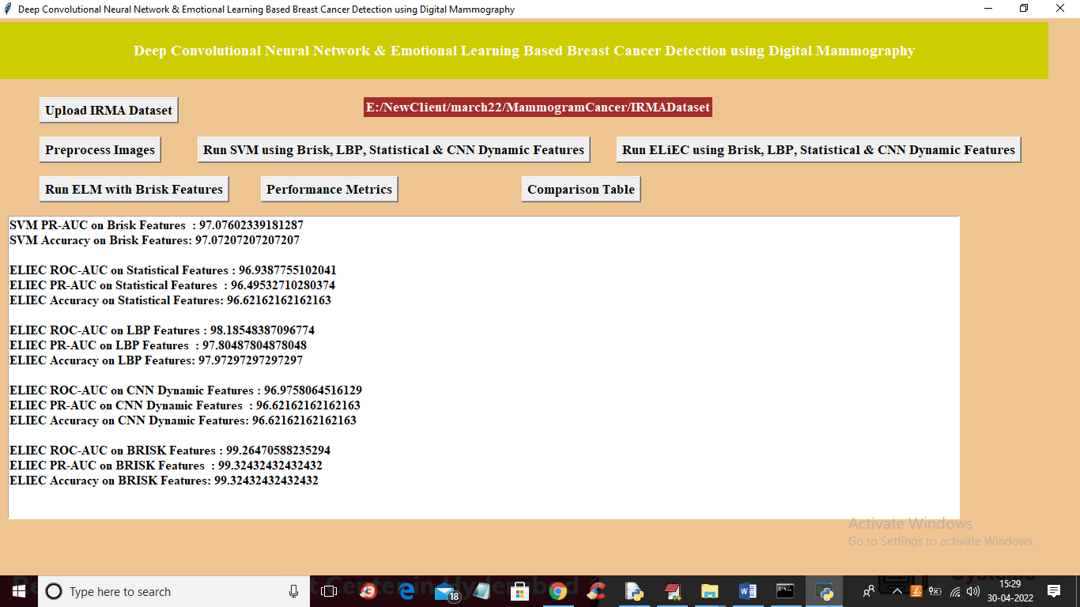

In above screen with ELIEC BRISK features we got 99.26% accuracy and now click on ‘Run ELM with Brisk Features’ to get below output

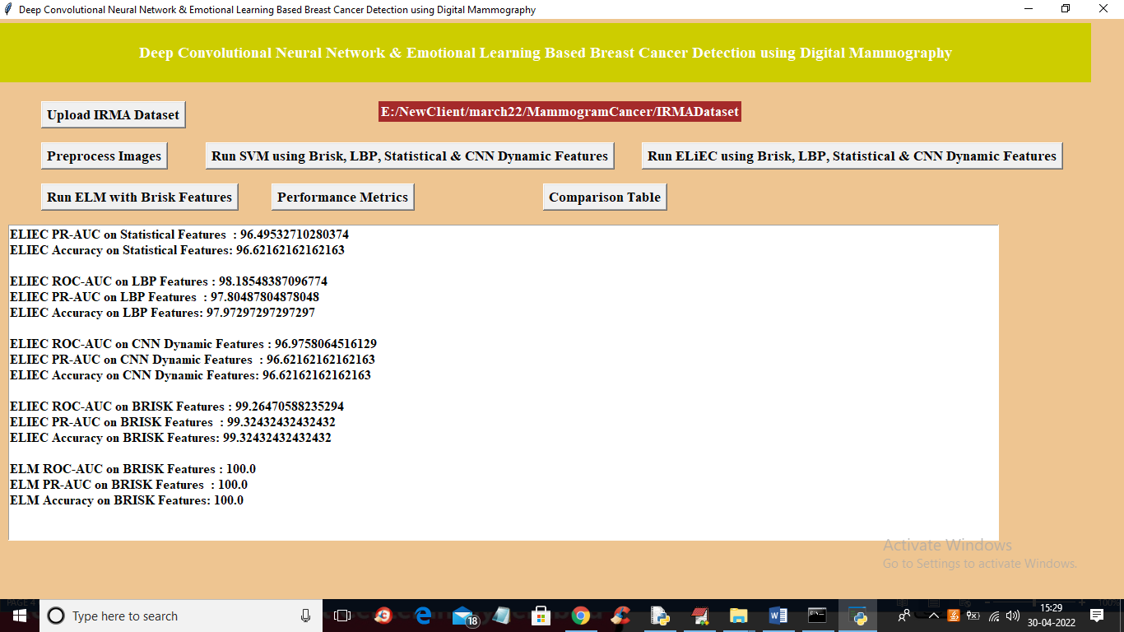

In above screen with ELM and Brisk features we got 100% accuracy and now click on ‘Comparison Table’ to get below output

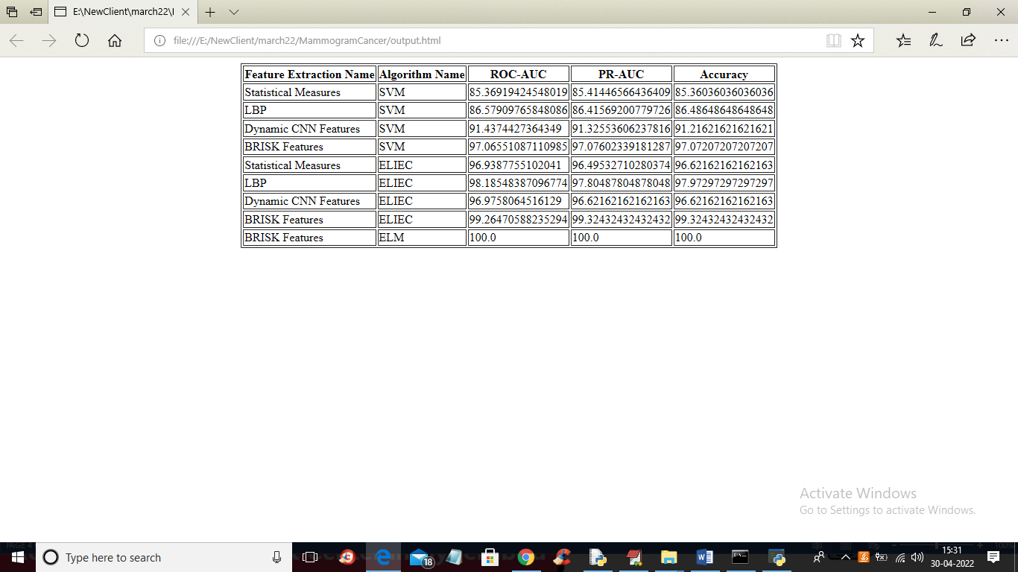

In above table we can see all algorithms with Brisk features has got high accuracy