Deep Convolutional Neural Network & Emotional Learning Based Breast Cancer Detection using Digital Mammography

Due to breast cancer disease lots of peoples are losing their lives and this death rate can be reduced by diagnosing this disease in time. In propose paper author is applying 4 features extraction technique on IRMA mammography dataset to efficiently predict such cancer.

Author has used Statistical Measures, Taxonomy, LBA (local binary patterns) and Dynamic Features Extraction using CNN algorithm and in all features extraction CNN features are giving better result. Author has evaluated performance of all 4 features extraction algorithm by using SVM and ELIEC (Emotional Learning inspired Ensemble Classifier). ELIEC is the super form of WEIGHTED KNN Algorithm.

In all 4 algorithms Taxonomy algorithm is not available so I am skipping that algorithm

In below screens I am showing code for features extraction using Statistical Measures

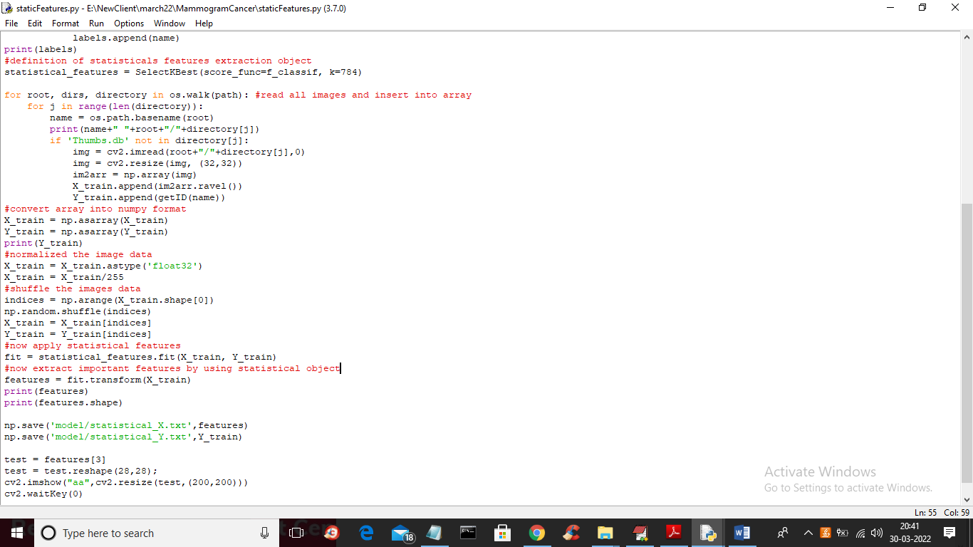

In above screen read red colour comments to know about statistical measures and in below screen showing code for LBP algorithm

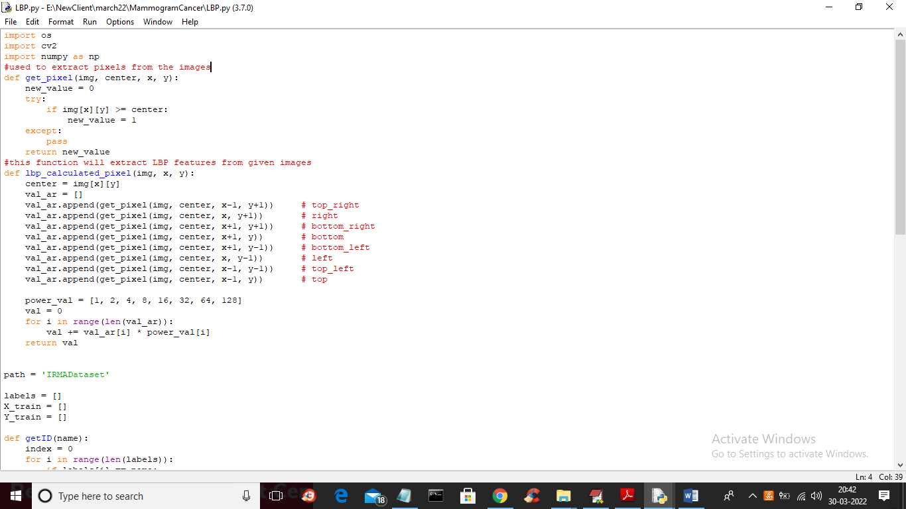

In below screen showing code for CNN training to extract features from it

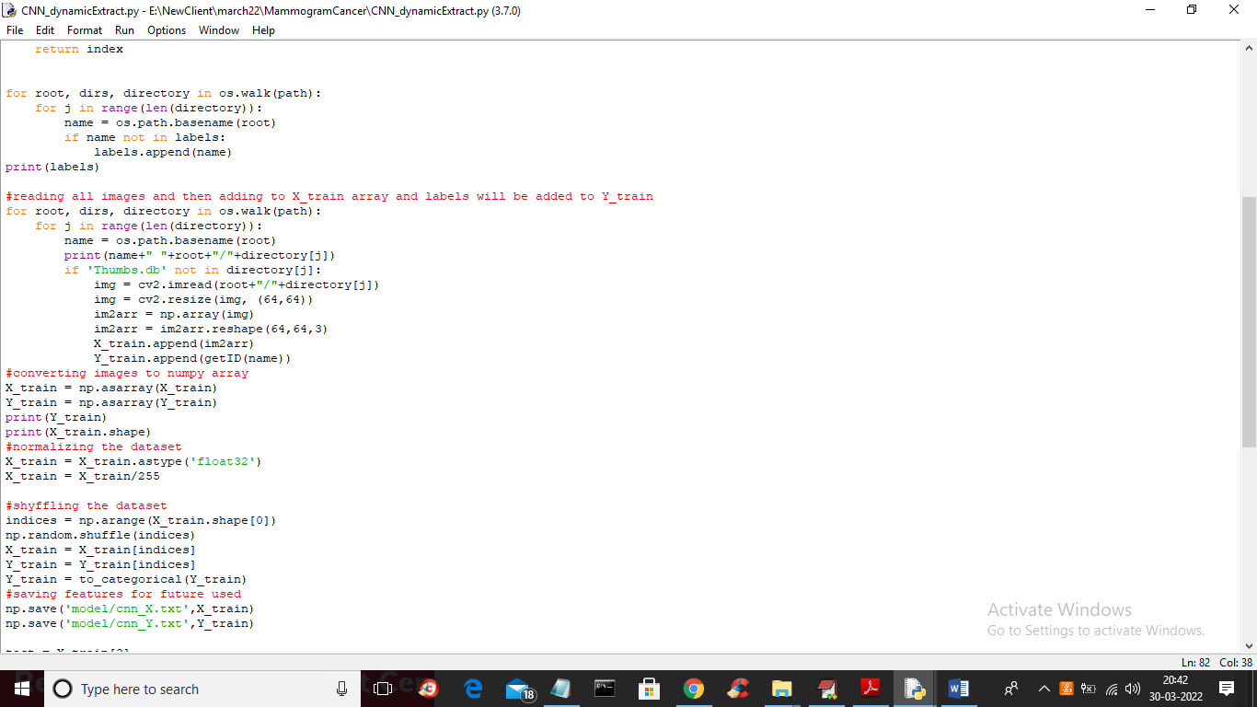

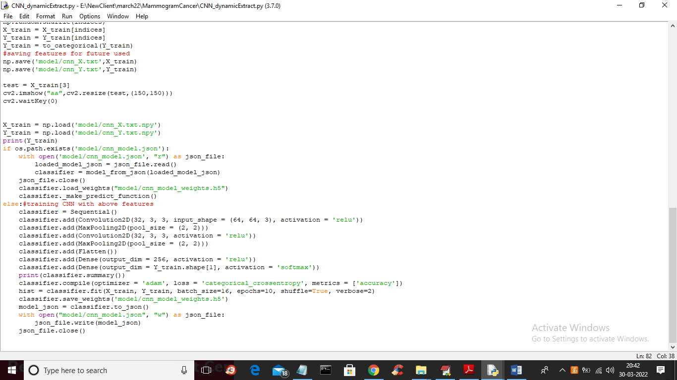

In above two screen read red colour comments to know training with CNN and this trained model can be used to extract features

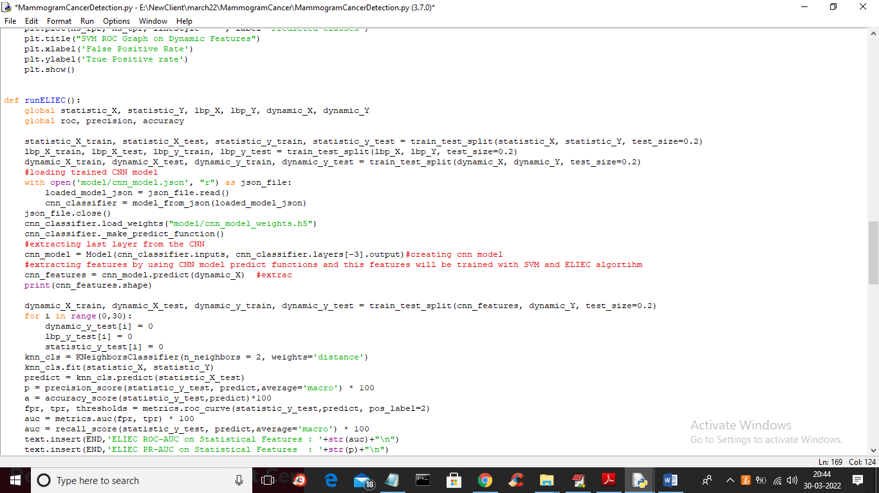

In above screen you can see CNN model loading and then extracting features from loaded model and this extracted features will get trained with SVM and ELIEC.

We are using below dataset images to train both algorithms



In above screen we have two classes such as NORMAL and CANCER (abnormal) and go inside any folder to view images

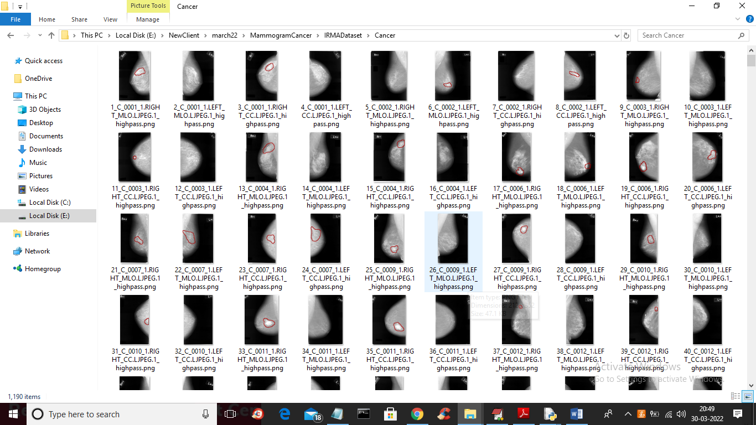

To implement this project we have designed following modules

1. Upload IRMA Dataset: using this module we will upload dataset images to application
2. Preprocess Images: using this module we will read all images and then extract Statistical features, LBP and Dynamic CNN features
3. Run SVM using LBP, Statistical & CNN Dynamic Features: using this module we will train SVM with 3 different features such as Statistical features, LBP and dynamic CNN and then apply this trained SVM model on test data to calculate ROC-AUC, Precision and Accuracy
4. Run ELiEC using LBP, Statistical & CNN Dynamic Features: using this module we will train ELIEC with all 3 features and then apply this trained model on test data to calculate performance metrics like accuracy etc.
5. Performance Metrics: using this module we will plot accuracy for both algorithms
6. Comparison Table: using this module we will show comparison values for both algorithms on all 3 features

SCREEN SHOTS

To run project double click on ‘run.bat’ file to get below screen

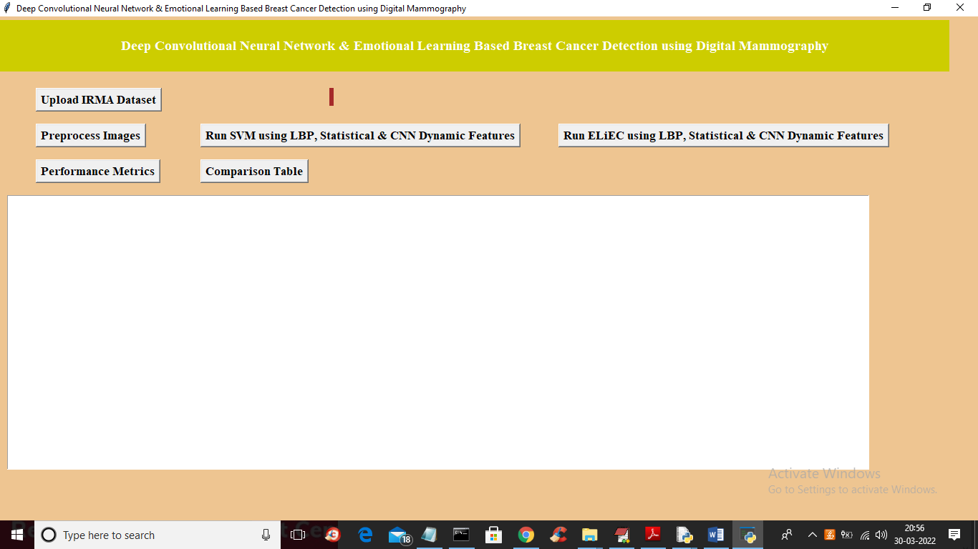

In above screen click on ‘Upload IRMA Dataset’ button to upload dataset and to get below screen

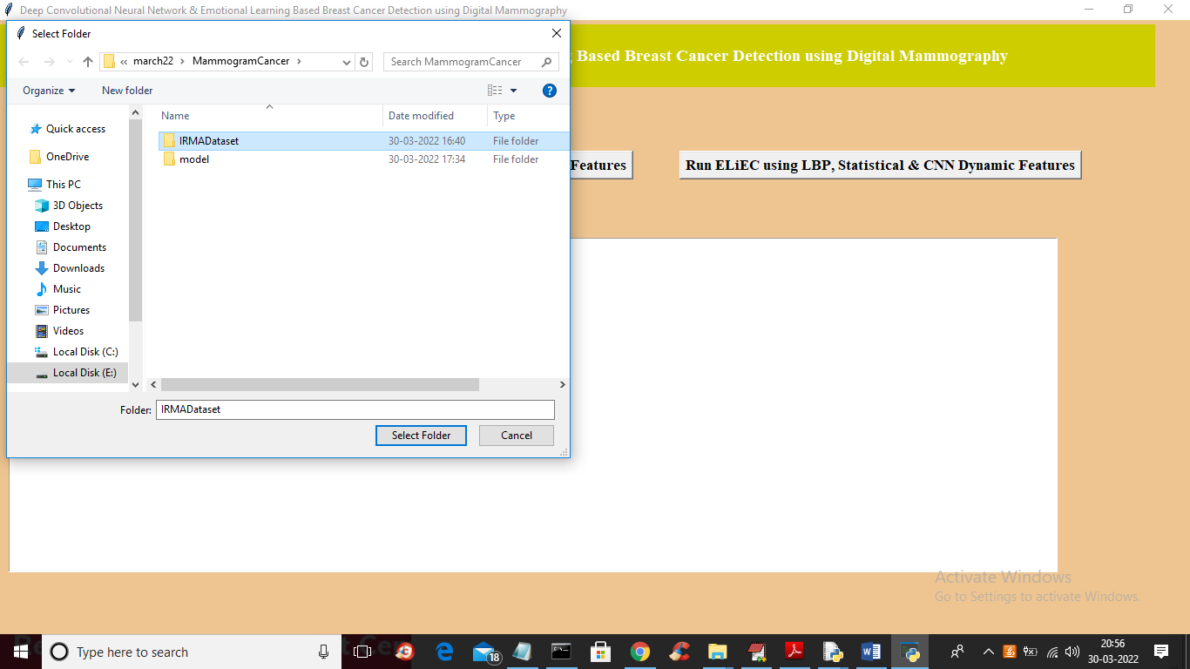

In above screen selecting and uploading ‘IRMADataset’ folder button and then click on ‘Select Folder’ button to load dataset and to get below screen

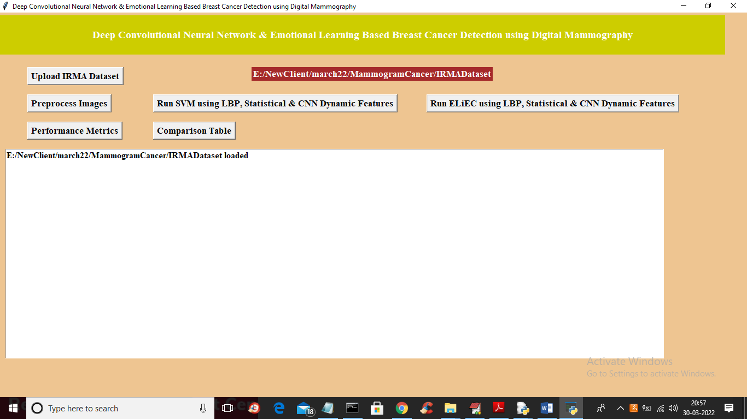

In above screen dataset loaded and now click on ‘Preprocess Images’ button to load all images and then extract statistical, LBP and CNN features and get below output

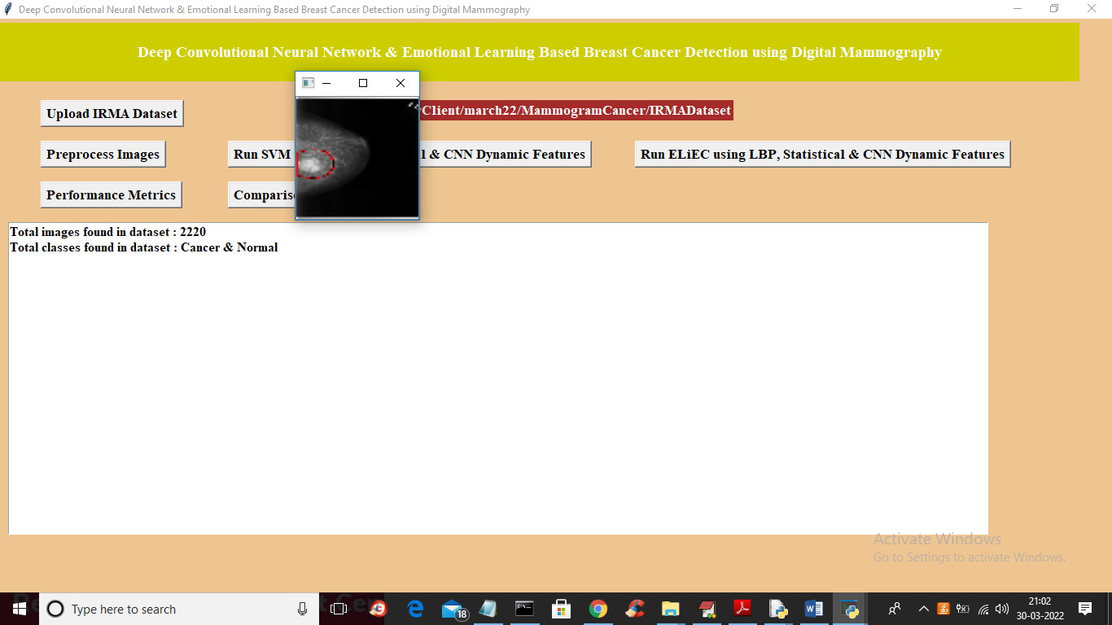

In above screen images loaded and features extracted properly and for sample I am showing one sample image and in dataset we can see total 2220 images are found and its contains normal and cancer classes images.

Now click on ‘Run SVM using LBP, Statistical & CNN Dynamic Features’ button to train SVM with all 3 feature and get below output

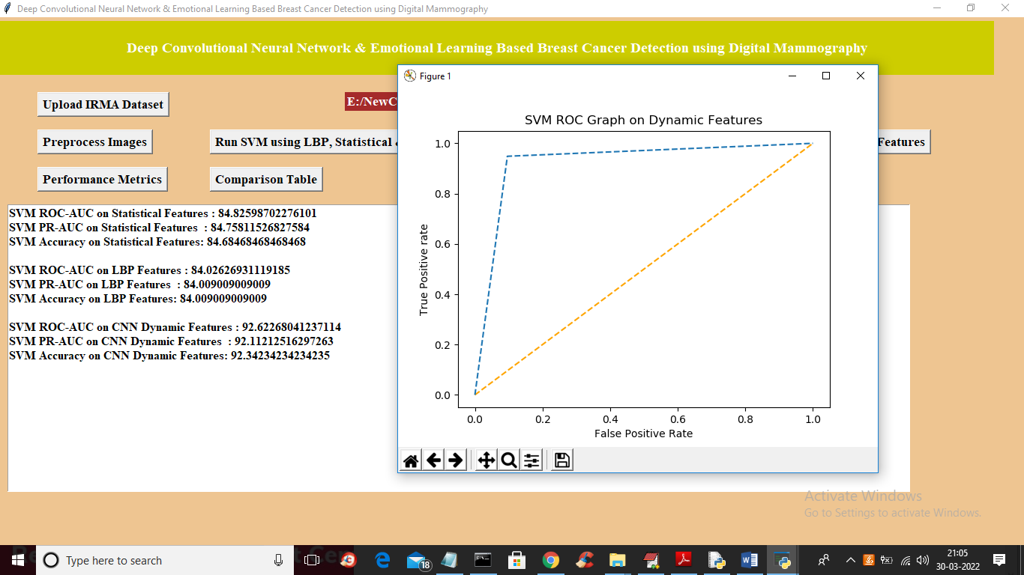

In above screen we trained SVM with statistical features and got accuracy as 84.68 and with LBP we got 84.009 and with CNN features we got SVM accuracy as 92% so CNN features are giving better performance with SVM and now click on ‘Run ELiEC using LBP, Statistical & CNN Dynamic Features’ button to train all 3 features with ELIEC algorithm and calculate accuracy

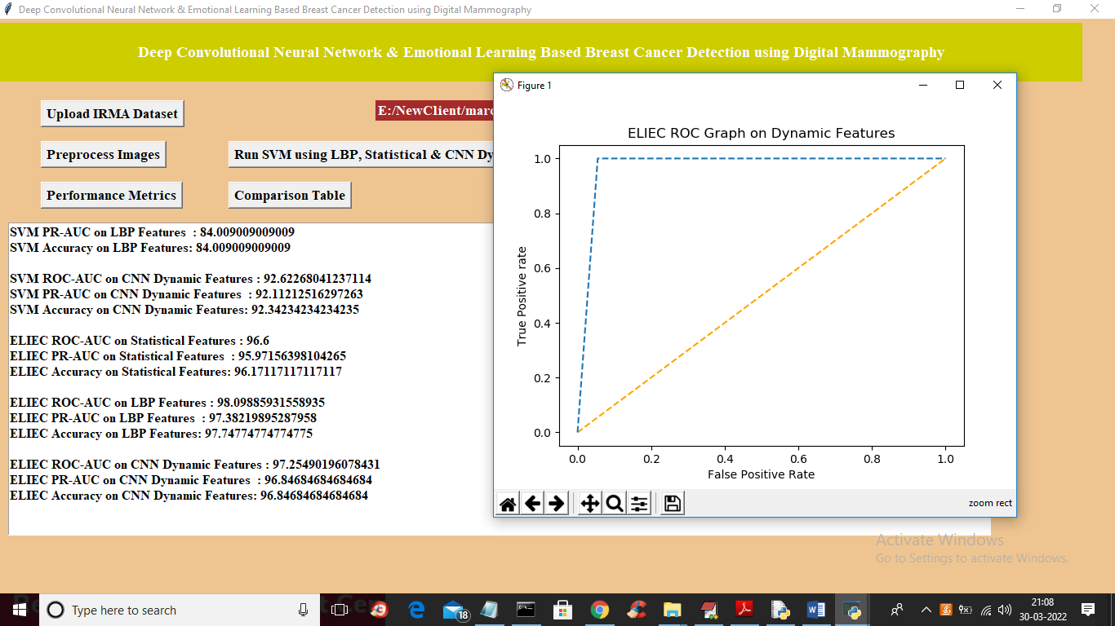

In above screen with ELIEC and statistical we got 96% accuracy and with LBP we got 97 and with CNN we got 96.84 so propose ELIEC is giving better performance compare to SVM and in above ROC graph x-axis represents false positive rate and y-axis represents true positive rate and blue line is the correct prediction which reached closer to 100% and now click on ‘Performance Metrics’ button to get below graph

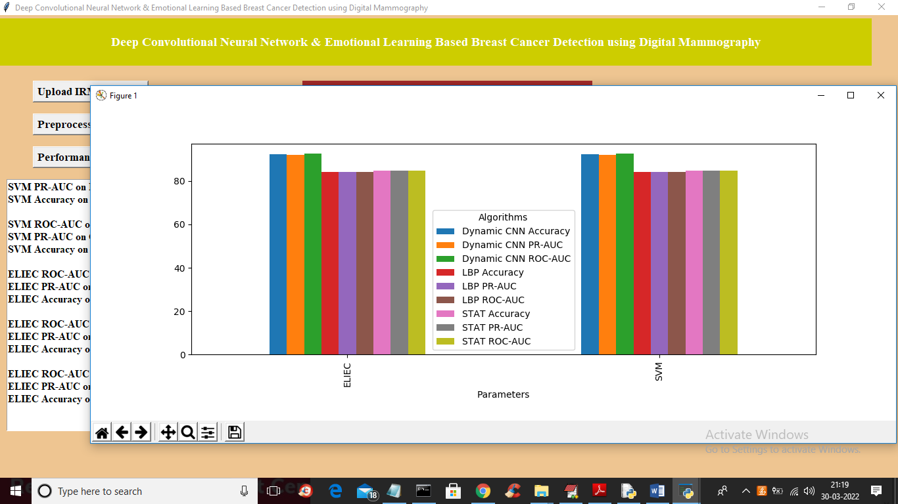

In above graph x-axis represents algorithm names and y-axis represents performance values and each different colour bar represents different metric and in graph we can see propose ELIEC got better performance. Now click on ‘Comparison Table’ button to get below output

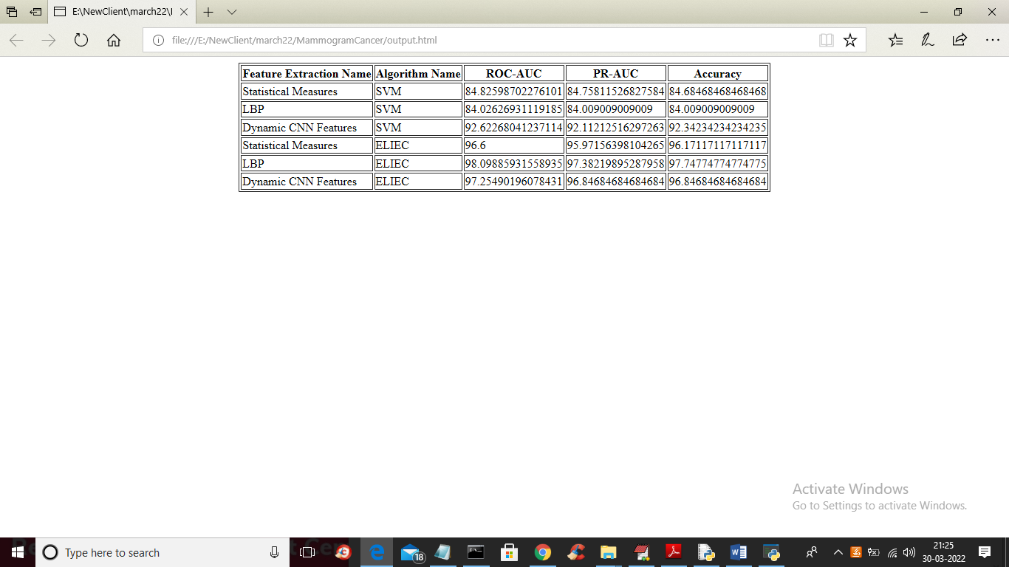

In above comparison table we can see for same LBP, statistical and CNN propose ELIEC got better performance compare to SVM