**Proposal for Old Slaymaker Territory**

**Filta’s Situation**: *Filta currently operates a corporate territory. There is no long term appeal or protocol for holding a corporate territory. Their options are to either cease service or sell the territory to a new owner.*

* **Filta Option One**
  + ***Pros***
    - Clean way to separate from the territory
    - Provides an opportunity to start fresh at a point in the future with a new owner
  + ***Cons***
    - Jeopardizes relationships at a national corporate level with Sodexo, as well as a few others. As you can see below, Sodexo is clearly the most significant customer in the area. To pull service with them not only upsets the regional Sodexo people, but also jeopardizes national relations.

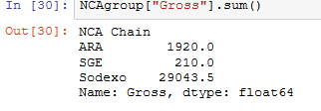

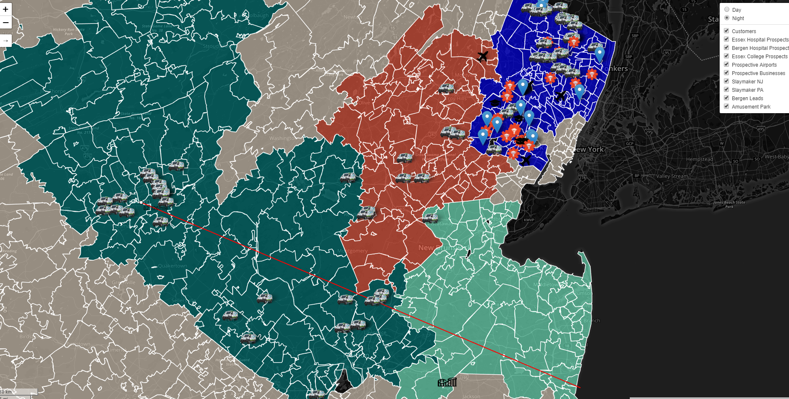

* **Filta Option Two** 
  + The most logical option is **Option Two**, sell to a new owner. The above map shows New Jersey and Pennsylvania, mapped by zip codes. Traditionally, Filta designates territory to owners in the Northeast by zip code.
  + The colors and objects mean:
    - **Deep Blue** – Currently owned Dorado Environmental, Inc. (DEI) Territory
    - **Light Green** – Options owned for DEI expansion
    - **Hunter Green** – Former franchisee territory now operated by Filta Corporate
    - **Red** – Owned by a separate franchisee
    - **Linen, Beige** – Other Zip Codes with no current ownership
    - Orange Circle – The concentration of Filta Corporate serviced customers
    - Red line – a line between Manasquan and the heart of the Lehigh Valley customer base, approximately 85 miles
    - **Yellow Circle** – Currently owned target customers of various designations
    - **Filta Van Icons** – represent customers that are targets
    - **Medical Icons –** represent medical customers/targets
    - **Airplane Icons –** represent airport targets
    - **Blue leaflet Icons –** represent current customers
    - **Cap Icons –** represent education customers/targets
    - ** Amusement Icon –** represent Amusement park targets
* **The Details around the Deal**
  + Based on DEI’s growth goals, acquiring the Lehigh Valley territory does appear logical as it adds customers and revenue, however:
    - Logistically difficult as there is one older technician currently working the territory. The business should have a second tech, part time or full, to really accommodate the work flow
      * This employment expansion would put a strain on monthly cash flows, especially in the summer when the majority of the clients, universities, are not active
    - There is infrastructure in terms of the following:
      * *One service van (~90k miles)*
      * *Two Generation 3 Mobile Filtration Units (MFUs)*
      * *One small storage area for warehouse storage*
      * *Technician parks van at his residence when it is not in service*
    - The **annualized revenue** currently derived is base service meaning it is done without any upselling or consideration for what the customer actually wants. It is truly a basic service.
    - Valuing the territory can only be done, accurately, by measuring the FiltaFry business. Other revenue sources such as FiltaBio (the business name for the waste oil collection) do not have reliable data. They have been deemed $0 here, but that is not a true assumption.
* **The Deal**
  + DEI would like toconstruct the following deal:
    - Visualizing this as a new acquisition of territory, not business. Therefore we will not be basing the purchase price on the sales revenue, but rather, on the territory fee used in the first DEI/Filta deal.
      * **$15,000.00** for the Lehigh Valley territory, as constructed by Michals. Of significance, there is no liquidity event at time 0. Rather, Filta will be paid a second royalty on every MFU used to service within this territory up until the $15,000.00 is paid off. At this point, DEI will revert back to the traditional format of one single royalty per MFU in service.
      * Part of the Lehigh Valley includes portions of NJ around the Princeton area, this territory will be included
      * Trade in both Gen 3 MFUs for 1 Gen 4 MFU
      * DEI reserves the right to close operations within the territory prior to the 24-25 month payback period if it is deemed that further operation would result in a lack of profitability or solvency.