Using Potomac River discharge forecasts to plan daily water allocations
Lalit Kishore
Abstract. A forecast can predict river discharge accurately and still support a water allocation that exceeds the next day’s available supply. We evaluated this distinction using daily discharge at the Little Falls Pump Station on the Potomac River. Four neural models predicted next-day discharge from 30 days of observations. We compared them with persistence, an equal-weight ensemble and a calibrated probabilistic ensemble on 2,192 days in 2020–2025. The stacked long short-term memory model had the lowest root mean squared error (111.22 m³/s), compared with 145.79 m³/s for persistence. The probabilistic ensemble had the lowest mean absolute error (37.79 m³/s). In a replay with fixed hypothetical demand and a diversion limit, planning from the ensemble’s fifth percentile reduced days with overcommitment from 63.55% to 1.46% relative to its mean forecast, while increasing average unmet demand by approximately 269,000 m³/day. The choice of planning statistic therefore had measurable consequences even with a fixed forecast model and allocation rule. The comparison uses observed river discharge, while the demand and diversion limits follow a hypothetical scenario.
Keywords: streamflow forecasting, Bayesian model averaging, prediction intervals, water allocation, Potomac River
1 Introduction
A water manager deciding how much water to promise tomorrow faces two costs. A high estimate of river flow can lead to commitments beyond available supply. A low estimate can leave demand unmet even on days when more water could have been delivered. Average forecast error describes neither cost directly.
Long short-term memory (LSTM) networks have been used successfully for rainfall–runoff modelling [1]. Forecast Bayesian model averaging (BMA) offers a way to turn several forecasts into a predictive distribution [2]. We use these established methods to ask two questions at a single gauge. How much do the models improve on carrying today’s flow forward? With the same probability distribution, how does planning from a conservative estimate change what can actually be delivered in a simulation?
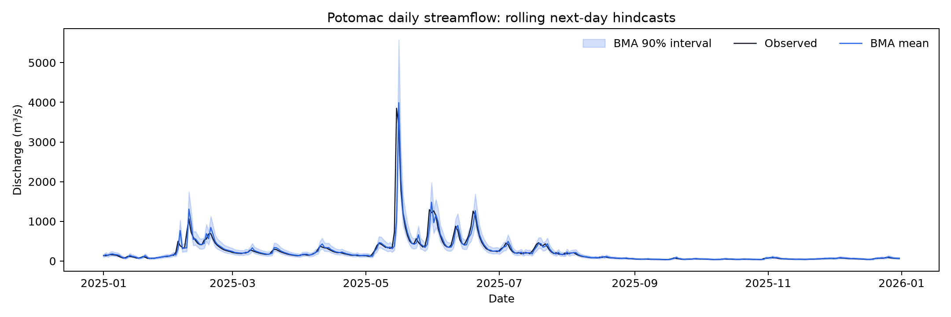
Fig. 1. Observed daily discharge and the calibrated ensemble forecast during the final year of the test period (2025). Shading indicates the central 90% prediction interval.
2 Data and methods
2.1 Daily discharge and test design
The U.S. Geological Survey (USGS) record for station 01646500 contains 13,149 daily mean discharges from 1 January 1990 to 31 December 2025 [3]. All values had approved status, including 174 also marked as estimated. We retained those flags and converted cubic feet per second to cubic metres per second using 0.028316846592. Input windows had to contain 30 consecutive days of valid observations.
We fitted the models on 7,275 target days through 2009, selected training epochs on 1,826 days in 2010–2014, and calibrated the forecasts on 1,826 days in 2015–2019. The test covered 2,192 consecutive days from January 2020 to December 2025. Each prediction used flow observed through the previous day. This design evaluates a sequence of one-day forecasts using retrospective records.
2.2 Point forecasts and uncertainty
Each neural network received log-transformed discharge, log(1 + Q), standardized using training data, plus sine and cosine terms for the annual cycle. Each predicted a correction to the final log-flow value. We compared a one-layer LSTM, a two-layer stacked LSTM, a bidirectional LSTM that read the historical window in both directions, and a two-layer Transformer with four attention heads. Hidden width was 32. The recorded run used seed 42, Adam, learning rate 0.001, batches of 128 and a maximum of 20 epochs with early stopping after five epochs without improvement.
Persistence carried the last observation forward. Equal averaging combined the four neural forecasts after correcting for the reversal of the log transformation on calibration data. For BMA we fitted a linear correction to each component on the log scale, then estimated mixture weights and a common residual variance by expectation-maximization. Transforming the resulting mixture to nonnegative discharge yielded the mean and its fifth and 95th percentiles.
2.3 From discharge to deliverable volume
Three hypothetical users each requested 1 million m³/day. For discharge Q in m³/s, the daily supply budget was 0.10 × 86,400 × max(Q − 20, 0) m³. Thus 20 m³/s was reserved before applying the 10% diversion limit. These values define the experiment and do not represent Potomac operating rules.
Each policy planned up to the smaller of forecast supply and total demand. We then used observed flow to calculate the day’s realized budget. Feasible delivery was the smaller of the plan and that budget. We counted a day as overcommitted if planned volume exceeded the realized budget by more than 0.000001 m³. Unmet demand was total demand less feasible delivery.
3 Forecast accuracy and allocation outcomes
Table 1. Next-day discharge at Little Falls, 2020–2025.
Forecast | RMSE¹ | MAE¹ | NSE | KGE
Persistence | 145.79 | 48.54 | 0.762 | 0.881
LSTM | 121.31 | 40.71 | 0.835 | 0.913
Stacked LSTM | 111.22 | 37.89 | 0.861 | 0.914
Bidirectional LSTM | 121.57 | 40.29 | 0.834 | 0.914
Transformer | 116.79 | 40.32 | 0.847 | 0.903
Equal average | 115.14 | 39.44 | 0.851 | 0.920
Forecast BMA | 111.87 | 37.79 | 0.860 | 0.916
¹ Root mean squared error (RMSE) and mean absolute error (MAE) are in m³/s. Nash–Sutcliffe efficiency (NSE) and Kling–Gupta efficiency (KGE, 2009 form) have an optimum of one.
The stacked LSTM reduced RMSE by 23.7% relative to persistence. BMA improved MAE by only 0.10 m³/s relative to the stacked LSTM. Equal averaging gave the highest KGE. The stacked LSTM carried 76.7% of the calibrated mixture weight. The central 90% BMA interval covered 92.97% of test observations and had a mean width of 156.39 m³/s.
Table 2. Allocation outcomes under the fixed demand scenario.
Planning input | Overcommitted days (%) | Mean unmet demand¹ | Mean excess commitment¹
Persistence | 54.47 | 1,589,306 | 63,317
BMA mean | 63.55 | 1,568,797 | 78,526
BMA fifth percentile | 1.46 | 1,838,129 | 2,717
¹ Volumes in m³/day, averaged across all 2,192 test days, including days with zero excess commitment.
The mean BMA plan delivered more water on average than persistence, yet exceeded the observed budget more often. Choosing the fifth percentile instead of the BMA mean reduced excess commitments from 1,393 days to 32. The cost was higher unmet demand, including water that could have been delivered under the same rules. Compared with a planner given each day’s observed flow in advance, the mean policy forwent 42,169 m³/day of feasible delivery. The fifth-percentile policy forwent 311,501 m³/day.
4 Discussion and limitations
Forecast selection and allocation policy answer different questions. At Little Falls, the lowest absolute error favored the ensemble mean, while a planner seeking fewer excess commitments could use a lower percentile of the same distribution. The replay quantifies the price of that choice. Selecting a percentile for an actual basin would require a defensible estimate of the relative costs of excess commitments and unmet demand.
These results describe one gauge, one random seed, one lead time and one design for demand. The forecast and allocation comparisons share the same six-year test period. Adjacent days are hydrologically dependent, and the small MAE difference between the top two forecasts is descriptive. Prospective evaluation should use observations as they were available at forecast time, several catchments and multiple seeds. Varying diversion limits and seasonal demand would show whether the allocation tradeoff persists.
4.1 Scope of the basin prototype
A companion implementation screens crop cover, surface wetness, flooding, slope change and turbidity from satellite inputs. It tracks when an observation becomes available, and can withhold a crop-demand estimate when required observations are stale or missing. Offline tests exercised these behaviors with synthetic inputs. The allocation replay used discharge alone. Field labels, paired measurements and dated event inventories are needed to evaluate satellite accuracy and any change in allocation outcomes. A separate audit of constructed-wetland phosphorus datasets did not supply inputs to the daily forecast.
5 Conclusion
At Little Falls, learned forecasts improved on persistence across the test period. Under a single allocation rule, a conservative forecast sharply reduced overcommitment but left more feasible demand unserved. Reporting both outcomes makes the cost of conservatism visible alongside the usual forecast error scores.
5.1 Data and code availability
The daily USGS source record, model settings, calibration and test predictions, and daily allocation decisions are identified in the project archive [4]. The results reported here use the archived seed-42 run and October 2026 allocation replay.
References
1. Kratzert, F., Klotz, D., Brenner, C., Schulz, K., Herrnegger, M.: Rainfall–runoff modelling using Long Short-Term Memory (LSTM) networks. Hydrology and Earth System Sciences 22, 6005–6022 (2018). doi:10.5194/hess-22-6005-2018.
2. Raftery, A.E., Gneiting, T., Balabdaoui, F., Polakowski, M.: Using Bayesian model averaging to calibrate forecast ensembles. Monthly Weather Review 133, 1155–1174 (2005). doi:10.1175/MWR2906.1.
3. U.S. Geological Survey: Potomac River near Washington, DC, Little Falls Pump Station. Station 01646500, daily discharge. https://waterdata.usgs.gov/monitoring-location/USGS-01646500/
4. Hydrology Institute project: Code and experiment records, revision bcf55f8 (2026). https://github.com/doraem-on/Hydrology_Institute-project/tree/bcf55f8

