Comparing recurrent networks and a Transformer for next day Potomac River discharge forecasts
Lalit Kishore
Abstract. Daily river discharge often persists from one day to the next, making the last observation a useful benchmark for evaluating neural forecasts. We compared three long short-term memory (LSTM) architectures and a Transformer using the same 30 days of discharge history and seasonal inputs at the Little Falls gauge on the Potomac River. We compared each model with persistence, equal averaging and a calibrated ensemble, reserving separate periods for training, validation, calibration and testing. Across 2,192 forecasts from 2020 to 2025, the stacked LSTM achieved the lowest root mean squared error (111.22 m³/s), a 23.7% reduction relative to persistence. The ensemble achieved the lowest mean absolute error (37.79 m³/s), only 0.10 m³/s below the stacked LSTM, and its central 90% interval covered 92.97% of observations. Both methods beat persistence on root mean squared error in five of six test years. A hypothetical allocation replay illustrates how the ensemble’s lower prediction bound changes commitments relative to its mean forecast.
Keywords: streamflow forecasting, long short-term memory, Transformer, model averaging, uncertainty calibration
1 Introduction
Can a more complex sequence model improve tomorrow’s flow forecast when today’s discharge is already known? For a slowly changing river, a forecast that repeats the last measurement may be difficult to beat. The practical comparison is therefore with persistence on the same forecast dates, including periods in which the simpler method performs well.
Long short-term memory (LSTM) networks have been applied to rainfall–runoff modelling [1]. Here we study a narrower prediction task at one gauge, using historical discharge and seasonality. We compare four architectures under a common training protocol, then test whether an ensemble improves on its individual members. Forecast Bayesian model averaging (BMA) also yields a range of plausible discharges [2], which we evaluate against observations and use in a simulated allocation decision.
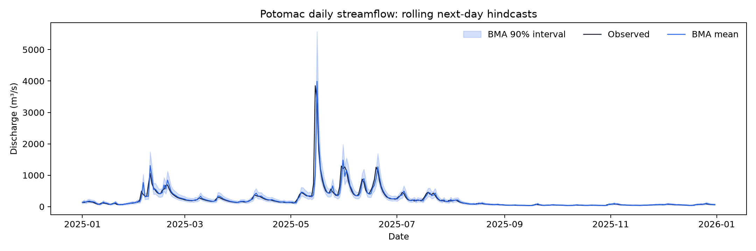
Fig. 1. Observed daily discharge and the calibrated ensemble forecast during the final year of the test period (2025). Shading indicates the central 90% prediction interval.
2 Data and methods
2.1 Daily discharge and test design
The U.S. Geological Survey (USGS) record for station 01646500 contains 13,149 daily mean discharges from 1 January 1990 to 31 December 2025 [3]. All values had approved status, including 174 also marked as estimated. We retained those flags and converted cubic feet per second to cubic metres per second using 0.028316846592. Input windows had to contain 30 consecutive days of valid observations.
We fitted the models on 7,275 target days through 2009, selected training epochs on 1,826 days in 2010–2014, and calibrated the forecasts on 1,826 days in 2015–2019. The test covered 2,192 consecutive days from January 2020 to December 2025. Each prediction used flow observed through the previous day. This design evaluates a sequence of one-day forecasts using retrospective records.
2.2 Point forecasts and uncertainty
Each neural network received log-transformed discharge, log(1 + Q), standardized using training data, plus sine and cosine terms for the annual cycle. Each predicted a correction to the final log-flow value. We compared a one-layer LSTM, a two-layer stacked LSTM, a bidirectional LSTM that read the historical window in both directions, and a two-layer Transformer with four attention heads. Hidden width was 32. The recorded run used seed 42, Adam, learning rate 0.001, batches of 128 and a maximum of 20 epochs with early stopping after five epochs without improvement.
Persistence carried the last observation forward. Equal averaging combined the four neural forecasts after correcting for the reversal of the log transformation on calibration data. For BMA we fitted a linear correction to each component on the log scale, then estimated mixture weights and a common residual variance by expectation-maximization. Transforming the resulting mixture to nonnegative discharge yielded the mean and its fifth and 95th percentiles.
2.3 Evaluation across models and years
We scored all methods against the same observed values in physical units. Root mean squared error gives greater weight to large misses, while mean absolute error weights errors in direct proportion to their magnitude. For the 90% interval, we counted observations at or between its endpoints and measured its average width. We also recalculated the principal comparison separately for each calendar year using the archived daily predictions.
As a downstream illustration, three hypothetical users each requested 1 million m³/day. Planned supply was limited to 10% of forecast discharge above a reserve of 20 m³/s, converted to daily volume. We compared plans with the budget calculated from observed discharge. A commitment above that budget counted as overcommitment. Feasible delivery was capped by both the observed budget and the plan.
3 Forecast accuracy and interval coverage
Table 1. Next-day discharge at Little Falls, 2020–2025.
Forecast | RMSE¹ | MAE¹ | NSE | KGE
Persistence | 145.79 | 48.54 | 0.762 | 0.881
LSTM | 121.31 | 40.71 | 0.835 | 0.913
Stacked LSTM | 111.22 | 37.89 | 0.861 | 0.914
Bidirectional LSTM | 121.57 | 40.29 | 0.834 | 0.914
Transformer | 116.79 | 40.32 | 0.847 | 0.903
Equal average | 115.14 | 39.44 | 0.851 | 0.920
Forecast BMA | 111.87 | 37.79 | 0.860 | 0.916
¹ Root mean squared error (RMSE) and mean absolute error (MAE) are in m³/s. Nash–Sutcliffe efficiency (NSE) and Kling–Gupta efficiency (KGE, 2009 form) have an optimum of one.
The stacked LSTM reduced RMSE by 23.7% relative to persistence. BMA improved MAE by only 0.10 m³/s relative to the stacked LSTM. Equal averaging gave the highest KGE. The stacked LSTM carried 76.7% of the calibrated mixture weight. The central 90% BMA interval covered 92.97% of test observations and had a mean width of 156.39 m³/s.
Table 2. Annual RMSE (m³/s) for the leading forecasts and persistence.
Test year | Persistence | Stacked LSTM | BMA mean | Coverage (%)
2020 | 123.49 | 86.45 | 86.91 | 91.5
2021 | 146.72 | 108.89 | 110.08 | 92.9
2022 | 137.01 | 108.37 | 108.43 | 93.4
2023 | 50.81 | 62.67 | 62.22 | 91.5
2024 | 165.16 | 110.68 | 111.08 | 92.9
2025 | 205.24 | 164.24 | 165.74 | 95.6
Coverage is the percentage of observed discharges within the ensemble’s nominal 90% interval. All rows use the same fitted models.
Persistence yielded the smallest RMSE of these three methods in 2023 (50.81 m³/s), when the stacked LSTM reached 62.67 m³/s. In 2025, the year with the largest persistence error, the stacked LSTM reduced RMSE from 205.24 to 164.24 m³/s. Annual interval coverage ranged from 91.5% to 95.6%. Aggregate coverage alone does not show how well the interval captures unusually low or high flows.
4 Discussion and limitations
Stacking two recurrent layers yielded the lowest pooled RMSE under the shared training settings. Neither bidirectional encoding nor the Transformer improved on it. The BMA mixture assigned 76.7% of its weight to the stacked LSTM, which helps explain why their point forecasts scored similarly. The mixture’s additional output is its predictive distribution. Its coverage exceeded the nominal target, so interval width matters when interpreting this result.
The experiment covers one gauge, one training seed and one forecast horizon. Models shared hidden width and training settings but differed in parameter count. The results therefore compare these fitted models, rather than isolating the effect of architecture. A multi-gauge, multi-seed replication with matched tuning budgets and separate low- and high-flow evaluation would test whether the observed ranking holds elsewhere.
4.1 Application to water allocation
In the fixed-demand replay, planning from the ensemble mean exceeded the available budget on 63.55% of days. Using its fifth percentile lowered that rate to 1.46%, but raised mean unmet demand from 1.569 to 1.838 million m³/day. This tradeoff illustrates a use for predictive uncertainty. The experiment used historical discharge and hypothetical demands and produced no estimate of operational water savings.
5 Conclusion
On six years of held-out Potomac observations, a stacked LSTM gave the lowest overall RMSE, while a calibrated ensemble nearly matched its point accuracy and supplied prediction intervals. Persistence outperformed both on RMSE in one test year. Reporting year-by-year errors alongside pooled scores makes that exception visible.
5.1 Data and code availability
The daily USGS source record, model settings, calibration and test predictions, and daily allocation decisions are identified in the project archive [4]. The results reported here use the archived seed-42 run and October 2026 allocation replay.
References
1. Kratzert, F., Klotz, D., Brenner, C., Schulz, K., Herrnegger, M.: Rainfall–runoff modelling using Long Short-Term Memory (LSTM) networks. Hydrology and Earth System Sciences 22, 6005–6022 (2018). doi:10.5194/hess-22-6005-2018.
2. Raftery, A.E., Gneiting, T., Balabdaoui, F., Polakowski, M.: Using Bayesian model averaging to calibrate forecast ensembles. Monthly Weather Review 133, 1155–1174 (2005). doi:10.1175/MWR2906.1.
3. U.S. Geological Survey: Potomac River near Washington, DC, Little Falls Pump Station. Station 01646500, daily discharge. https://waterdata.usgs.gov/monitoring-location/USGS-01646500/
4. Hydrology Institute project: Code and experiment records, revision bcf55f8 (2026). https://github.com/doraem-on/Hydrology_Institute-project/tree/bcf55f8

