EXPERIMENT NUMBER: 3
AIM
To create an Employee–Department–Project schema, insert at least 30 employees across 5 departments and 8 projects, and execute SQL queries demonstrating Selection, Projection, Aggregate Functions, GROUP BY, HAVING, CASE expressions, and ORDER BY.

SOURCE CODE
CREATE DATABASE CompanyDB;
USE CompanyDB;

CREATE TABLE Department (
dept_id INT PRIMARY KEY,
dept_name VARCHAR(50),
location VARCHAR(50)
);

CREATE TABLE Employee (
emp_id INT PRIMARY KEY,
emp_name VARCHAR(50),
job_title VARCHAR(50),
salary DECIMAL(10,2),
hire_date DATE,
dept_id INT,
FOREIGN KEY (dept_id) REFERENCES Department(dept_id)
);

CREATE TABLE Project (
project_id INT PRIMARY KEY,
project_name VARCHAR(100),
budget DECIMAL(12,2),
dept_id INT,
FOREIGN KEY (dept_id) REFERENCES Department(dept_id)
);

CREATE TABLE Employee_Project (
emp_id INT,
project_id INT,
hours_worked INT,
PRIMARY KEY (emp_id, project_id),
FOREIGN KEY (emp_id) REFERENCES Employee(emp_id),
FOREIGN KEY (project_id) REFERENCES Project(project_id)
);

INSERT INTO Department VALUES
(1, 'IT', 'Delhi'),(2, 'HR', 'Mumbai'),
(3, 'Finance', 'Bangalore'),(4, 'Marketing', 'Pune'),
(5, 'Operations', 'Hyderabad');
INSERT INTO Project VALUES
(101, 'Cloud Migration', 1500000, 1),(102, 'AI Analytics', 2000000, 1),
(103, 'Employee Portal', 800000, 2),(104, 'Financial Reporting', 1200000, 3),
(105, 'Digital Campaign', 1000000, 4),(106, 'Market Research', 700000, 4),
(107, 'Supply Chain System', 1800000, 5),(108, 'Process Automation', 1300000, 5);

INSERT INTO Employee VALUES
(1, 'Aarav Sharma', 'Software Engineer', 65000, '2022-01-15', 1),
(2, 'Ananya Verma', 'Data Analyst', 58000, '2022-03-20', 1),
(3, 'Rohan Gupta', 'Software Engineer', 72000, '2021-07-10', 1),
(4, 'Priya Singh', 'System Administrator', 62000, '2023-02-05', 1),
(5, 'Arjun Mehta', 'Cloud Engineer', 85000, '2020-11-18', 1),
(6, 'Neha Kapoor', 'Data Scientist', 90000, '2021-09-25', 1),
(7, 'Rahul Malhotra', 'HR Executive', 45000, '2022-04-12', 2),
(8, 'Sneha Jain', 'HR Manager', 75000, '2019-08-15', 2),
(9, 'Karan Arora', 'Recruiter', 48000, '2023-01-20', 2),
(10, 'Meera Joshi', 'Training Manager', 65000, '2020-06-10', 2),
(11, 'Vikas Yadav', 'HR Executive', 46000, '2023-05-18', 2),
(12, 'Ishita Rao', 'Recruiter', 50000, '2022-12-01', 2),
(13, 'Aditya Kumar', 'Accountant', 55000, '2021-02-15', 3),
(14, 'Simran Kaur', 'Financial Analyst', 68000, '2020-09-10', 3),
(15, 'Manish Shah', 'Accountant', 52000, '2022-07-05', 3),
(16, 'Pooja Agarwal', 'Finance Manager', 85000, '2019-04-20', 3),
(17, 'Nitin Bansal', 'Auditor', 62000, '2021-11-12', 3),
(18, 'Riya Mehta', 'Financial Analyst', 70000, '2023-03-25', 3),
(19, 'Kabir Khan', 'Marketing Executive', 50000, '2022-05-10', 4),
(20, 'Tanya Roy', 'Marketing Manager', 78000, '2020-01-15', 4),
(21, 'Dev Patel', 'Content Strategist', 58000, '2021-08-20', 4),
(22, 'Aditi Sinha', 'SEO Specialist', 52000, '2023-06-15', 4),
(23, 'Varun Das', 'Marketing Executive', 49000, '2022-10-01', 4),
(24, 'Nisha Gupta', 'Brand Manager', 72000, '2020-12-10', 4),
(25, 'Sahil Verma', 'Operations Executive', 50000, '2021-03-15', 5),
(26, 'Kavya Nair', 'Operations Manager', 80000, '2019-07-20', 5),
(27, 'Mohit Sethi', 'Logistics Coordinator', 55000, '2022-02-10', 5),
(28, 'Diya Sharma', 'Process Analyst', 62000, '2023-04-05', 5),
(29, 'Yash Thakur', 'Operations Executive', 48000, '2022-09-15', 5),
(30, 'Anjali Mishra', 'Supply Chain Analyst', 68000, '2021-12-20', 5);

INSERT INTO Employee_Project VALUES
(1,101,120),(2,102,100),(3,101,140),(4,101,90),(5,102,160),(6,102,150),
(7,103,80),(8,103,120),(9,103,100),(10,103,90),(11,103,70),(12,103,85),
(13,104,110),(14,104,130),(15,104,100),(16,104,140),(17,104,90),(18,104,120),
(19,105,100),(20,105,130),(21,105,110),(22,106,90),(23,106,80),(24,106,120),
(25,107,100),(26,107,140),(27,107,110),(28,108,120),(29,108,90),(30,108,130);

-- SELECTION
SELECT * FROM Employee
WHERE salary > 70000;
-- PROJECTION
SELECT emp_name, salary
FROM Employee;

-- AGGREGATE
SELECT
COUNT(*) AS Total_Employees,
SUM(salary) AS Total_Salary,
AVG(salary) AS Average_Salary,
MAX(salary) AS Maximum_Salary,
MIN(salary) AS Minimum_Salary
FROM Employee;

-- GROUP BY
SELECT dept_id, COUNT(*) AS Employee_Count
FROM Employee
GROUP BY dept_id;

SELECT dept_id, AVG(salary) AS Average_Salary
FROM Employee
GROUP BY dept_id;

-- HAVING
SELECT dept_id, COUNT(*) AS Employee_Count
FROM Employee
GROUP BY dept_id
HAVING COUNT(*) > 5;

-- CASE
SELECT
emp_name,
salary,
CASE
WHEN salary >= 80000 THEN 'High Salary'
WHEN salary >= 60000 THEN 'Medium Salary'
ELSE 'Low Salary'
END AS Salary_Category
FROM Employee;

-- ORDER BY
SELECT emp_name, salary
FROM Employee
ORDER BY salary DESC;

OUTPUT
Selection – Employees with salary greater than 70000
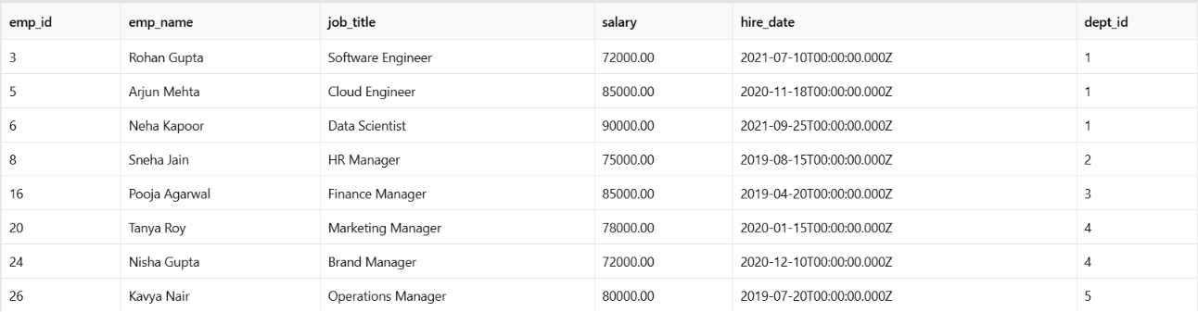

Projection – Employee names and salaries
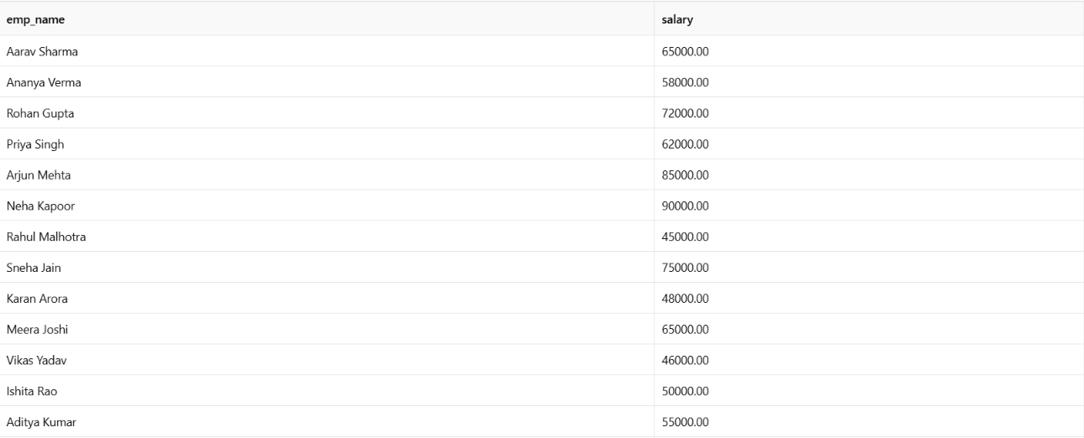
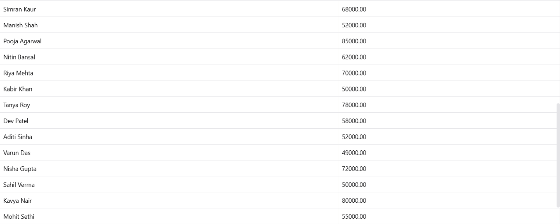

Aggregate Functions

GROUP BY – Employees per department
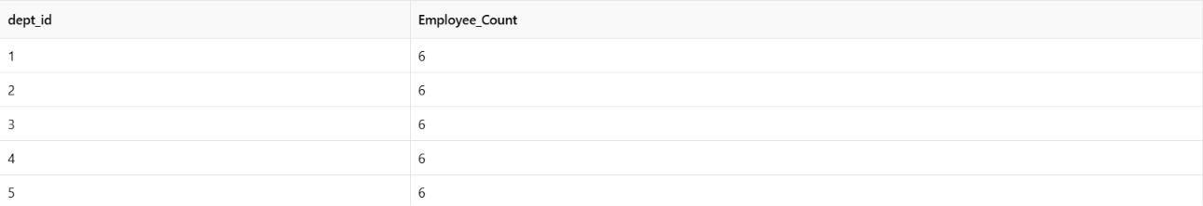
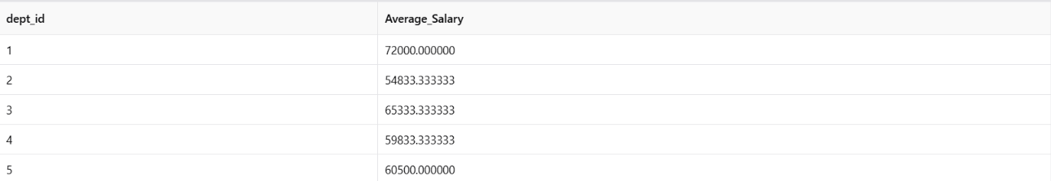

HAVING – Departments with more than 5 employees
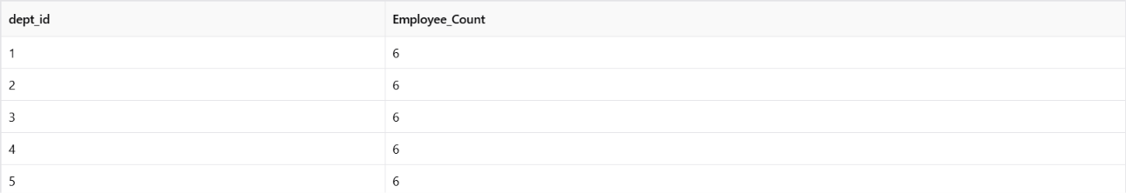

CASE Expression – Salary Category
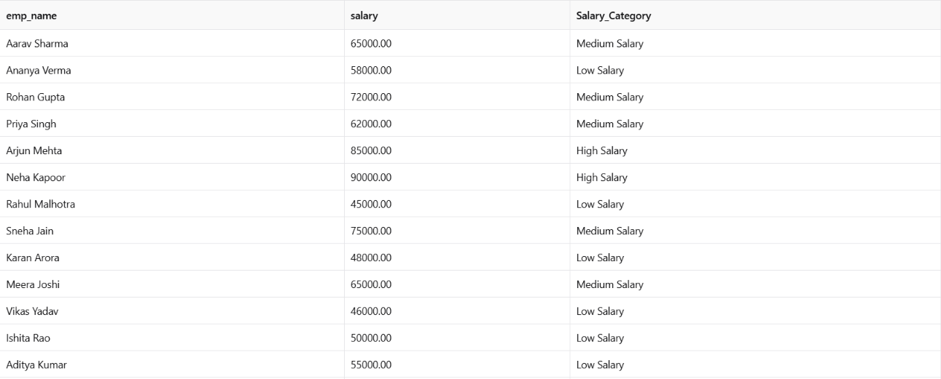
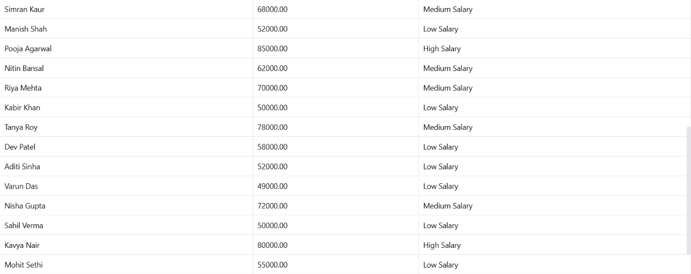

ORDER BY – Salary in descending order
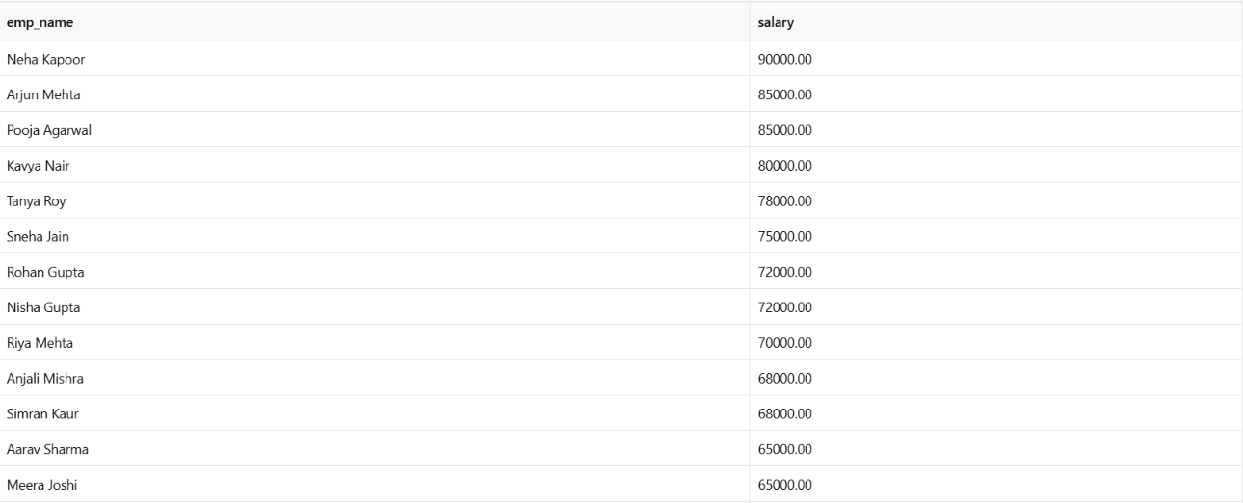


RESULT
The Employee–Department–Project schema was successfully created with 30 employees, 5 departments, and 8 projects. The required SQL operations including Selection, Projection, Aggregate Functions, GROUP BY, HAVING, CASE expressions, and ORDER BY were successfully executed.

