EXPERIMENT NUMBER: 4
AIM
To write and execute SQL queries on the Employee–Department–Project schema using INNER JOIN, LEFT JOIN, Self-Join, 3-Way Join, Correlated Subqueries, EXISTS, simulated INTERSECT and EXCEPT, and compare their execution plans using EXPLAIN.

SOURCE CODE
USE CompanyDB;

-- 1. INNER JOIN
SELECT e.emp_name, d.dept_name
FROM Employee e
INNER JOIN Department d
ON e.dept_id = d.dept_id;

-- 2. LEFT JOIN
SELECT d.dept_name, e.emp_name
FROM Department d
LEFT JOIN Employee e
ON d.dept_id = e.dept_id;

-- 3. SELF JOIN
SELECT e1.emp_name AS Employee1,
e2.emp_name AS Employee2,
e1.dept_id
FROM Employee e1
JOIN Employee e2
ON e1.dept_id = e2.dept_id
AND e1.emp_id < e2.emp_id;

-- 4. THREE-WAY JOIN
SELECT e.emp_name,
d.dept_name,
p.project_name
FROM Employee e
JOIN Department d
ON e.dept_id = d.dept_id
JOIN Project p
ON d.dept_id = p.dept_id;

-- 5. CORRELATED SUBQUERY
SELECT e.emp_name, e.salary FROM Employee e
WHERE e.salary >
(
SELECT AVG(e2.salary) FROM Employee e2
WHERE e2.dept_id = e.dept_id
);
-- 6. EXISTS
SELECT d.dept_name FROM Department d
WHERE EXISTS
(
SELECT 1 FROM Employee e
WHERE e.dept_id = d.dept_id
);

-- 7. SIMULATED INTERSECT
SELECT emp_id FROM Employee
WHERE dept_id = 1
AND emp_id IN
(
SELECT emp_id FROM Employee_Project
WHERE project_id = 101
);

-- 8. SIMULATED EXCEPT
SELECT emp_id FROM Employee
WHERE dept_id = 1
AND emp_id NOT IN
(
SELECT emp_id FROM Employee_Project
WHERE project_id = 101
);

-- 9. EXPLAIN FOR INNER JOIN
EXPLAIN
SELECT e.emp_name, d.dept_name FROM Employee e
INNER JOIN Department d
ON e.dept_id = d.dept_id;

-- 10. EXPLAIN FOR LEFT JOIN
EXPLAIN
SELECT d.dept_name, e.emp_name
FROM Department d
LEFT JOIN Employee e
ON d.dept_id = e.dept_id;

-- 11. EXPLAIN FOR THREE-WAY JOIN
EXPLAIN
SELECT e.emp_name, d.dept_name, p.project_name
FROM Employee e
JOIN Department d
ON e.dept_id = d.dept_id
JOIN Project p
ON d.dept_id = p.dept_id;
OUTPUT
1. INNER JOIN
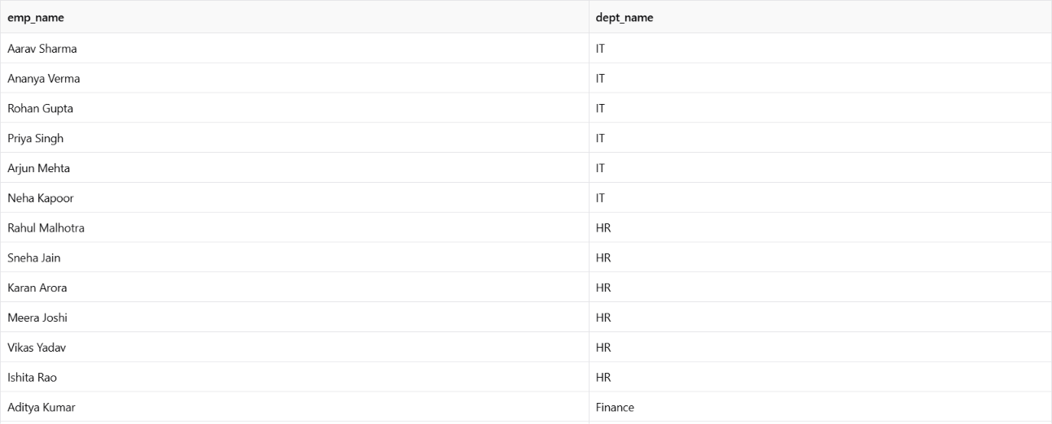
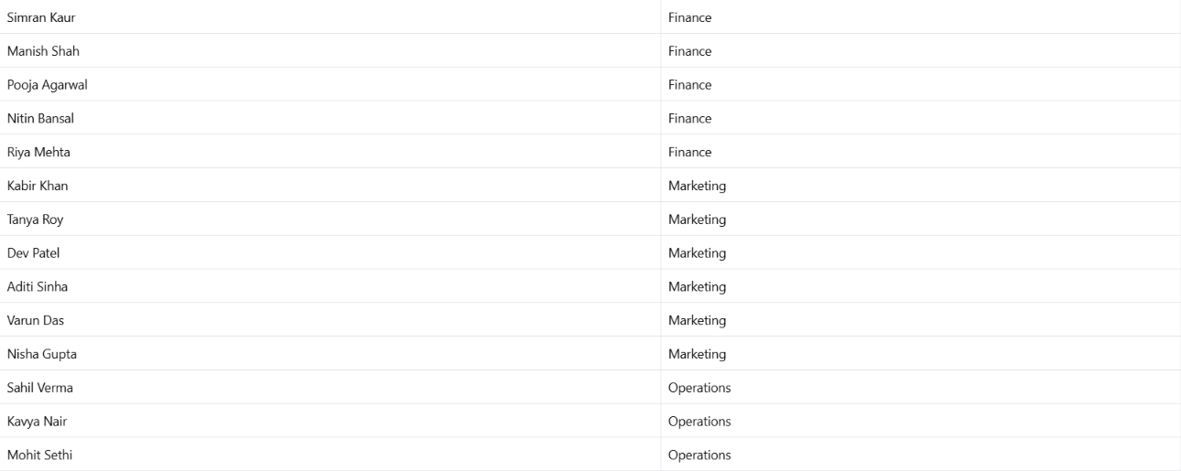

2. LEFT JOIN
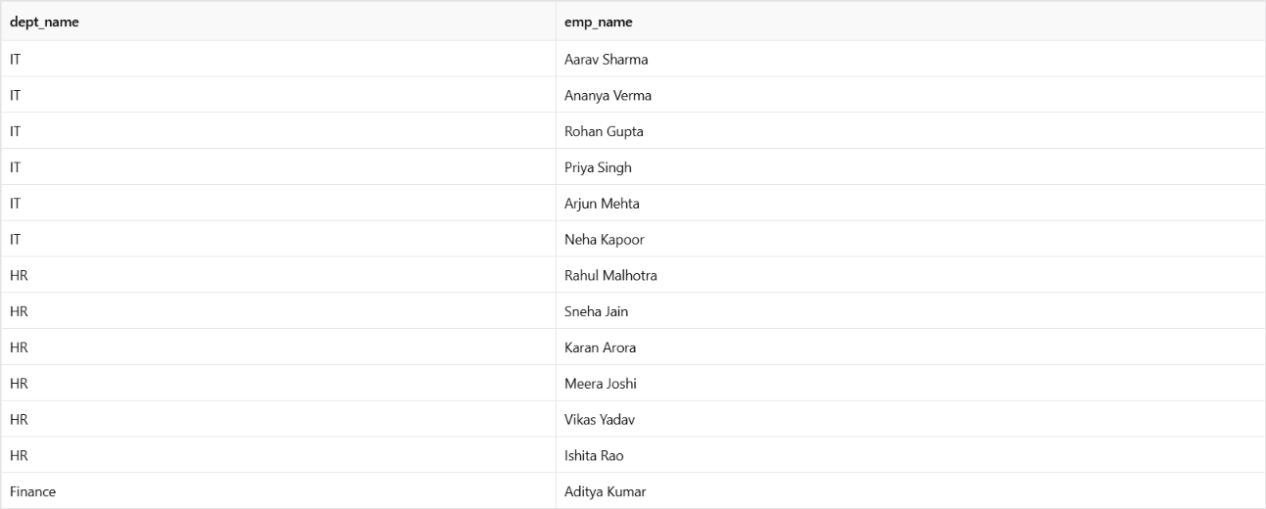
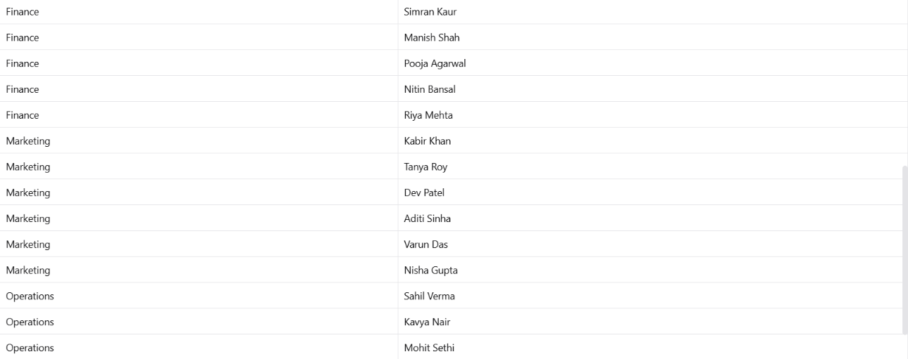

3. SELF-JOIN
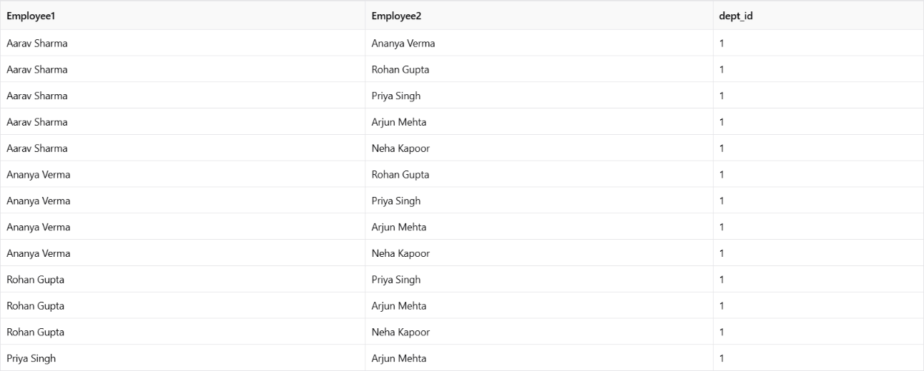
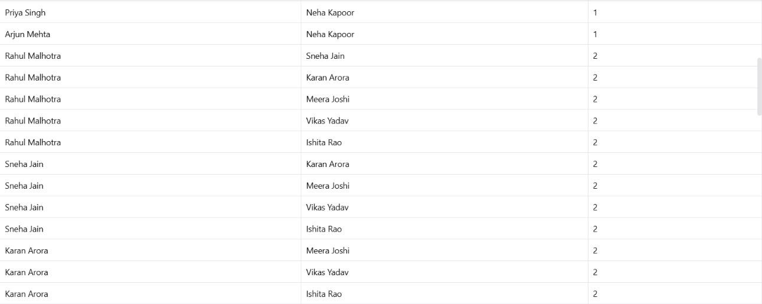
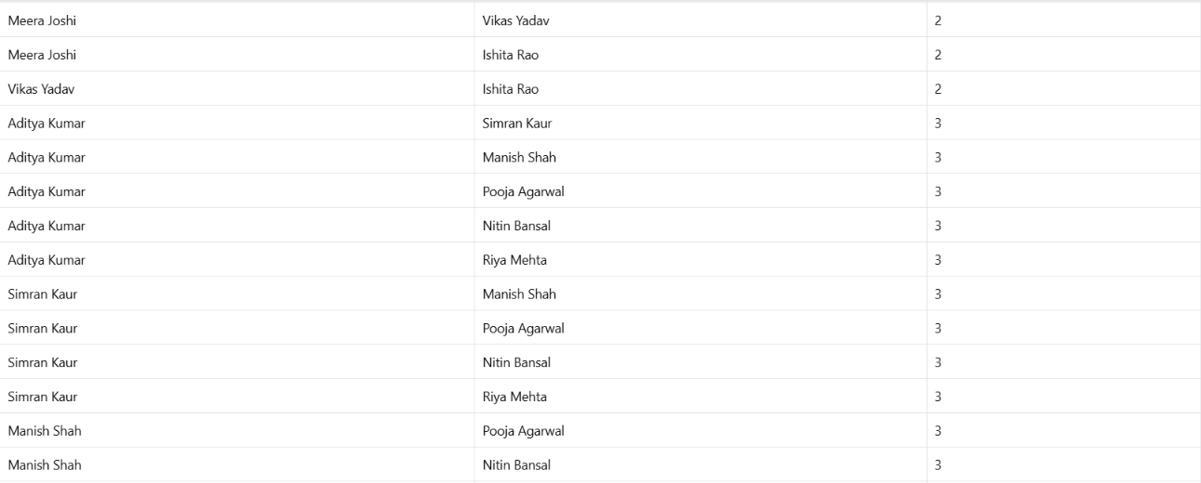
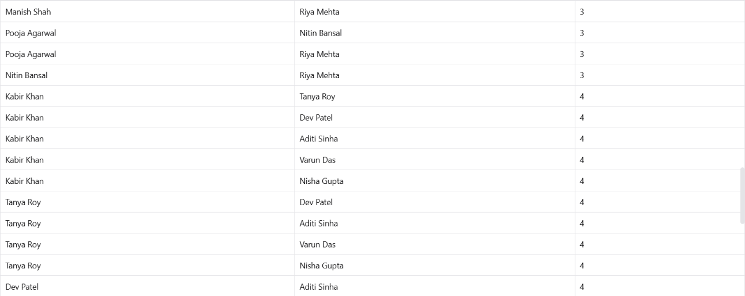
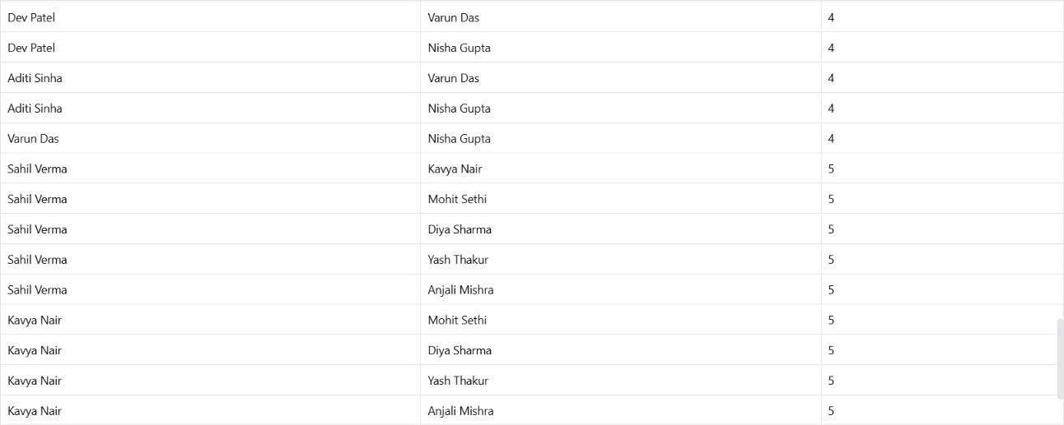
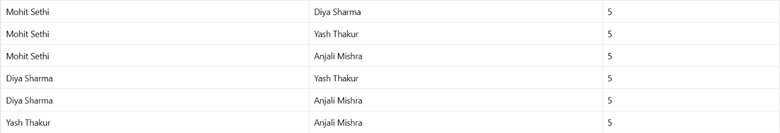

4. THREE-WAY JOIN
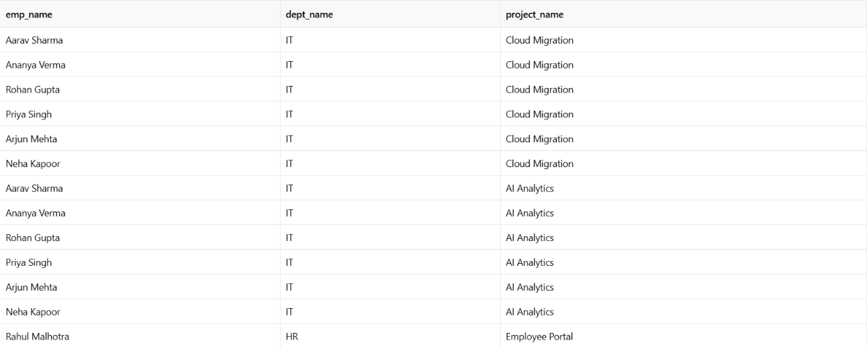
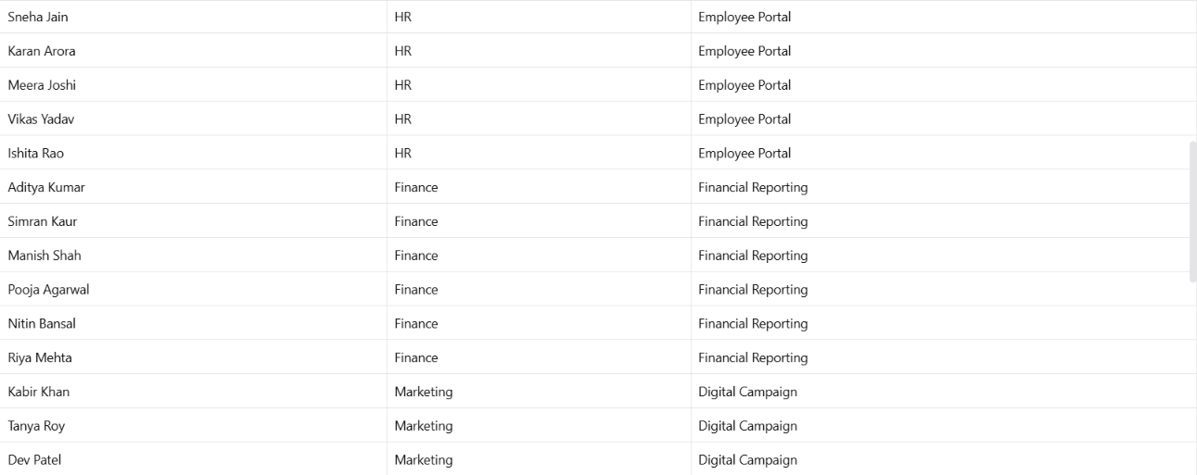
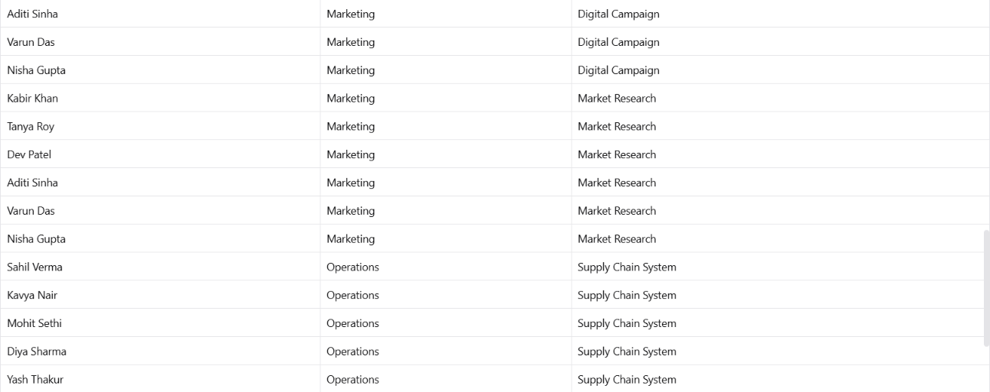


5. CORRELATED SUBQUERY
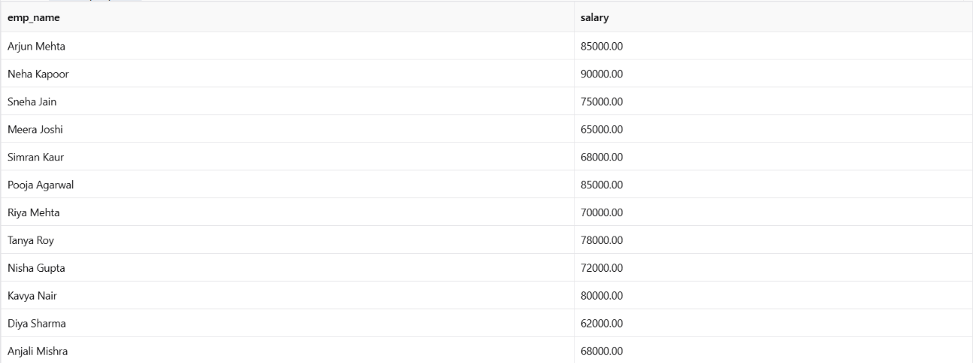

6. EXISTS
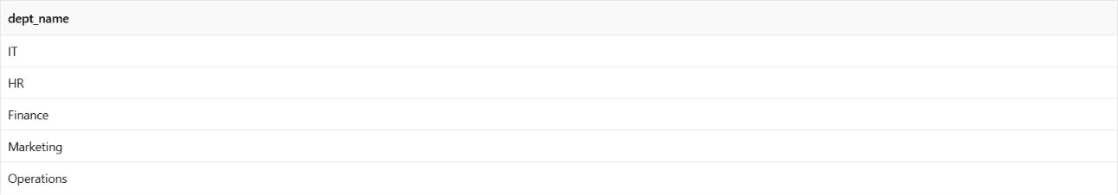

7-8. Simulated INTERSECT and EXCEPT
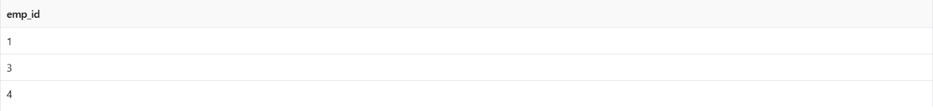
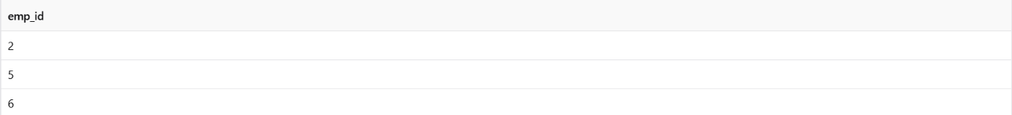

9-11. EXPLAIN
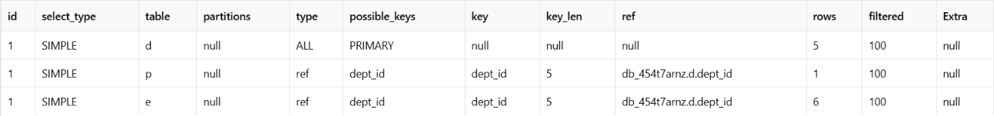

RESULT
The required queries using INNER JOIN, LEFT JOIN, Self-Join, 3-Way Join, Correlated Subquery, EXISTS, simulated INTERSECT, and simulated EXCEPT were successfully executed. The EXPLAIN command was also used to examine and compare the execution plans of different queries.

